Brock Pinagel

Dr. Colin M. Wasiloff

MBA 6103 Statistics for Data Analytics and Visualization

18 May 2025

Assignment 1

Use R to tidy up the file “legal_weed_age_GSS2018.csv” and create the legalize bar graph with percent of responses in age group.

Paste the 2016 figure from the lecture and this new 2018 figure into a brief business style memo that describes the results presented in the figures.

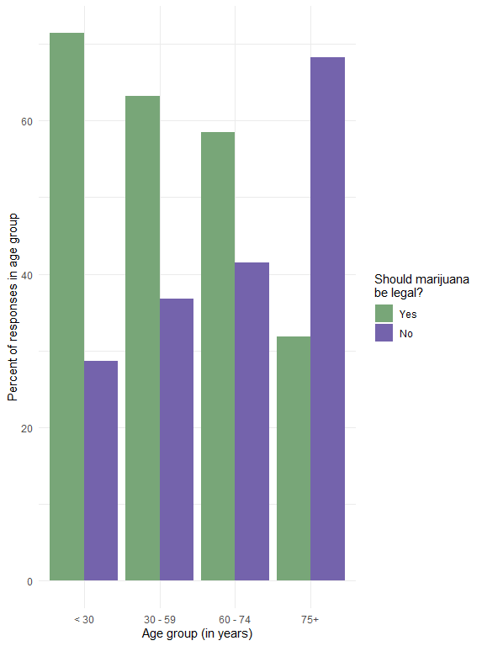Figure 1. Results of 2016 GSS

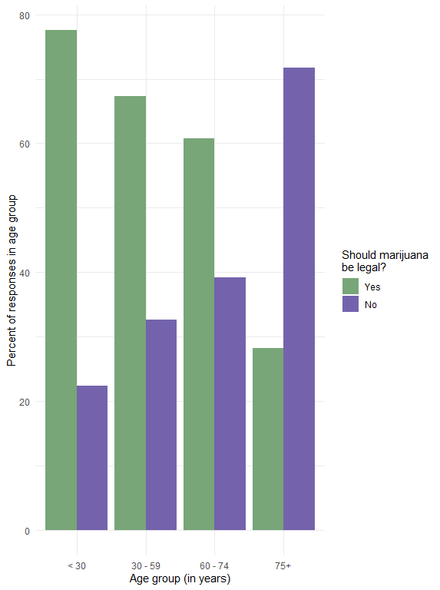Figure 2. Results of 2018 GSS

To: Dr. Colin M. Wasiloff

From: Brock Pinagel

Date: 5/18/2025

Subject: Analysis of GSS Data on Marijuana Legalization

Dr. Colin M. Wasiloff,

Figures 1 and 2 present the analysis of the 2016 and 2018 GSS data, respectively, regarding the attitude on marijuana legalization. The 2016 and 2018 GSS data shows that the majority of survey participants below the age of 75 support the legalization of marijuana. In contrast, survey participants over the age of 75 overwhelmingly oppose the legalization. In addition, marijuana legalization support grew slightly among survey participants below the age of 75, however, disapproval increased slightly for participants ages 75+ in the 2018 GSS data.