Brock Pinagel

Dr. Colin M. Wasiloff

MBA 6103 Statistics for Data Analytics and Visualization

27 May 2025

Assignment 4

Figure 1. Data Frame Summary

| **No** | **Variable** | **Stats / Values** | **Freqs (% of Valid)** | **Graph** | **Valid** | **Missing** |
| --- | --- | --- | --- | --- | --- | --- |
| 2 | EFFICIENCY [numeric] | |  | | --- | | Mean (sd) : 92.6 (11.2) | | min ≤ med ≤ max: | | 50.8 ≤ 93.1 ≤ 115.8 | | Q1 - Q3 : 88.9 - 97.7 | | Skew, Kur : -1.4 , 4.1 | | 32 distinct values |  | 32 (100.0%) | 0 (0.0%) |
| 3 | HRSWRK [numeric] | |  | | --- | | Mean (sd) : 6.6 (1.5) | | min ≤ med ≤ max: | | 3 ≤ 7.2 ≤ 7.8 | | Q1 - Q3 : 6 - 7.8 | | Skew, Kur : -1.3 , 0.6 | | 14 distinct values |  | 32 (100.0%) | 0 (0.0%) |
| 4 | HRSDOWN [numeric] | |  | | --- | | Mean (sd) : 1 (1.4) | | min ≤ med ≤ max: | | 0 ≤ 0.5 ≤ 4.7 | | Q1 - Q3 : 0 - 1.5 | | Skew, Kur : 1.5 , 1 | | 16 distinct values |  | 32 (100.0%) | 0 (0.0%) |

**Group**: MTYPE = Machine 2   
**Dimensions**: 53 x 4   
**Duplicates**: 0

| **No** | **Variable** | **Stats / Values** | **Freqs (% of Valid)** | **Graph** | **Valid** | **Missing** |
| --- | --- | --- | --- | --- | --- | --- |
| 2 | EFFICIENCY [numeric] | |  | | --- | | Mean (sd) : 83.4 (13.8) | | min ≤ med ≤ max: | | 61.7 ≤ 84 ≤ 115.2 | | Q1 - Q3 : 69.4 - 93.7 | | Skew, Kur : 0.2 , -1.1 | | 53 distinct values |  | 53 (100.0%) | 0 (0.0%) |
| 3 | HRSWRK [numeric] | |  | | --- | | Mean (sd) : 5.2 (2.4) | | min ≤ med ≤ max: | | 0.6 ≤ 6 ≤ 7.8 | | Q1 - Q3 : 3.5 - 7.6 | | Skew, Kur : -0.4 , -1.3 | | 28 distinct values |  | 53 (100.0%) | 0 (0.0%) |
| 4 | HRSDOWN [numeric] | |  | | --- | | Mean (sd) : 1.5 (1.8) | | min ≤ med ≤ max: | | 0 ≤ 0.9 ≤ 7.2 | | Q1 - Q3 : 0 - 2.7 | | Skew, Kur : 1.3 , 0.8 | | 26 distinct values |  | 53 (100.0%) | 0 (0.0%) |

**Group**: MTYPE = Machine 3   
**Dimensions**: 35 x 4   
**Duplicates**: 0

| **No** | **Variable** | **Stats / Values** | **Freqs (% of Valid)** | **Graph** | **Valid** | **Missing** |
| --- | --- | --- | --- | --- | --- | --- |
| 2 | EFFICIENCY [numeric] | |  | | --- | | Mean (sd) : 80.5 (9.1) | | min ≤ med ≤ max: | | 51.1 ≤ 80.9 ≤ 100.2 | | Q1 - Q3 : 76.6 - 86.4 | | Skew, Kur : -0.7 , 1.7 | | 35 distinct values |  | 35 (100.0%) | 0 (0.0%) |
| 3 | HRSWRK [numeric] | |  | | --- | | Mean (sd) : 5.9 (2.2) | | min ≤ med ≤ max: | | 1.5 ≤ 7.2 ≤ 7.8 | | Q1 - Q3 : 3.6 - 7.8 | | Skew, Kur : -0.7 , -1.2 | | 24 distinct values |  | 35 (100.0%) | 0 (0.0%) |
| 4 | HRSDOWN [numeric] | |  | | --- | | Mean (sd) : 1.9 (2.2) | | min ≤ med ≤ max: | | 0 ≤ 0.5 ≤ 6.2 | | Q1 - Q3 : 0 - 4.1 | | Skew, Kur : 0.7 , -1.2 | | 24 distinct values |  | 35 (100.0%) | 0 (0.0%) |

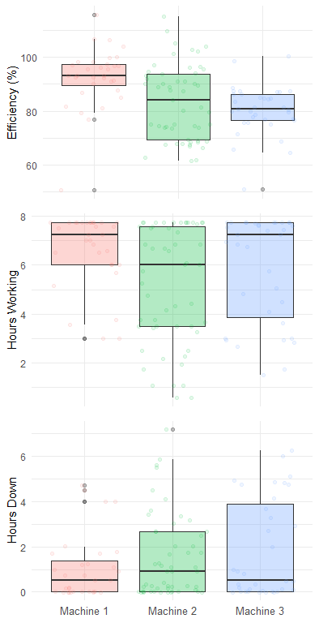Figure 2. Data Frame Boxplot

Table 1. Descriptive Statistics of the Case Study Variables

|  |  |  |  |  |  |
| --- | --- | --- | --- | --- | --- |
|  | variable | MTYPE | n.valid | mean | sd |
| 1 | EFFICIENCY | Machine 1 | 32 | 92.59 | 11.18 |
| 2 | EFFICIENCY | Machine 2 | 53 | 83.36 | 13.80 |
| 3 | EFFICIENCY | Machine 3 | 35 | 80.53 | 9.15 |
| 4 | HRSDOWN | Machine 1 | 32 | 1.03 | 1.41 |
| 5 | HRSDOWN | Machine 2 | 53 | 1.51 | 1.82 |
| 6 | HRSDOWN | Machine 3 | 35 | 1.86 | 2.17 |
| 7 | HRSWRK | Machine 1 | 32 | 6.65 | 1.47 |
| 8 | HRSWRK | Machine 2 | 53 | 5.18 | 2.42 |
| 9 | HRSWRK | Machine 3 | 35 | 5.89 | 2.17 |

To: Dr. Colin M. Wasiloff

From: Brock Pinagel

Date: 5/27/2025

Subject: Analysis and Recommendation for Major Manufacturing Facility

Dr. Colin M. Wasiloff,

Analysis results of the major manufacturing facilities daily production records are shown in Figures 1, 2 and Table 3. Results shown in Table 1 indicate machine type 3 worked fewer hours (mean = 5.89) and broke down for longer periods (mean = 1.86) resulting in lower efficiency (mean = 80.53%) than machine type 1. Furthermore, results from Table 1 also indicate machine type 1 worked more hours and broke down for shorter periods (mean = 1.03) resulting in higher efficiency (mean = 92.59%) overall. In addition, Table 1 also shows machine type 2 worked fewer hours than both machine types 1 and 2 (mean = 5.18), spent slightly less time down than machine type 3 (mean = 1.51), and was slightly more efficient than machine type 3 (mean = 83.36%). In conclusion, I recommend that machine types 2 and 3 be replaced with machine type 1 to increase productivity and efficiency, and to reduce downtime.