Brock Pinagel

Dr. Colin M. Wasiloff

MBA 6103 Statistics for Data Analytics and Visualization

9 June 2025

Module 7 Assignment

1. Work with the DISTANCE variable in the data file "opioid_dist_to_needle_exchange_2018.csv" which reports distance in miles to the nearest substance abuse facility that provides legal needle exchange.
   1. Transform the raw DISTANCE variable into log(1+x), square root, and cube root, create histograms of each transformation with normal density overlay, then create a 2x2 multi-panel figure. Paste your figure below and describe which transformation is visually closest to the normal distribution.

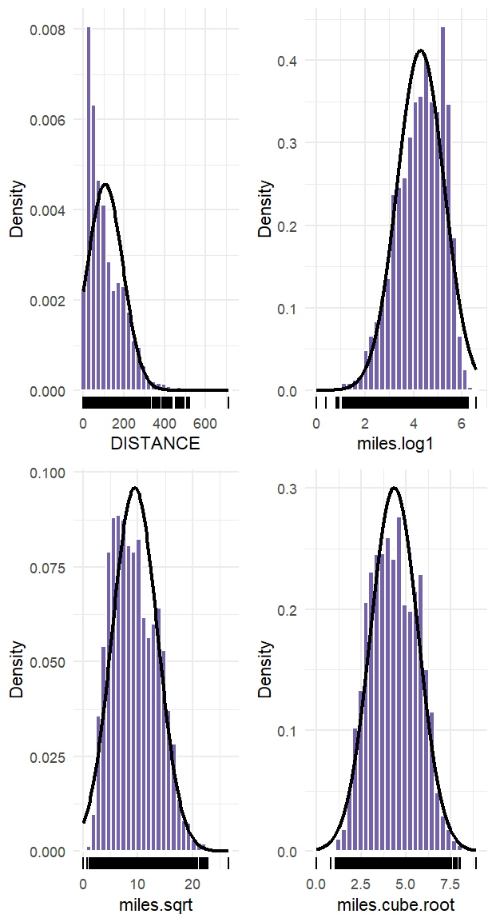Figure 1. 2x2 Multi-panel Distance Variable Histogram

“mile.cube.root” is the closest transformation to the normal distribution both visually and mathematically with a skewness of 0.09. Raw distance has a skewness of 1.29, “miles.log1” has a skewness of 0.23, and “miles.sqrt” has a skewness of 0.40.

* 1. What is the z score and percentile of 200 miles to the nearest needle exchange facility using cube root transformation?

Z-score = 1.126342

Percentile = 87th

* 1. Take a sample of 500 counties using set.seed(1945). What is the mean distance in miles?

103.49 miles

* 1. What is the mean distance in miles from 20 samples of counties where each sample had 500 counties in it?

105.52 miles

* 1. 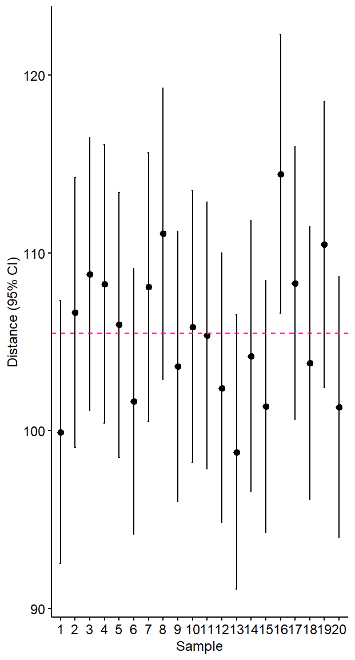Create a figure of the means and confidence intervals for the 20 samples of the 500 counties randomly selected from the population with the population mean shown as a dashed horizontal reference line. Describe how many sample means have the population mean within their 95% confidence interval.

Figure 2. Means and Confidence Intervals

The margin of error for sample 16 falls outside of the mean, however, the other 19 sample means have the population mean within their 95% confidence interval.

* 1. What is the mean (95% CI) of the sample of 500 counties?

Mean = 103.4879

1. Work with the file "GSS2018.csv". Select the variables GRASS, OWNGUN.

#GRASS: "Should marijuana be made legal", 0=IAP, 1=LEGAL, 2=NOT LEGAL, 8=DK, 9=NA

#OWNGUN: "Have gun in home", 0=IAP, 1=YES, 2=NO, 3=REFUSED, 8=DK, 9=NA

* 1. What is the proportion (95% CI) of Americans who think marijuana should be legal?

64.82%

* 1. What is the proportion (95% CI) of Americans who have a gun in the home?

35.10%

1. A recent poll asked 457 registered voters “Who is better positioned to beat Joe Biden in the 2024 election?” 52% selected Donald Trump, and 43% selected Someone Else. The poll did not report the Margin of Error.
   1. What is the estimated Margin of Error?

+/- 4.6 percentage points

Trump = 47.4-56.6

Other = 38.4-47.6

* 1. What is your interpretation of the poll results?

I interpret the poll results to mean of the 457 registered voters between 47.4% and 56.6% believe Donald Trump is better positioned to beat Joe Biden. In contrast, 38.4% to 47.6% of the 457 registered voters believe someone else is better positioned to beat Joe Biden.