**Daily Scrum or Standup Meeting**

Team name: ______TEAM 4___________________

Scrum Master: ______ Brock Francom_________

Date:___________11/18/19____________________

|  |  |  |  |
| --- | --- | --- | --- |
| **Team Member** | **What did you do since the last scrum?** | **What do you plan to do before the next scrum?** | **What obstacles do you have?** |
| Carter Figgins | Managing documents and standup meetings | Focus on smashing bugs | none |
| Brock Francom | Unit test views | Fix bug | none |
| Waseca Hodson | Unit test models | Fix bug | none |
| Sterling Tolley | Began implementing user password change and testing UI. |  |  |
|  |  |  |  |

# Burndown

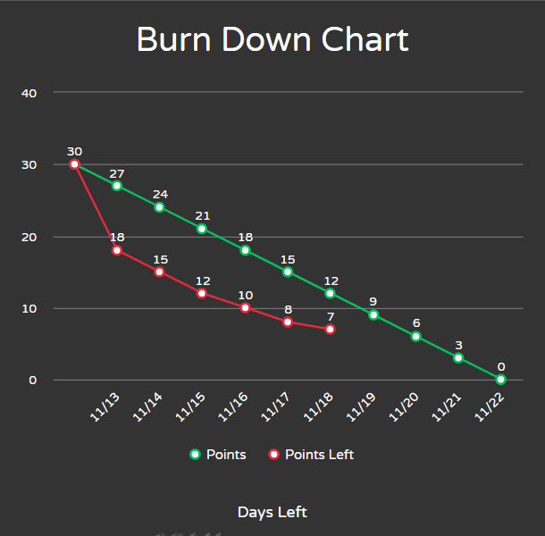

# Screenshot of you project board

