**Daily Scrum or Standup Meeting**

Team name: ______TEAM 4___________________

Scrum Master: ______ Sterling Tolley_________

Date:___________11/6/19____________________

|  |  |  |  |
| --- | --- | --- | --- |
| **Team Member** | **What did you do since the last scrum?** | **What do you plan to do before the next scrum?** | **What obstacles do you have?** |
| Carter Figgins | Commit live auction branch. Worked on my bid. | Finish my Bid. Finish unit testing | Unit testing |
| Brock Francom | Got the bids working, and init images working. | More checking on the ItemLists | laziness |
| Waseca Hodson | Removed Access table and the user key.  Changed some default delete styles.  Implemented some logic in the view file for voiding a tx. Met with Erik to discuss best implementation option. | Continue implementing behavior logic.  Figure out the model manager and preset queries and investigate APIs | Implementation options for triggers – discussed with Erik. |
| Sterling Tolley | Finished authorization views and controllers, added an initialization function. began documentation of major additions | Finish documentation of available features, fix styling bugs, test login page. | testing |
|  |  |  |  |

# Burndown

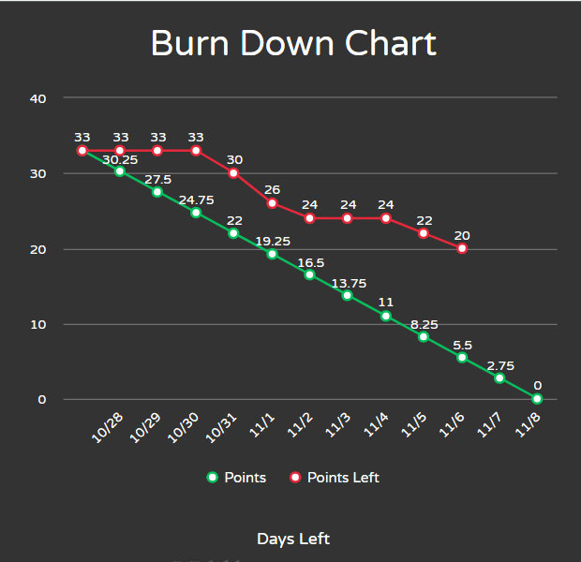

# Screenshot of you project board

