Brodie Lucht

Mr Howell (RHO)

Limitation of Ring Accelerators

12 Physics – IA 3 - 2021

Due Date: 26-07-2021

Contents

Rationale 2

Analysis 3

Design of particle accelerators, capability for electron acceleration 3

Special relativity’s effect on fast moving particles 4

Linear electron accelerators are the only option due to special relativity 5

Evaluation 6

Quality of Evidence 6

Improvements to the investigation 6

Evaluation of claim 6

Extensions to the investigation 6

Conclusion 7

Appendix 7

Appendix 1 7

Bibliography 7

# Rationale

The claim is, *particle accelerators are designed to incorporate special relativity*. The claim is based around Einstein’s theory of special relativity. Special relativity is a theory that all motion must be defined relative to a frame of reference and forms part of the basis for modern physics. Relativistic speeds, those at which special relativity applies, is considered to be any speeds >0.1c (Walding, 2019). The first aspect of the claim is the theory behind the design of particle accelerators. A particle accelerator is a device that produces a beam of fast moving electrically charged atomic or sub atomic particles (“Particle accelerator | instrument,” n.d.). The research and development of particle accelerators has been driven forward by high energy physics (Bryant, n.d.). Particle accelerators have two main designs, the first and currently most common is the ring accelerator and the second design is the linear accelerator (“How Particle Accelerators Work,” n.d.). The second aspect of the claim is the consequence special relativity on the high energy particle. If a particle exceed 0.1c, the effect of time dilation and length contraction from the frame of reference of the particle have to be considered. Due to the nature of high energy particles in an accelerator easily exceeding this threshold, for example a 1MeV electron travels at v ~ 86% c (Plettner et al., 2005), the consequences of special relativity need to be considered. This leads to the third aspect of the claim and how the implications of special relativity pose a limitation to ring accelerators. Due to the synchrotron radiation emitted by high energy charged particles in a circular orbit, ring accelerators are not suitable for accelerating electrons over 100GeV (Plettner et al., 2005).

This led to the development of the research question:

*Do linear accelerators have the advantage over ring accelerators for the future of high energy physics and achieving TeV electron accelerators?*

# Analysis

## Design of particle accelerators, capability for electron acceleration

Particle accelerators have been a constantly developing technology since the 1920s. The driving force being high energy physics that studies the nature of particles that constitute matter. The evolution and development of new, higher energy particle accelerators over time are represented in figure 1. One of the limitations with the graph it is purely a graphical representation of the information and no data regarding the advancements of higher energy particle accelerators were provided.

**Figure 1: Accelerator Energy vs Time, up to 1980s** (Plettner et al., 2005)

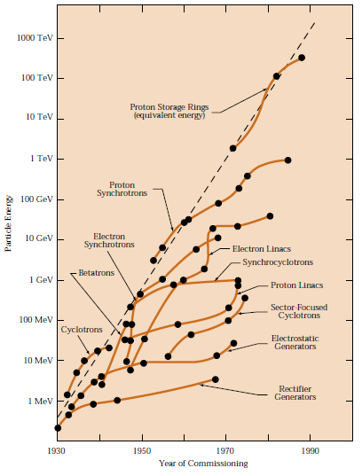

Currently the world’s largest and more post powerful particle accelerator is the Large Hadron Collider. It is a ring accelerator design which had a diameter of 27km (“The Large Hadron Collider | CERN,” n.d.). One of the advantages of the ring accelerator designs is it allows the particle to travel hundreds of thousands of times though the rings in order to gradually build up its kinetic energy. In comparison in a linear accelerator the entire acceleration has to be performed in the singular length of the accelerator (Plettner et al., 2005). One of the first linear colliders was the SLAC linear collider. It was a 2mile long collider which in the late 1960s was achieving energy levels of 20GeV and due to advances in technology by the 1980s was achieving 50GeV electron beams (“The Stanford Linear Accelerator Center,” n.d.). The main limitation of this source is the possible bias, as the organisation is the owner of the SLAC linear accelerator. This was one of the earliest linear accelerators, and is the pioneering embodiment of the new linear accelerator design, theoretically capable of reaching TeV electron acceleration.

## Special relativity’s effect on fast moving particles

The two relativistic occurrences which particles undergo while traveling at high speeds are time dilation and length contractions. Time dilation is the effect of time passing slower in the frame of reference of the particle moving at high speeds, this has the same effect as length contraction, where the distance travelled by the particle appears to be reduced (Walding, 2019). A primary example of how time dilation is utilised in particle physics are storage rings. A storage ring is a type of circular or ring particle accelerator which is used to keep particle beams for many hours. The high velocities of particles inside these cells allow for unstable particles to be kept for longer periods of time.

Another effect of special relativity on particle accelerators is the fact nothing with mass can reach the speed of light. This can be described by the kinetic energy equation, $E_{K}=0.5 ×Mass × Velocity Squared$. This formula demonstrates that a change in kinetic energy would induce both a change in mass and a change in speed. This is most prominent at speed approaching the speed of light when most the change occurs to the mass, this is demonstrated by the graph in figure 2. The main limitation with the graphical data is it was not accompanied by any mathematical/experimental data, along with the age of the source being over 20 years old.

**Figure 2: Effect of increasing kinetic energy of a particle**

(“Mass, energy, the speed of light - it’s not intuitive,” 1996)

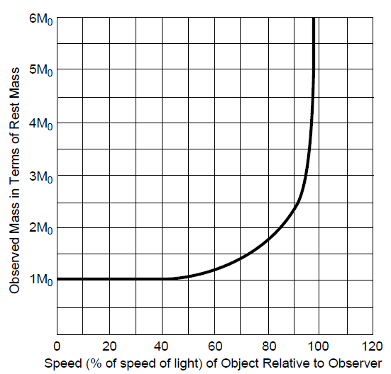

## Linear electron accelerators are the only option due to special relativity

The primary limitation of ring electron accelerators is caused by synchrotron radiation losses. Synchrotron radiation is produced when electrically charged particles follow a circular trajectory, when it was first discovered it was considered a negative side effect. (“synchrotron radiation « Einstein-Online,” n.d.). While nowadays there are many particle accelerators whose sole purpose is to produce this radiation, in the pursuit of high energy electron acceleration it is still a hindrance. The properties of this radiation emitted from the acceleration of electrons is determined by special relativity (Margaritondo and Rafelski, n.d.). While special relativity is not the causality of the radiation, its effects cause the radiation to be densely concentred and intense, hence resulting in significant loss of energy. For example while a 14TeV proton only loses 60eV of energy due to radiation per turn in the 4.2km radius or 27km diameter of the Large Hadron Collider, an electron at the same energy would be losing 20TeV per turn (Plettner et al., 2005). Even in a ring collider the radius of earth, the electron would still lose 13GeV per turn. To avoid the problem of synchrotron radiation, linear accelerators will be required since the radiation is only produced while the charged particle is undergoing a radial/circular orbit. The key issue of linear accelerators is the acceleration gradient, how fast the electron can reach the target energy due to the limited accelerator length available. The proposed CLIC linear accelerator, is predicted to require a site length of 48km in order to reach a 3TeV electron (Holzer, 2017).

# Evaluation

## Quality of Evidence

A range of sources were utilised in collecting the information throughout this report, including research papers, government publications and education and organisation sources. Two of the organisation webpages utilised were, CERN and SLAC national accelerator laboratory. These websites are published by the organisations behind the Large Hadron Collider and the SLAC linear collider respectively and the information taken from the websites is possibly bias and therefore should be verified by a third party source. Nevertheless while the information wasn’t explicitly verified, the data collected from the sites aligned with that which was collected from other papers and therefore can be considered reliable. Other limitations with some of the sources utilised is the age of the publications, some being up to 25 years old, which pose the possibility of outdated information. This was one of the main observations when acquiring evidence relevant to the research question, public availability of sources, especially those published within the last decade being very limited.

## Improvements to the investigation

In order to address the limitations and quality of the evidence collected in this investigation, some improvements could be made. Firstly, accessing more sources and specifically more recently published scientific journals would help improve the reliability and validity of the data collected. Another possible improvement would be to have sources with more raw and experimental data, instead of just visual representations and lone figures.

## Evaluation of claim

The research question addressed throughout this investigation is “Do linear accelerators have the advantage over ring accelerators for the future of high energy physics and achieving TeV electron accelerators?” The evidence collected suggests that linear accelerators do have the edge over ring accelerators due to their ability to forego the effects of radiation created from having charged particles in a radial orbit. While this might be the case for the specific use of electron accelerators, ring accelerators still have the spatial efficiency edge and are able to achieve high energy levels of protons and other particles, along with uses where the synchrotron radiation has become the intended result. When applying the finding of this investigation to the claim of “*particle accelerators are designed to incorporate special relativity”* it is clear that due to the high velocity of the particle that all particle accelerators are designed to incorporate and account for the effects of special relativity.

## Extensions to the investigation

In this investigation the research questioned focused in on a small aspect of the claim, which could also be considered from multiple other angles. One of these possible alternate viewpoints of this claim would be to look further into why ring accelerators have been far dominant over linear accelerators specifically focusing on the acceleration gradient and inherent cost associated. Further research could also be conducted into how, through an understanding of special relativity, the energy of particles are manipulated to achieve intended frequency and quantity of synchrotron radiation emissions, and its beneficial uses.

# Conclusion

It can be seen that the evidence gathered sufficiently demonstrates how special relativity has to be carefully considered in the design of particle accelerators and is one of the reason some accelerators have to be designed to be task specific. While the age and source of some the information gathered might be suboptimal, the quantity of corresponding evidence gathered for the report allows it to be reputable. Therefore the claim that, “*particle accelerators are designed to incorporate special relativity”,* can be supported by the evidence gathered. Which focused on the effects of special relativity has on a small subsection of particle accelerators, electron accelerators. This could also be a possible extension to the investigation and ways to explore this claim further.

# Appendix

## Appendix 1

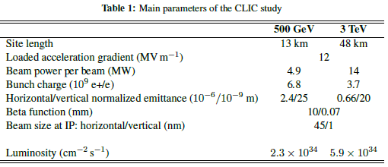

(Holzer, 2017)

# Bibliography

Bryant, P., n.d. A brief history an review of accelerators. CERN.

Holzer, B., 2017. Introduction to particle accelerators and their limitations. CERN.

How Particle Accelerators Work [WWW Document], n.d. . Energy.gov. URL https://www.energy.gov/articles/how-particle-accelerators-work (accessed 7.16.21).

Margaritondo, G., Rafelski, J., n.d. The relativistic foundations of synchrotron radiation. University of Arizona.

Mass, energy, the speed of light - it’s not intuitive, 1996.

Panofsky, W., 1997. The evolution of particle accelerators and colliders.

Particle accelerator | instrument [WWW Document], n.d. . Encycl. Br. URL https://www.britannica.com/technology/particle-accelerator (accessed 7.16.21).

Plettner, T., Byer, R., Siemann, R., 2005. The impact of Eistein’s theory of special relativity on particle accelerators. Institute of physics pulishing.

SLAC National Accelerator Laboratory [WWW Document], n.d. . Energy.gov. URL https://www.energy.gov/ea/slac-national-accelerator-laboratory (accessed 7.16.21).

synchrotron radiation « Einstein-Online, n.d. URL https://www.einstein-online.info/en/explandict/synchrotron-radiation/ (accessed 7.16.21).

The Large Hadron Collider | CERN [WWW Document], n.d. URL https://home.cern/science/accelerators/large-hadron-collider (accessed 7.16.21).

The Stanford Linear Accelerator Center [WWW Document], n.d. URL https://www.slac.stanford.edu/gen/grad/GradHandbook/slac.html (accessed 7.16.21).

Walding, R., 2019. New Century | Physics | For Queensland | Unit 3 & 4, Third. ed. Oxford University.