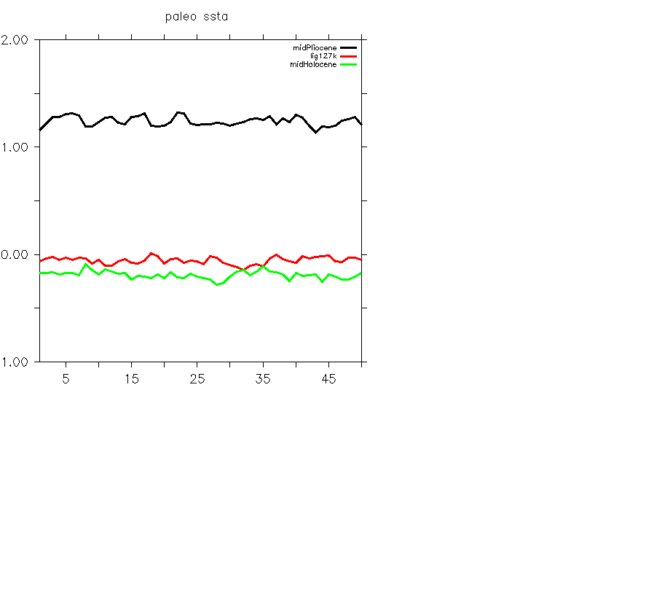

Paleo SSTA, the black line represents the midPliocene (one model), the red line represents the lig127k (four models ensemble mean), the green line represents the midHolocene (five models ensemble mean). The unit is degree.