Sprint 3 Phase 3 Planning

## Know the end from the beginning

* Sprint ends March, 28th 2020
* This sprint will probably take 10 hours a person to complete.
* We are planning to meet every Tuesday and Thursday.
* Pick a metric to evaluate each other on during the retrospective
* Trello has a point system. Every task is worth a number of points. 1 points is worth 1 hour of work. In Theory we should all have similar points that indicate that we spent similar amounts of time on the project.
* Brody Larsen is the Scrum Master
  + Johnathan Kunz
  + Brody Larsen
  + Chris Winwood
  + Kosta Sergakis

Fill out details for each story

* Search for tools as a user
  + Small task
  + When on the tools page, the user will be able to search for a tool that they are looking for
  + The search functions we implement needs to search the database. If the search function doesn’t find what the users typed in, then return a message saying “cant find tool”.

Tasks

* + Create a text field for user to type
  + Take the input and use that to search for a matching tool in the database
* Filter through categories of tools as a user
  + Small task
  + While on the tools page, the user is presented a list of all the tools. The user should be able to look at categories of tools. IE look at bike repair tools.
  + If the user selects “bike repair” then all the tools in the “bike repair” category in the database need to on display. The other categories can’t be displayed either.

Tasks

* + Create a list on the side of the page with all the database categories.
  + When a category is selected then the page updates or goes to a new page with just that category of tools
* Add objects to Customers
  + Medium task
  + When a user selected a tool to check out that tool needs to be added to a list of tools that the user wants to check out
  + The user should be able to checkout multiple tools at once.

Tasks

* + Change the user object so it has an item list with all the tools it wants to check out.
* Checkout tools
  + Medium task
  + The user needs to block off access for a week to other users so a tool doesn’t get “double booked”
  + Once an item is checked out that tool should not be able to be checked out until the tool is returned

Task

* + A tool object needs to be able to keep track of whether it is checked out, late, or free
* Set up Check out page
  + Medium task
  + Create a checkout so the user can check out the tools
  + The page needs to take the items in the user’s tool list and change their availability value to checked out.

Task

* + Run javascript to change the tool object value tot checked out
  + Check to see if the user is logged in
* Add “add” button to the tool on tools page
  + Medium Task
  + Each tool listed need to have an add button so that tool is added to the user
  + The button should add the tool to the user so they can later checkout those tools

Tasks

* + Create a button
  + That button needs to add the tool to the list
* Tools check out
  + Medium task
  + When a customer checks out a tool, that tool is considered checked out and wont be available to others to check out until it is returned.
  + If a tool is checked out, someone else should not be able to check it out also. People can still reserve it however.

Tasks

* Be able to change a tool object to depict that is a checked out and not available for others to checkout.
* A checked out tool still needs to be reservable.
* Format search textboxes on tools page
  + Small task
  + The text boxes that are used for the filter feature are not centered on the page
  + If the texts boxes are not centered then the job isn’t done

Tasks

* + Change the textbox alignment tag
* Add employee Portal
  + Medium task
  + A special user with more privilege needs to be added so the company can override things
  + If the employee user cant checkout tools then things aren’t done

Tasks

* + Make a new object that implements a user. This new object can do other things that regular users can’t.
* Remove broken image from carousel
  + Small task
  + There is an image that doesn’t show up while the carousel is on display
  + If that image is still in the rotation then the problem isn’t fixed

Tasks

* + Delete the picture from the folder that holds the carousel pictures
* Be able to return Tools
  + Medium task
  + The employee need to be able to change the tool status to in stock
  + If the employee cant change the status of a tool, then we are not done.

Tasks

* + Give employee objects the ability to change the status of a tool
* Only allow tools to be checked out if user is logged in
  + Medium task
  + Before the status of a tool is changed, there needs to be a check to see if the user is logged in
  + A guest user cannot checkout a tool

Tasks

* + Add logic to the user object to check is the user is logged in

## Artifacts

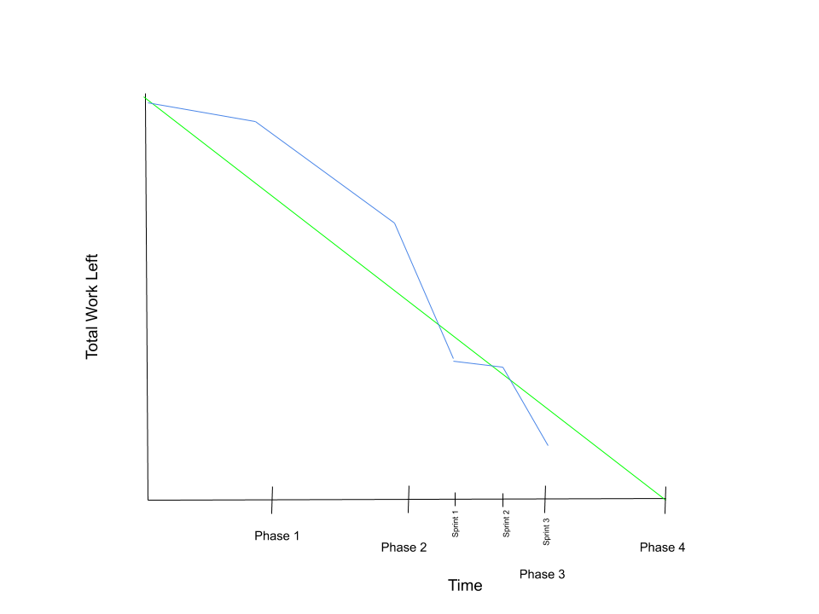

This is the backlog of things after phase 3.

