Sprint 1 Phase 3 Planning

## Know the end from the beginning

* Sprint ends March, 14th 2020
* This sprint will probably take 10 hours a person to complete.
* We are planning to meet every Tuesday and Thursday.
* Trello has a point system. Every task is worth a number of points. 1 points is worth 1 hour of work. In Theory we should all have similar points that indicate that we spent similar amounts of time on the project.
* For sprints 2 & 3: List 1 item from your retrospective that you said you were going to do better at that you are going to focus on this sprint.
* Brody Larsen is the Scrum Master
  + Johnathan Kunz
  + Brody Larsen
  + Chris Winwood
  + Kosta Sergakis

## Fill out details for each story

* For the start of the First sprint we have no leftovers from the last sprint/phase.

This Sprint we are planning on doing the following:

* The website will have a slideshow carousel on the main page
  + This should be a small (maybe medium) task
  + The slideshow should rotate through 3 or more pictures. Each picture should show for 8 seconds. (the user may click on a button that goes to a picture, that also resets the 8 seconds)
  + The goal we have is to look and act like Netflix’s slideshow carousal. It needs to rotate through the list of pictures with smooth fade transitions.
  + A list/database is required to store the pictures.

Tasks

* + A script is needed to rotate through the pictures
* As a user, be able to see if a submission was accepted
  + This is a small task
  + When a reservation is sending a message on the website should return feedback on whether the server successfully stored the reservation
  + If the website gives a false positive or a false negative, it will be assumed the feedback system doesn’t work

Tasks

* + The webpage needs to display a message
  + The database or another program needs to check or return that the request was successfully accepted and the tool is reserved for the specific customer
* As a user, be able to see a logo on the header and footer of every page
  + This is a small task
  + A picture of the company ‘s logo needs to be added to the webpages

Tasks

* + If the logo is not added to the header and footer of every webpage, the task is not done
  + A .jpeg or .png or .gif of the logo needs to added to the static file of the Spring file system
  + The .html needs to display the picture of the logo
* Format tools.html to look better
  + A small task
  + The look of the tools page is still being decided on
* As a user, be able to go to a contact page.
  + A medium task
  + The contacts page needs a google maps of where the warehouse is (adding google maps will be done next sprint). The Contacts page needs to display the company’s contact information. It also needs a form to send emails to the tool company.
  + The webpage needs to clearly describe what the email is form is doing. We can’t expect the user to know what the random textboxes on the page are for.

Tasks

* + Figure out google maps API so our website can display google maps.
  + Display tool company’s contact info on webpage
  + Create forms that make it easy to send an email to the tool company
* As a user, go to a projects page.
  + This is a medium to large task
  + The projects page is a webpage that has pictures and descriptions of people using the tools they got from the tool rental company to remodel a house.
  + The page should do a good job of promoting the tool company as a help service to the community. Not so much an advertisement of the brand of tools

Tasks

* + Pictures of customers/people using tools to remodel a house need to be gathered.
  + Testimonies need to be gathered so they can be displayed on the website
  + The pictures and descriptions need to be organized on a webpage
  + Unit tests
  + Medium task
  + We have to come up with as many small tests that check all the individual parts of our program work
  + Finished unit tests are tests that pass
* Sign Up Page
  + Small task
  + A webpage that has a form that takes input and creates a new customer object/adds a new customer to the database. A user objects needs a username, email and password.
  + The sign up page should make/add a new user to the database. If a user wants there elevated access they need to remember a username and a password that is associated with their username to prove who they are in theory.

Tasks

* + Create a webpage with a form that takes input from the user and create a new user.
* Sign in Server
  + Large task
  + Be able to access the database without having to go through the website interface
  + If we can make/use a 3rd party database to add, remove and edit things in the database without needing to touch the website then we can created a Server sign in

Tasks

* Find a database manipulator
* Create a login section so we are able to see the data in the database
* Add and delete objects to Customer profiles
  + Small task
  + Be able to add or remove tools to a list that the customer wants to check out. The tools aren’t being checked out yet just being added to a list so they can check out the tools on the list

Tasks

* + Every customer has a list associated with what tools they want to check out.
  + That list should follow the customer around while they navigate the website.
  + Once the tools are checked out they should be removed from the list and added to the checked out list.

## Artifacts

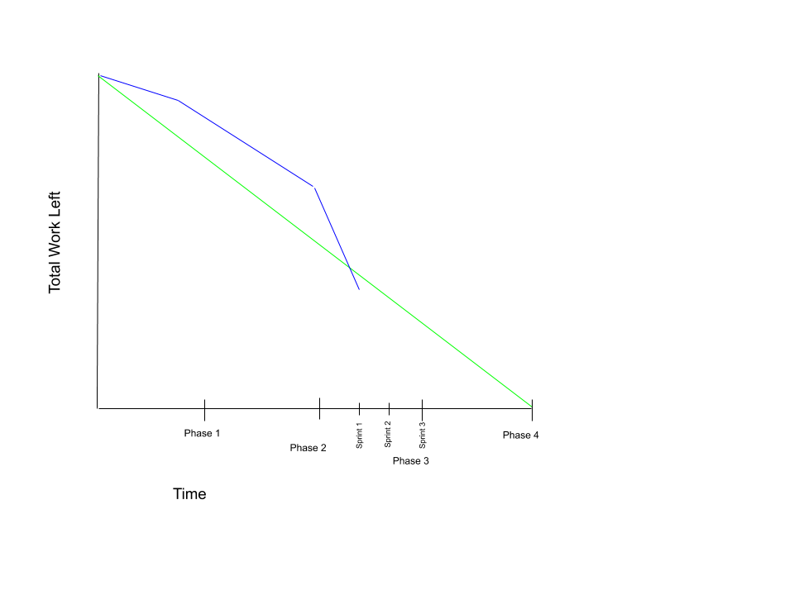

At this time we have no backlog.