Tyler Campbell

CSCI 1260 002

Zork Project 5 Screenshots

The game was coded so that the console refreshes for a better UI. Here is some example screenshots of interactions.

This one shows the display and layout of finding a weapon and a monster at the same time. The weapon is giving and then the damage is incresed on this same turn.

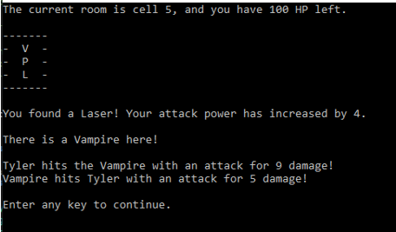

After the weapon is claimed it disappears from the map.

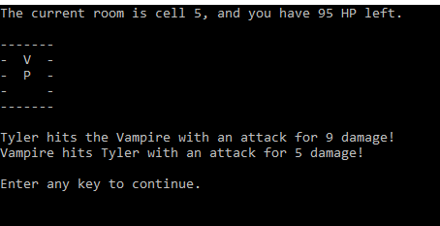

Defeating the monster on your attacks stops them from doing their attack. This was a bug I had to fix intitially.

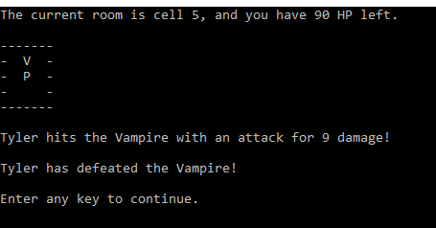

After the enemy is defeated, the room map updates and they will not respawn.

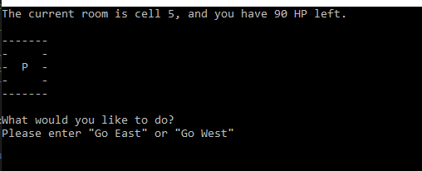

Trying to go left at cell 1 (or cell 0, the first of the array of cells) is blocked.

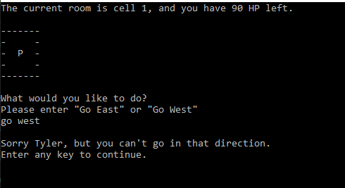

Going back to cell 5, no enemy or weapon shows up again.

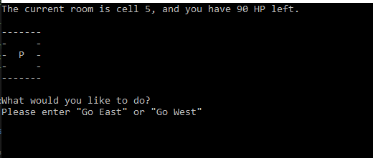

New enemy type discovered at cell 6

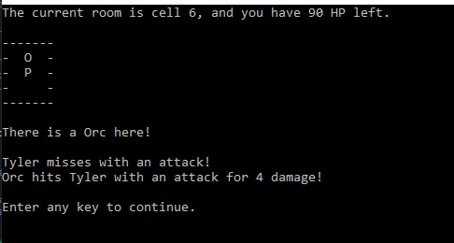

Enemy defeated.

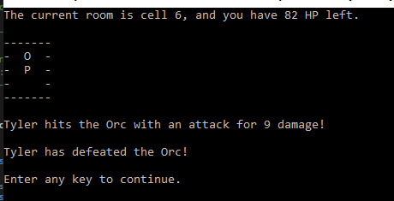

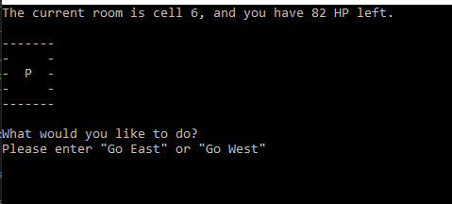

This was the last cell in this generation, go east causes the player to win here.

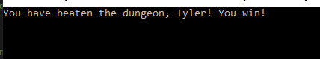

Starting a second run of the program where the player only has 10 health to display a death.

First enemy found on cell 3, no weapon yet so base damage from player.

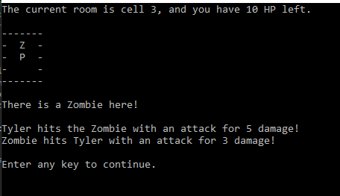

Close call.

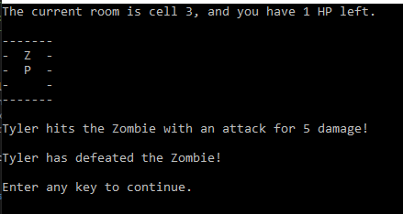

Stick found, small power increase. Also realized during this that Stick and Sword will both display S as currently coded, will go fix this.

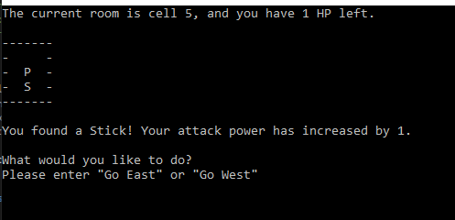

New enemy found in cell 6, after his attack the player will drop below 1 hp.

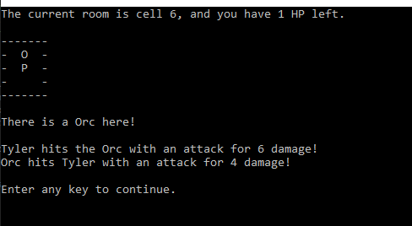

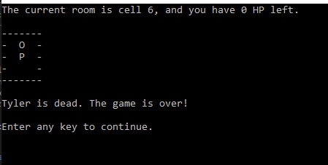

As a small note, will probably go update so that the player icon changes to an X if the player is dead too.

Updates:

