Aaron Campuzano

CIS 344

Project 1

The Miniworld I chose is for the cleaning service. I found a guide on how to do accounting and bookkeeping for a cleaning service[1]. One of the entities I shall make is Clients since they are one of the major objects to keep track of. Their addresses, email, and phone numbers should be the attributes for clients with Client Name being the main attribute. Another entity shall be expenses with its primary key being gross expenses, the rest would be the cleaning supplies, cleaning tools, the payroll, and things of that nature. The final entity is the work that should be done or Cleaning with its primary key being the total cleaning fee, the rest of attributes would be the start time, end time, and labor costs. The relationship between the client and cleaning is a many-to-one relationship and for cleaning and expenses is a many-to-many relationship.

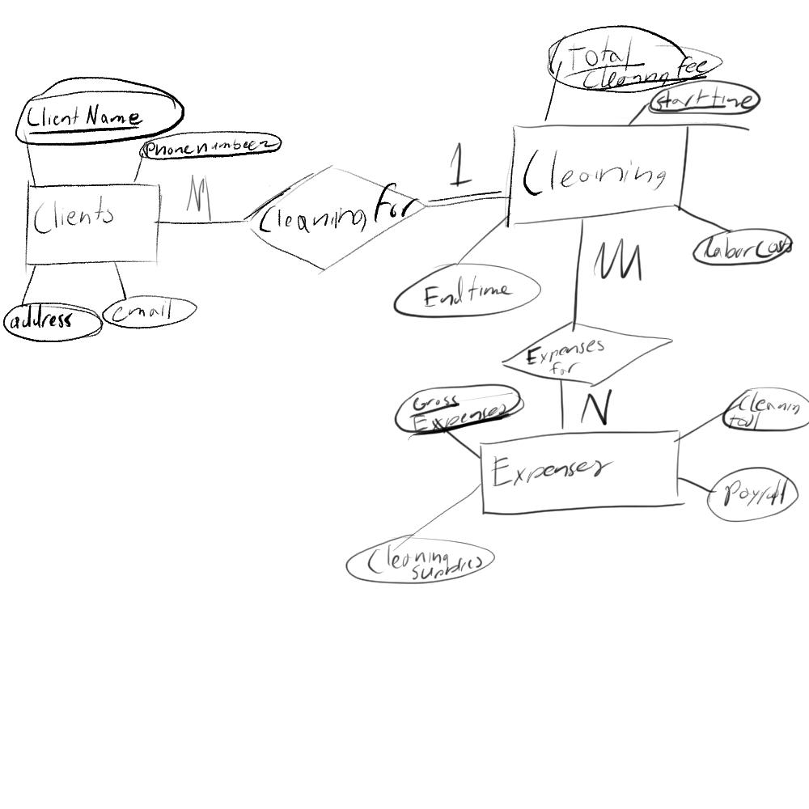

1. https://www.freshbooks.com/hub/accounting/accounting-for-cleaning-businesses