Task 2 – Test Log
Description of test | Test data to be used  (if required) | Expected outcome | Actual outcome | Comments and intended actions
System Test – Making sure the program runs | N/A | Program runs without crashing | 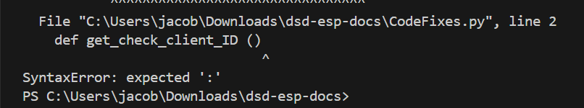  Program crashes | There is a syntax error as the function definition is missing a colon on line 2  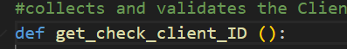
System Test – Making sure the program runs | N/A | Program runs without crashing | 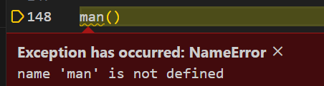  Program crashes | There was a typo on line 148 where the “main” function call was missing an i  
System Test – Making sure the program runs | N/A | Program runs without crashing | 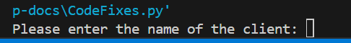
Unit Test, Normal Data – Checking the get_check_client_ID works as intended | Name = “e”  ClientID = “0000000000” | Program accepts ClientID | 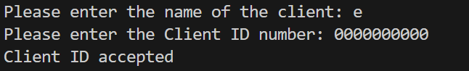  Client ID has been accepted
Unit Test, Boundary Test, Extreme Data  Checking the get_check_client_ID only accepts 10 characters | Name = “e”  ClientID = “000000000” | Program rejects the ClientID and loops back | 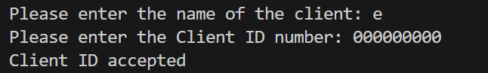  Client ID has been accepted | The function was only checking if the length of ClientID was greater than 10, now it is checking if it is exactly 10 as per the set task information
Unit Test, Boundary Test, Extreme Data  Checking the get_check_client_ID only accepts 10 characters | Name = “e”  ClientID = “000000000” | Program rejects the ClientID and loops back | 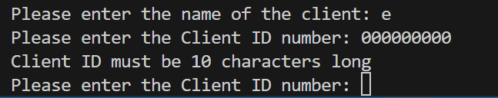  Program rejects the ClientID and loops back
Unit Test, Boundary Test, Extreme Data  Checking the get_check_client_ID only accepts 10 characters | Name = “e”  ClientID = “00000000000” | Program rejects the ClientID and loops back | 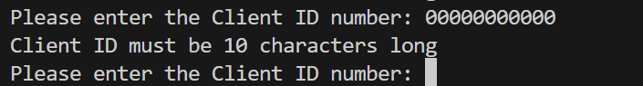  Program rejects the ClientID and loops back
Unit Test, Normal Data  Checking the get_check_investment_amount | Name = “e”  ClientID = “000000000”  investmentAmount = 5 | Program accepts investmentAmount | Program accepts investmentAmount
Unit Test, Erroneous Data  Checking the get_check_investment_amount | Name = “e”  ClientID = “000000000”  investmentAmount = “five” | Program rejects investmentAmount | 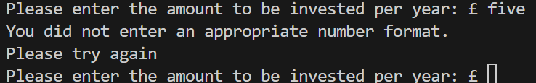  Program rejects investmentAmount
Unit Test, Normal Data  Checking the investment_type function works as intended | Name = “e”  ClientID = “000000000”  investmentAmount = 5 | Program accepts investment amount | 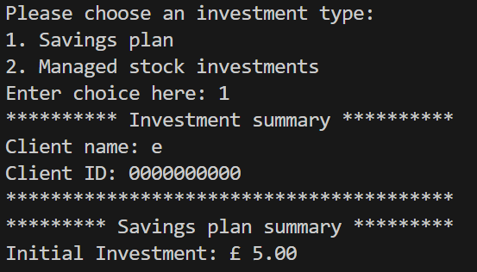
Boundary Test, Normal Data  Checking the investment_type function works as intended | Name = “e”  ClientID = “000000000”  investmentAmount = 200000 | Program accepts investment amount | 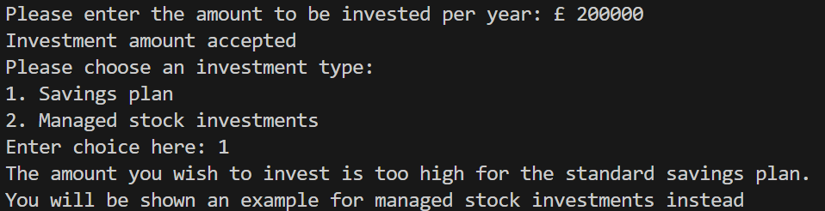  Program did not accept investment amount and output incorrect report | Program rejects values greater than or equal to 20000 when we just want it to reject values greater than.
Boundary Test, Normal Data  Checking the investment_type function works as intended | Name = “e”  ClientID = “000000000”  investmentAmount = 200000 | Program accepts investment amount | 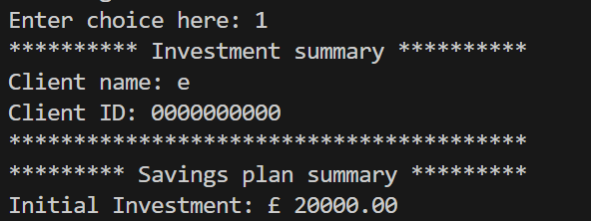
Regression Test, Normal Data  Checking the investment_type function works as intended | Name = “e”  ClientID = “000000000”  investmentAmount = 5 | Program accepts investment amount | 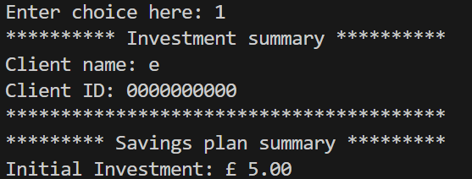
Unit Test, Normal Data  Checking the managed_stocks function works as intended | Name = “e”  ClientID = “000000000”  investmentAmount = 5  choice = 2 | minProfit = 26.12 | 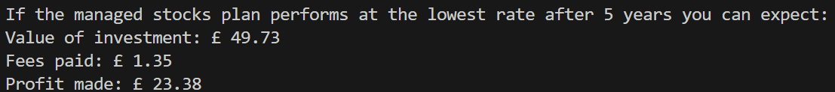  minProfit is wrong | Wrong modifier used to calculate 4% of minimum value.
Unit Test, Normal Data  Checking the managed_stocks function works as intended | Name = “e”  ClientID = “000000000”  investmentAmount = 5  choice = 2 | minProfit = 26.12 | 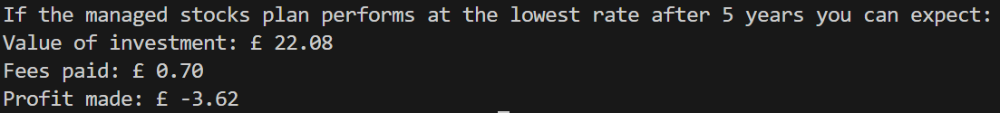
[Add additional rows as needed then delete this instruction]
Copyright and Acknowledgements
‘T-LEVELS’ is a registered trademark of the Department for Education.
‘T Level’ is a registered trademark of the Institute for Apprenticeships and Technical Education.
The T Level Technical Qualification is a qualification approved and managed by the Institute for Apprenticeships and Technical Education.
‘Institute for Apprenticeships & Technical Education’ and logo are registered trademarks of the Institute for Apprenticeships and Technical Education.
Pearson Education Limited is authorised by the Institute for Apprenticeships and Technical Education to develop and deliver this Technical Qualification.
Pearson and logo are registered trademarks of Pearson.
Copyright in this document belongs to, and is used under licence from, the Institute for Apprenticeships and Technical Education, © 2025

