In this evaluation I will outline how the solution produced meets the system and user requirements as well as suggesting how the solution could be further developed.

Main Menu
The main menu clearly outlines the features of the program to the user and guides them to the appropriate part of the program.
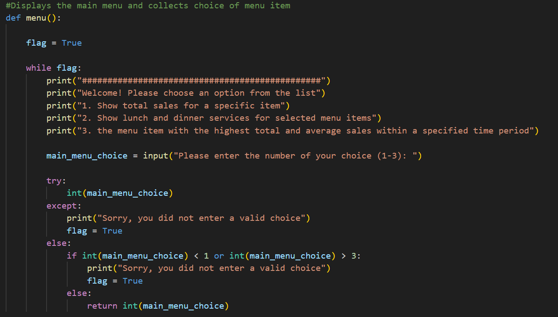
The menu function loops until the option the user chooses passes the validation checks for data type and boundary. The user experience could be improved by clearer user guidance and error messages. For example, instead of outputting “Sorry, you did not enter a valid choice”, to tell the user they did not input the accepted data type, in this case, an integer, the program could output “Sorry, you did not input a whole number”. The case is the same as the boundary test, and it could instead output “Sorry, you did not select an option listed on the menu”.
There is also no option to quit, forcing the user to manually close the program.
However, this does meet user requirements in the ease-of-use department as the user only needs to enter a corresponding numeric value to select an option from the given menu items.

Lunch and Dinner Services for Selected Menu Items
The program meets the system requirements for selecting an item from Gurreb’s BBQ menu, and outputs the result in a meaningful way, showing trends and patterns over time.
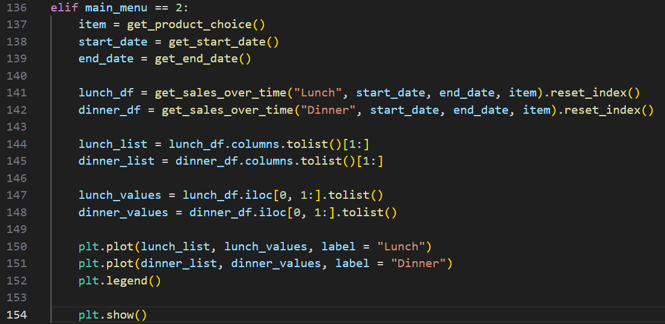
My solution has re-used functions written by the senior programmer to get the relevant information to filter the dataframe as required from lines 137 to 139. Lines 141 and 142 call a new function, passing the relevant data to get data only concerning the selected menu item and service. Lines 144 to 148 convert the dataframes returned from that function to lists which only contains the relevant values to display on the graph that is to be output on lines 150 to 154. This graphical output shows the trends and patterns over a selected date period by the user and clearly outlines, as shown by the label values passed into the plt.plot functions for lunch and dinner, meeting this system requirement.
However, lines 150 to 154 leave a lot to be desired for the user requirements. The graph output, only plots two lines and labels them as lunch and dinner. This is good so that the user knows which is line is which. But, there are no labels being used to tell the user what the X and Y axis on the graphs are actually being used for. The graph is also lacking a title, and because there is no rotation on the date values on the x-axis, sometimes if the period of time entered is rather long, for example a month, it becomes difficult to read as the text overlaps.
Therefore, while meeting the system requirements, and being easy-to-use with the senior developer’s functions, it does not meet the user requirements in an effective way.

Data Security
The solution handles data in a secure way with limited use of global variables and does not overwrite data while handling dataframes and anything else that could potentially cause conflicts.
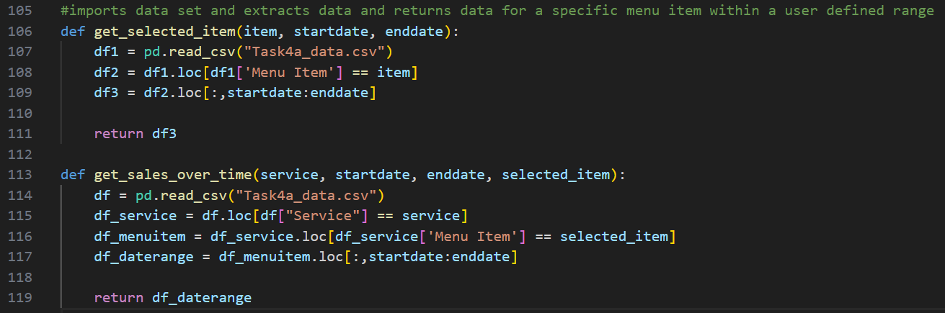
The “get_selected_item” function has a start date, end date and item passed into it to use for relevant data filtering. As the data is imported and gradually filtered from lines 107 to 109, the previous dataframes are not changed, and any alterations are saved into new variables, being “df2” and “df3”.
The “get_sales_over_time” function has the service, start date, end date and selected item passed to it all data filtering from lines 115 to 117 use new dataframe variables as to not cause conflicts.
Variables that are also used in the previous function are also used, but because these variables are passed into both functions, they are local, meaning that the use of global variables is limited, making the code secure.

Potential Improvements
To enhance the application further, a graphical user interface (GUI) could be implemented. At the moment, the solution uses a command line interface (CLI), which is not commonly used for applications designed for end-users. This solution seems more like a functional prototype. While the user experience is easy within a CLI it is not industry standard.
As outlined earlier in this evaluation, the user experience could be improved through enhancing the outputs and making them more meaningful, by providing better guidance through error messages and labelling the graph more effectively.

Conclusion
My solution only meets one of the system requirements, and the user requirements could be further developed. Trends and patterns over time for lunch and dinner services are displayed using a line graph, which is a suitable format for showing these. However, the graph is incomplete and can sometimes produce outputs that are difficult for the user to read. While code security is good as outlined by the system requirements, the maintainability and readability of the code could be improved as use of commenting is limited, and there are some use of variables that become global as the data used in the main body of code after the user selects an option in the menu are not bound to a function. That being said, the system making use of its CLI is easy to use as the user only needs to enter numbers that correspond to options or dates in a DD/MM/YYYY format to get their adaptable, graphical and somewhat meaningful output.

