Los Santos

Fire Rescue and Medical Services

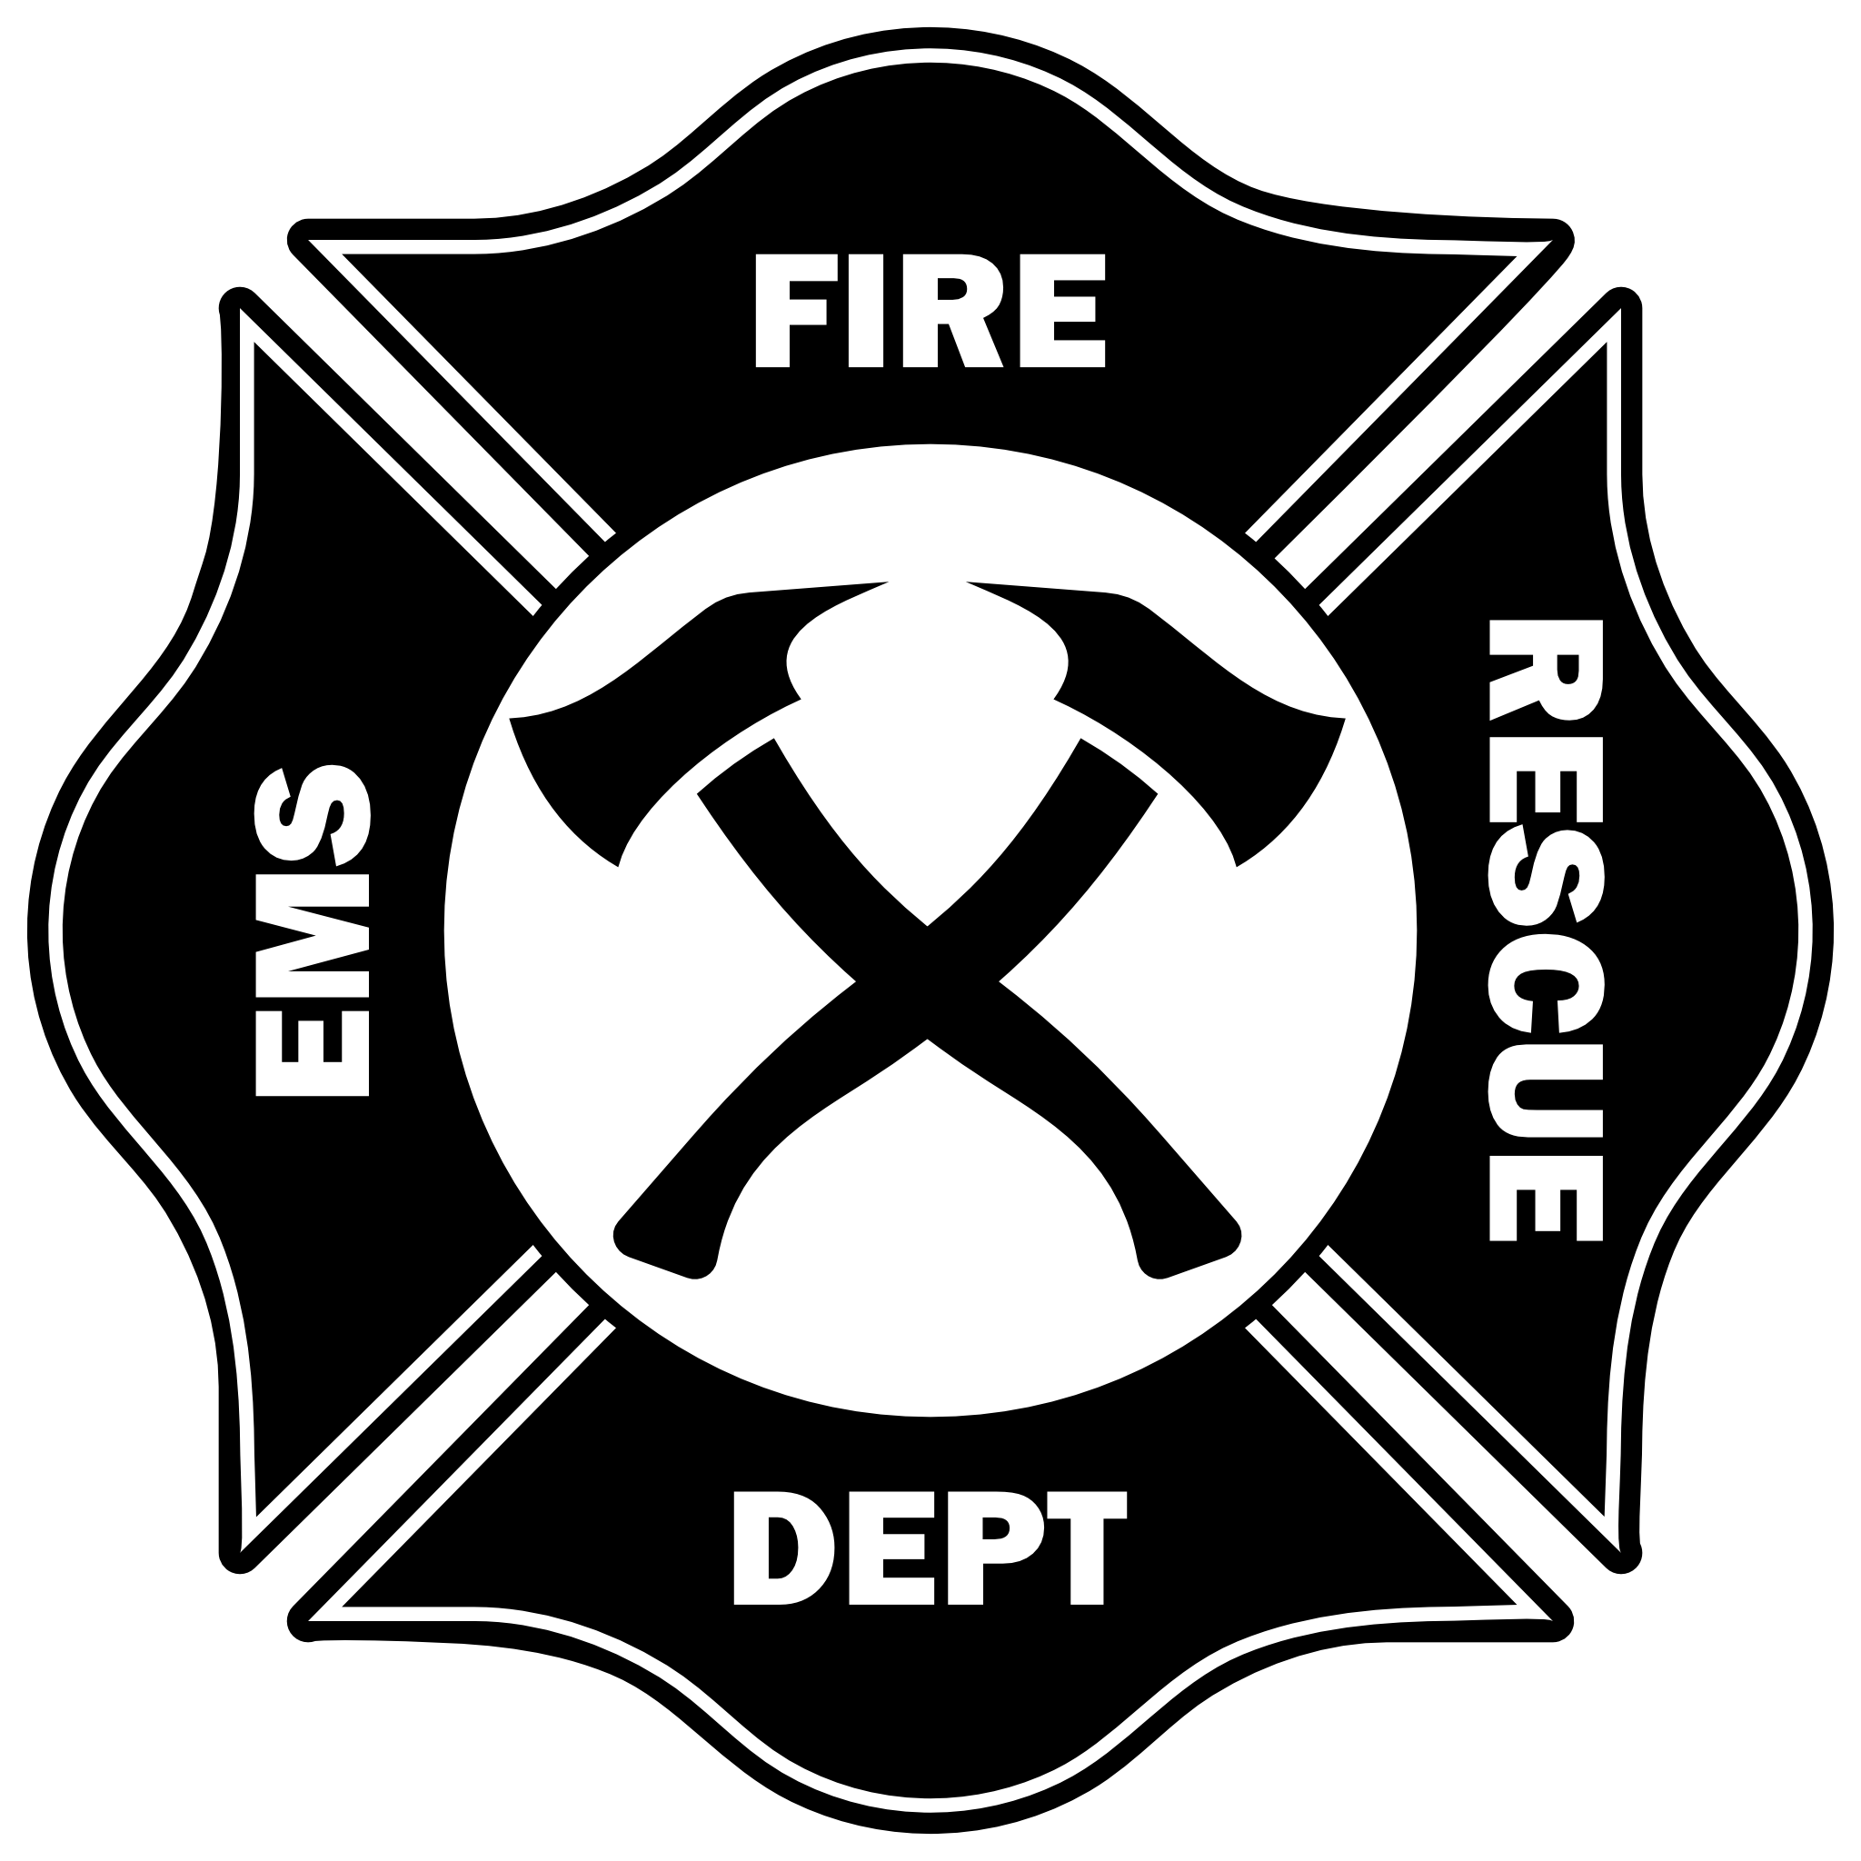

Standard Operating Procedures
Table of contents
Welcome 3
Roleplay Standards 4
Knowledge Levels Vary 4
Controls and Functions 5
Quick Department Keybinds 5
Fire Apparatus Hose Controls 5
Ambulance and Stretcher Controls 6
Dispatch Controls 7
Department Organization 8
Ranks 8
Roles 8
Buildings 9
Vespucci Fire House 9
Davis, El Burro, and Paleto Fire Houses 9
Los Santos Medical Center 9
Del Perro Pier Clinic, & Paleto Medical Center 10
Radio Usage 11
Vehicle Usage 12
Vehicle Numbering 12
Medical Roleplay - Community Concept 13
Medical Role Play Knowledge 14
Firefighter Paramedics 14
On Scene Medical Roleplay 14
On Scene Basics 14
Additional Medical Knowledge and Reading 15
Hospital Staff Roleplay 15

Welcome
We understand there are many communities to pick from. Thank you for playing here and making your mark on our character’s and personal lives.
We operate a Fire Department to address two rather common challenges that face roleplay communities. Forced medical roleplay because the game is literally out to kill you and players feeling like that have to stand around and wait.
The Fire Department model hopes to solve these issues. We have deployed scripts that require a player to opt-into medical roleplay even if Fire Department players are on. When they press this button we expect that they want the medical scene roleplay and expect a trip to a hospital.

Should we have deeper interest in medical roleplay such as an ER/Private Doctor we’ll accommodate by alerting them that a patient is coming in.

The other part of the problem-solving is the spawning of randomly pre-determined fires which fan the flames of some spontaneous roleplay.

In this document we’ll go over expectations, tools, and other topics that relate to how the department functions.

Congratulations you’ve become one of Los Santos’ Hottest!

Roleplay Standards
While we role play as a fire department who provides emergency medical services, medical calls do supersede any fire call as we use an opt-in, call for assistance approach, and expect the person who presses that option to expect medical roleplay including a trip to the hospital. Should we have someone who wants to roleplay a doctor they’ll be notified that we’re bringing a patient in.

Knowledge Levels Vary
You are not expected to know the names of all medications ever made but knowing basic first aid will certainly help you get by in roleplay. If a player says their ankle is hurt, toss a splint on it so it's immobile for transport.

There is a 3rd eye menu option that allows you to check for injuries and you can use that as a prompt for the patient. If the player is in a downed state you can also check for a pulse and the injured will be able to select their pulse giving you a direction to go. Be vocal with statements like “I’m checking for a pulse,” or “I am checking for injuries,” even if you’re the only paramedic on scene, this tells everyone around your actions so they can react as you’re using your tools.
Above all, don't sweat the small stuff. Take your time on a scene with those who opt in to the roleplay. Get them on a stretcher, even if they sit on the end or sides to look over their injury.

Controls and Functions
Our community’s server has a load of controls and functions for our role in roleplay. We’ll be predominantly using the 3rd eye to interact with objects and people. You’ll occasionally use other keys outside of E to interact with something in particular.

Quick Department Keybinds

Key | Function
Hold left ALT key | Third Eye (3rd Eye)
F2 | Dispatch Notifications
F3 or /mdt | MDT System
F4 | Emote Menu
F6 | EMS Controls (most common in 3rd eye)
E | A very common interact key
J | A radial menu

Try as we might, we may not be able to get everything into Third Eye interaction menus. If you find you’re always reaching for some menu and it isn’t integrated into 3rd eye please mention it.

Fire Apparatus Hose Controls
Outside of your basic vehicle controls some of our apparatus have fire hose controls.
Key | Function
E | Attach or detach hose line
G | Detach Hydrant line

The fire hose tech can be finicky but we’ve found some tips and tricks to keep it behaving as expected.

- Press E to attach to a truck or hydrant.
- If attached to a truck, walk away and use the hose with your weapon controls.
- If attached to a hydrant, walk to a truck and attach to it by pressing G.
- If you attached a hydrant to a truck, reequip the fire hose and then press E.
- Once the hose is no longer needed, move closer to the truck to release the fire hose.
- If a truck is attached to a hydrant you can release it by pressing G at the truck.

Obviously this is the technical jargon in roleplay we’ll use more descriptive terms.

Ambulance and Stretcher Controls
We’ve adapted a stretcher script to work with our menus and third eye.

Key | Function
/stretcher | Spawns a stretcher.
/delstretcher | Deletes a stretcher.
X | Pick up or “push,” and release a stretcher.
Hold E | Opens ambulances rear doors.
G | Attaches or “loads” a stretcher.

Usage tips and tricks.
Once a stretcher is spawned you can use the third eye to access controls such as what props appear on it or if the backrest is up or flat.

The patient, or even you, can “use the stretcher” to sit or lay down on it. We’ll want to encourage the patient to use it and pick the position they want to be in. We can always adjust the headrest after they have chosen a position. To get off the stretcher you use the third eye again and choose the correct menu.
DO NOT TAKE THEM THROUGH AN ELEVATOR OR TELEPORT

Deleting Stretchers
It’s imperative that we clean up our stretchers. They’re network synced so everyone can see them just sometimes takes a second to update. That said, when it’s not being used we need to delete it. If you spawned it you can immediately delete it with the command. If you’re helping someone you need to pick it up, release it, and then use the commands.

A roleplay suggestion is removing it from the hospital room or walking it back to the ambulance to then use the command.

Dispatch Controls
When a call comes in you can press E to respond for a brief period. After the alert fades you can retrieve it by pressing F2 and still respond to it by clicking on the alert and choosing attach.

When you have finished the call it is important that you remove yourself from the call by going into dispatch by pressing F2 and clicking the call to choose detach.

Department Organization
Our department is unique as we currently include hospital staff within our realm, in roleplay they are however separated, but all the documentation is here in this document.

Ranks
Board of Commissioners < - Server OOC leadership, very different from in character leadership.
Chief
Chief of Medicine
Battalion Chief
Captain
Surgeon
Lieutenant
Emergency Medicine Doctor
Engineer
Instructor
Firefighter Paramedic II
Resident
Firefighter Paramedic I
Probie

Roles
From Lieutenant and up the roles are more or less leadership. They help guide the ship, document processes, in and out of character. In character they have access to the boss menu to bring on new team members.

Rank titles below Lieutenant are for flavor and pay progression. That said, everyone can have an impact on how the organization functions. Just be ready for some additional OOC/IN responsibility starting at Lieutenant.

For clarity's sake an admin/leader/management player’s character is not automatically chief, nor does having a leadership rank in the organization make you, the player, an admin, mod, or management within the community’s official structure.

Buildings
We maintain several properties in the city. You will find details about them here.

Vespucci Fire House
We’ll refer to this house as house 1 or “Vespucci”. It is rather large with plenty of room for fire house roleplay. More importantly it has the tools for our “in city” job.

Key features are bay doors that stay open when unlocked. This is a way to invite others in. Let them come in, say hi. However there are locked doors in the building such as the office wing, medical wing, and bunk wing. It is important to know that these locks can be picked. Our department rule is, hey welcome in, but if you’re here to mess with is “We’ll take you out. If you need safety even from the cops, come on in.”
That said, the medical supply room has a passcode of 3019 and will auto lock. The rest of the locks you just press E to unlock and lock again.

As this city grows this particular fire house can expand to 8 bays.

Davis, El Burro, and Paleto Fire Houses
All three of these fire houses feature similar bay door functions, and all the necessary shops and stashes but are well out of our current area of focus for community roleplay. Their blips have been disabled until we expand.

Los Santos Medical Center
All medical buildings offer basic job functions for obtaining job items although the medical centers do not give firefighting equipment.

Los Santos Medical Center is large and has 3 shops, lower floor middle cabinets behind reception. Then the cabinets along the entry wall in both ICU and Recovery. There are two elevators and helicopter pads on the roof. There is also a pass through garage with access to a morgue from the garage as well. The elevators on the ICU side will take you to the garage.
It is important to note we can not take a patient through an elevator while on a stretcher.

Del Perro Pier Clinic, & Paleto Medical Center
Paleto Medical Center is rather small and the supplies are in the cabinets in the O.R.

Del Perro Clinic is tiny but still full service. Job tools are all along the walls in areas that make sense.


Radio Usage

The Los Santos Radio Communications Authority is an administrative body appointed by the Governor of San Andreas to regulate the use of radio frequencies in the Los Santos Metropolitan Area which includes Los Santos County, Blaine County, including the Sandy Shores, Paleto Bay, townships and municipalities.

Our administrative duties include the governing of the 500 radio frequencies and their sub frequencies which are for public use, private use, and emergency services use.

We’ve assigned the radio frequencies in the following manor:

All Department Dispatch *Population Depending
Ch. 1
Fire & EMS
Ch. 1.1 - Fire EMS Main
Ch.1.12 - Fire EMS - ER (Doctor Comms)
Ch. 1.13 - 1.19 - Scene Ops / Misc Use.

Police
Ch. 1.2 - Police Main
Ch. 1.21 - Detective Comms
Ch 1.22 - 1.29 Scene Ops / Misc Use
Public Use
Ch. 2.0 - 500
* The use of a unified dispatch depends on the population at the present time. Lower population times departments can bounce “dispatch” calls off each other. Example: “Dispatch show 78 is 10-8” or “Dispatch show 3010 is back in service and returning to quarters.” Should the need arise Fire/EMS and Police departments can break out onto their own assigned Main channels to handle their own dispatch and to reduce audio clutter.

Vehicle Usage
There are no real hard rules on what vehicles you use but use one that fits the scene. If it is a fire call, show up in a fire engine or ladder truck. If it is a medical call where you may have to transport a patient, use an ambulance.

Double up when possible but be ready to fly solo. Coordinate a response, if taking an engine to the call, announce it as “3011 responding,” which just so happens to be an engine “number.”

Vehicle Numbering
Our numbering system works similar to a large metro area that employs a unified dispatch system.

What do these numbers mean?
Department Number |  | House/Station/ or Admin | Unit type
30 |  | 1 | 0
Department number. Which in our case we’re all in Los Santos Fire and cover the needs of the island but we can “expand” if we need to.

House, Station, or Administrator number, for now we’re working out of Vespucci as we’ve built more of the activity in that region for now. As the community and department grow we’ll assign house numbers as needed. If the 3rd number in a unit is a 0 it is an administrative vehicle. Example 3000 is the chief.

Unit Types. This tells others what the vehicle is and what it can do.

0 - Command vehicle.
1 - Engine, the workhorse of fire suppression.
2 - Ladder, this has an aerial ladder, for now ours is static.
3 - Unassigned for now.
4 - Rescue, relied on for a host of tools for extractions and rescues.
5 - Water/ Light Rescue. For us it's the mountain fetcher/Life guard unit.
7 - Unassigned for now.
8 - Unassigned for now.
9 - Ambulance, patient transport.

Air and sea vehicles are simply Air 1 and Sea 1.

Helicopters
You can access Air 1 via the roof of the Vespucci Fire Station.
Watercraft
You can access watercraft from various points around the whole map. Blips are off to save blip resources.
Dock right behind Vespucci Fire Station - The very first dock down the ramp.
Dock at the end of Del Perro Pier - Go to the end of the pier and climb down the ladder, you can't miss it.
Dock near the marked diving area - Go out on the pier and to the right on the lower dock.
End of Paleto Pier - Go to the beach at the end of the Paleto Pier.
Lighthouse Dock - Go to the lighthouse dock and it will be on the right side.

Medical Roleplay - Community Concept
We as a community strongly encourage that when a player is down they make a choice, to let the timer go or opt-in to medical roleplay. If you respond to a call of a person down be prepared to “give them the works” but also read the situation. If they seem put off, help speed them up, but reach out in OOC to let them know that they can let the timer lapse and revive without consequences for their character. Many communities often impose hefty costs and wipe inventory so we’re fairly unique in this regard.

Above all we want to encourage opt-in medical roleplay as opposed to forced roleplay because some local freaked out and hit them with a car, or something.

Medical Roleplay Knowledge
You’re not expected to be a medical professional but oftentimes it helps to have some basic understanding of terminology and functions.
Currently if you have access to HBO/Max The Pit is a rather realistic medical drama focused on an Emergency Department. If you don’t have access to it, Dr Mike Reacts on YouTube has a few episodes that cover the show. Again don’t feel forced into watching this stuff but it may help give you an edge in your roleplay.

Firefighter Paramedics
For many of us we’re Firefighter Paramedics. Not long ago departments across the globe started seeking out a more utility knife type of approach to their staffing, ergo, firefighter paramedics. In roleplay we are this “utility knife” and we’re here for either aspect as a firefighter, paramedic, or both. The one thing we can’t ignore however is the call for a person injured.

DO NOT IGNORE A PERSON INJURED CALL

We can however freely ignore a fire call as they are automatically generated and have a relatively “short lifespan” while a person injured is your fellow roleplayer in distress.

On Scene Medical Roleplay
Our goal here is to provide the on scene medical roleplay to the best of our abilities. This entails getting someone in a condition to transport them to a hospital for further treatment, we’re not doing field surgery, we’re stabilizing and transporting, though by all means if your character aspires to be a surgeon...

On Scene Basics
When we first arrive on scene our task is to ensure it is safe to approach. This can be as quick as a few seconds or longer if we’re dealing with wildlife or locals. Once it seems safe to get to the patient we should do so. Once it is safe you can /stretcher to get the stretcher out and get ready to “work.”

Vitals and Injury Check
Once we’re near the patient we should immediately check for vitals by vocalizing it and using /me INSERT WHAT YOU ARE DOING HERE. Side note F6 menu gives you some shortcuts to basic emotes. In this vitals check we’re obtaining information. Is our patient speaking, what are their injuries, is there a pulse, are they breathing?

Initial Field Treatments
Again we’re not going to be performing surgery in the field but we’re certainly giving them the “works.” Does the injury involve incredibly high pain levels? Well maybe we should push something in an IV. Is the injury a broken bone? Splint it!

- We however should use our First Aid kit to revive them so they can access stretcher controls.

Once we’ve gotten the patient in shape enough for transport we should make our way to a medical facility. Use your best judgement here. Is it a broken bone or serious trauma? If it feels “serious” you would probably head to Los Santos Medical Center, otherwise head to the closest place that makes sense.

THERE IS NOT A MEDICAL CENTER IN SANDY

Additional Medical Knowledge and Reading
I have compiled some older medical SOP/training modules, thanks Digi, and have included them here. Again this is older material, and some SOPs aren’t truly necessary here, but the medical terms are worth reviewing.

Medical Modules

Hospital Staff Roleplay
We’re not organized around a hospital as our base of operation as a Fire Department but we can still accommodate someone who seeks to roleplay as a Doctor. If this grows in interest we may seek splitting the roles apart but until then we’re all in the same bucket if you will.

