# **CSC289 Programming Capstone**

# **Product RoadMap**

**Project Name:** CentRes

**Team Number:** #6

**Team Lead/Scrum Master:** S. Andy Short

# **Key Product Features:**

{**NOTE**: This should be your top 3 - 4 KEY features, not all features belong here}

| Feature |
| --- |
| Interfaces for specific roles within a restaurant. This is dynamic and can be used for a myriad of different restaurant types and layouts. |
| Record data in a persistent database. Some examples of the data held: Employee information including username, first name, last name and password (stored safely in an up to date and highly secure hash string), inventory count for food and ingredients. Also, logs for employee logins and logouts, employees currently clocked in for the purpose of query by manager and host for guest seating, menu items requested vs quantity in stock to ensure demand is met by incrementing supply orders and vise versa (this reduces waste and increases overall profit). |
| Allow roles with higher level permissions (ex. Manager) to create new roles and modify restaurant layout (table placement, including table type). This allows for a client restaurant to have autonomous control over a many integral pieces of the application. The point of this feature is to decrease reliability on the developer which streamlines the process of enacting changes to the restaurant and staff. The client would therefore have spend less time waiting for simple changes to be implemented by the developer as changes at these levels aren’t a high priority for most development firms that may deploy this Point-Of-Sale solution. We are looking to create a new take on the POS system as many of the current market options are convoluted in use and deployment with very little managerial customization. We aim to make the client and it’s staff, plus the guests have a streamlined experience in serving and service respectively. |

# **Feature Roadmap (tables):**

{Add ROWs as needed …}

## **High priority:**

| Feature | Size | Priority |
| --- | --- | --- |
| Servers can create, edit, and submit an order. | [large] | High |
| Back-of-house employees can see incoming orders and mark completed orders appropriately. | [large] | High |
| Hosts/Managers can assign servers to/from tables | [large] | High |
| Hosts/Managers can seat customers by assigning them to a table, and server implicitly | [large] | High |
| Employees can Login/Logout | [medium] | Low -> High (not necessary until final product release) |

## **Medium priority:**

| Feature | Size | Priority |
| --- | --- | --- |
| Order Item customization | [medium] | Medium |
| Viewing a receipt for an order | [medium] | Medium |
| Enhanced appearance through use of CSS | [small/medium] | Medium |

## **Low priority:**

| Feature | Size | Priority |
| --- | --- | --- |
| Ability to change an order item after it has been submitted to the kitchen. | [medium/large] | Low |
| Create a that allows manager to edit restaurant layout | [large] | Low |

# **Feature Roadmap (Trello screen capture):**

Shown on page 4.

# **Sample Content**

# **Feature roadmap (tables):**

## **High priority:**

| Feature | Size | Priority |
| --- | --- | --- |
| Make a database | Large | High |
| Create Login Page | Small | High |
| Upload Sales Data | Small | High |
| Upload Inventory Data | Small | High |
| Create an Inventory Page | Medium | High |

## **Medium priority:**

| Feature | Size | Priority |
| --- | --- | --- |
| Account Password Reset | Small | Medium |
| Permission Levels | Medium | Medium |
| Dashboard Alerts | Small | Medium |
| Inventory Alerts | Small | Medium |

## **Low priority:**

| Feature | Size | Priority |
| --- | --- | --- |
| Account Password Reset | Small | Low |
| Create Sales Analytics Page | Medium | Low |
| Sales Trends | Medium | Low |
| Sales Analysis | Medium | Low |
| Inventory Projections | Medium | Low |
| Pay by credit and debit card | Medium | Low |

# **Feature Roadmap (Trello screen capture):**

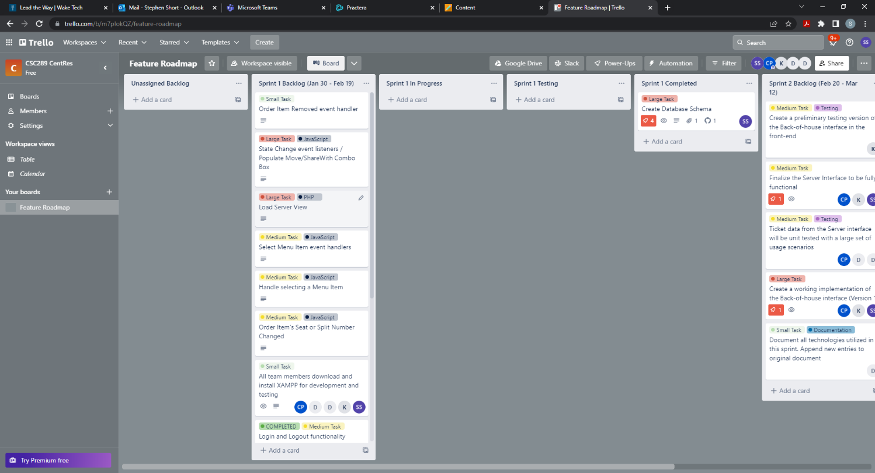

## REFERENCES

The following list of references provide alternative examples of Trello Roadmap formats with “How to …” information. You are not required to follow any of these examples to the letter, however your prioritization and estimated size/difficulty should be clearly defined.

## **Setting up Trello Roadmap simplified: 3 Easy Steps**

* URL: <https://hevodata.com/learn/setting-up-trello-roadmap/>

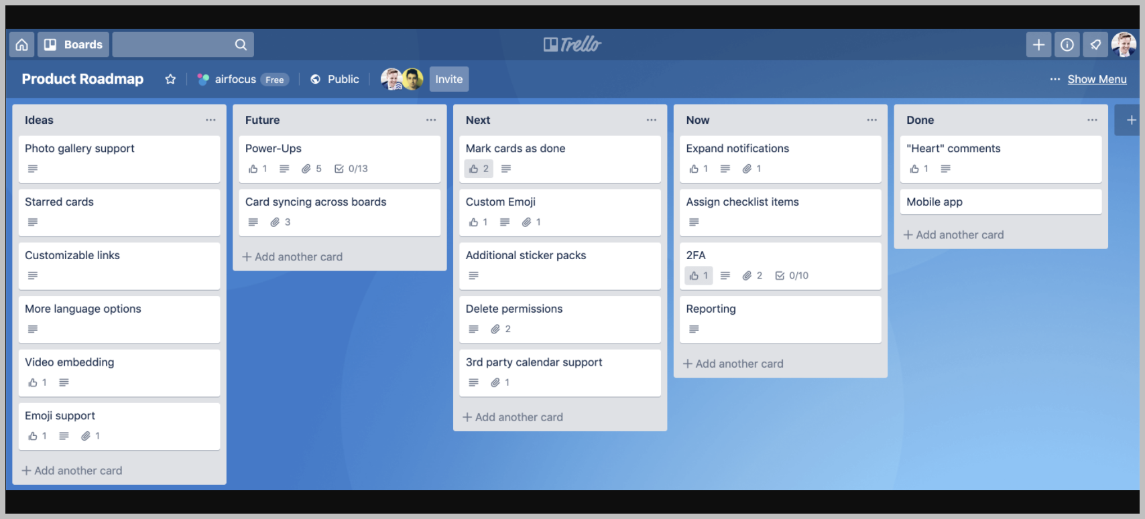

Figure - Retrieved from https://blog.trello.com/hs-fs/hubfs/3_trello-no-af-power-up.png?width=5760&name=3_trello-no-af-power-up.png

## **How to Create a Product roadmap in Trello**

* URL: <https://projectmanagers.net/how-to-create-a-product-roadmap-in-trello/>

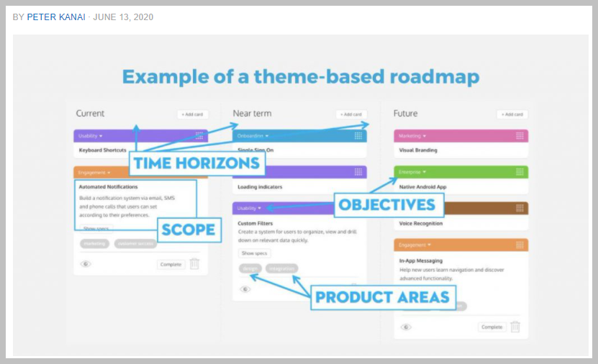

Figure - Retrieved from https://projectmanagers.net/how-to-create-a-product-roadmap-in-trello/

Create Roadmaps with Trello

* URL: <https://openclassrooms.com/en/courses/4544601-build-a-product-roadmap/5069281-create-roadmaps-with-trello>

How To Plan and Prioritize Your Product Roadmap in Trello

* URL: <https://blog.trello.com/product-roadmap-trello-airfocus>

## **Trello Product Roadmap Template**

**Product Management > Product Roadmap Template**

<https://trello.com/templates/product-management/product-roadmap-template-FrbAJsbH>

**Note**: I have not tried working with this template but wanted to let you know it exists. You can just as easily create your own **Board** just like those shown or mentioned above.