transaction_hash | receiving_wallet_id
150fb44378c692db3f639ad4fb029789094685a1ae0023d1c878fd9c65ae4a7d | 372Rnnmzcaw6My5dJCHy2G4jgHtjESpJx6
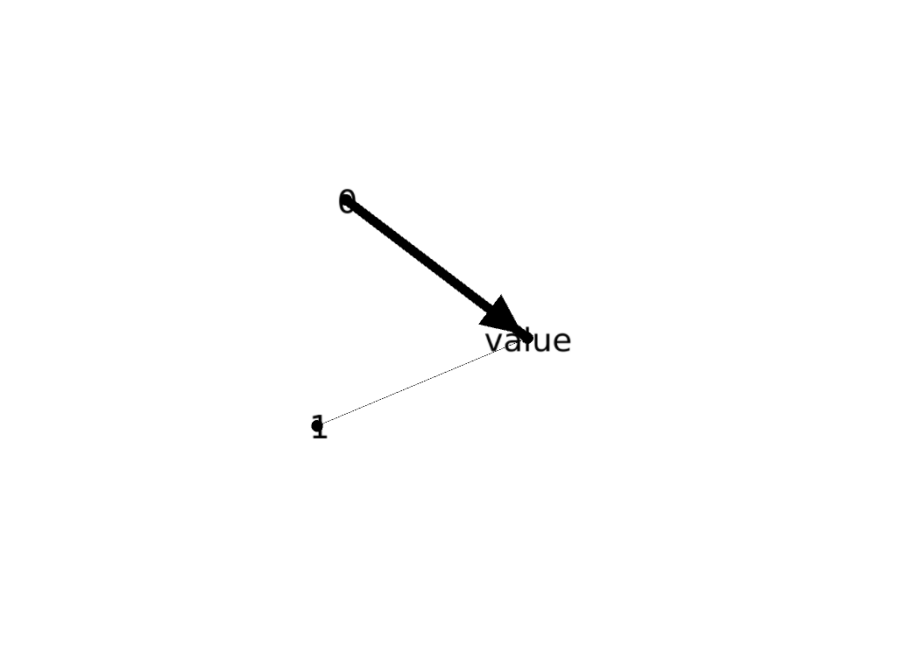

transaction_hash | receiving_wallet_id
1064e804527cefcadda01b4308d8fef1b817d609c260fe1cb6d397d2d7b2a31d | bc1q7y5e8vnsem3uu239j08ndyqtvuxwc86cy6klyv8eghgurqtphekqmxsv5l

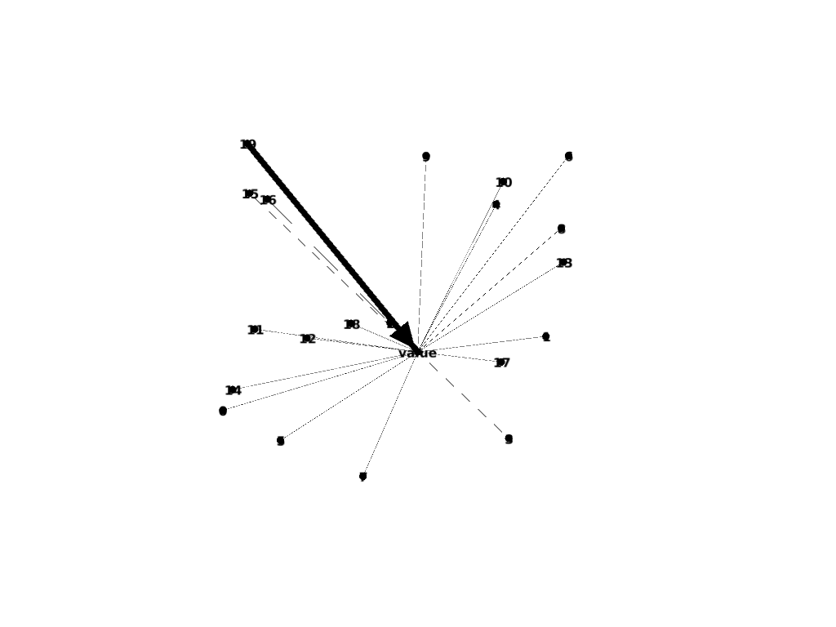

transaction_hash | receiving_wallet_id
5b066f162d3508318bcff8d95c357bc13cf29044013173b99220b1d7cc8e2304 | bc1qdsh5vrjalxv465jeqauu8t933htkcxgku24gg9a8tf9pkm6fh3vqfmpt6e

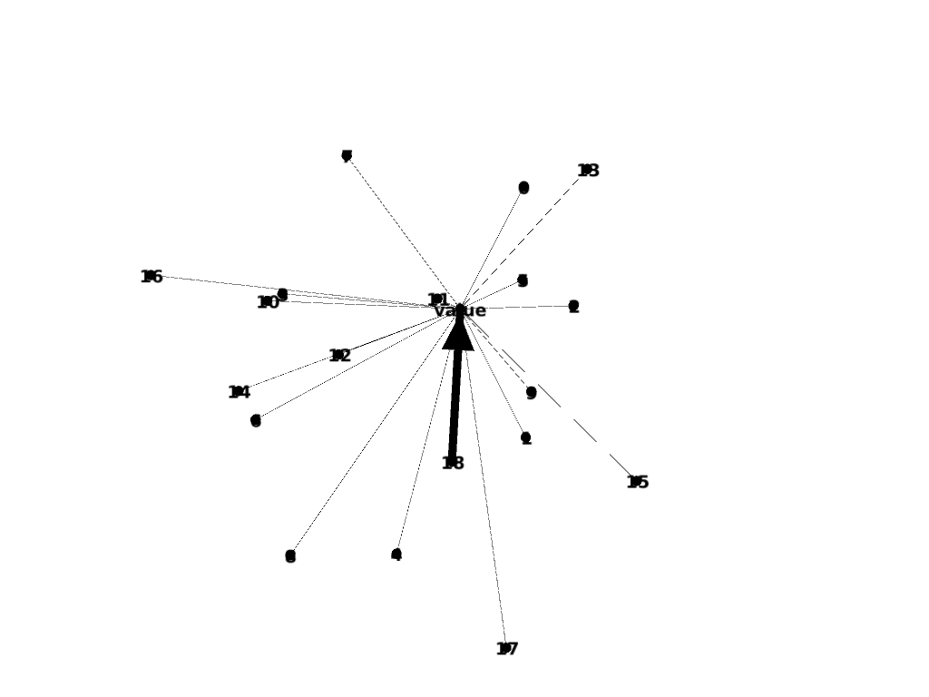

transaction_hash | receiving_wallet_id
6423eb2def8926c5737edcd68700cfa6361dbcb985a49de829e04533558d1108 | bc1qxzag0d7lyf4le5njg95z2pxrg4x8xqash48y2t6s5kfjwf3tzunsj7yhcu

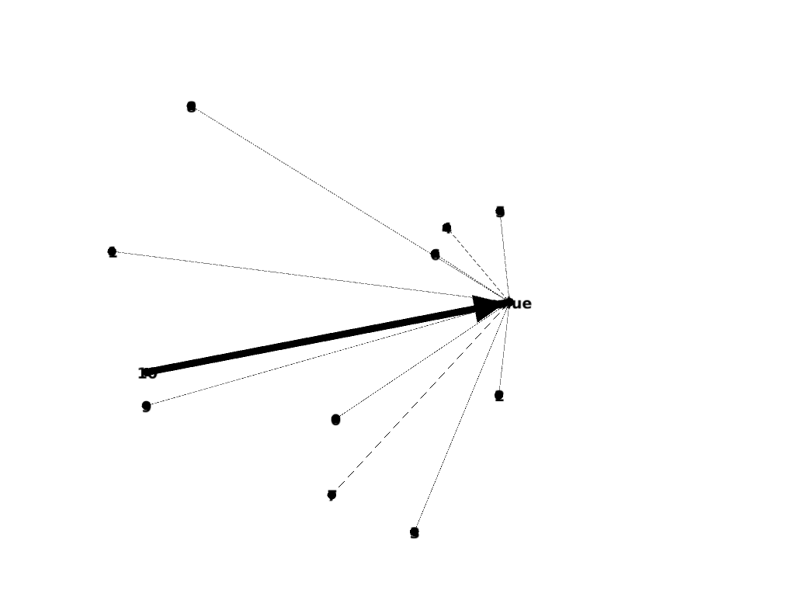

transaction_hash | receiving_wallet_id
6423eb2def8926c5737edcd68700cfa6361dbcb985a49de829e04533558d1108 | bc1q56d2yaavh24fhffkwr9r50wt6zjm8pzqt9he9dxdmjt6th6x84lq555xqe

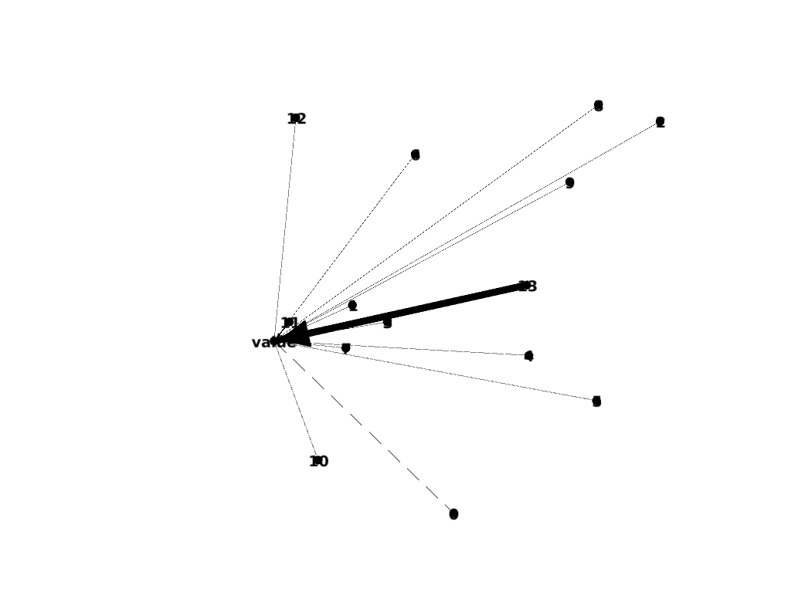

transaction_hash | receiving_wallet_id
d3003a90ba0116f176f0906516ae3913635ba321c02928808ac32e2e8d684cc0 | d3003a90ba0116f176f0906516ae3913635ba321c02928808ac32e2e8d684cc0



transaction_hash | receiving_wallet_id
e5dcfc830e79b146ce90037fdd0685243f00849de9ab89e40e66a7fbc039143c | bc1qfusepe5w7gn7l2e0pe8u9rpc8w4vth9ksttxe7m8msszhl4m5zuq2ruv2x

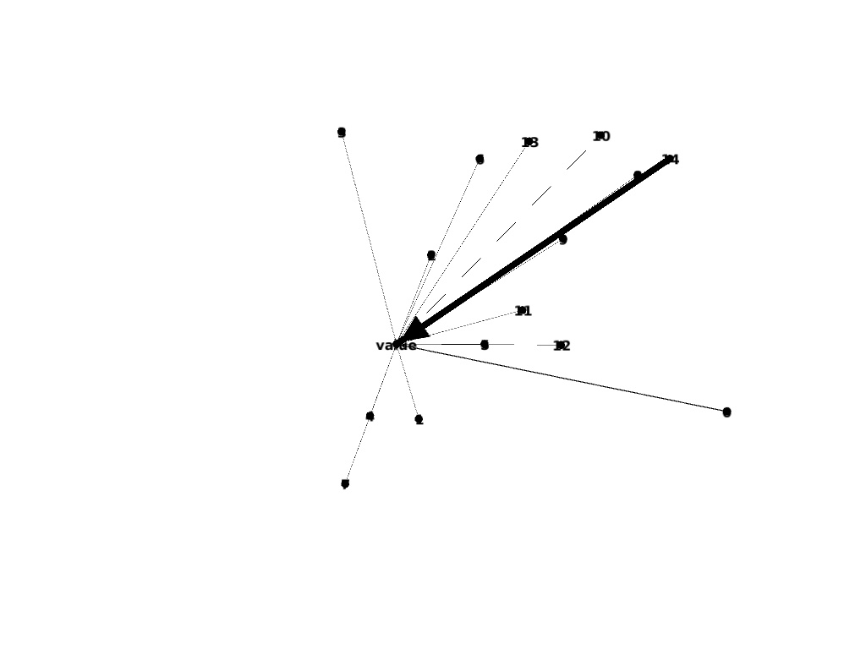

transaction_hash | receiving_wallet_id
a9b85dcbd39ff26bdea8dbd43e3cc1c9f3146cfa18a0db3de76f030d86692d9b | fbca51f435657bd347ef37a369698140b3afa0072630b707a24fe743b3a7ea1e

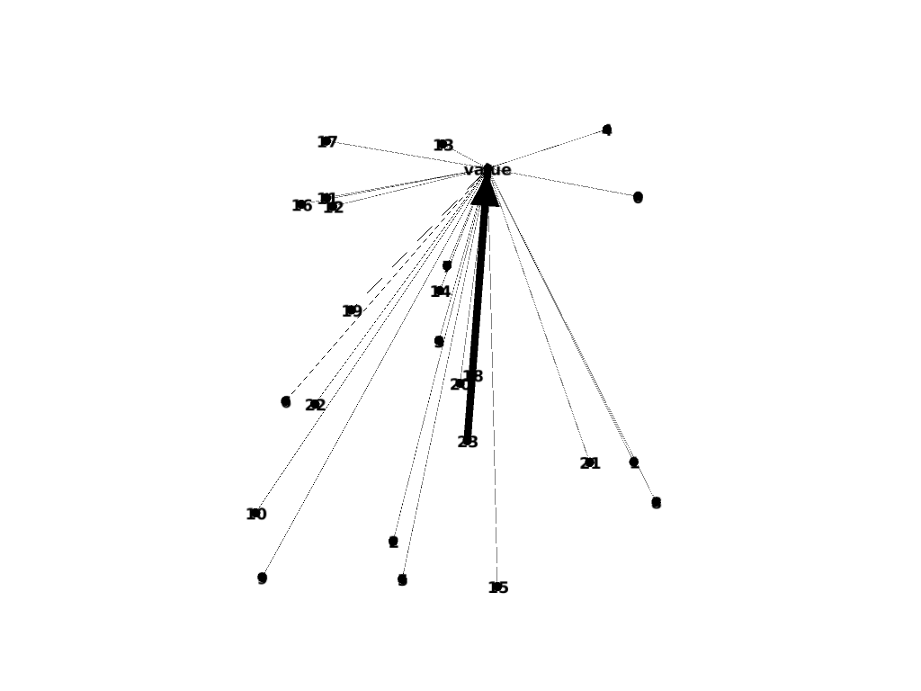

transaction_hash | receiving_wallet_id
fbca51f435657bd347ef37a369698140b3afa0072630b707a24fe743b3a7ea1e | bc1q7edgq0sc3mu98503vu59ec7qxm6zynz6zvhruk4427yzphflqt4qyfh6tr

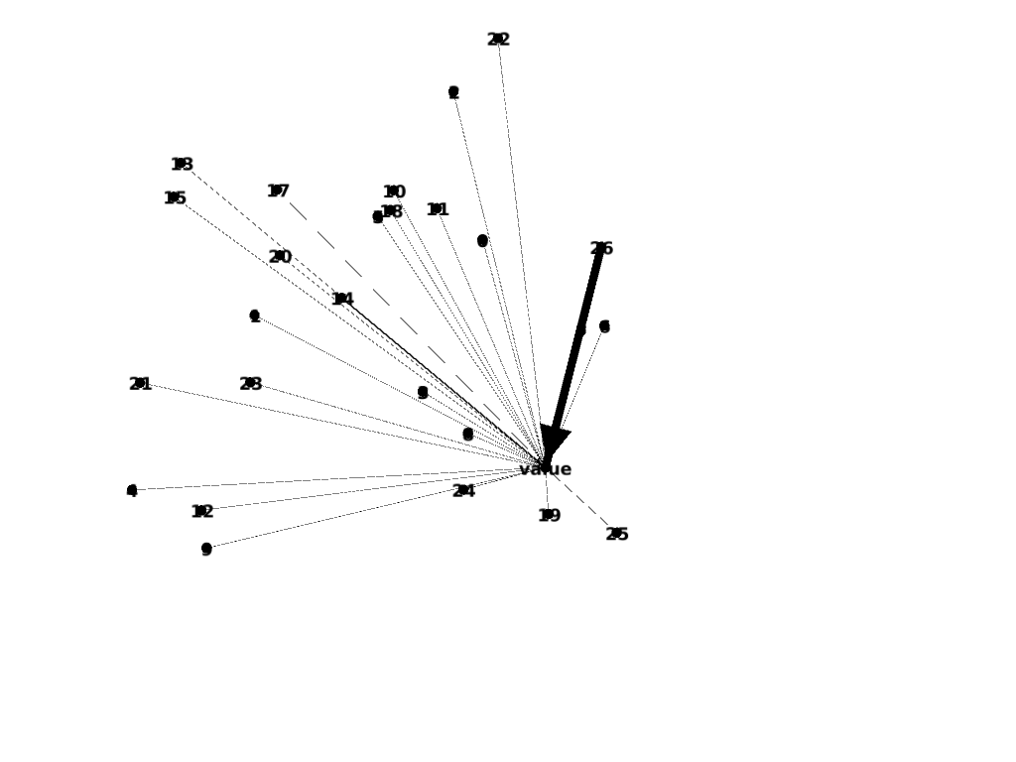

transaction_hash | C
c8e7b7461213f46530aaf7b8f0cf3a4bdc10fe0f6ca127376d5e0462580b2174 | bc1q37ew29yf9d5t2g6fpzy79fmj2msnpsgts4gcsh

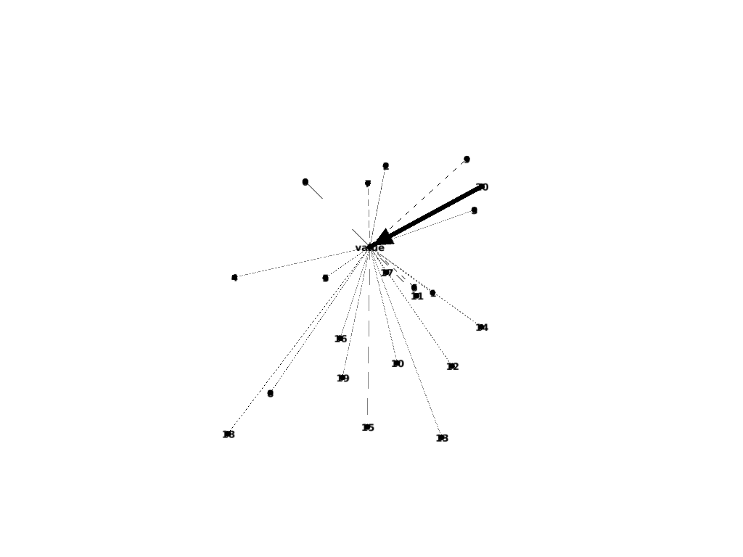

transaction_hash | transaction_hash
c8e7b7461213f46530aaf7b8f0cf3a4bdc10fe0f6ca127376d5e0462580b2174 | bc1q37ew29yf9d5t2g6fpzy79fmj2msnpsgts4gcsh

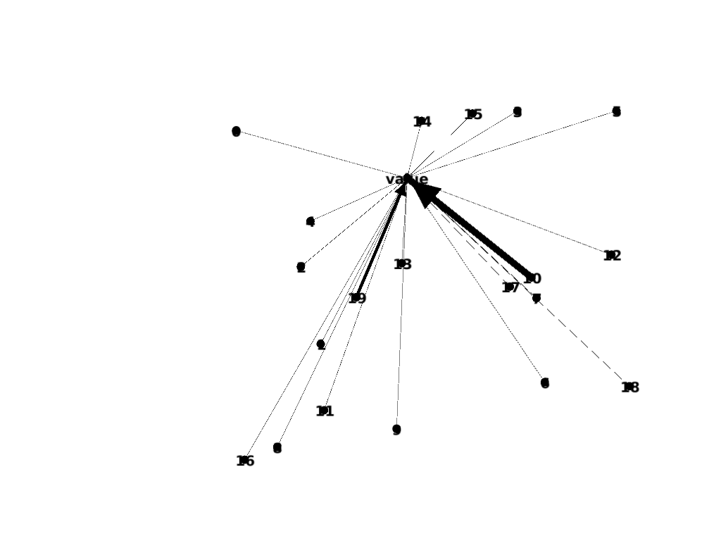

transaction_hash | receiving_wallet_id
6961ff348f6a83d7d2bdee4c780da0a150ea9b6497bc8d80046a82276c9d53d2 | bc1qnglum7n643auhys7at35sytkpr2t4p6wgk5w9v

