# TX Flow Table

|  |  |  |  |
| --- | --- | --- | --- |
|  | **hash** | **real_time** | **num_outputs** |
| 0 | 150fb44378c692db3f639ad4fb029789094685a1ae0023d1c878fd9c65ae4a7d | 2023-04-06 09:16:40 | 4 |
| 1 | 1064e804527cefcadda01b4308d8fef1b817d609c260fe1cb6d397d2d7b2a31d | 2023-04-07 00:11:11 | 20 |
| 2 | 5b066f162d3508318bcff8d95c357bc13cf29044013173b99220b1d7cc8e2304 | 2023-04-07 00:52:13 | 19 |
| 3 | b092ef45288487a4e3c71332613f070a5d82ee5363e9e1599cef1f79a4de1d3f | 2023-04-07 01:57:06 | 14 |
| 4 | 6423eb2def8926c5737edcd68700cfa6361dbcb985a49de829e04533558d1108 | 2023-04-07 03:44:55 | 11 |
| 5 | d3003a90ba0116f176f0906516ae3913635ba321c02928808ac32e2e8d684cc0 | 2023-04-07 04:30:17 | 1 |
| 6 | e5dcfc830e79b146ce90037fdd0685243f00849de9ab89e40e66a7fbc039143c | 2023-04-07 13:24:34 | 15 |
| 7 | a9b85dcbd39ff26bdea8dbd43e3cc1c9f3146cfa18a0db3de76f030d86692d9b | 2023-04-07 15:45:23 | 24 |
| 8 | fbca51f435657bd347ef37a369698140b3afa0072630b707a24fe743b3a7ea1e | 2023-04-07 17:09:38 | 27 |
| 9 | c8e7b7461213f46530aaf7b8f0cf3a4bdc10fe0f6ca127376d5e0462580b2174 | 2023-04-07 17:58:59 | 21 |
| 10 | 323f3a70d928ade1eec2a3c8b47dcb35278ad41ea573253fa160b9f6951307a8 | 2023-04-07 19:04:04 | 20 |
| 11 | 6961ff348f6a83d7d2bdee4c780da0a150ea9b6497bc8d80046a82276c9d53d2 | 2023-04-07 19:24:25 | 2 |

# 06 Apr 2023 10:16:4

Hustlers University / War Room Wallet: bc1qesjkw9r8mq0n3pk7p7amsfz9mdjpg2kn9yl2v9 sends 6.8 Bit Coins to a wallet that has transacted 10 times. An unusually large amount of Bit coins in the wallets recent history.

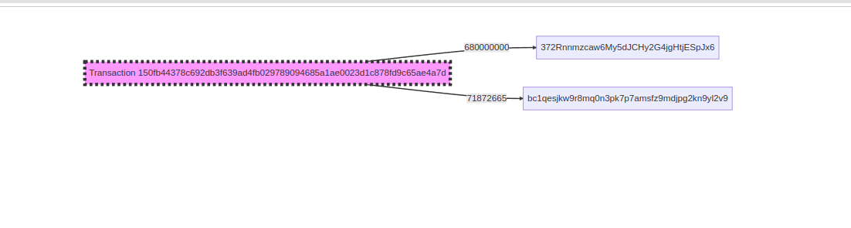

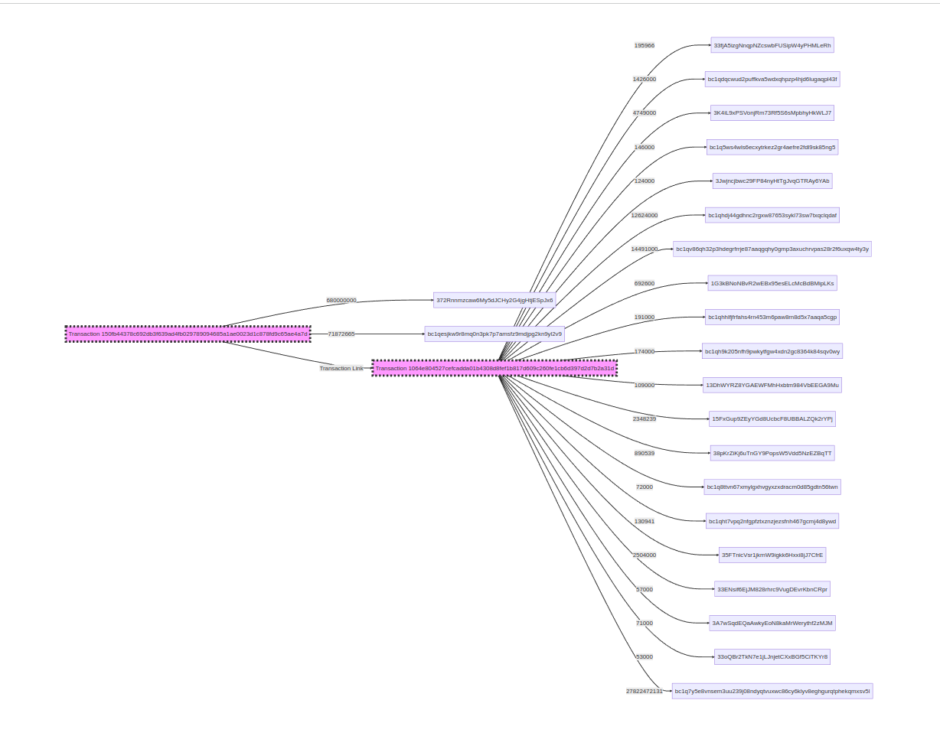

# **07 Apr 2023 01:11:10**

The receiving wallet sends the funds received as part of a very large transaction. Note, in this transaction it is one of many other inputs.

# 07 Apr 2023 01:11:10

Within the same day, a series large output transactions occur . Seemingly transferring the bulk of the funds received at hop 2 along a main branch at each hop.

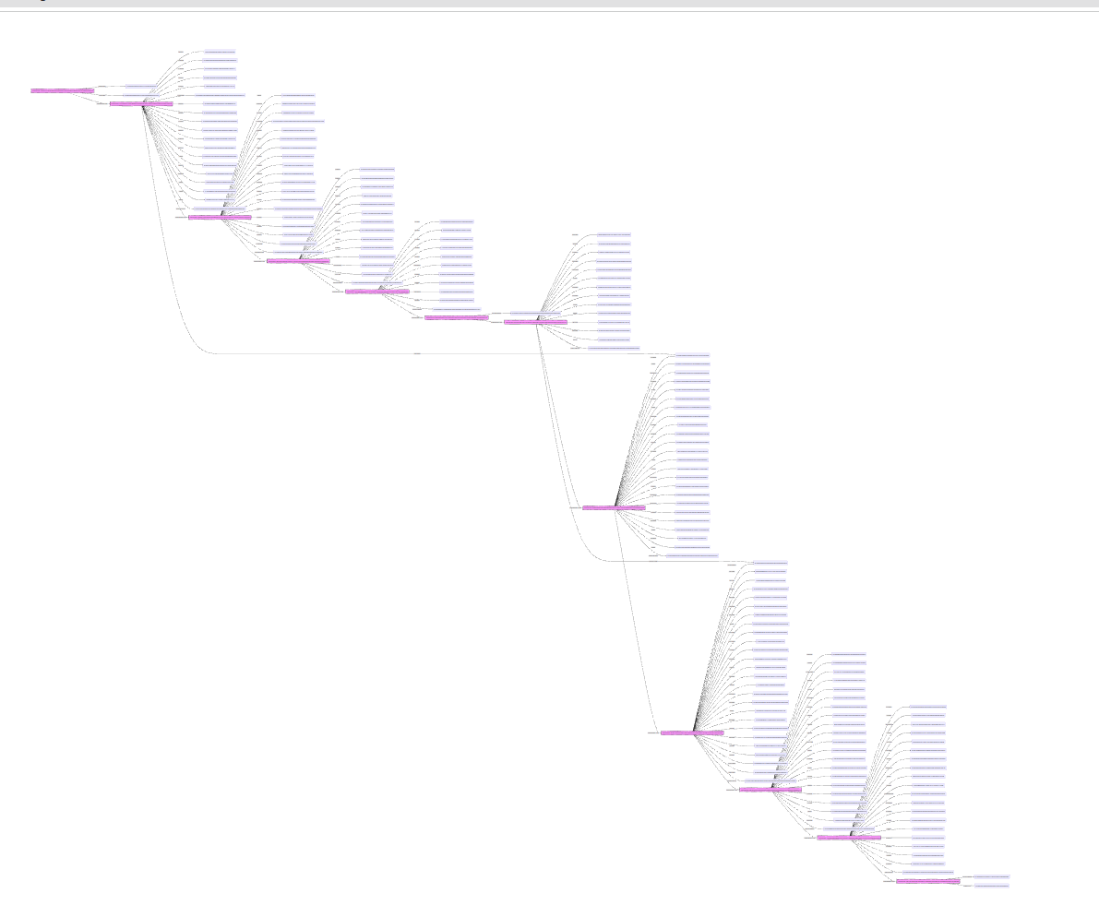

# **07 Apr 2023 08:24:25**

At this hop, the transaction flow schema changes dramatically. The bulk of the 27822472131 that has travelled along the main branch is split into amounts totalling no more than 3 Bitcoins, and distributed among a further 53 wallets. At this stage tracing becomes extremely frustrating, and time consuming.

However several of these branches have been traced to Crypto Exchanges based in the Seychelles.

