 | NILE JOURNAL OF COMPUTING  Volume 1, Issue 1, 2026  https://doi.org/10.5281/zenodo.njc.2026.0101
――――――――――――――――――――――――――――――――――――――――――――――――――――――――――――――
Nigeria Road Management System: A Citizen-Centric Platform for Road Monitoring, Reporting, and Progress Tracking
Chibuzor Clinton Agada¹*, Ephraim Ayokunle Tackie Ofoli¹, Isaac Akorede-Abayomi Odujoko¹,
Aisha Mohammed Rasheed¹, Prince Arinze Wenceslaus Obinabo¹, Mubarak Ibrahim Audu¹, and Johnwendy C.N.¹
¹Department of Computer Science, Faculty of Natural and Applied Sciences, Nile University of Nigeria, Abuja, Nigeria
*Corresponding Author: Chibuzor Clinton Agada (e-mail: clinton.agada@nileuniversity.edu.ng)
ABSTRACT:
KEYWORDS: citizen reporting, construction progress tracking, crowdsourcing, inspection alerts, multi-tier architecture, Nigeria roads, spatial dashboard, transparency.
I. INTRODUCTION
Road transport is the main mode of transport for both passengers and goods in Nigeria. The national road network that covers an estimated 193,200 kilometres is the largest in West Africa (Farouq et al., 2017). This network is the main roadway of the cities, peri-urban areas and rural regions and accounts for more than 90% of passenger and goods travel. Despite its strategic significance, a significant part of the network is still in disrepair. The common sightings by motorists and pedestrians are deep potholes, structurally unsafe bridges, eroded shoulders and flooded carriageways (Adepoju, 2021). This chronic degradation causes a progressive deterioration of the vehicle, long delays and higher frequencies of accidents, which puts a significant socio-economic burden on society and the economy (Jaiye & Elisha, 2020).
Institutional fragmentation is a feature of the governance of road infrastructure in Nigeria. Federal roads are managed by the Federal Ministry of Works in consultation with the Federal Road Safety Corps (FERMA), State roads are managed by State Ministries of Works and Local roads are managed by Local Government Councils (Ogbu & Ezeh, 2019; Olojede et al., 2019). The Traffic law enforcement is delegated to different State traffic agencies (STAs) and the Federal Road Safety Corps (FRSC) (Ajiboye et al., 2020). In practice, such institutions are highly reliant on manual inspection, telephonic complaints, and paper documentation (Odinfono & Olawole, 2024). Unfortunately, in many cases of degraded roads, the road does not get logged for a long time before it's considered for a remedy. As such, common traffic violations (such as ignoring one-way signs, speeding, parking on private property, and littering in drains) are often unenforceable because of the lack of a citizen-friendly evidence reporting system (Umar et al., 2021).
Another important challenge is the lack of transparency in the construction and rehabilitation of the roads. Inadequate materials have been used by contractors and some contractors have been seen either leaving project sites after mobilisation funds have been released or leaving them before any subsequent stages of the project have been completed (Adepoju, 2021; Ugochi, 2020). Since there is no clear digital record of progress using photographs, it's very hard for supervisory personnel to see if contractual requirements have been met. Some of these can be directly addressed through a computerised system that allows citizens to report road defects and traffic violations, requires the contractors to submit progress photos and automatically alerts when the deadlines for inspections have passed.

The current road management practices in Nigeria are mostly manual, inefficient and uncoordinated. This prevailing system has four major drawbacks. First, citizens have no efficient digital system to submit their complaints about potholes or structural damage to roads with a geotagged photo, and complaints can only be made at the end of a physical visit or informally, which means that the repair process takes too long (Farouq et al., 2017). Secondly, construction activities are not recorded digitally, using an open format with photographic evidence, which allows for inferior construction methods and missed deadlines to remain unchecked (Adepoju, 2021). Third, traffic violations like one-way contraventions, illegal parking and dropping of waste on roads occurs without any form of regulation in place, without citizens having any way to submit supporting photos with evidence (Umar et al., 2018). Fourth, maintenance agencies do not have an automated notification system that can alert when a road or project inspection is due, resulting in poorly maintained infrastructure and maintenance schedules (Odinfono & Olawole, 2024).
To meet the needs of these exigencies, this study addresses three main research questions. Are there any existing systems for the management of road construction, maintenance, monitoring and enforcement of road traffic laws in Nigeria? What are the main drawbacks of current methods of road management, in terms of transparency, coordination between agencies, material quality, and public reporting? What do you think the functional attributes of a computerised Nigeria Road Management System should include to enable citizen reporting, track the progress of road construction, monitor the state of the roads and improve their decision-making by officials?
This study intends to develop, deploy and test a web-based Nigeria Road Management System (NRMS) that facilitates citizens to report defects and violations, monitor the construction progress and notify officials of outstanding inspections.
The study addresses the aim through three specific objectives: The first goal is to design the multi-level architecture of the system, the database schema, and the UML design for contractors, road officials and users. The second goal is to implement the core software modules, including citizen reporting of defects and violations with photographic upload, contractor progress monitoring, automated alerts for inspections and an administrative monitoring dashboard. The third goal is to test the final system to ensure a successful functioning, reporting and notification in representative scenarios.

II. RELATED WORKS
The results of research on road management and transport technology in Nigeria can be categorized into three main groups: (i) administrative and institutional record-management systems, (ii) geospatial and emergency-response systems, and (iii) automated sensing and computer-vision systems. While these studies show the possibilities of the use of digital tools, they are institution-centered, limited and mostly isolated from public inclusion. It synthesises all the literature which has been audited with respect to the five variables: system architecture, core features, technology stack, problem solved, and unaddressed gaps and finally identifies the gap which the proposed Nigeria Road Management System (NRMS) addresses.

2.1 Administrative and Institutional Record-Management Systems
One group of research is dedicated to the digitisation of the records of the government itself. The Federal Road Safety Corps (FRSC) faced problems of traffic offence information being decentralised in states and local government areas (LGAs) which Sese (2020) addressed through a client–server distributed database. The solution was to solve a real issue of record fragmentation for internal use, but had no citizen facing reporting, photo uploads or road condition tracking. In a similar manner, Dabo and Yunus (2020) showed that GIS tools can be used to map the road facilities in Katsina, however, the GIS system was limited to an internal database and was not accessible to the common man. Akanbi and Abegunde (2020) extended this institutional logic to a mobile solution for vehicle plate registration and accident logging for the FRSC which lacked the reporting of road-surface defects and monitoring of construction progress.
The overall architecture principle that underlies these systems is that the citizen is not the subject of data, but rather is purely passive. Information is moving towards the agency, and there is no flow of information back to the public. This will constrain accountability and the amount of road condition data that can be gathered at ground level. Farouq et al. (2017) provide empirical evidence on the impact of this limitation: they found severe issues with the manual, paper-based reporting system, and citizen discontent about the process of reporting road-defects in Kano State. Their study did not, however, result in a working web or mobile platform.

2.2 Geospatial and Emergency-Response Systems
A second cluster is related to the use of spatial analysis in road safety. Audu et al (2021) created a spatial decision support system (SDSS) with ArcGIS 10.3, Network Analyst and GPS to map accident hotspots and to calculate the shortest ambulance routes in Ibadan. The system enhanced the response times for all emergencies and showcased the benefit of geospatial intelligence to road management. However, its coverage was strictly post-crash: It only covered emergency medical response, and did not include anything like defect reporting, preventive maintenance or contractor tracking. The system thus addresses a downstream symptom and not an upstream problem, of poor road quality.

2.3 Automated Sensing and Computer-Vision Systems
The third cluster delves into automated enforcement and monitoring. Umar et al. (2021) developed an image processing client–server system to detect vehicles running the red light that uses licence plate detection and optical character recognition (OCR) to identify the licence plate of the vehicles using k-NN algorithm and MATLAB. The system enabled automatic detection of violation, but it needed to be based on a specialised fixed infrastructure and had no functionality for citizen reporting and road-condition monitoring. It is capital intensive and location dependent, and is hard to deploy to spread out and low-cost road monitoring requirements in Nigeria.

2.4 Cross-Cutting Limitations and Data-Quality Concerns
There are a number of cross-cutting limitations which are identified across all three clusters. There is a systematic lack of involvement of the public. While Toriola-Coker et al (2020) found that citizens' lack of involvement in public roadworks was a major issue that leads to the failure of public road projects, none of the systems audited provides a way for citizens to report defects and/or verify progress of the contractor. Secondly, there is an inconsistent data collection. According to Odinfono and Olawole (2024), 55% of the traffic crash data collection is not done using standardized paper forms in southwestern Nigeria, resulting in inconsistencies between police and road-safety records. Third, they are not integrated systems, as each system solves a small part of the road-management problem, without the citizen crowdsourcing, contractor milestone tracking and inspection alert systems all being in one place.

2.5 Summary of Audited Systems
TABLE I: Summary of Related Systems Audited Across the Five Project Variables
Study & Year | Architecture | Core Features | Tech Stack | Problem Solved | Unaddressed Gap
Afieroho et al. (2023) | Web E-Government Framework | Public project tracking, citizen adoption survey | SPSS, PLS-SEM, Web Portal | High public willingness to adopt digital tracking tools | Theoretical survey model only; no functioning tool with photo reporting
Farouq et al. (2017) | Relational Database Audit | Road defect logging, user dissatisfaction survey (Kano) | SPSS, Average Index Analysis | Exposed weaknesses and frustration with manual defect logging | Fully manual and paper-based; no web or mobile platform
Sese (2020) | Client–Server Distributed DB | Centralised traffic offence database for FRSC | Client–Server, Distributed SQL | Centralised offence records across states and LGAs | Internal officers only; no citizen reporting, photo uploads, or road tracking
Audu et al. (2021) | Spatial Decision Support (GIS) | Accident hotspot mapping, ambulance routing (Ibadan) | ArcGIS 10.3, Network Analyst, GPS | Improved emergency response times | Post-crash only; excludes defect reporting and contractor tracking
Umar et al. (2021) | Image Processing Client–Server | Licence plate detection and OCR | k-NN, MATLAB, Camera | Automatic detection of red-light violations | Requires fixed roadside cameras; no citizen reporting or condition monitoring
Dabo and Yunus (2020) | GIS Internal Database | Mapping of road facilities (Katsina) | GIS | Effective mapping of road assets | Internal database; inaccessible to ordinary citizens
Akanbi and Abegunde (2020) | Mobile System | Vehicle plate registration, accident logging (FRSC) | Mobile Platform | Digitised plate registration and accident logs | No road-surface defect reporting or construction-progress monitoring
Odinfono and Olawole (2024) | Survey / Data Audit | Analysis of crash data collection practices | Survey Analysis | Revealed 55% reliance on non-standard paper forms | No system proposed; diagnostic only
Toriola-Coker et al. (2020) | Conceptual / Empirical Study | Public participation in road projects | — | Identified lack of public involvement as failure factor | No digital platform proposed

2.6 Proposed Improvement and Value-Add Delta
The literature available for review shows that the current systems are institutional based, function separately and do not involve the public. The proposed Nigeria Road Management System (NRMS) combines citizen crowdsourcing, contractor milestone tracking and automated alerts for inspections within a single platform which addresses these gaps. Table II is a comparison of standard existing practice to the proposed contribution for NRMS.
TABLE II: Value-Add Comparison (Standard Practice vs. Proposed NRMS)
Functional Area | Standard / Existing Practice | Proposed NRMS Contribution (Value-Add Delta)
Citizen Defect Reporting | Slow verbal complaints, physical office visits, or unverified social media posts without precise location data | Web and mobile interface for reporting potholes and violations with attached photos and automatic GPS coordinates
Contractor Progress Tracking | Contractor-submitted paperwork with little or no public photo verification before payment | Dedicated contractor portal requiring timestamped progress photos for each construction milestone before inspection clearance
Inspection Alerts | Irregular manual visits with no automated reminder when inspections are overdue | Automated background engine that checks the database daily and sends email/SMS alerts when a road inspection is overdue (> 30 days)
Official Dashboard & Analytics | Disorganised paper files and separate spreadsheets with no interactive map or condition status | Central dashboard showing monitored roads, critical road counts, ongoing construction projects, and overdue inspections on an interactive map
The value add delta is thus not simply additive but architectural, as NRMS transforms the passive citizen as a subject and turns institutional records into a platform of public accountability and turns manual inspection with rules into automated monitoring.
III. METHODOLOGY

3.1 Research Design
The methodology used in this study is Design Science Research (DSR) that is suitable for research where the significant contribution is an innovative software artefact. As part of information systems and software engineering, DSR is a paradigm that is well accepted as one that focuses on the design and evaluation of artefacts for solving real-world problems, as explained by Hevner et al. in 2004. Design science differs from behavioral science, which aims to explain or predict phenomena, by producing knowledge using design and evaluation of artefacts, as pointed out by Hevner et al. in 2004.
The DSR process is based on the design cycle developed by Wieringa (2014), which involves two activities: designing an artefact that will enhance an aspect of the context for stakeholders and then empirically testing the artefact in the context to see how well it works. This “validation in context” principle is at the heart of the methodology: Not only is an artefact created but it must also be demonstrated as solving the identified problem in the operational context, a point made by Wieringa in 2014.
The architecture of the system is fully documented before the implementation starts, and the system requirements are traceable to the changes made in its design.
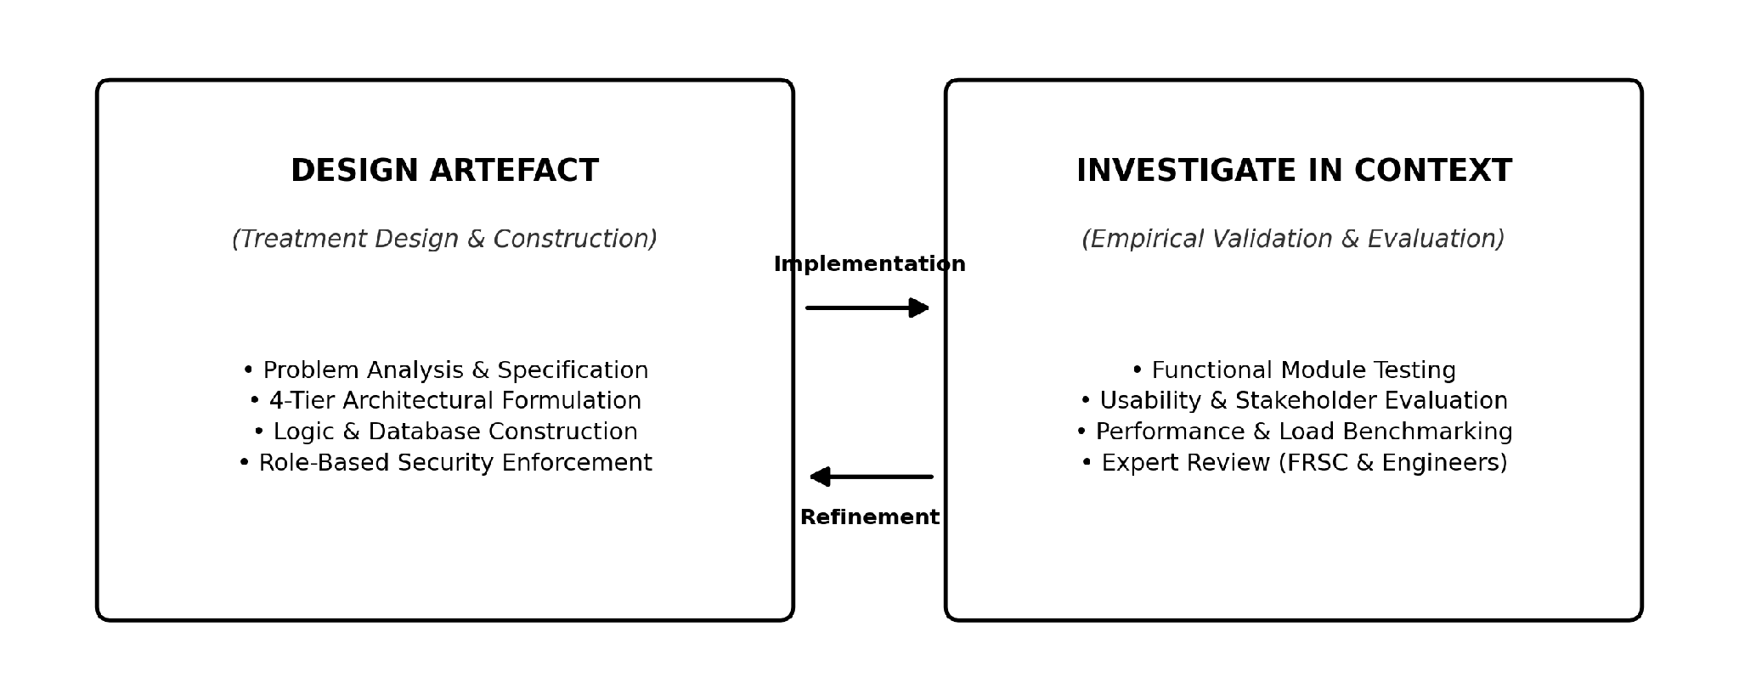
Figure 3.1: Wieringa's (2014) Design Science Research Cycle Applied to NRMS.

3.2 System Architecture
The Nigeria Road Management System (NRMS) is based on a four-tier architecture for separation of concerns, which includes presentation, business logic, data persistence and notification services.
TABLE III: Architectural Tiers and Component Allocations

Tier | Responsibility | Components
Client Tier | User interaction | Citizen Portal, Contractor Portal, Officials Dashboard
Logic Tier | Business rules and workflow | User Management, Report Management, Contractor Progress, Inspection Alert Engine, Map Analytics
Data Tier | Persistence and caching | PostgreSQL + PostGIS, Cloudinary/S3, Redis
Output Tier | Notifications and reporting | SMS/Email Services, Map Rendering (Leaflet/OpenStreetMap), PDF/CSV Export
This separation provides three design properties: security (role-based access is enforced on the server), maintainability (an independent modification of tiers, without redesign of clients), and scalability (horizontal scaling without redesign of clients).
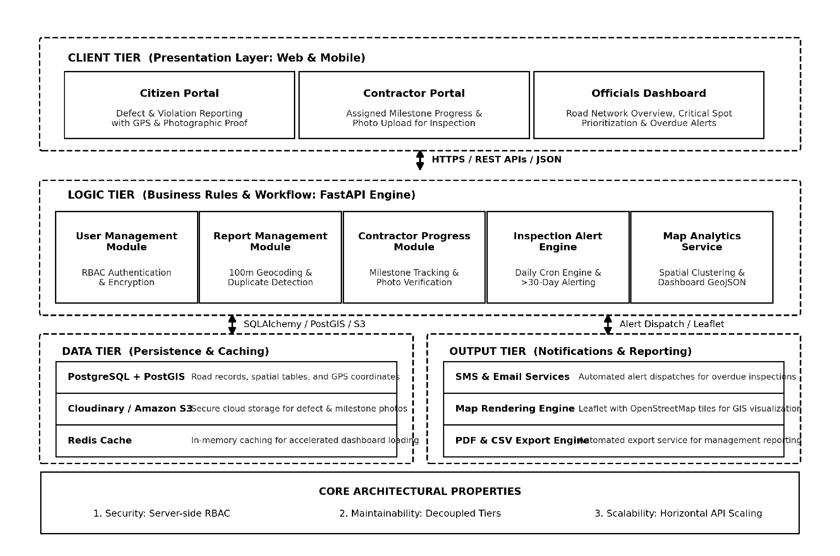
Figure 3.2: Detailed NRMS Four-Tier System Architecture.

3.3 Functional Modules
Client Tier. A Citizen Portal allows users to submit road defects (such as potholes and erosion) and traffic violations (such as driving on one way and parking illegally) through an instant web and mobile interface, capturing photos and GPS coordinates. The Contractor Portal allows registered contractors to view the projects assigned to them, upload of the progress pictures with date and time stamp for the completed milestones and request inspection. The Officials Dashboard will show road counts, critical road spots, current projects and overdue inspection counts.
Logic Tier. The User Management Module encompasses all the security measures required for registration of new users, the secure authentication of all users, the encryption of their passwords and role-based access control for four roles: citizen, contractor, inspector, and administrator. Citizen submissions are received by the Report Management Module, a 100-metre radius is used to detect if there is a duplicate report and an urgency priority is assigned. The Contractor Progress Module documents project progress, calculates work completed as a percentage and stores progress photos to verify progress. The Inspection Alert Engine runs on a daily basis to alert road sections or projects with an inspection date more than 30 days ago. The Map Analytics Service takes the GPS data and clusters reported defects geographically to show them together and formats the data to be displayed in a dashboard.
Data Tier. Road records and GPSCoordinates use the PostgreSQL/PostGIS spatial data storage database. Photographs are stored in Cloudinary/S3. Redis is used for caching on dashboards.
Output Tier. Notification Services send out SMS and email alerts for late inspections. Map Rendering is Leaflet + OpenStreetMap tiles. Report Generation is a tool that generates PDF/CSV reports to pass to management.

3.4 Data Flows
Four standard data flows (F1-F4) specify the interactions between actors, application logic and persistence layers during operation.
TABLE IV: System Operational Data Flows (F1 to F4)

Flow | Actor | Process | System Response
F1: Report Submission | Citizen | Selects defect type, attaches photo, submits GPS coordinates | Stores photo in cloud, persists report in database, returns tracking number
F2: Progress Upload | Contractor | Selects milestone, uploads progress photos | Records update as “Pending Inspection,” notifies supervising officer
F3: Inspection Alert | System | Daily scan for inspections >30 days overdue | Generates alert, dispatches SMS/email to maintenance engineer
F4: Administrative Triage | Official | Reviews defects on map, assigns maintenance team | Status transitions from “Under Review” to “Assigned”
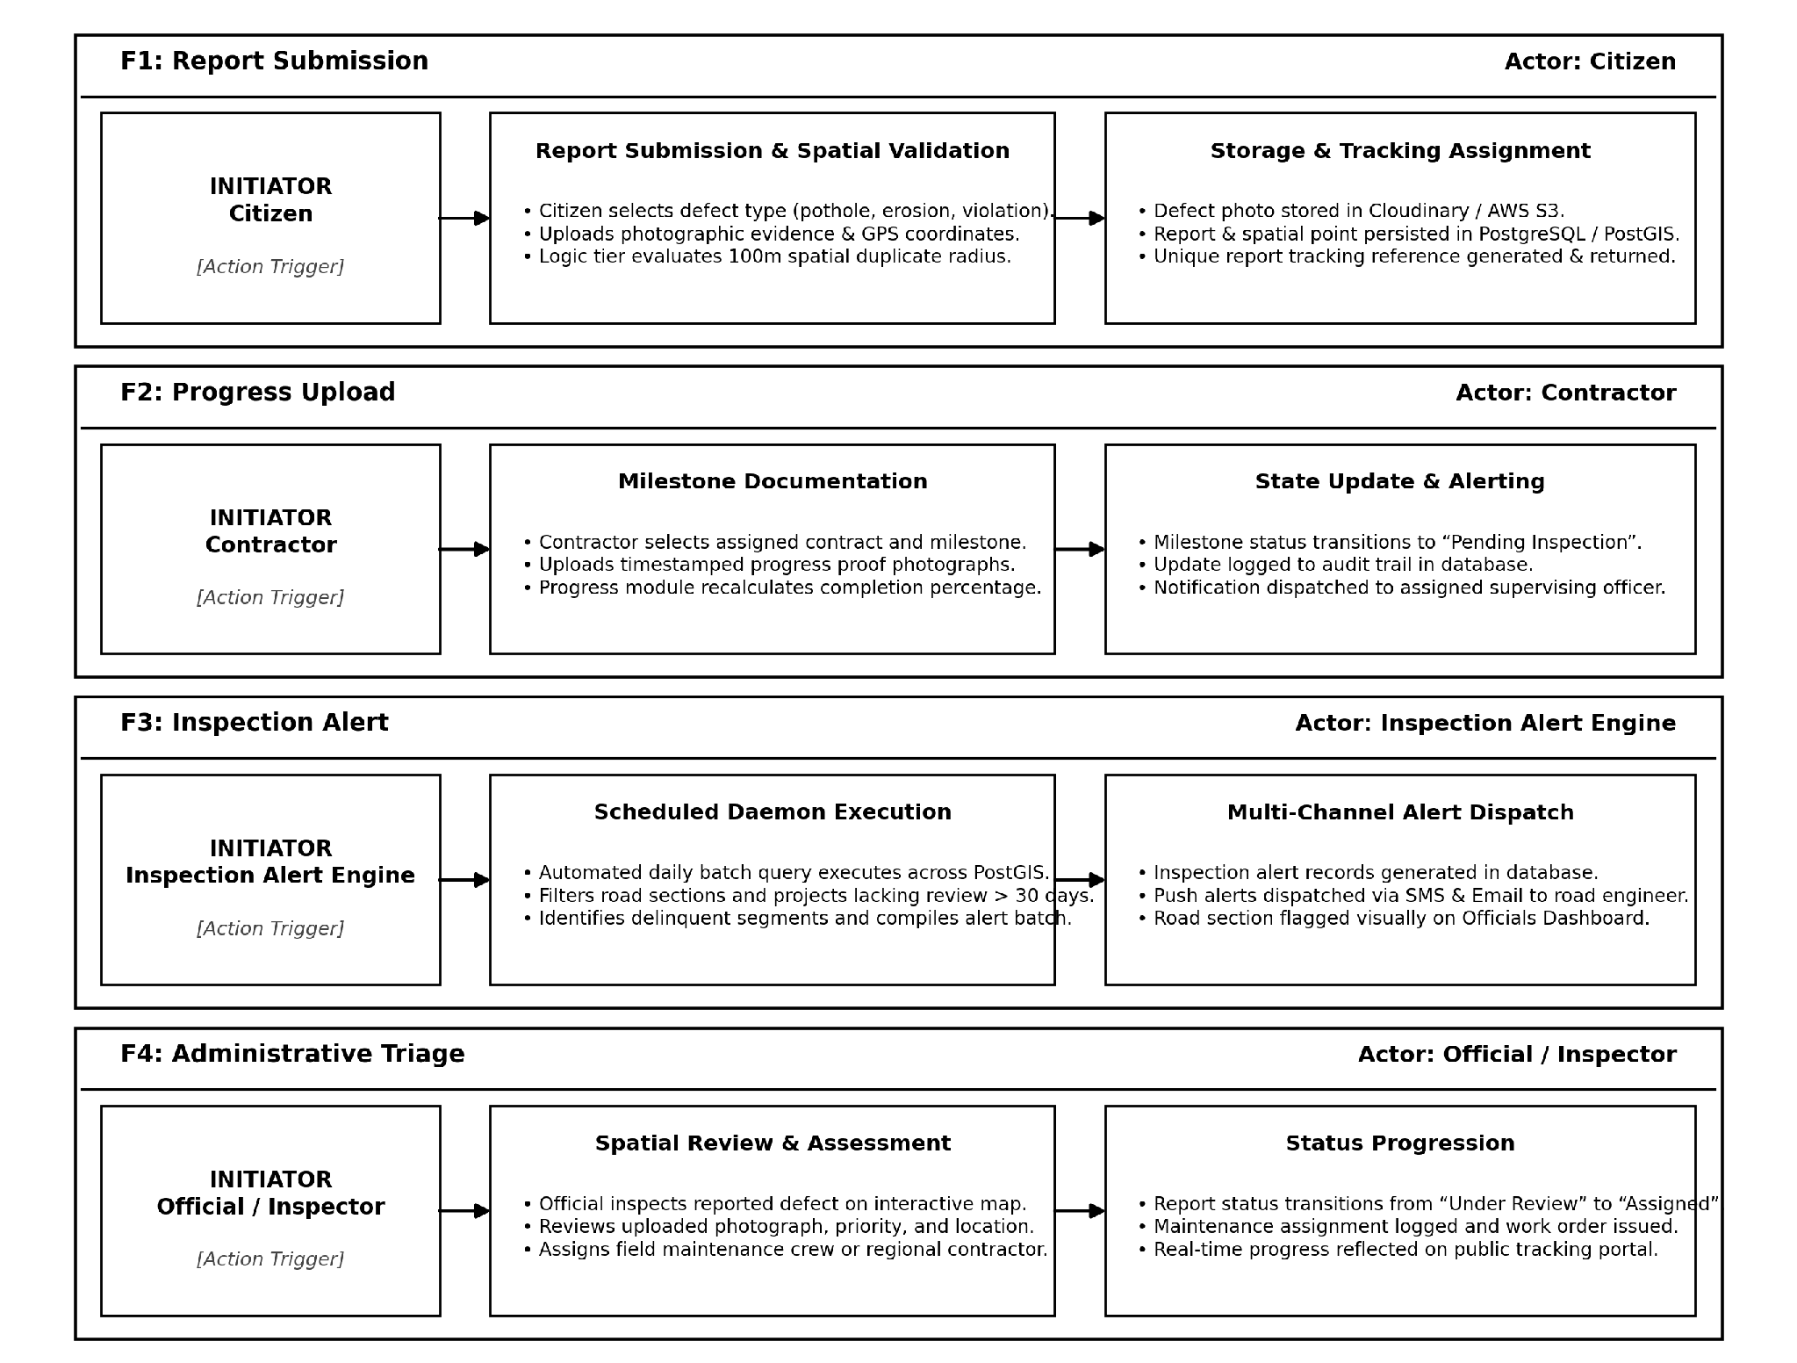
Figure 3.3: End-to-End System Operational Data Flows.

3.5 Technology Stack
The selection of technologies was based on three different criteria: reliability, open-source accessibility and ease of deployment.
TABLE V: Technology Selection and Rationale

Layer | Technology | Rationale
Frontend | HTML, CSS, JavaScript | Responsive mobile performance; dashboard and form support
Backend | FastAPI | High-throughput concurrent photo upload and API request handling
Database | PostgreSQL + PostGIS | Native spatial queries for GPS coordinates and geographic clustering
Storage/Cache | Cloudinary + Redis | Secure off-database media storage; accelerated dashboard loading
Mapping/Notification | OpenStreetMap + Leaflet; SMS/Email | Open-source interactive mapping; reliable alert delivery

3.6 Design Traceability
Architectural decisions are documented in relation to a gap in the literature. The 100-metre duplicate detection rule is for the issue of data quality that was highlighted by Odinfono and Olawole (2024) and concerns inconsistency in data. This is done by the automated 30-day inspection alert, which takes care of irregular manual inspection practices. The contractor photo-verification workflow is aimed at the lack of transparency in payments. This traceability allows the artefact to meet directly the deficiencies recorded and not just a technical exercise.

3.7 Evaluation Plan
The artefact will be assessed according to the four complementary assessment approaches mentioned in foundational design science literature and based on the DSR principles:
- Functional validation: Task each module – test them against the specified requirements - duplicate detection accuracy, alert trigger reliability.
- Usability evaluation: Task based testing using representative citizens, contractors and officials.
- User experience testing: API request times, photos upload rates and maps rendering times with simultaneous traffic.
- Expert Review: Structured walk-throughs with road engineers and FRSC officials to determine operational fit.
REFERENCES
Adepoju, O. O. (2021). Analysis of road transportation infrastructure construction and maintenance for sustainable development in South-Western Nigeria. Journal of Sustainable Development of Transport and Logistics, 6(1), 4–15. https://doi.org/10.14254/jsdtl.2021.6-1.4
Afieroho, P., Perkins, R., Zhou, X., Hoanca, B., & Protasel, G. J. (2023). Adopting e-government to monitor public infrastructure projects execution in Nigeria: The public perspective. Heliyon, 9(7), e18552. https://doi.org/10.1016/j.heliyon.2023.e18552
Ajiboye, A. O., Kolawole, O., & Adebanjo, A. A. (2020). Assessment of the statutory duties of Federal Road Safety Corps aimed at reducing crashes and carnages in Ibadan, Southwest Nigeria. Journal of Art, Architecture and Built Environment, 3(2), 968. https://doi.org/10.32350/jaabe/2020/32/968
Akanbi, O. D., & Abegunde, O. (2020). Design and implementation of mobile information system for Federal Road Safety Corps (FRSC) of Nigeria. International Journal of Sensor Networks and Data Communications, 9(2), 1–6.
Audu, A. A., Iyiola, O., Popoola, A., Adeleye, B., Medayese, S., Mosima, C., & Blamah, N. (2021). The application of geographic information system as an intelligent system towards emergency responses in road traffic accident in Ibadan. Journal of Transport and Supply Chain Management, 15, a546. https://doi.org/10.4102/jtscm.v15i0.546
Babatunde, A. A., Adewuyi, G. K., & Oyekola, M. A. (2019). Road condition monitoring of major and minor route in part of Ibadan metropolis using geo-spatial approach. Journal of Geography, Environment and Earth Science International, 22(4), 1–12. https://doi.org/10.9734/jgeesi/2019/v22i430156
Dabo, M. Z., & Yunus, S. (2020). Road transport information system: A panacea for road transport facility management in Katsina Local Government, Katsina State, Nigeria. FUDMA Journal of Sciences, 4(2), 230–238. https://doi.org/10.33003/fjs-2020-0402-230
Farouq, M. M., Anwar, F., Baba, Z., Labbo, M. S., & Aliyu, D. (2017). Road maintenance management in Kano State, Nigeria: Case study of Kano metropolitan. IOSR Journal of Mechanical and Civil Engineering, 14(3), 50–62. https://doi.org/10.9790/1684-1403035062
Gambo, N., & Musonda, I. (2021). Effect of the Fourth Industrial Revolution on road transport asset management practice in Nigeria. Journal of Construction in Developing Countries, 26(1), 21–42. https://doi.org/10.21315/jcdc2021.26.1.2
Hevner, A. R., March, S. T., Park, J., & Ram, S. (2004). Design science in information systems research. MIS Quarterly, 28(1), 75–105. https://doi.org/10.2307/25148625
Jaiye, D., & Elisha, A. (2020). The menace of uncontrolled trailer/truck loads and the use of weigh-in-motion device on carriageways in Nigeria. International Journal of Transport Development and Integration, 4(1), 1–13. https://doi.org/10.2495/tdi-v4-n1-1-13
Medayese, S., Alfa, M. T., Abd’Razack, N. T., & Agbawn, F. O. (2019). Analysis of the extent of red light running in Minna, North-Central Nigeria. Journal of Contemporary Urban Affairs, 3(2), 124–136. https://doi.org/10.25034/ijcua.2018.470zd9
Ndugbu, L. N., & Ndugbu, U. K. (2021). Road offence information management system in Nigeria: A most needed technology intervention. Journal of Computer Science and Engineering, 2(1), 164–172. https://doi.org/10.36596/jcse.v2i1.164
Odinfono, J., & Olawole, M. (2024). Road traffic crash data in Southwestern Nigeria: A qualitative analysis of sources, contents and management methods. Traffic Injury Prevention, 25(8), 1–9. https://doi.org/10.1088/15389588.2024.2398670
Ogbu, S., & Ezeh, F. (2019). Federal vs. state roads: Assessing the influence of intergovernmental relations models on road maintenance in Nigeria. European Journal of Business and Management Research, 4(5), 94–102. https://doi.org/10.24018/ejbmr.2019.4.5.94
Olojede, O., Agbola, S., & Samuel, K. (2019). Residents’ assessment of local government road infrastructure delivery in Ile-Ife, Nigeria. Local Economy: The Journal of the Local Economy Policy Unit, 34(6), 570–588. https://doi.org/10.1177/0269094219857044
Sese, T. E. (2020). Framework for client-server distributed database system for Federal Road Safety Commission Nigeria. Advances in Social Sciences Research Journal, 7(5), 183–195. https://doi.org/10.14738/assrj.75.8237
Toriola-Coker, L., Alaka, H., Agbali, M., Bello, W., Pathirage, C., & Oyedele, L. (2020). Marginalization of end-user stakeholders in public private partnership road projects in Nigeria. International Journal of Construction Management, 22(14), 2736–2748. https://doi.org/10.1080/15623599.2020.1766189
Ugochi, M. U. (2020). Road pavement failure and exploratory analysis of requirements for effective management of highway maintenance projects. International Journal of Innovative Research and Development, 9(8), 57–67. https://doi.org/10.24940/ijird/2020/v9/i8/aug20057
Umar, B., Olaniyi, O., Agajo, J., & Isah, O. R. (2021). Traffic violation detection system using image processing. Computer Engineering and Applications Journal, 10(2), 371–382. https://doi.org/10.18495/comengapp.v10i2.371
Wieringa, R. J. (2014). Design science methodology for information systems and software engineering. Springer. https://doi.org/10.1007/978-3-662-43839-8

