Team Null Software Proposal

Bart Downey  
Noah Woyak  
Michael Voorhies  
Karl Lukan

Contents

Objectives 3

Functionality 3

Design 3

Accessibility 3

Process 4

Contact 4

Current Timeline 4

Sprint 1 – Proposal & Requirements Gathering 4

Sprint 2 – UI/UX Finalized 4

Sprint 3 – Data Integration 4

Wireframes 5

Conclusion 6

Contacts 6

# Objectives

The project will consist of two components. The first being the redesign of the current property assessment site, the second being an administrative utility in order to update the site’s data easier.

The current website has UX/UI problems that will be addressed to provide a more user-friendly experience while keeping or enhancing existing features.

As of right now, data is provided to the site via an XML document. This document is populated with information from another XML document about every month, this causes unnecessary time overhead which can be automated by a utility application. The specifics of the utility application will be fleshed out in follow-up meetings.

## Functionality

The new site will largely leverage existing features. One notable change is the deprecation of PDF’s. Assessed property details will be displayed in a format conducive for printing.

The utility application will facilitate the merging of two XML documents, those being the one in current use and its updated counterpart. This will save significant time as data will not need to be updated manually.

## Design

Currently, the site has some UX problems such as poor search feedback, labyrinthian navigation, missing form validation, and the layout isn’t responsive. All of these and more will be addressed.

## Accessibility

The site markup doesn’t utilize tags that would help users using screen readers, this will be added in the redesign.

# Process

We will be operating on units of work called ‘sprints’ that take up to 2 weeks. At the end of each sprint, we’ll meet to discuss and demonstrate progress as well as any questions we have.

## Contact

Contact with Stevens Point employees will be largely done through Sandy Kratzke. Communication in-between sprints may be necessary and will consist of emails.

## Current Timeline

### Sprint 1 – Proposal & Requirements Gathering

Gather necessary information to determine project scope. With this information, we’ll have UI mockups to present.

### Sprint 2 – UI/UX Finalized

Changes to proposed UI if needed. The visuals and UX of the website are largely complete and presentable.

### Sprint 3 – Data Integration

Use provided XML to achieve complete functionality.

# Wireframes

### Home page

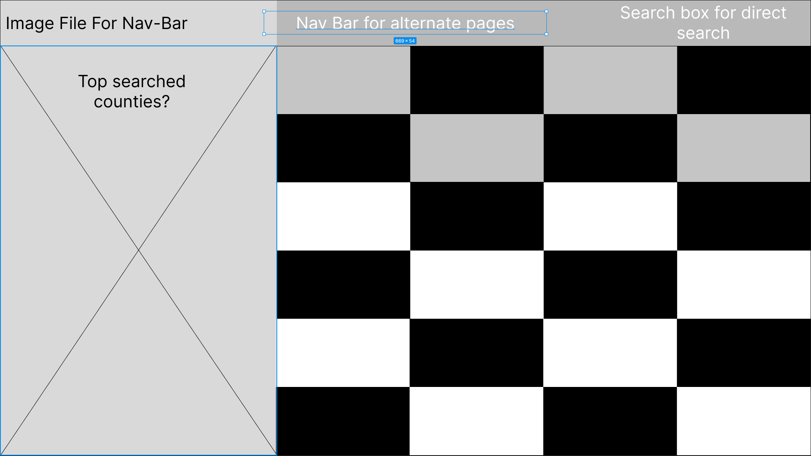

# Conclusion

We’re honored to have been given the opportunity to work on a project with such exposure. Expect more communication from us as we work on it. Currently, we don’t feel like we have enough details regarding the access and manipulation of the sites data, this will be resolved with further discourse.

To contact us, email Bart Downey at [downey5249@my.mstc.edu](mailto:mailtodowney5249@my.mst)