
Penlnlllla
- •.••.• 'I U.' 11Io II

:lJt-'H'j()1 • \\,\'Jw.pcfro,org lION. ij£U.oJA, PCoF:T C4lCH. •• RlJ f'l;JlJl "i1O, roWT TI)'~"i!E."'D
-- .... ----------
)'8
Km •.. "Mw/flllli
lo'\U:N
A 11111111'1 • (:iIlll) 'I/Ii !]tlll
2009 Newsletter
Page 7
Harstine Island Women's Club

I I
Women's Club provides a format to meet neighbors and become involved in the community.

Social activities include the monthly meeting (except July) where members gather for camaraderie and programs.
Lunch is either a brown-bag
along with a provided dessert

or one of our theme lunches. Holiday House is a popular venue which showcases handcrafted items, a perfect way to start your holiday shopping.
It is held the Saturday after Thanksgiving fl.t the Community Hall and Fire Station. Kids' Carnival is held the 2""
Saturday in August. Young people and adults work together to provide a fun - filled day
for the children. There are games, clowns and prizes. !\ great activity [or children nnd grandchildren! Whon someone 1'1'0111 tilt' islllllli pa~""e:-:; on the WOllH'll provide ;1 ITH~mol'ial Ililieh :Ie I.IIU Conllllllnity Hall. .l.t is a RCt'vic(2 th:lt :dlows the family
The Harstine Island Garden Club is one the most informally organized clubs in the RICC family of' organizations, with a COl'e nll.:lllhur:-;hip whu meet the 1,,1 'l'hUl'Sfl:ly nl' Uw 1Il011Lh, 7:00 p.m. :11, the ludl 111lIl'H.o.; nLlll'l'wi:-;c nnkd . Ml'llllJ(\l'Hh;p iH 1I1lnil to nIl WIHIlll'l' ill11'1'IIjo(llld III I_:IlI'Iil\tlil'l: 111111
to grieve, as well as feel the sense of community the island provides. Generations mingle and the island history lives on. If you want to show off your association with Harstine Island, there are logos galore at the Women's Club booth at the Saturday Market. Sweatshirts, fleece vests, denim shirts, visors and of course T-shirts are some of the clothing items available. License plate holders and mugs are part of the various choices. The book The Island Remembers, which gives a historical view of the island is available as well as our new cool<book, Harstine Island
Cooks!
tvl:iny of these :H.;tivi\.ies raise funds and t1w use of' those funds i:-i allother itllportilllL pitr!, of' W{)I1H;n's Cluh. WI.:. provide scholarships for local students, contribute to Pioneer
School and local food banks, and help with the expenses of keeping the Community Hall insured and in shape.
This last yea r we were able to give $50 to each of the Pioneer Elementary classroom teachers as well as supplies collected at our September meeting. People who enjoy sewing meet monthly in each others homes on the third Tuesday from 10:00 to 2:00 to share handiwork. relaxation and lunch. Join us at Women's Club and experience the feeling of belonging that only a small community can offer.
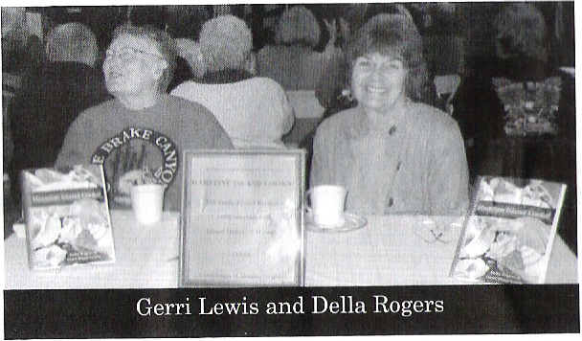
Garden Club
October, puts on an annual Apple Squee,e and Fall Festival and schedules pruning workshops wi th
.••. professional
.,j ilJ'horisLs. At c:l<.:h
ur L1H'SC ('\'('11(.:-; (,hl' 11l!1I1111l'nd1in W'llWH
