**HOW TO CHANGE MSSQL SERVER FOR TEAMCENTER**

**On existing MS/SQL server**

**Log on to Microsoft SQL Server Management Studio**

**Detached Teamcenter Database**

**Transfer MDF, LDF and iLog from DATA folder**

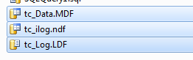

**To DATA folder of new MS/SQL Server**

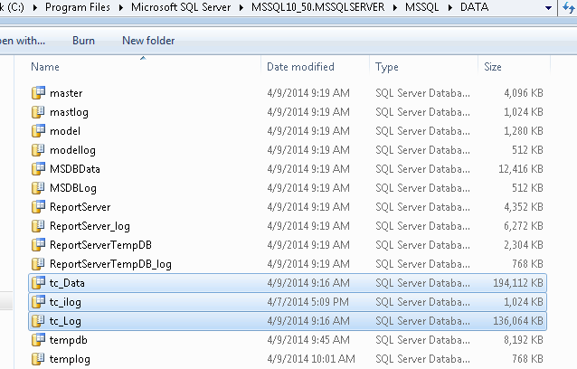

**Log on to Microsoft SQL Server Management Studio .**

**Select Databases** 

**RMB🡺Attach**

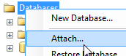

**Select Add**

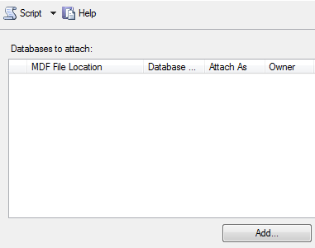

**Browse to tc_DATA.MDF file and select OK to attached tc database instance.**

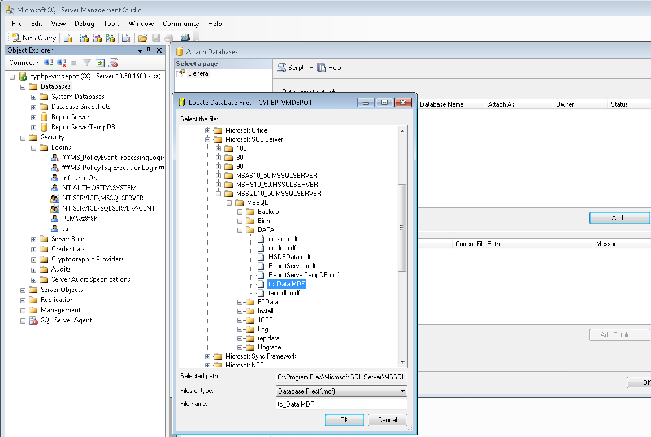

**Log on to SQL Server Management Studio as user sa (SQL Server Authentication)**

**Select New Query**

**Type**

Use tc

**Execute**

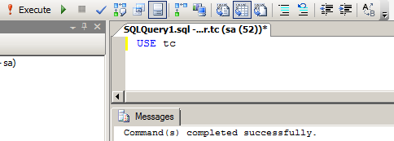

**To check for orphaned users, type**

EXEC sp_change_users_login 'Report';

**Execute**

(You will see output like the screenshot below if there are any orphaned users. In this example, user “infodba″ is showing up as an orphaned user. )

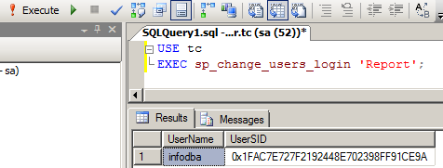

If you don’t already have a login to map to, you can have sp_change_users_login create one for you and with a password. The above code does this and creates a login with the same name and a password of ‘Tc1001sql2008R2′ as an example.

EXEC sp_change_users_login 'Auto_Fix', 'infodba', NULL, 'STRONGPASSWORD';

**Execute**

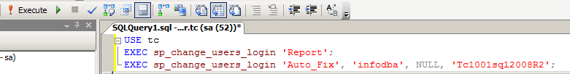

**Select user infodba**

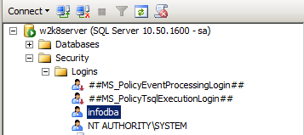

**Unchecked “Password Policy”**

**Change password to infodba.**

**Verify Default database is tc**

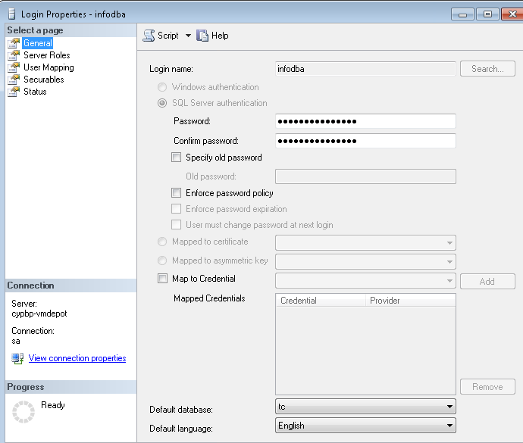

**Current Server Role does not allow login from Management Studio.**

**Select Server Roles.**

**Add sysadmin role.**

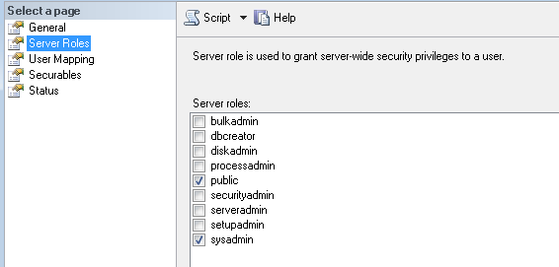

**File**🡺**Disconnect Object Explorer**

**File**🡺**Connect Object Explorer**

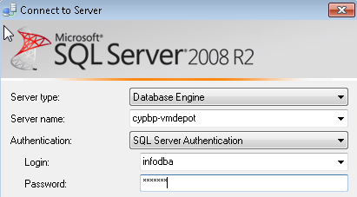

**Log in as infodba and password is infodba**

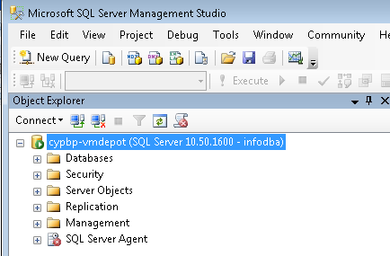

**On Teamcenter server, validate Teamcenter database connection to new MS/SQL server**

**Go to C:\Temp**

**Create a file called TestSQL.udl**

**Execute this file to start Data Link.**

**Provider Tab Select Microsoft OLE DB Provider for SQL Server**

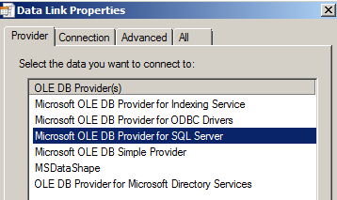

**Select Next**

**In Connection Tab, fill in required values then select Test Connection**

**Example:**

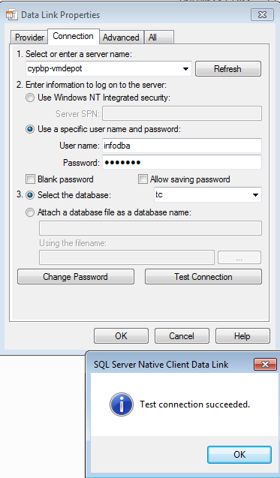

**Edit %TC_DATA%\tc_profilevars.bat**

**Modify TC_DB_CONNECT and TC_DB_SERVER to reflect new SQL server and encrypted password.( if you changed password of user infodba)**

**Test database connection.**

**install –ayt**

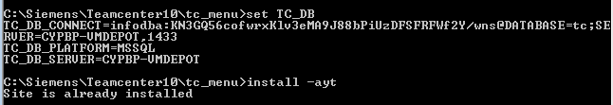

**Regenerate schema file**

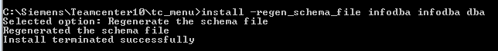

**Edit %TC_DATA%\tc_profilevars.bat**

**Set POM_SCHEMA variable to new pom_schema file.**

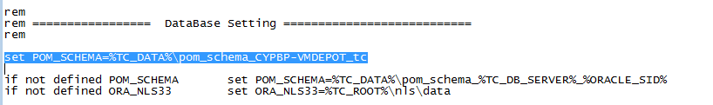

**Edit %TC_ROOT%\install\configuration.xml**

**Modify host value to reflect the new MS/SQL Server**

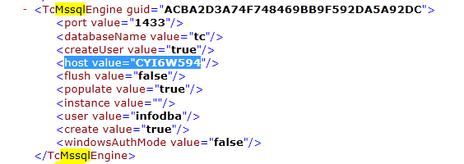

**Log on to Teamcenter to validate.**