DOC-002 Design Specification
Status | Release Candidate
Version | 1.0-RC2
Date | 25 July 2026
Approved chapters | 1, 2, 3.1 and 3.3

1. Document Information

Purpose
This document defines the functional and architectural design of HEMS Core.

Audience
- Project Owner
- Developers
- Testers
- Future Contributors

Related Documents
- DOC-001 README
- DOC-003 Architecture
- DOC-004 Data Dictionary
- DOC-005 Entity Registry
- DOC-006 Design Decisions
- DOC-007 Project Status
- DOC-008 Roadmap
- DOC-009 Test Plan
- DOC-010 Project Rules

2. Purpose & Vision

2.1 Purpose
HEMS Core is an intelligent, modular and reliable Home Energy Management System. It continuously determines the best overall operating strategy for the residential energy ecosystem while balancing safety, cost, battery lifetime, self-consumption and user preferences.

2.2 Vision
HEMS Core acts as the central intelligence layer above Home Assistant integrations. Every significant decision must be explainable and traceable. Safety always takes precedence over optimisation.

2.3 Mission Statement
To continuously determine the best possible energy decision while balancing safety, reliability, cost, comfort, battery lifetime, solar self-consumption and user preferences.

2.4 Success Criteria
- Reliable autonomous operation.
- Explainable decisions.
- Minimal unnecessary battery relay switching.
- Protection of connected equipment.
- Graceful handling of integration failures.
- Future-proof modular architecture.

2.5 Guiding Principles
- Safety First
- Modular Architecture
- Hardware Independence
- Transparency & Explainability
- Reliability

2.6 Transparency & Explainability
HEMS Core shall never operate as a black box.
For every significant decision it shall be possible to determine:
- What decision was made.
- Why the decision was made.
- Which inputs and policies were used.
- Which alternatives were rejected.
- What outcome was expected.
- The confidence level.
- Whether execution was successful.
The user should always be able to answer the question “Why is HEMS Core doing this?” without inspecting YAML, automations or source code.

2.7 Decision Hierarchy
- Safety
- System Integrity
- Equipment Protection
- User Policies
- Energy Optimisation
- Comfort

2.8 HEMS Core Design Manifest
HEMS Core is a modular, deterministic and explainable Home Energy Management Platform. It makes safe and verifiable energy decisions independently of the underlying runtime.

Principle Zero
No module may assume success. Every important action must be verified before it is considered complete.

Design Values
- Safety First: Safety always takes precedence over optimisation, comfort and financial return.
- Verify, Don't Assume: An action is complete only after Control & Verification has confirmed the expected result.
- Explain Every Decision: Every significant decision must be traceable, reproducible and understandable.
- Deterministic by Design: Equivalent inputs, policies, configuration and state produce the same result.
- Modularity over Complexity: New functionality is added through modules, providers or adapters rather than hidden coupling.
- Graceful Degradation: Loss of data or functionality leads to a controlled and safe lower capability level.
- Platform Independence: Home Assistant is the first runtime platform, not part of the HEMS decision logic.
- Closed-loop Control: The control cycle includes measurement, decision, validation, execution, verification and feedback.
- Clarity Above Cleverness: HEMS Core prefers explicit, understandable and maintainable solutions over clever but opaque solutions.

3. Architecture
Chapter 3 defines the architecture of HEMS Core itself. Home Assistant is the runtime platform and user interface, but it is not the architecture.

3.1 Architecture Vision

3.1.1 Purpose
HEMS Core is designed as a modular, scalable and extensible Home Energy Management System. It determines the best energy decision at any moment using current data, forecasts, user policies and safety rules.
The architecture is deliberately independent of specific hardware, energy suppliers and Home Assistant integrations. New technologies and changing market conditions must be accommodated without redesigning the core architecture.
Home Assistant acts as the runtime platform and user interface. Energy logic and decision-making remain inside HEMS Core.

3.1.2 Architecture Goals
- Safety always has priority.
- Decisions are transparent, traceable and explainable.
- Functionality is modular and loosely coupled.
- New devices and integrations can be added through defined interfaces.
- Failures remain isolated where possible.
- The system remains maintainable throughout its lifecycle.
- The architecture scales from resource-constrained hosts such as a Raspberry Pi to more capable systems.

3.1.3 Design Philosophy

Safety First
No optimisation may compromise user safety, equipment safety or installation integrity. When safety and optimisation conflict, safety always wins.

Explainable by Design
HEMS Core is not a black box. Every significant decision must be explainable, reproducible and auditable.
For every significant decision, HEMS Core must be able to answer:
- What was decided?
- Why was this decision made?
- Which data was used?
- How current and reliable was that data?
- Which policies were active?
- Which Safety Guards were evaluated?
- Which alternatives were considered?
- Why were alternatives rejected?
- What confidence level was assigned?
- What outcome was expected?
- What was the actual execution result?
- Did the result differ from the expectation, and why?
- Which module made the decision?
- Which HEMS Core version and configuration were active?
- Was the action executed successfully, or was a fail-safe activated?

Separation of Responsibilities
Each module has one clear responsibility and does not take over responsibilities assigned to another module.

Loose Coupling
Modules communicate through defined interfaces and events. Functional modules do not depend directly on hardware integrations.

Vendor Independence
HEMS Core must not depend on one manufacturer, supplier or integration. New adapters must be addable without changing core decision logic.

Event-Driven Architecture
HEMS Core reacts to relevant events such as price changes, battery-state changes, forecast updates, policy changes and health changes. Periodic validation remains available as a configurable safety net.

Deterministic by Design
Under equivalent inputs, policies, configuration and system state, HEMS Core should reach the same decision. This improves predictability, testing and auditability.

Progressive Degradation
When data or integrations are unavailable, HEMS Core remains safe and deliberately falls back to a lower capability level instead of failing unpredictably.

3.1.4 Architecture Principles
- One central decision-maker: the Decision Engine.
- One central safety validation layer: the Safety Layer.
- Controllers are the only modules permitted to translate approved decisions into device actions.
- Integrations contain no energy strategy.
- The dashboard presents information and captures user intent, but does not make energy decisions.
- Every significant decision creates an explainability and audit record.
- Rejected alternatives are recorded with a reason.
- HEMS Core shall never make a silent decision.
- Unnecessary switching between charging and discharging must be prevented.

3.1.5 Non-Goals
HEMS Core is not:
- A replacement for Home Assistant.
- A collection of unrelated Home Assistant automations.
- A device-specific battery controller.
- A mandatory cloud platform.
- A closed vendor ecosystem.
HEMS Core is a modular decision layer that runs on Home Assistant and makes energy decisions using objective data, user policies and safety controls.

3.1.6 Functional Dependencies and Capability Assessment
HEMS Core is vendor-independent, but the quality and scope of its decisions depend directly on the availability, freshness and quality of input data. Missing data must reduce capability, never safety.
Minimum data for safe basic operation:
- Current household import/export power from a P1 meter or equivalent source.
- Current battery state, including State of Charge, operating mode and availability.
- A supported battery integration exposing safe control entities or services.
- Basic PV-system status.
Recommended data for effective optimisation:
- PV-production forecast, for example Helios or Solcast.
- Dynamic electricity prices.
- Actual PV inverter power.
- Historical consumption and production data.
- Relevant weather information.
- Integration-specific diagnostics, including the estimated Zendure relay-switch count where available.
HEMS Core distinguishes three independent system views:
View | Question | Meaning
System Health | Is the system technically working? | Status of integrations, sensors, data freshness and execution feedback.
Safety Status | May this action be executed safely? | Result of Safety Guards and fail-safe conditions.
Capability Level | Which functions can currently be offered responsibly? | Available functionality based on required healthy inputs and integrations.
Capability levels:
- Full — all required integrations and data are available; all supported functions are enabled.
- Advanced — all core functions are available; one or more advanced optimisations are unavailable.
- Basic — safe operation remains available, but predictive or market-driven optimisation is restricted.
- Limited — only safe fallback behaviour and essential monitoring are available.
Capability is reassessed at startup and whenever relevant health or data-quality events occur. HEMS Core activates only those functions for which all required inputs and integrations are available and healthy.

3.1.7 Explainability Retention
Explainability is mandatory, but retention duration and detail level are configurable so HEMS Core remains suitable for resource-constrained systems such as a Raspberry Pi.
The configuration shall support at least:
- Retention duration for detailed decision records.
- Retention duration for compact decision summaries.
- A separate retention duration for safety incidents, errors and execution deviations.
- A configurable purge interval.
- Storage profiles such as minimal, balanced, extended and custom.
Retention settings must never remove information required for current safety decisions, and audit storage must not endanger host stability.

3.2 Architecture Overview
This section defines the normative reference architecture of HEMS Core. It establishes layer boundaries, permitted dependencies, control flow, verification responsibilities and platform separation. All implementations must conform to these rules unless an approved Architecture Decision Record explicitly changes them.

3.2.1 Architectural Philosophy
HEMS Core uses a layered, modular and closed-loop architecture. Each layer has one primary responsibility and communicates through explicit contracts. Data flows upward. Decisions flow downward. Control verifies execution. Reporting observes. Safety protects everything.

3.2.2 Layered Architecture
The functional architecture consists of seven logical layers. Home Assistant is the runtime platform beneath those layers. The Safety Layer is the only cross-cutting layer.
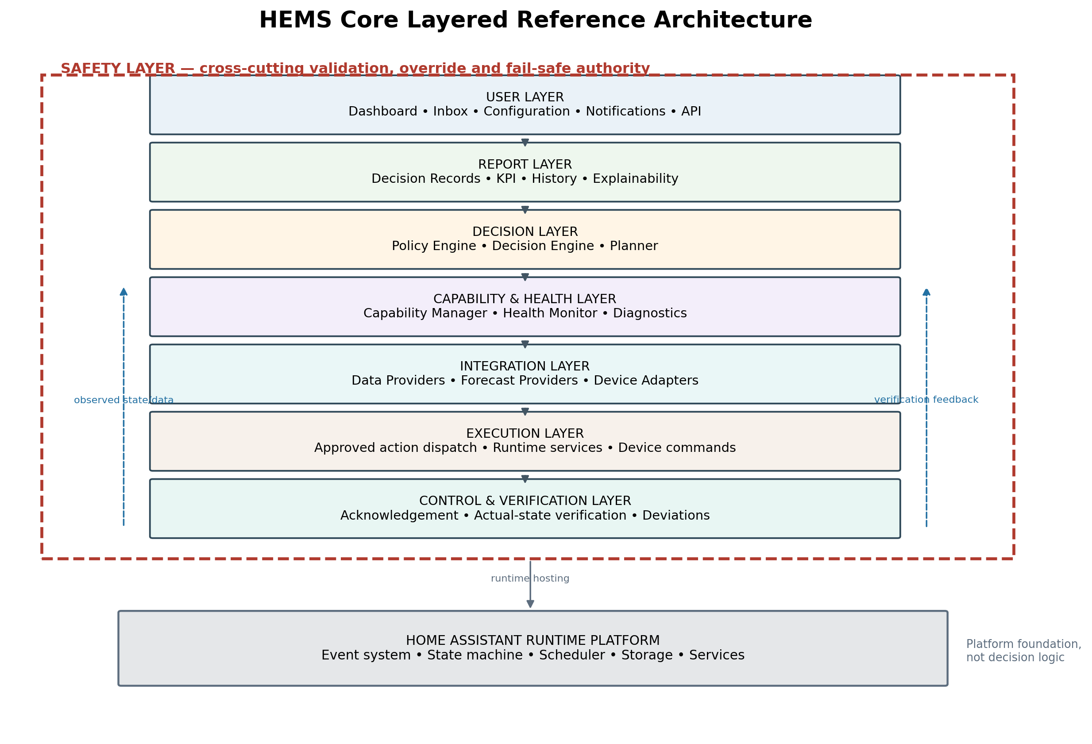
Figure 3.2-1 — Layered reference architecture

3.2.3 Layer Responsibilities
A check mark identifies a permitted or primary responsibility. A cross identifies an explicitly prohibited responsibility. Safety may validate or block functions across the architecture, but it does not perform energy optimisation. Reporting may observe all layers, but it never controls them.
Responsibility | User | Report | Decision | C&H | Integration | Execution | C&V | Safety
User interaction and intent | ✓ | ✕ | ✕ | ✕ | ✕ | ✕ | ✕ | ✕
Policy/configuration input | ✓ | ✕ | ✓ | ✕ | ✕ | ✕ | ✕ | ✓
Collect and normalize data | ✕ | ✕ | ✕ | ✕ | ✓ | ✕ | ✕ | ✕
Assess health/data quality | ✕ | ✕ | ✕ | ✓ | ✕ | ✕ | ✓ | ✓
Determine strategy | ✕ | ✕ | ✓ | ✕ | ✕ | ✕ | ✕ | ✓
Plan stable operating mode | ✕ | ✕ | ✓ | ✕ | ✕ | ✕ | ✕ | ✓
Validate/block unsafe action | ✕ | ✕ | ✕ | ✕ | ✕ | ✕ | ✕ | ✓
Dispatch approved command | ✕ | ✕ | ✕ | ✕ | ✕ | ✓ | ✕ | ✓
Verify expected vs actual | ✕ | ✕ | ✕ | ✓ | ✓ | ✕ | ✓ | ✓
Record decisions and audit | ✕ | ✓ | ✕ | ✕ | ✕ | ✕ | ✕ | ✕
Show KPI/history/explanation | ✓ | ✓ | ✕ | ✕ | ✕ | ✕ | ✕ | ✕

3.2.4 Layer Definitions

3.2.4.1 User Layer
Captures user intent and presents system information through dashboards, configuration, inbox items, notifications and public APIs.
Not responsible for: making energy decisions or directly controlling devices.

3.2.4.2 Report Layer
Creates Decision Records, audit events, KPI data, explainability views and history. It may observe every layer through events and records.
Not responsible for: changing planner state, initiating retries, validating safety or issuing commands.

3.2.4.3 Decision Layer
Contains the Policy Engine, Decision Engine and Planner. It selects the strategy and converts it into a stable proposed action using hysteresis, debounce and minimum mode duration.
Not responsible for: direct hardware access, execution verification or safety override.

3.2.4.4 Capability & Health Layer
Assesses integration health, data freshness, consistency and available functions. It assigns the Full, Advanced, Basic or Limited capability level.
Not responsible for: energy optimisation or device control.

3.2.4.5 Integration Layer
Normalizes external observations and exposes provider/device capabilities through adapters.
Not responsible for: energy strategy or autonomous operating-mode selection.

3.2.4.6 Execution Layer
Translates a safety-approved action contract into a runtime service call or device command and returns execution evidence.
Not responsible for: selecting a different strategy when execution fails.

3.2.4.7 Control & Verification Layer
Compares the requested and expected result with acknowledgement and observed device state. It reports success, timeout or deviation and provides feedback to Decision, Capability & Health, Safety and Reporting.
Not responsible for: taking a new optimisation decision or silently retrying without policy and safety approval.

3.2.4.8 Home Assistant Runtime Platform
Provides the event system, state machine, scheduler, storage and service mechanisms used by the HEMS Core implementation.
Not responsible for: HEMS policies, energy decisions or architectural responsibilities.

3.2.5 Safety Layer
The Safety Layer is the only cross-cutting layer. Every action must be validated immediately before execution. Safety may approve, constrain, delay, replace or reject an action. It protects people, installation integrity, battery and connected equipment and activates a predefined fail-safe state when normal operation cannot be validated.
- Safety validation is authoritative.
- Optimisation and user preference may never overrule Safety.
- Safety decisions and interventions are always reported.
- Safety does not perform financial or comfort optimisation.

3.2.6 Communication and Dependency Rules
- Functional modules communicate through explicit interfaces, events and immutable decision records.
- No User, Report, Decision or Capability module may call a physical device directly.
- The Report Layer may subscribe to all relevant events but may not issue operational commands.
- Execution accepts only a current Safety-approved action contract.
- Control & Verification receives the expected result and obtains actual-state evidence through normalized integration data.
- Integration adapters contain no energy strategy.
- Home Assistant entities and services are implementation details behind interfaces, not architectural contracts.
- Any exception requires an approved Architecture Decision Record.

3.2.7 Information Flow and Closed-loop Control
The primary control path is: collect data → assess health and capability → determine strategy → plan stable action → validate safety → execute → verify actual result → feed back → report. A command is not complete when it has merely been sent; it is complete only after successful verification.

3.2.8 Component View
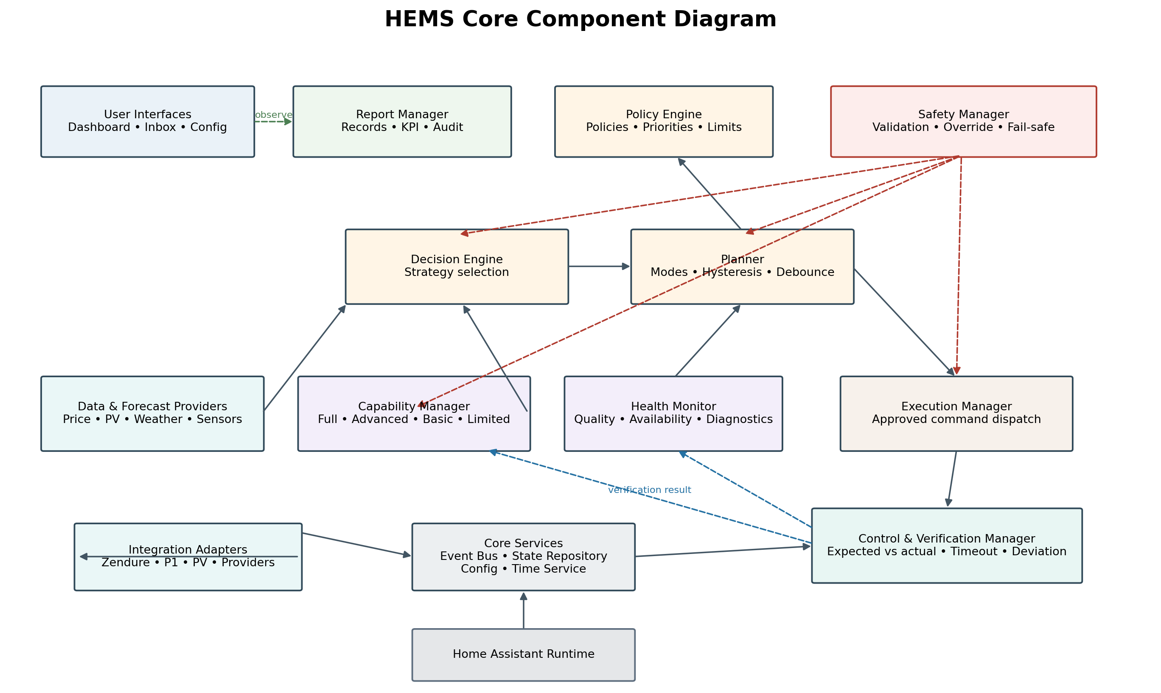
Figure 3.2-2 — HEMS Core modules and principal dependencies
Core Services provide shared infrastructure such as the internal Event Bus, State Repository, Configuration Manager and Time Service. They contain no energy strategy and do not bypass layer boundaries.

3.2.9 Complete Energy Decision Sequence
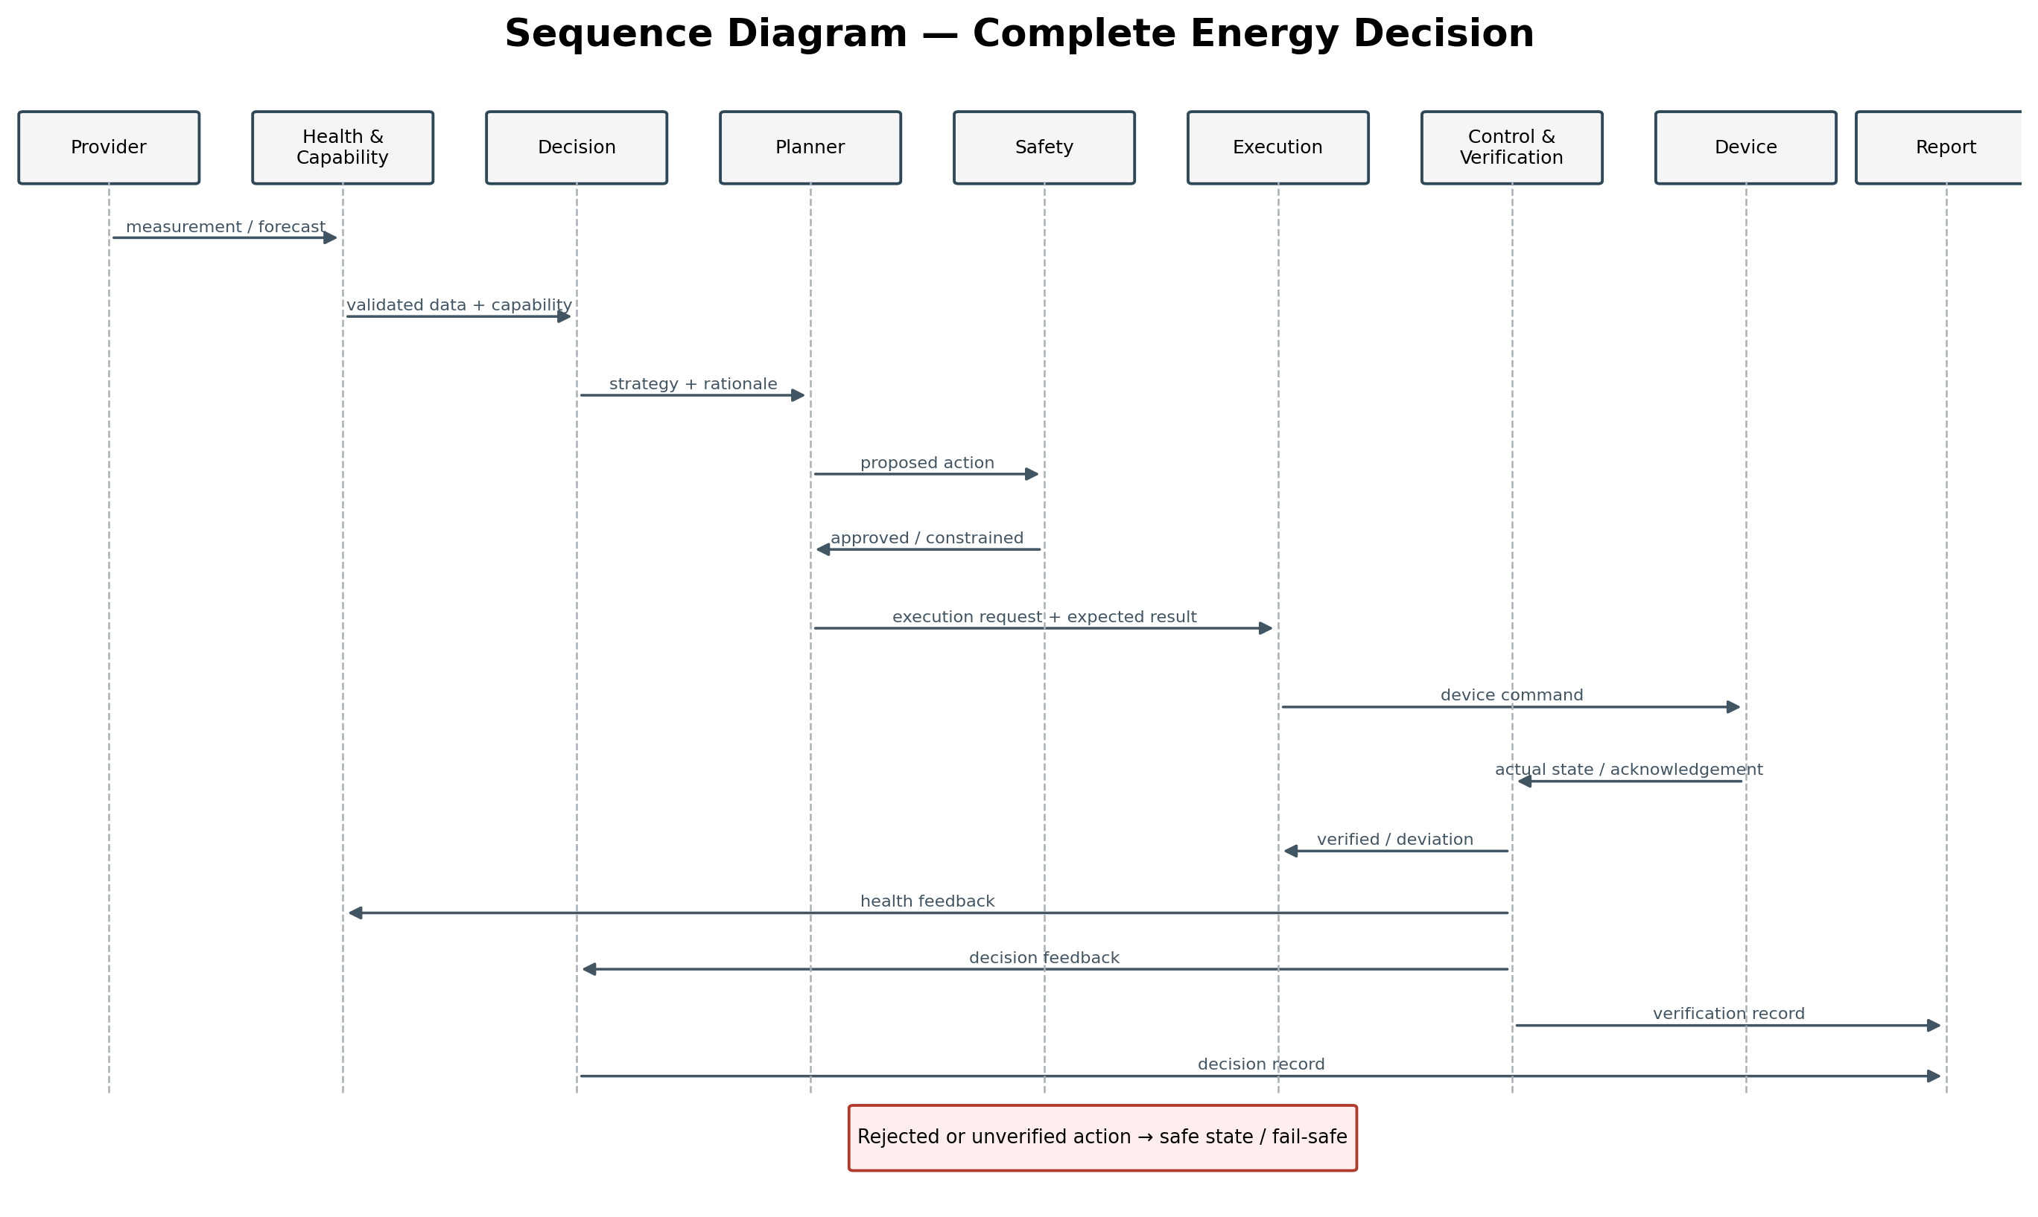
Figure 3.2-3 — End-to-end decision, execution and verification sequence
Every significant decision receives a correlation identifier that links source data, policy context, Safety outcome, execution evidence, verification result and Decision Record.

3.2.10 Planner State Model
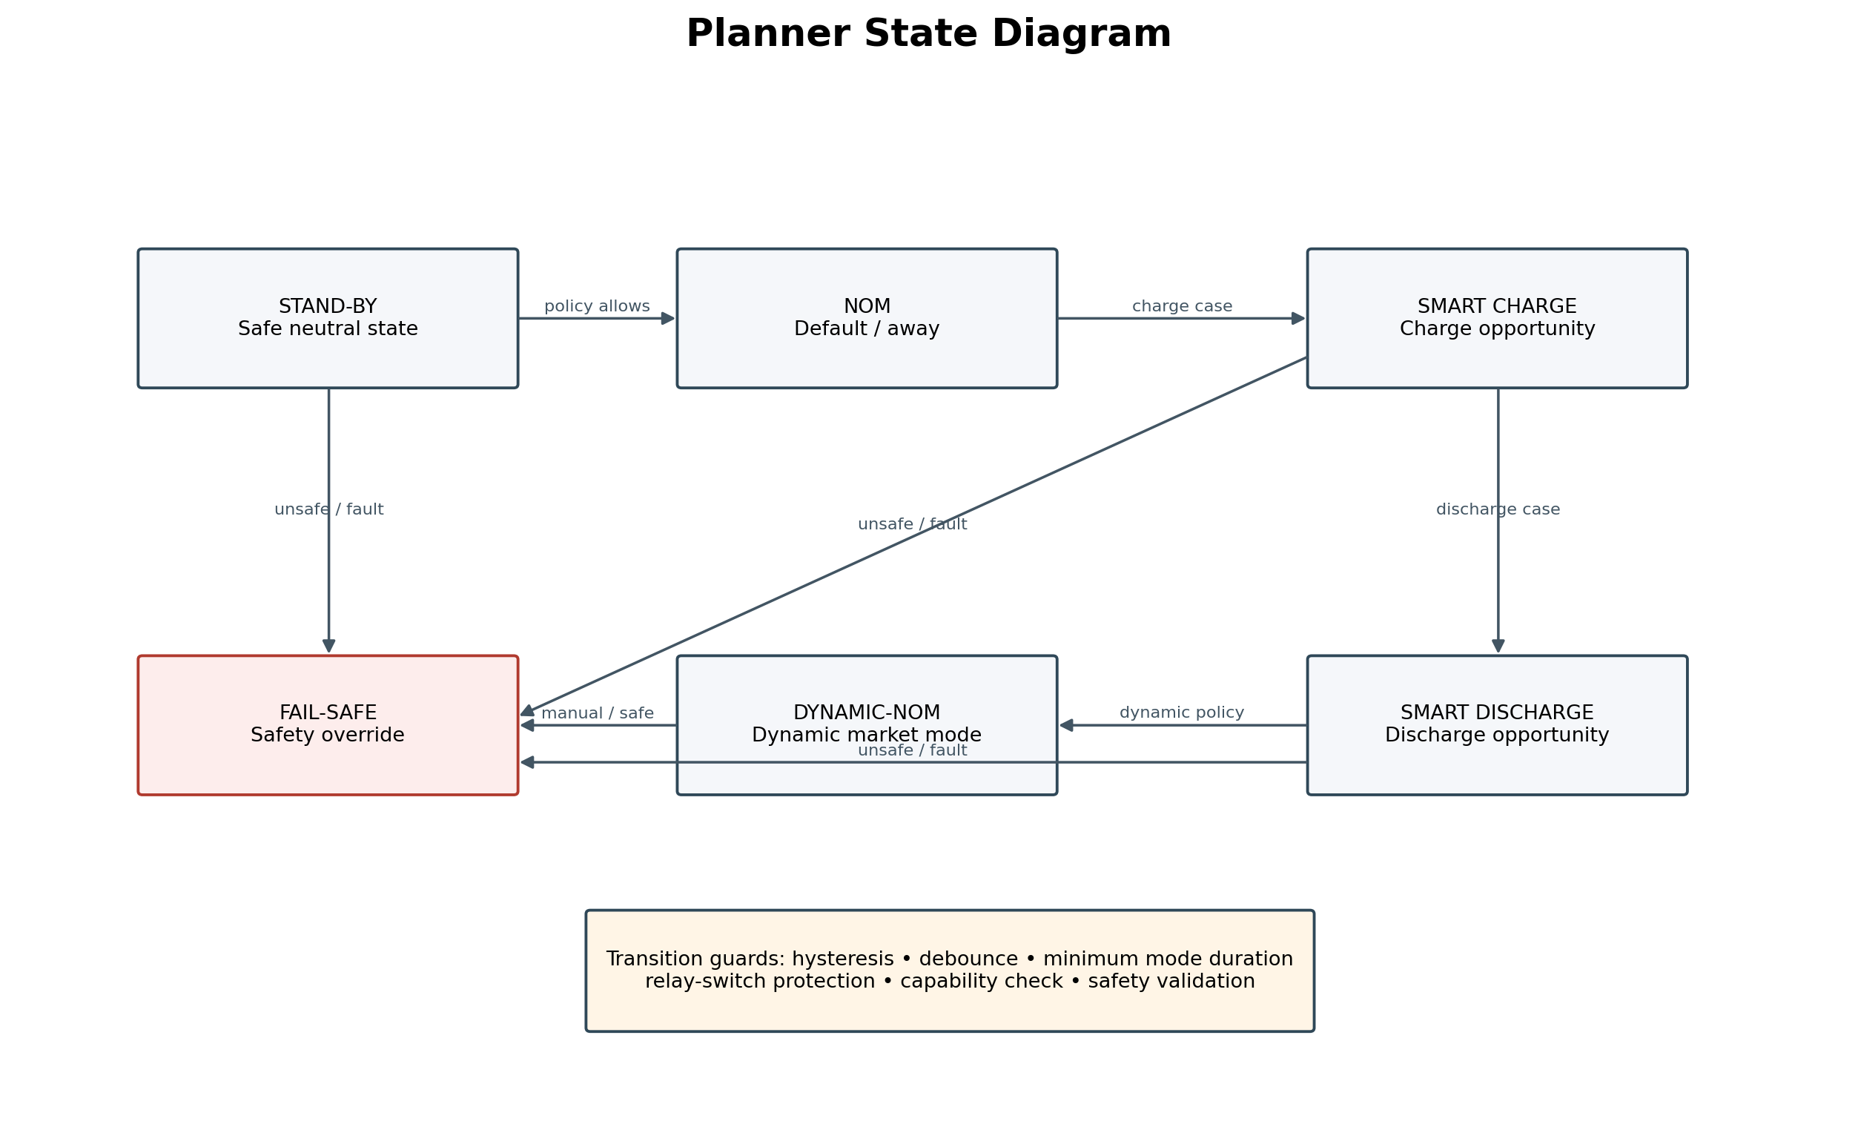
Figure 3.2-4 — Planner modes and guarded transitions
The Planner does not chase the instantaneous optimum. Transitions are guarded by hysteresis, debounce, minimum mode duration, capability checks, Safety validation and relay-switch protection. The estimated Zendure switching count is both a control input and a monitoring KPI.

3.2.11 Module Interface Overview
Interfaces are logical contracts. Their implementation may use Home Assistant events, entities, services, scripts or internal data structures, provided that the contract, ownership and direction remain unchanged.
Interface | Producer | Consumer | Minimum payload | Rule
I-DATA | Providers / Adapters | Capability & Health | value, unit, timestamp, source, quality | Read-only normalized observation
I-HEALTH | Health Monitor | Capability, Safety, Report | component, status, severity, age, diagnostics | No optimisation
I-CAPABILITY | Capability Manager | Decision, Planner, User | level, available functions, restrictions, reasons | Full / Advanced / Basic / Limited
I-POLICY | User / Policy Engine | Decision, Planner, Safety | priority, limits, preference, validity | Explicit policy contract
I-DECISION | Decision Engine | Planner, Report | strategy, reason, confidence, alternatives, validity | No device command
I-PLAN | Planner | Safety, Report | requested mode, guards, timing, expected result | Stable action proposal
I-SAFETY | Safety Manager | Planner, Execution, Report | approved/rejected, constraints, alternative, reason | Authoritative result
I-EXECUTE | Execution Manager | Adapter / Runtime | command, target, correlation ID, timeout | Idempotent request
I-EVIDENCE | Adapter / Integration | Control & Verification | acknowledgement, actual state, timestamp, raw result | Raw execution evidence
I-VERIFY | Control & Verification | Decision, Health, Safety, Report | correlation ID, expected, actual, status, deviation | Authoritative verification result
I-REPORT | All modules | Report Layer | event type, correlation ID, context, version | Append-only audit event

3.2.12 Error Handling and Fail-safe Behaviour
Error handling follows progressive degradation. Failure of an optimisation input must not automatically remove safe operation. Each fault is detected, classified, contained, reflected in capability and recorded before the next decision cycle.
Detection and classification: The Health Monitor detects stale data, unavailable integrations, inconsistent values, execution timeouts and actual-state deviations.
Containment: The affected provider, adapter or function is isolated while healthy functions remain available.
Capability degradation: The Capability Manager disables functions whose required dependencies are unavailable and publishes the new capability level.
Safe action selection: Safety selects the predefined safe state when no normal action can be validated. Stand-by is the preferred neutral state unless a device-specific rule requires another state.
Execution verification: A successful service call is only acknowledgement. Control & Verification must confirm the actual state within the configured timeout and tolerance.
Retry control: Retries are bounded, idempotent and require explicit retry policy plus renewed Safety validation. Verification never retries silently.
Recovery: Normal capability returns only after stable healthy observations for a configured recovery period, preventing oscillation.
Auditability: Faults, degradations, interventions, retries, recoveries and unresolved deviations are stored with timestamps, reason, responsible module and software/configuration version.
Fault class | Example | Required response | Permitted operation
Warning | Non-critical forecast missing | Record and reduce confidence | Continue if safe dependencies remain
Degraded | Price or forecast provider unavailable | Lower capability and apply fallback policy | Basic or Limited operation
Execution fault | Command timeout or state deviation | Stop after retry limit; select safe state | No further optimisation command
Safety critical | Unsafe battery state or invalid limits | Immediate block/override and alert | Only predefined fail-safe action
System integrity | Corrupt configuration or inconsistent core state | Freeze optimisation and preserve evidence | Stand-by / read-only monitoring

3.2.13 Non-functional Requirements
The following requirements apply to the architecture as a whole. Quantitative thresholds are defined in implementation and validation specifications, but the architectural mechanism is mandatory.
Attribute | Requirement | Architecture mechanism | Verification
Performance | Decision processing must complete within the applicable market/control interval without overloading the host. | Event-driven evaluation, bounded calculations, cached normalized input. | Latency, CPU and memory measurements on target hardware.
Reliability | A single provider or adapter failure must not crash HEMS Core or erase the last safe state. | Isolation, timeout, idempotency, persistent state and progressive degradation. | Fault-injection and restart tests.
Safety | No hardware action may occur without current Safety validation. | Independent Safety authority, hard limits and fail-safe states. | Boundary and unsafe-condition tests.
Availability | Safe monitoring/control remains available when optimisation dependencies fail. | Capability levels and fallback policies. | Provider outage scenarios.
Explainability | Every significant decision must be reconstructable. | Decision Records, correlation IDs, alternatives, expected and actual result. | Audit completeness tests.
Extensibility | New devices/providers can be added without changing decision-core internals. | Stable provider and adapter contracts. | Mock adapter/provider conformance test.
Maintainability | Code, configuration and documentation use consistent terminology and remain versioned. | Modular packages, naming rules, Git source of truth, diagnostics. | Code and documentation review.
Testability | Core logic is testable without physical devices. | Pure decision functions and simulated providers/adapters. | Automated unit, integration and scenario tests.
Security | Secrets and credentials are never stored in the repository or exposed in reports. | Secret storage, least privilege, redaction and restricted interfaces. | Secret scan and permission review.
Data integrity | Decisions use timestamped, attributed and quality-assessed data. | Normalized data contract and freshness thresholds. | Missing, stale and contradictory-data tests.
Clarity | Architecture, interfaces, code and documentation must be understandable and use one vocabulary. | Explicit responsibility boundaries and Clarity Above Cleverness. | Architecture and terminology review.

3.2.14 Architecture Conformance
An implementation conforms only when it preserves the defined responsibility boundaries, routes every hardware action through Safety validation and Control & Verification, records relevant decisions through the Report Layer and supports controlled degradation. Convenience automations that bypass these contracts are outside HEMS Core.

3.2.15 Architectural Constitution
The following rules are normative. They may be changed only through an explicit, approved Architecture Decision Record (ADR).
- Each module has one primary responsibility.
- Only the Safety Layer is cross-cutting.
- The Report Layer is strictly observing and non-controlling.
- No module outside Integration and Execution may access device-specific runtime interfaces directly.
- Every important action is verified by Control & Verification before completion.
- Every significant energy decision is reproducible and explainable.
- New functionality is introduced through modules, providers or adapters rather than architectural bypasses.
- Home Assistant is a runtime platform and not part of the HEMS decision logic.
- Clarity is preferred over cleverness unless measurable necessity justifies complexity.

3.2.16 Future Extensibility
New devices, energy contracts, forecast providers, optimisation algorithms and runtime platforms are added through stable interfaces. The architecture itself should remain unchanged unless a new requirement cannot be satisfied without violating the Architectural Constitution.

3.3 Canonical Domain Models
Status: Approved. Architecture Decision Record ADR-008 is accepted and normative for HEMS Core.

3.3.1 Purpose
Canonical Domain Models define the stable internal language of HEMS Core. External systems may use different formats, units, resolutions and terminology. Integration adapters translate those source-specific representations into canonical, platform-independent objects before other HEMS Core modules may consume them.
External implementations change; canonical domain models remain stable.

3.3.2 Architectural Position
The canonical-model boundary is located between Integration Adapters and the consumers of normalized data. Canonical Domain Models are contracts, not an active decision-making layer.
- External source or device
- Integration Adapter
- Canonical Domain Model
- Capability & Health assessment
- Decision Context
- Decision Layer

3.3.3 Architectural Question
How are energy, market, grid, device, forecast, policy and health concepts represented consistently and independently of suppliers, devices and runtime platforms?

3.3.4 Canonical Models
Energy Model: Represents current and historical energy flows, including household consumption, PV production, grid import, grid export, battery charging and battery discharging. Power and energy are separate concepts and every value has an explicit unit and direction.
Market Model: Represents the economic value of energy for a defined interval. It may include import price, export value, supplier components, taxes, negative prices and contract-specific components. It is not tied to hourly or quarter-hourly pricing.
Grid Tariff Model: Represents fixed, time-block, capacity, peak-dependent, congestion-related, seasonal or regional grid charges. The model supports any number of tariff bands and must not assume that a future Dutch design contains exactly five blocks.
Effective Cost Model: Combines applicable market, supplier, tax and grid components into an effective import cost and export value for optimization, while retaining every underlying component for explainability and audit.
Time Interval Model: Provides start, end, time zone, resolution, validity, source and quality metadata. HEMS Core reasons over generic intervals rather than hard-coded hours or quarter-hours. Fixed and irregular intervals are both valid.
Battery Model: Represents State of Charge, current operating state, supported abstract modes, availability, limits, capability, health, last verified state and estimated relay-switch count. It contains no vendor-specific entity names.
Grid Model: Represents physical grid import/export, connection limits, phase information where relevant, availability and operational congestion signals. Physical grid state remains separate from financial grid tariffs.
Forecast Model: Represents PV, load, price and tariff forecasts with forecast interval, publication time, confidence, uncertainty, quality and model version.
Policy Model: Represents normalized policies independent of YAML, dashboards, databases or Home Assistant helpers. Each policy has identity, category, scope, priority, hard-or-soft classification, validity, source and version.
Capability & Health Model: Represents what the system can currently offer and how reliable its dependencies are, including stale data, unavailable adapters, degraded inputs, verification faults and supported actions.

3.3.5 Normalization Rules
- Adapters normalize units, time zones, interval boundaries, direction, precision, terminology and quality status.
- Raw provider fields and Home Assistant entity names must not enter the Decision Layer.
- Ambiguous signed values must be translated into explicit direction and positive magnitude.
- Missing, stale, contradictory or unsupported data must be represented explicitly and never silently inferred.
- The original source, observation time, receipt time and transformation version remain traceable.

3.3.6 Cost Composition
Optimization may use a composed effective cost, but component information must never be discarded. A decision record must be able to explain whether a result was driven by the energy-market price, supplier costs, taxes, grid charges or another applicable component.
Canonical field | Example | Meaning
interval | 18:00–18:15 Europe/Amsterdam | Generic validity period
effective_import_cost | 0.387 EUR/kWh | Total cost used by optimization
components.market | 0.105 EUR/kWh | Energy-market component
components.grid | 0.140 EUR/kWh | Dynamic grid-tariff component
quality | valid | Data-quality state
schema_version | 1.0 | Canonical contract version

3.3.7 Versioning
- Every canonical model has an explicit schema name and version.
- Existing field meaning may not change silently.
- Backward-compatible extension is preferred.
- Removal or incompatible change requires a migration path and an approved ADR.
- Adapters declare the model versions they produce; consumers declare the versions they accept.

3.3.8 Relationship with Decision Context
The Context Builder creates one immutable DecisionContext by selecting and combining relevant canonical objects. It does not redefine or reinterpret the underlying domain models. One decision transaction therefore operates on one timestamped and traceable canonical snapshot.

3.3.9 Failure and Degradation Behaviour
Condition | Required behaviour
Unknown tariff component | Preserve as an extensible component; do not silently discard it.
Overlapping intervals | Mark as conflicting and prevent unqualified use.
Missing interval | Represent explicitly as missing data.
Missing time zone | Do not assume local time.
Unknown unit or direction | Do not publish as normalized data.
Stale source data | Propagate quality status to Capability & Health and Decision Context.
Incompatible schema version | Reject processing in a controlled and reportable manner.
Changed market or tariff structure | Extend adapter/model contracts; do not modify Decision Engine internals.

3.3.10 Normative Architecture Rules
- HEMS Core uses Canonical Domain Models for internal cross-module data exchange.
- External formats terminate at the adapter boundary.
- The Decision Layer knows no supplier, manufacturer, entity name or configuration format.
- Time is represented through generic intervals, not hard-coded hourly or quarter-hourly structures.
- Market price and grid tariff remain separate domain concepts.
- Effective Cost may combine components without losing component-level traceability.
- All values have explicit units, direction, time and quality metadata.
- Canonical objects are immutable once published for a transaction.
- New market structures, tariff resolutions, providers or devices must not require changes to Decision Engine internals.
- Country-specific rules enter through adapters and policies, not through hard-coded generic-core logic.

3.3.11 ADR-008 Decision
ADR-008 — Canonical Domain Models
Status: Accepted
Decision: HEMS Core introduces Canonical Domain Models as the stable internal abstraction between external integrations and the decision core.
Changes in market structures, tariff resolutions, providers or devices must be absorbed by adapters and canonical models, not by the decision core.

Chapter Status
Chapter | Status | Release decision
Chapter 1 — Document Information | Approved | Included in RC1
Chapter 2 — Purpose & Vision | Approved with Design Manifest added | Review wording in RC1
Chapter 3.1 — Architecture Vision | Approved | Included in RC1
Chapter 3.2 — Architecture Overview | Release Candidate | Decision Layer approved; remaining architecture review continues
Chapter 3.3 — Canonical Domain Models | Approved | ADR-008 accepted; included in RC2

