Project 1: Static Foundations
Feedback for My Favorite MTG Cards
Student: Bronson Chow Course: CSC 436, Fall 2026 Reviewed at: 3c55fcb
Repo: github.com/BronsonChow/bronsonchow.github.io Page: csc436/436_lab1.html
Submitted URL: bchow.netlify.app/csc436/436_lab1.html (private) Public copy: bronsonchow.github.io/csc436/436_lab1.html

Grade: 65 / 100
Category | Points | Earned | One line
Semantic HTML | 20 | 10 | One semantic element on the page (nav), four h1s, an invalid xmlns
CSS layout | 25 | 20 | Real Flexbox for the cards, custom properties, a proper dark theme; the last card stretches
Responsive design | 15 | 12 | No horizontal scroll, cards wrap 2 / 2 / 3; no media query of your own
JavaScript interaction | 15 | 11 | API fetch with localStorage caching is the most ambitious JS in the class; it 404s on every load by design
Repository and deployment | 15 | 6 | Submitted URL is private (401); README is for a different course; four commits, all on the due date
Content and polish | 10 | 6 | Real cards, real taste, real alt text; two sentences of copy and a deliberate broken entry
Total | 100 | 65 | Strong JavaScript instincts on a page that skips the HTML the brief was testing.

How this review was made
Your instructor reviewed this project with Claude (Anthropic's AI) as a second set of eyes. Claude cloned the repo, read the submitted page, its stylesheet and script, and the shared nav, footer and settings scripts, loaded the page at phone, tablet and desktop widths, ran the W3C validator, read the console and localStorage, and clicked the theme toggle. Every note and every point in this document was read and approved by your instructor. Same standard, same rubric, just more time spent looking at your code than one human has in a grading week.
About the reused repo: your instructor approved submitting a page inside your existing personal site. So this review grades the page, its stylesheet and script, and the commits since the project was assigned, not the 160 commits of history before it. The README and live-URL requirements still apply to this project.

The short version
The interesting part of this page is the script. Seven Magic cards pulled from the Scryfall API, cached in localStorage so the second visit is instant, rendered with real card art and the card name as alt text. That is async/await, try/catch, caching, and DOM creation, and it works. Nobody else in the class did a network request.
The rest of the page did not get the same attention. The HTML is five divs. The only semantic element is the nav, and it is injected by a script. There are four h1s, three of them in the footer. The brief's first requirement, three semantic sections and one h1, is not met. The README documents your CSC 225 project and says nothing about this one. And the URL you submitted returns "This site is private" in a private window. The brief says a broken link at grading time means the project is graded on what can be seen. Your GitHub Pages copy of the same repo is public, which is why there is a grade at all. Fix the Netlify setting before Project 2, or submit the GitHub Pages URL.

What Claude measured
Check | Result
Submitted Netlify URL in a private window | HTTP 401, "This site is private. Sign in with an invited Netlify account"
Same page on GitHub Pages | HTTP 200, loads normally
Horizontal scroll at 375 / 768 / 1280 px | None at any width
Cards per row at 375 / 768 / 1280 | 2 / 2 / 3; on phones the last card is twice the width of the others
Console on every load | 1 error (404 for card id test), 16 console.log lines
W3C HTML validator | 1 error: xmlns="fn" on the html element
Semantic elements on the page | nav only (injected). No header, main, section, article, footer
h1 elements | 4 (page title plus General, Credit, Contact in the footer)
Images | 7 cards from the API, all with alt text, plus the logo
@media rules in 436_style.css | 0
localStorage after one visit | 8 cachedCard entries, one of which is a cached 404 error body
Commits touching csc436/ | 4, all on Sep 15 between 1:35 PM and 10:07 PM
README for this project | None. Root README is the CSC 225 API writeup

The page at three widths
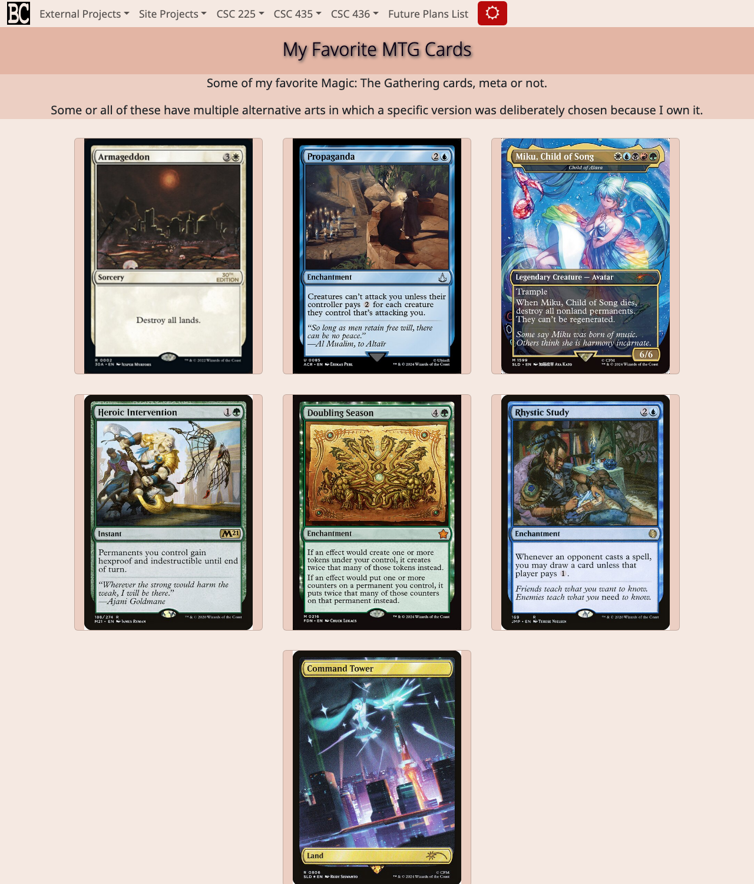
Desktop, 1280px, from the public GitHub Pages copy. Three cards per row, seventh centered alone.
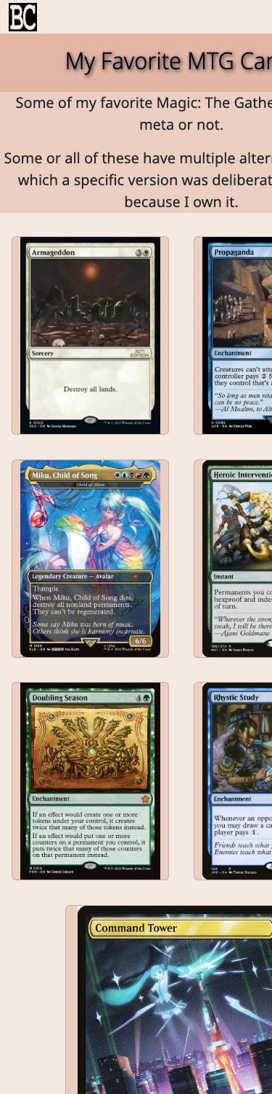  Phone, 375px. Two per row, no horizontal scroll; the last card stretches. | 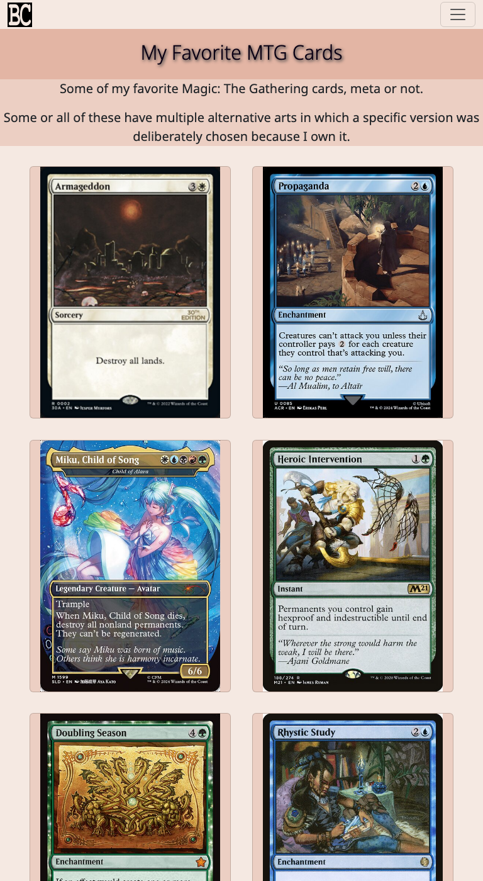  Tablet, 768px. Still two per row; hamburger nav.

Semantic HTML: 10 / 20

What is working
- lang, viewport, a real title, a favicon. Every card image gets the card's name as alt text (436_lab1_script.js line 58), which is exactly right for an image that is the card. The nav is a proper ul > li > a with Bootstrap's aria attributes.

What to change
- The page is five divs. 436_lab1.html lines 25 to 38: div#nav, div.hero-div, div.para-container, div#cardCell, div#footer. The brief asked for at least three distinct content sections using header, nav, main, section, article, footer. The rendered page has one: the nav that navbar.js injects. Everything you need is already there as a class; change the tags. header around the nav mount, main around the content, section for the hero and intro, article for each card (in showCard), footer for the footer mount.
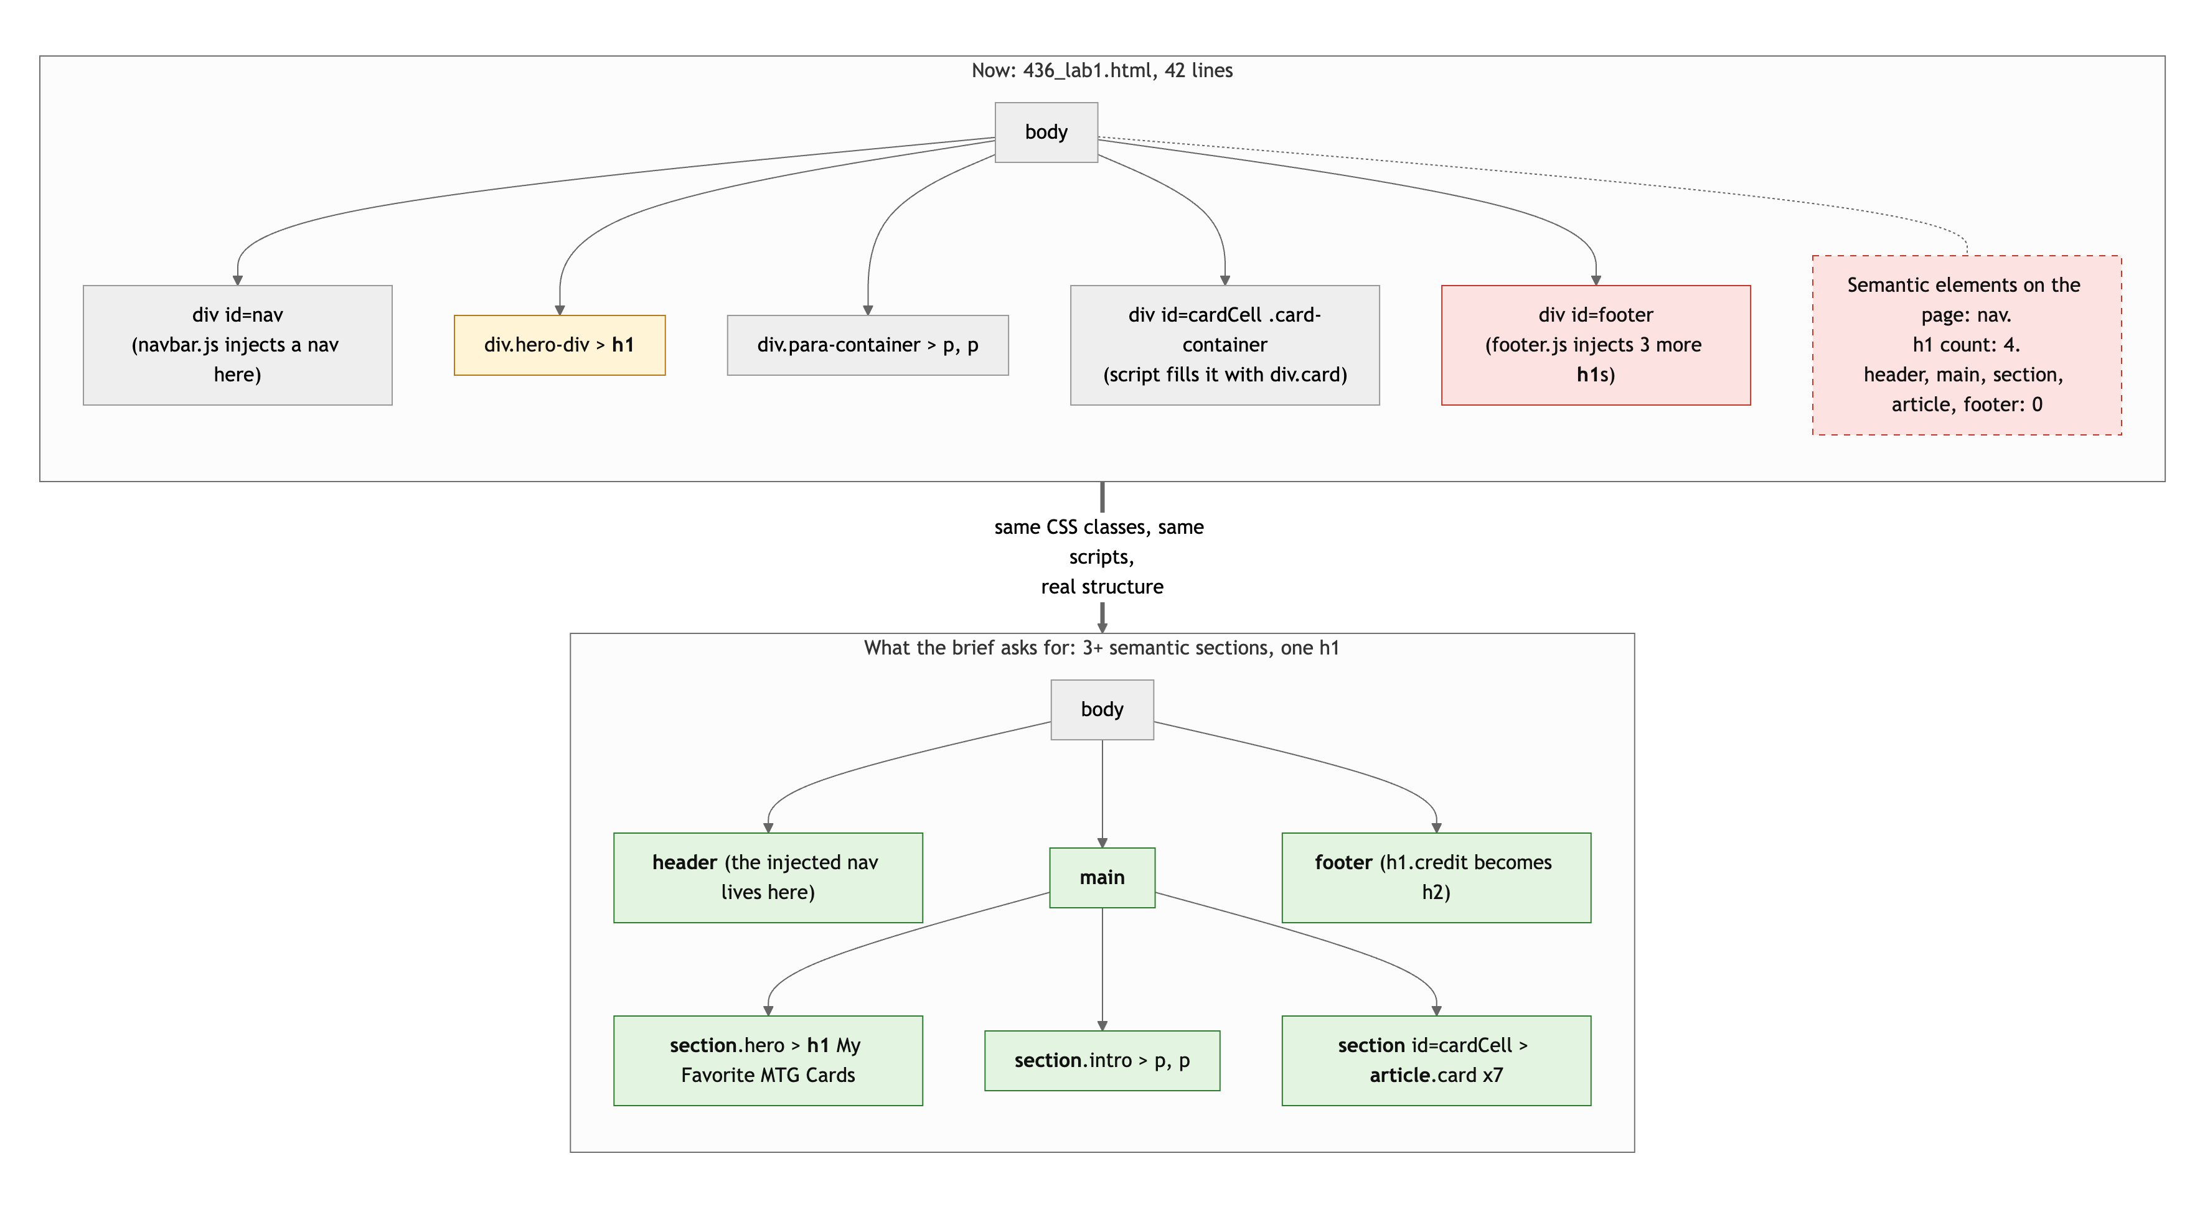
Diagram 1. The page skeleton now (top) and with the semantic elements the brief asks for (bottom).
- Four h1s. The page title (line 28) is correct. Then footer.js adds h1.credit for General, Credit and Contact (footer.js lines 48, 55, 59). Those are h1 because h1.credit has a style rule, not because they are page titles. Make them h2 (or p) and move the style. A page has one h1.
- xmlns="fn" (line 2) is the only validator error, and it is on every page in the site. xmlns is an XHTML namespace declaration, and "fn" is not a namespace. Delete the attribute.
- Six href="#" links in the nav dropdowns. Bootstrap's dropdown pattern, so it is understandable, but role="button" on an anchor is what a button element is for.

CSS layout: 20 / 25

What is working
- Flexbox for the card gallery, yours: flex-wrap, centered, with flex: 1 0 calc(100% / 3) and a max-width cap on each card (436_style.css lines 32 to 44). That is the layout doing real work. Flexbox or Grid satisfies the brief, so no deduction for the missing Grid.
- Custom properties and a real dark theme. Six color tokens in :root, a [data-bs-theme="bc-dark"] block that overrides them with nested rules (lines 134 to 179), and rgb(from var(--main-color-2) r g b / 50%) relative color syntax for the translucent surfaces. That is current CSS, used correctly.

What to change
- The last card stretches. With seven cards and flex: 1 0 calc(100% / 3), the seventh sits alone on its row and flex-grow: 1 widens it to the max-width while the others are narrower. Claude measured 155px for six cards and 320px for the seventh at 375px wide. On tablet and desktop every card hits the 20rem cap, so they match. flex: 0 0 calc(100% / 3) (no grow) or repeat(auto-fit, minmax()) on Grid keeps them uniform.
- * { font-family } (lines 1 to 3) sets the font on every element including icons, which is why Font Awesome needs its own class to win. Put it on body and let inheritance work.
- Bare transition: 0.2s on body and .navbar-brand (lines 21, 129) animates every property. Name the ones you mean.
- h1 { font-size: 1.5rem } then h1.hero-head and h1.credit: three h1 styles is a sign the footer headings should not be h1.

Responsive design: 12 / 15

What is working
- No horizontal scroll at 375, 768 or 1280. The card row wraps from two to three across. Bootstrap collapses the nav to a hamburger under 992px. The hero and paragraphs are fluid.

What to change
- No media query of your own. 436_style.css has zero @media rules. The wrap is an intrinsic pattern, which the brief accepts, but the phone layout is just the desktop layout squeezed: 137px cards are hard to read. One @media (max-width: 600px) that makes cards flex-basis: 50% with less margin, or a min-width query the other way, would make the phone view deliberate.
- The card container has gap: 0.1rem and each card has margin: 1rem. One of those is doing all the work. Pick one.

JavaScript interaction: 11 / 15

What is working
- This is the most ambitious JavaScript in the class. fetchCards (436_lab1_script.js lines 13 to 44) walks a list of Scryfall ids, checks localStorage first, fetches only what is missing, caches the JSON, and showCard builds a div.card with the art. async/await, try/catch, a cache layer, and DOM creation, in sixty lines. Second visit loads instantly. Good.
- The theme toggle (shared userSettings.js and navbar.js) persists to localStorage and swaps the icon. It works; Claude clicked it.

What to change
- The page throws a 404 on every load, on purpose. The id test is in the live card list (line 10) "for testing error handling." The rubric says "no console errors." Test ids belong in a test, not in production.
- The error handling does not handle the error. fetch does not throw on a 404; it resolves with a response whose ok is false. So your catch never runs, the 404's JSON body is written to localStorage as cachedCardtest and stays there forever, the console logs "Card test cached successfully," and showCard silently skips it. The user sees nothing. Check result.ok before caching, and tell the user when a card fails:
const result = await fetch(`https://api.scryfall.com/cards/${cardID}`);
if (!result.ok) throw new Error(`Scryfall returned ${result.status} for ${cardID}`);

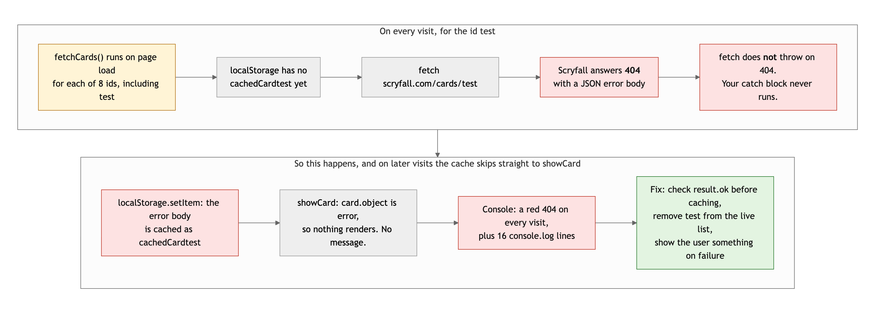
Diagram 2. What actually happens to the test id on every visit, and where the fix goes.
- The new code has no event listener. The brief's interaction "must select elements, listen for an event, and change the page." The fetch runs on load. The only event-driven behavior is the pre-existing theme toggle, wired with an inline onclick="darkMode()" (navbar.js line 71) rather than addEventListener. A "Load more" button, a "shuffle" button, or a filter by color would make this page's own script satisfy the requirement.
- Sixteen console.log lines per visit. Useful while building, noise when shipped. Remove them or gate them behind a debug flag.
- Small, in the shared code: matchMedia("(prefers-color-scheme: bc-dark)") (userSettings.js line 5) is not a valid media query, so it is always false and the OS dark-mode check never fires. The real value is dark.

Repository and deployment: 6 / 15

What is working
- The four commits touching csc436/ are real steps: files added, fetch added, CSS reformatted, footer case added. Each commit also updates verchanges.txt with a version number, which is a habit most professionals do not have. The messages are specific.

What to change
- The submitted URL is private. bchow.netlify.app returns 401 with "This site is private. Sign in with an invited Netlify account to view it." The brief: "Both links must work in a private or incognito browser window. If a link is broken at grading time, the project is graded on what I can see, which may be nothing." Your GitHub Pages deployment of the same repo is public and identical, which is why this was graded at all. Turn off site protection in Netlify (Site configuration, then Access and security), or submit the GitHub Pages URL. Test in a private window before you submit.
- There is no README for this project. The root README is the CSC 225 VocaDB API writeup. The brief requires a README with the project title, a description, how to run it locally, and the live URL. None of those exist for this page. A csc436/README.md is fine.
- All four commits are on September 15. Understandable for a page added to an existing site, but the brief asked for history that shows the project developing over time.

Content and polish: 6 / 10

What is working
- It is real and it is yours: seven cards you own, chosen for the specific printing, with the art pulled live and credited to Scryfall in the footer. The alt text is the card name. The dark theme matches the rest of your site.

What to change
- Two sentences of copy. The brief asked for real content, and a heading plus two lines is the thinnest text in the class. Why these seven? What deck are they in? One sentence per card, shown under the art from the API's oracle_text or your own notes, would turn a grid of images into a page.
- A broken entry shipped on purpose. The test id is a red line in the console on every visit.
- The lone stretched card at the end of the grid looks like a layout bug, because it is one.

Your next three moves
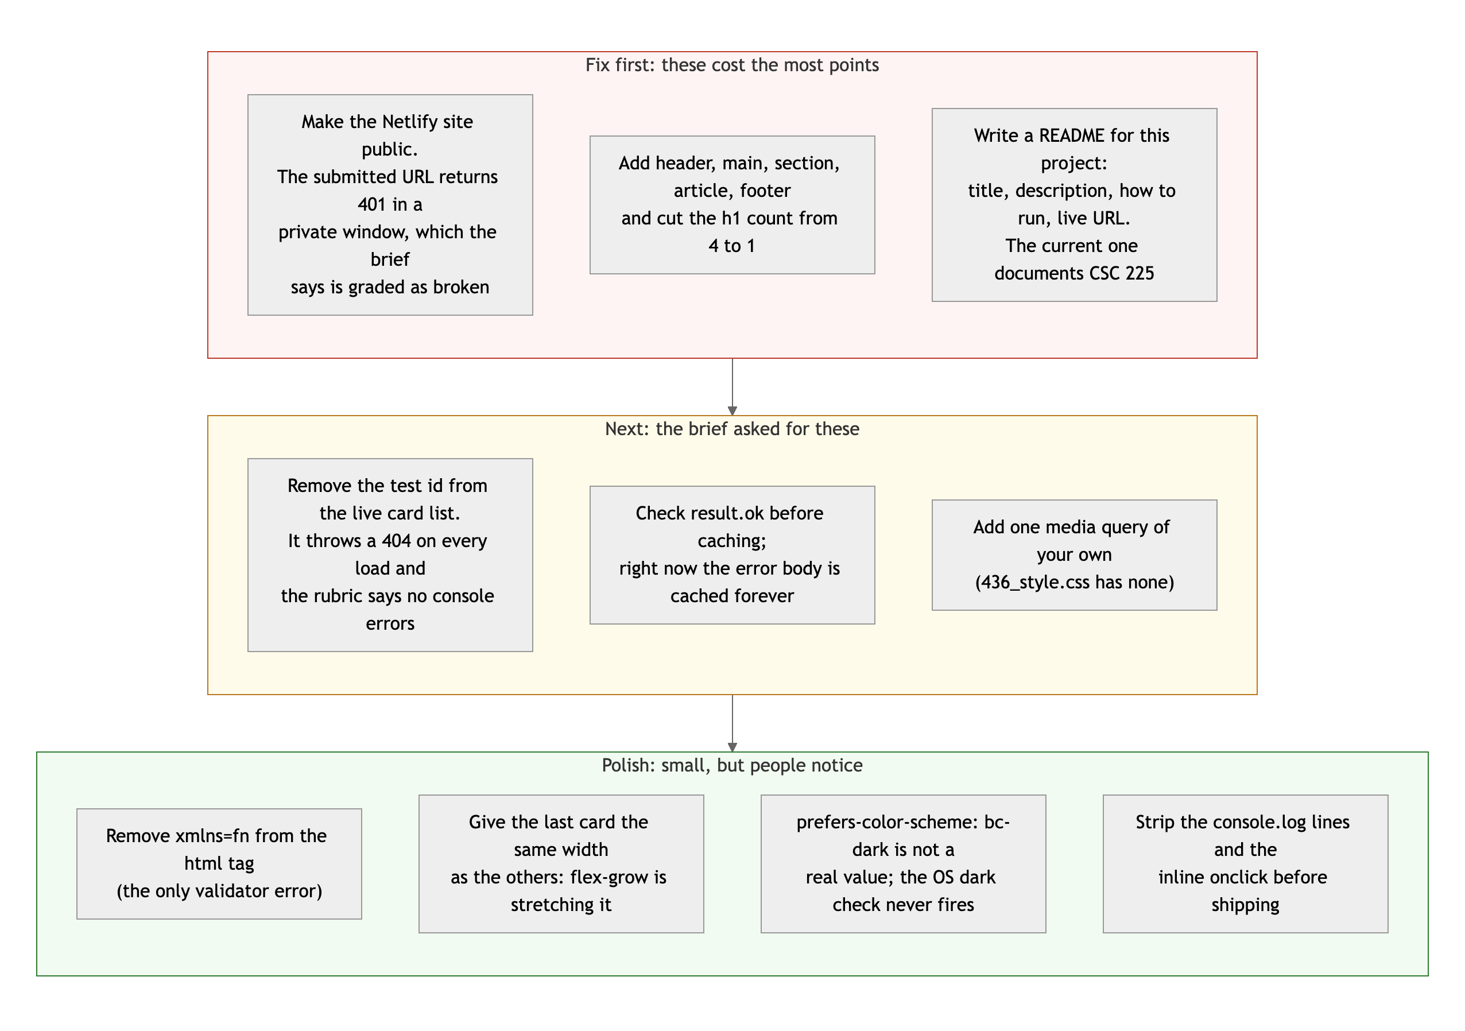
Diagram 3. Priority order. Top row first: it is where the points are.
- Make the site public and test the link in a private window. Five minutes in Netlify settings. This alone was the biggest deduction, and Project 2 has the same rule.
- Fix the skeleton and the footer headings. header, main, three sections, article per card, footer, one h1. Thirty minutes, and it is the first requirement in the brief.
- Finish the error handling. Check result.ok, do not cache failures, remove the test id, and show a message when a card fails. Then the most ambitious script in the class is also a correct one.

You can clearly write JavaScript. This project was checking whether you can also write the HTML underneath it. Next time, do both.
This review lives in a pull request on your repo. It only adds feedback files and does not touch your code. Merge it, close it, or just read it. Questions go to office hours or the Brightspace board.

