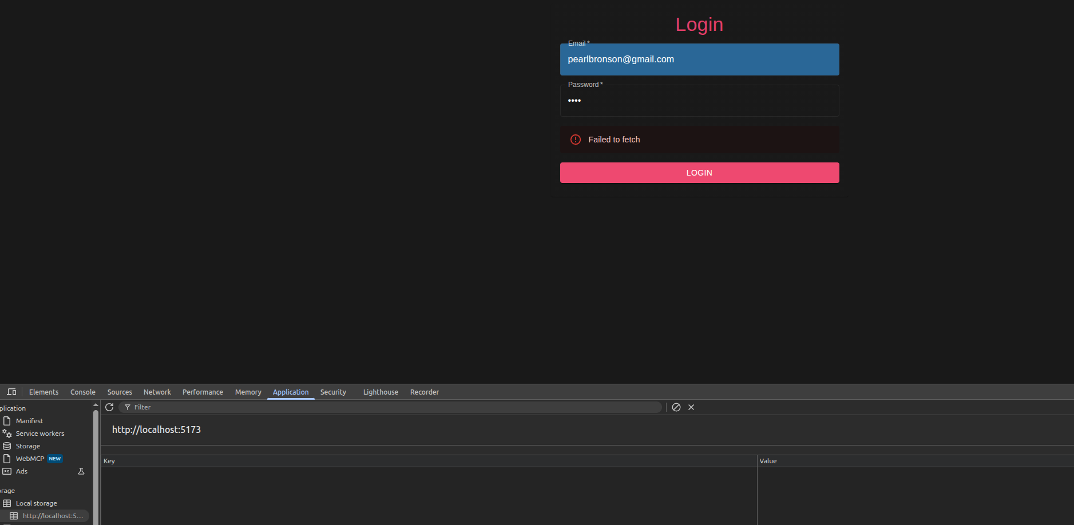
Failed login attempt, no accounts registered.

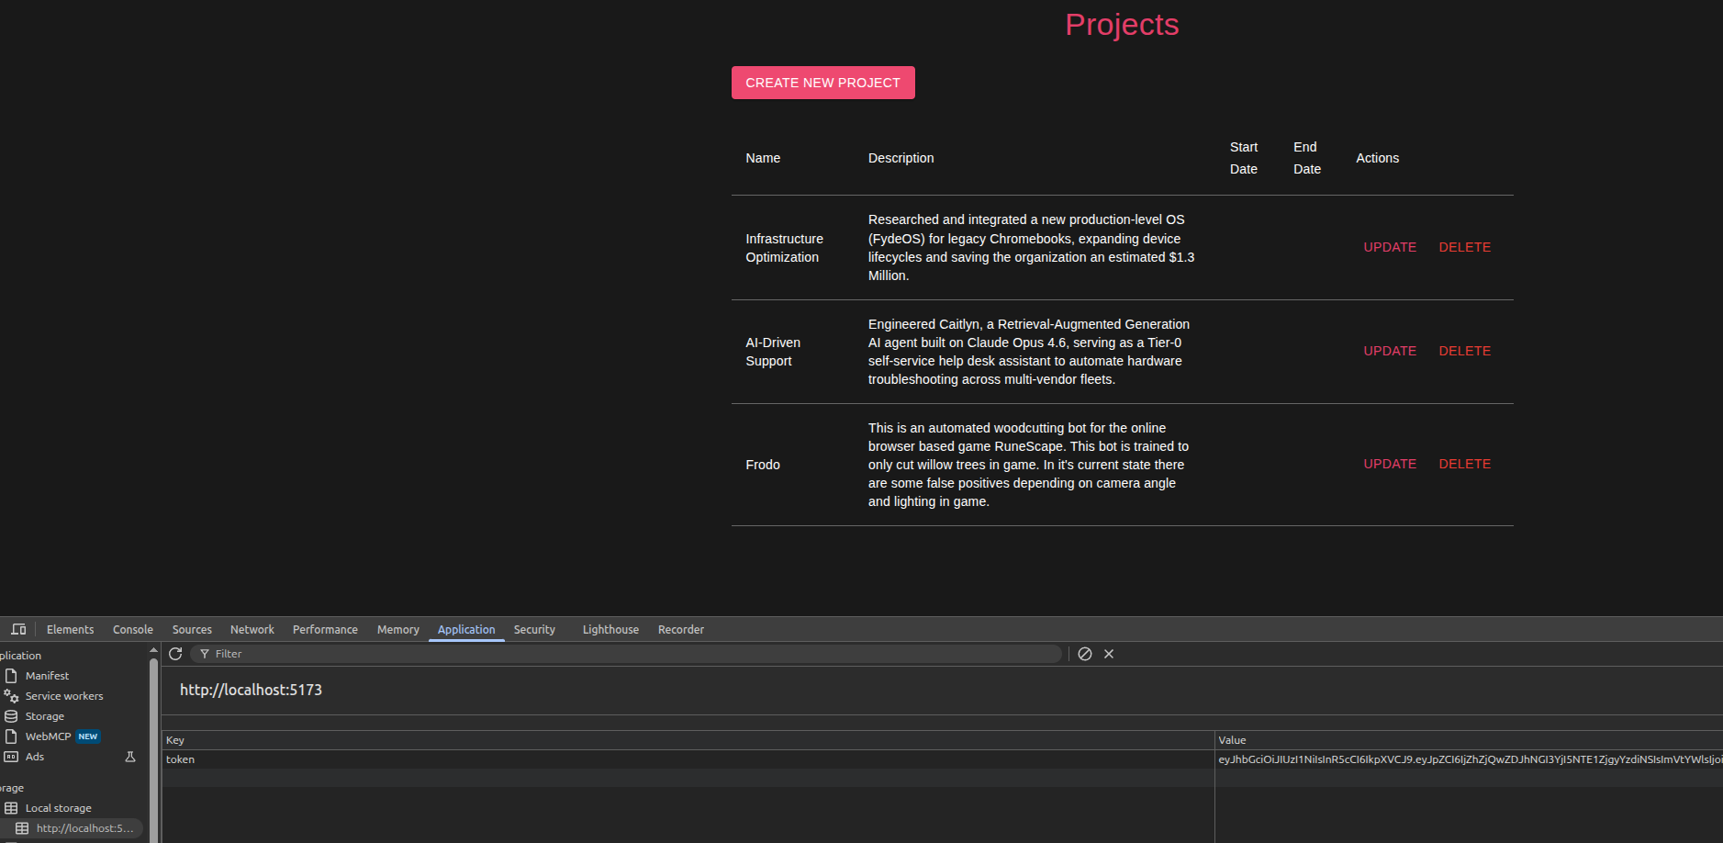
Login with known accounts and viewed projects

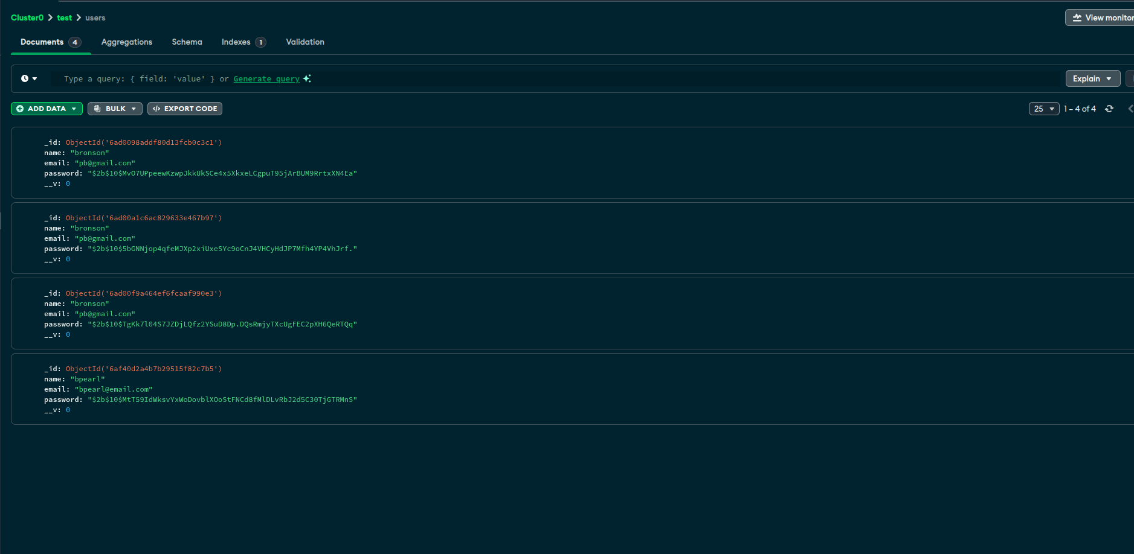
before creating accounts
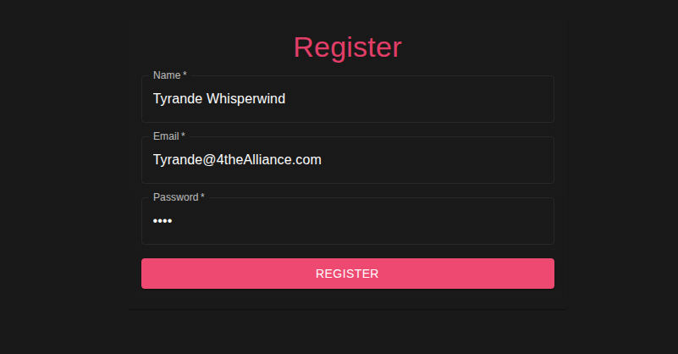
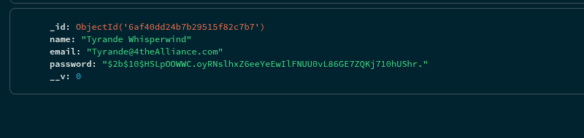
account entered through app and then registered shows up in mongodb

