Your Child

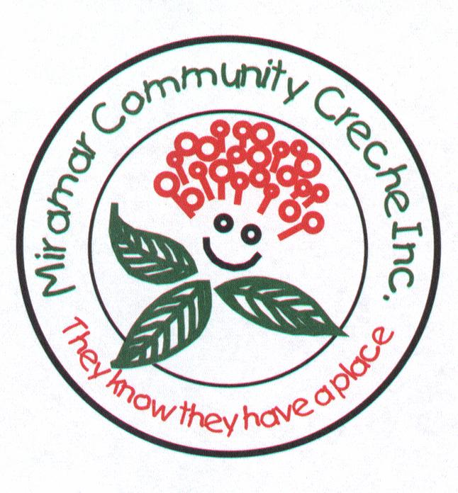

Teaching Staff Parents/Whanau

C.H.I.L.D. CHATs
To encourage Collaboration between Home and
the Individual child’s Learning and Development.

- Do you want an opportunity to participate in a formal
discussion about your child with the Teachers?

- Do you want to share information about your child
and their learning and development?

- Do you want to know about your child’s time at creche,
what they spend their time doing
what their interests at creche are?

The Teachers are available to get together with you to talk about your child.
The Chat will be approx. 20 minutes duration.

The C.H.I.L.D. CHATs can be held either:
- At creche or in your child’s home,
- in the afternoon or in the evening,
depending on your preference.

The Teachers will share your child’s Individual Profile with you.
Parents will be requested to fill out a “CHILD CHAT”
sheet before the get together.

Please let one of the Teachers know if you are interested
in setting up a C.H.I.L.D. CHAT time.

Your Child

Teaching Staff Parents/Whanau

C.H.I.L.D. CHATs
To encourage Collaboration between Home and
the Individual child’s Learning and Development.

- Do you want an opportunity to participate in a formal
discussion about your child with the Teachers?

- Do you want to share information about your child
and their learning and development?

- Do you want to know about your child’s time at creche,
what they spend their time doing
what their interests at creche are?

The Teachers are available to get together with you to talk about your child.
The Chat will be approx. 20 minutes duration.

The C.H.I.L.D. CHATs can be held either:
- At creche or in your child’s home,
- in the afternoon or in the evening,
depending on your preference.

The Teachers will share your child’s Individual Profile with you.
Parents will be requested to fill out a “CHILD CHAT”
sheet before the get together.

Please let one of the Teachers know if you are interested
in setting up a C.H.I.L.D. CHAT time.

