
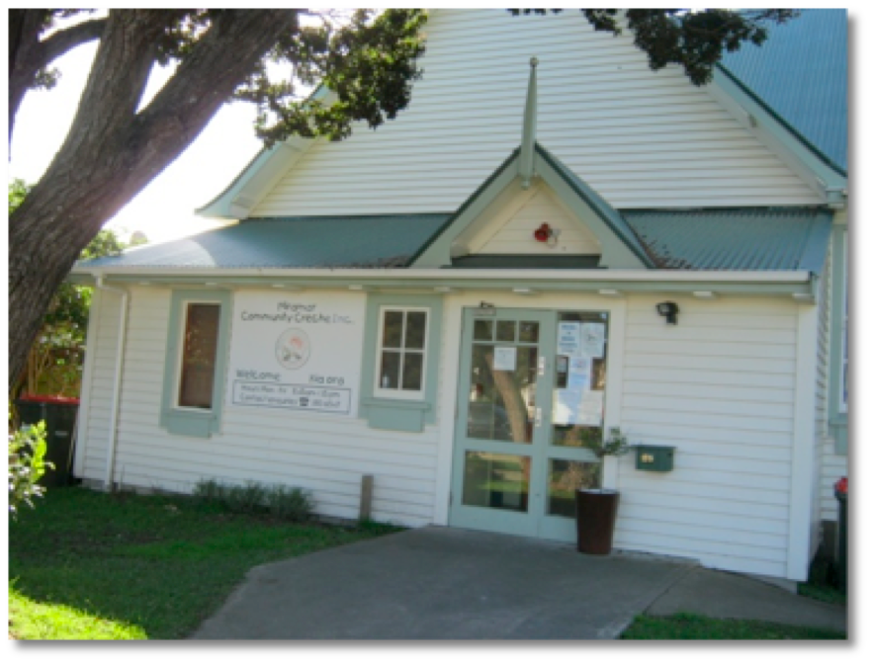


Miramar Community Crèche
29 Chelsea Street
Miramar
Wellington

Phone: 380 6547
Fax: 380 6488
Email: miramar.creche@paradise.com

Enrolment Fee
An enrolment fee of $20.00 is charged per child and will be added to the first invoice issued after your child starts Crèche.
Invoices
Invoices will be issued by the second Friday of each month and should be paid within 7 days of receipt. Please check your child’s Distribution Pocket each time you come to Crèche.
Payment
- Our preference is for the fees to be paid by cheque or internet banking.
- If paying by cheque, please place your payment in the green money box above the Administration Bay, just outside the Crèche office door. Please cross your cheques so they cannot be cashed.
- If paying by internet banking, the Crèche bank account details appear on each invoice.
- If paying by cash, please see Lynda Hopkin, who will issue a signed receipt for your payment. Alternatively you can post your payment to the Miramar Community Crèche, P O Box 15-054, Miramar.
Receipts
Receipts will be issued as requested. If you would rather have one receipt at the end of the financial year (for tax purposes) we are only too happy to do this. Simply request this on your invoice at the end of the financial year.
Overdue Fees
- If you are having difficulty meeting payment please approach the Manager as soon as possible so an arrangement can be made.
- The Manager reserves the right to remove your child’s name from the roll temporarily until overdue balances have been paid.
- The Crèche also reserves the right to use debt collection agencies to recover unpaid fees and to pass any costs of collection on to the debtor.

Welcome

Te Whare Manaaki Tamariki o Te Motu Kairangi

Crèche Fees

Terms and Conditions

These terms and conditions are in place to make it as fair as possible for all parents whose children attend our Crèche.

The Crèche employs a Financial Administrator who deals with all fees and invoice queries. Please telephone:

Carolyn: 934 0346 or
Chris: 380 6547 (Centre Manager)

Session Fees

Fees are payable as soon as your child starts Crèche and will be payable for all sessions that your child is enrolled for including absence due to sickness, holiday or any other reason.

Fees are not payable during the end of year school holidays or public holidays when Crèche is closed.

Crèche fees are payable even when parents are spending time at the Crèche settling in their children.

Creche fees are payable if a Teacher Only Day should fall on a day that the crèche would normally be open.

Absences of more than 3 weeks

Please refer to our Policy “Crèche Fees”. The Ministry of Education ceases to provide funding for any child that is absent from Crèche for more than 3 weeks.

To limit the negative financial impact on the Crèche, if you wish your child’s space to remain open on the roll you are required to pay your child’s usual Crèche fees for their entire absence and in addition to this you are also required to pay the Ministry of Education funding rate in respect of your child for the remainder of their absence (beyond 3 weeks).

Alternatively, you may request that your child be removed from the roll from the beginning of their absence and once your child is available to return to Crèche their name will be added to the Waiting List. You are required to give at least two weeks notice of any such intended absence.

Days Attending

There is a minimum of 2 sessions per week. If your child starts with 1 session per week they must move up to two sessions per week within 4 weeks or whenever there is a space.

Casual Attendance

If your child attends an additional session on a casual basis the same session fee is payable. The fee for that will be included in the following months invoice.

A session fee can not be transferred from another session that your child did not attend for whatever reason.

Standard Fees

For Children Under 2 years old

The current fee per 4 hour session (8.45am to 12.45 pm) is $30.00 (GST Inclusive)

For Children aged between 2 and 3 years old

The current fee per 4.75 hour session (8.45am to 1.30 pm) is $31.50 (GST Inclusive)

For children over 3 years of age, receiving 20 hours ECE:

An optional charge of $9.75 (GST inclusive) per 4.75 hour session (8.45am to 1.30pm)

Plus $6.53 per unattested hour, over and above 20 hours per week

20 Hours ECE

Miramar Community Crèche Inc has implemented the 20 Hours ECE initiative. If your child is 3 or 4 years of age you have the option to attest hours under this initiative to the Crèche up to a total of 20 hours at all Early Childhood facilities your child attends. For these hours the Ministry of Education covers the basics of this care and education for you.

To cover the extra teacher we employ at Crèche we ask for an optional charge of $9.75 per session. This will be invoiced to you each month. All hours your child attends that are not attested to Miramar Community Crèche will be charged at the usual hourly rate of $6.53 (GST inclusive). An attestation form is attached to your FULL enrolment form.
Work and Income NZ

If you are eligible for a childcare subsidy from ”Work and Income NZ” you will be expected to pay full fees until the Crèche receives written notification of your subsidy approval. If the subsidy is backdated resulting in overpaid fees we will refund the difference or credit the next invoice.

It is the parent’s responsibility to inform WINZ of any changes to their child’s crèche attendance.

Please talk to the Senior Teacher if you require further information about eligibility for Childcare subsidies. The application form needs to be signed by the Senior Teacher.

