# Tools

* Python 3
* Jupyter Notebook

# Data Extraction

SQL Query to get global data

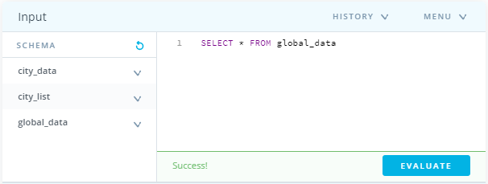

SQL Query to get the list of cities in my country

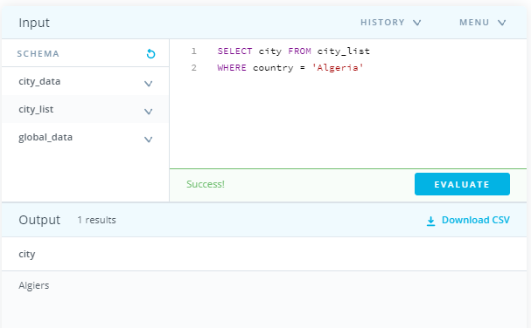

There is only one city available which Is Algiers, actually, I leave in Algiers

SQL Query to get local data

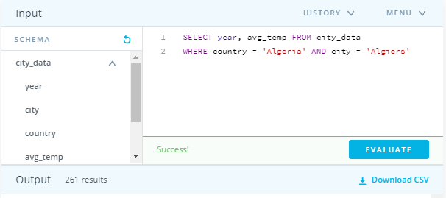

# CSV files opening

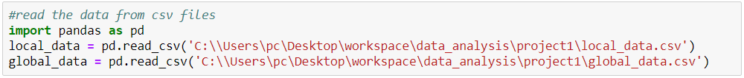

Data description

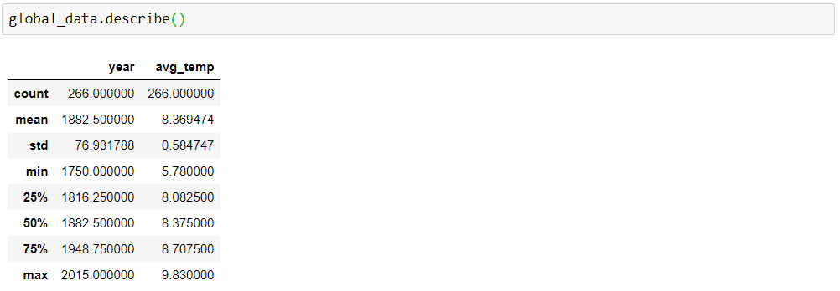

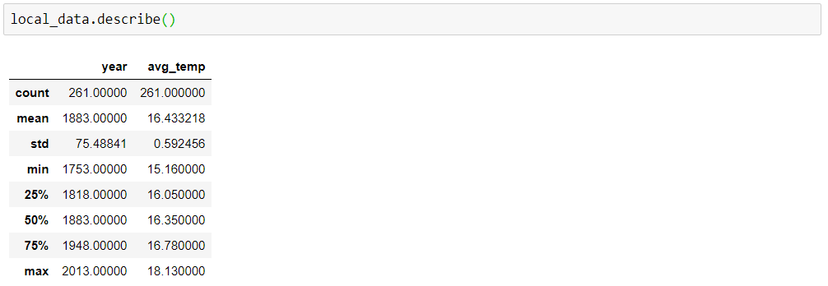

# Calculating moving averages



# Creating line chart

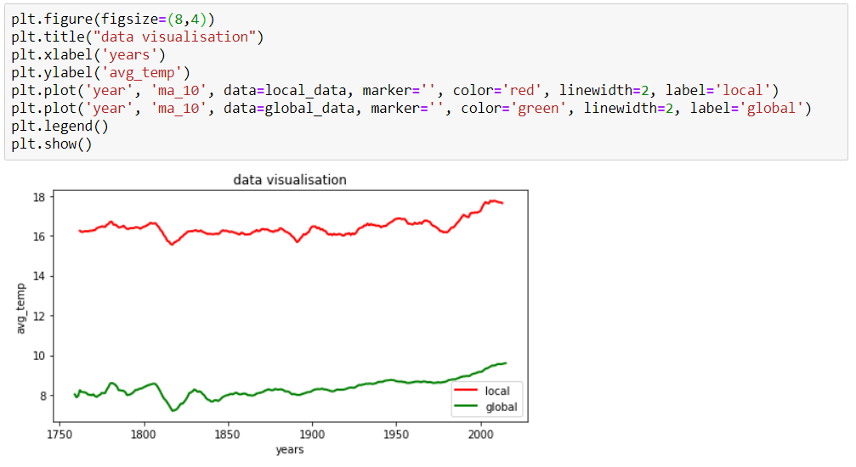

# Observations

* According to the local temperature average my city is hotter compared to the global temperature average.
* The global average temperature is increasing over the years, the world is getting hotter
* Similarly the local average temperature is increasing over the years
* The difference between local average temperature and global average temperature is consistent over the years (slight changes)