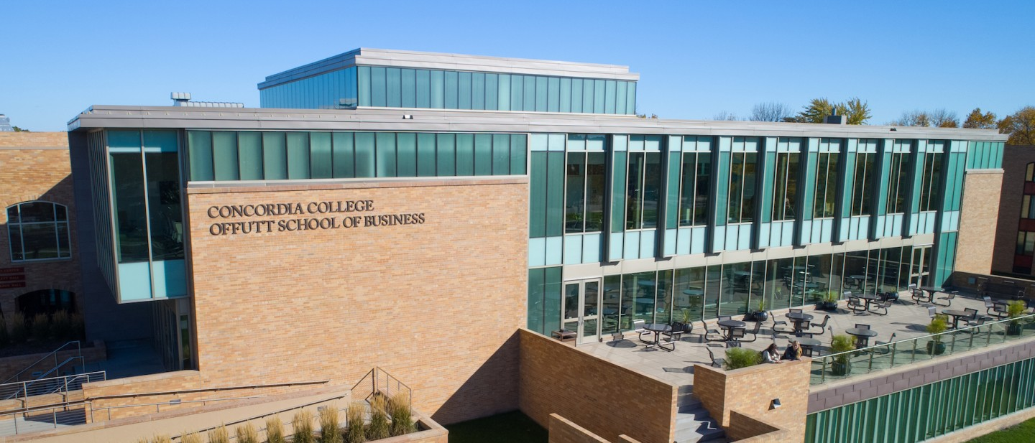

Project Proposal

|  |
| --- |
| The Chef’s Laundry |

|  |  |
| --- | --- |
| Course | **CSC 311 – Mobile Applications Development** |
|  | |
| Team Name | **The Darth Side** |
|  |  |
| Team Members | **Jaleta F. Tesgera** |
|  | **Segni T. Tulu** |
|  | **Brook M. Gebreeyesus** |
|  | **Pedro Ochoa** |

|  |
| --- |
| Executive Summary |
| **Your executive summary should resemble an elevator pitch: your motivation is to quickly persuade a decision maker to get involved in your project.** |
| * **What is the purpose of your project; what problem(s) does it address?** * **Why is your project important; why is it relevant? (NOTE: not in terms of the class to get a good grade)** * **Who could your project help; who is your audience or customer?** |
| This game aims to entertain players while simulating the experience of running a restaurant, including duties like food preparation, customer service, financial management, and strategic decision-making. The objective of the game is often to properly manage the restaurant and expand it over time while overcoming numerous obstacles. These games can be instructive as well, educating players on the numerous facets of managing a restaurant as well as the value of effective time management, client relations, and financial planning. Our target audience are generally people who love playing games that challenge their decision making abilities whilst improving their management skills. |

|  |
| --- |
| Background and Problem History |
| * Explain the problem domain and relevant background information about your project * Provide a brief history of the problem; when did it start? What attempts have been made to solve it? * NOTE: Think in terms of your PROJECT, not in terms of this class |
| This is not necessarily made to solve a specific problem, but rather provide a source of entertainment and education for potential players. Playing restaurant games can be a fun and interesting way for individuals with an interest in the food and hospitality sector to learn more about the business, gain knowledge of management and operations, and hone desired skills, or explore a new career virtually without having to spend money or time on formal education or training. |

|  |
| --- |
| Solution |
| * How does your team plan to solve the problem? * What makes your approach different from other solutions? |
| We are not necessarily trying to solve a problem, but a game which provides endless entertainment and knowledge about the restaurant business for those who love cooking, or serving. Moreover, this game also provides a virtual solution for individuals who want to develop various skills. Furthermore, this game also helps starting chefs get familiar with the kitchen environment, ingredients, steps, etc. as well as, develop prioritization and organizational skills. |

|  |
| --- |
| Project Deliverables |
| * What will be the “product” of your team’s project? What documents will you create? |
| The general content of the project includes the design, and development of a restaurant simulation application. This application will be made on Android Studio using Kotlin as our primary language and Adobe and Autodesk as design tools. Our collaboration and version control software will be Git and GitHub which we will use to share and update our work to maintain the flow as a team. The tentative design for our documents are that we create this game as a simulation for both a chef’s perspective and a waiters perspective that will include a couple activity pages and design mockups. |

|  |
| --- |
| Success Criteria |
| * How will your team define success? What aspects of your project can you quantify to objectively measure success? * NOTE: Think in terms of your PROJECT, not in terms of this class |
| For the sake of better understanding we put our criteria as a bullet point below:   * Successful completion of the application * Testing and debugging the application * Positive feedback from colleagues and instructors * Launched in the Play store * User adoption and retention |

|  |
| --- |
| List of Required Project Resources and Materials |
| * What resources (books, websites, data sets, problem domain information sources, software, etc.) will be / have been required to complete your project? |
| As a team we are going fully invest our time and potential into launching a defect free app and that will require a lot of sources and materials. We don’t have a complete list for the sources (we will have more along the development of the program) but these are generally the ones we are going to use intensively over the course of time.   * Book: Head First Android Development, KOTLIN 3rd Edition * W3 Kotlin Tutorial: <https://www.w3schools.com/KOTLIN/index.php> * Free Code Camp Kotlin Tutorial: <https://www.youtube.com/watch?v=EExSSotojVI> * Auto-Cad 360 App Tutorial: <https://www.youtube.com/watch?v=XKIqht_WFKs> |