# How to Ad-Hoc Install Brookdale Teach Mobile on the iPad

## The following are instructions for installing and testing the Brookdale Teach Mobile Application on your iPad device through iTunes.

#### First, we will assume that you have the following:

1. The ***Brookdale Teach*** application to be installed (an .**ipa** extension)
2. The Mobile Provisioning Profile which allows the application to install (an .**mobileprovision** extension)
3. Latest version of iTunes as well as iOS Firmware installed

#### Next, to install you need to do the following:

1. Locate the .**mobileprovision** file, double-click on it, and XCode's ***Organizer*** window will automatically open and install the provisioning profile into your current stack.
   1. 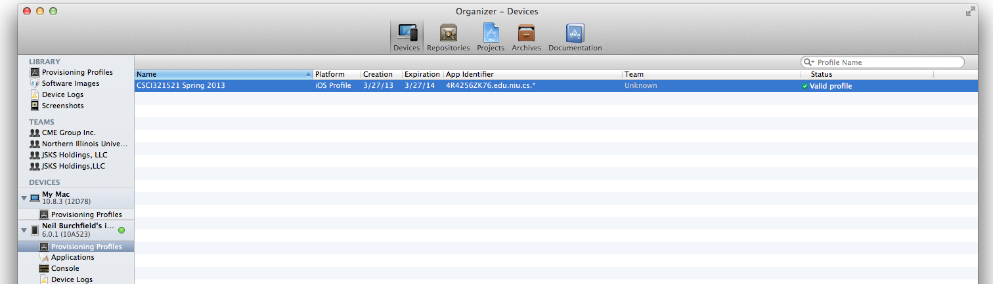To verify look at the list of all Provisioning Profiles and locate the one that was installed. It should have a green check mark next to it stating "Valid Profile".
2. 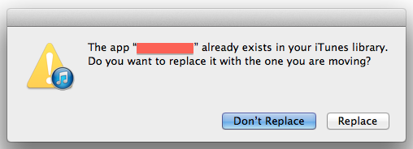Next, locate and double-click on the **.ipa** application file and iTunes should open. If you get the following prompt by iTunes just click ***replace***.
3. In iTunes, go to the **Apps**portion in your iPad section, search for ***Brookdale Teach*** (or ***Bobcats)*** and click install. If the option to install isn’t available and the alternative to remove is, then click remove***,***and click Sync towards the bottom of the page. Then once iTunes has finished, repeat the previous step with the install option and the application will install on your device.

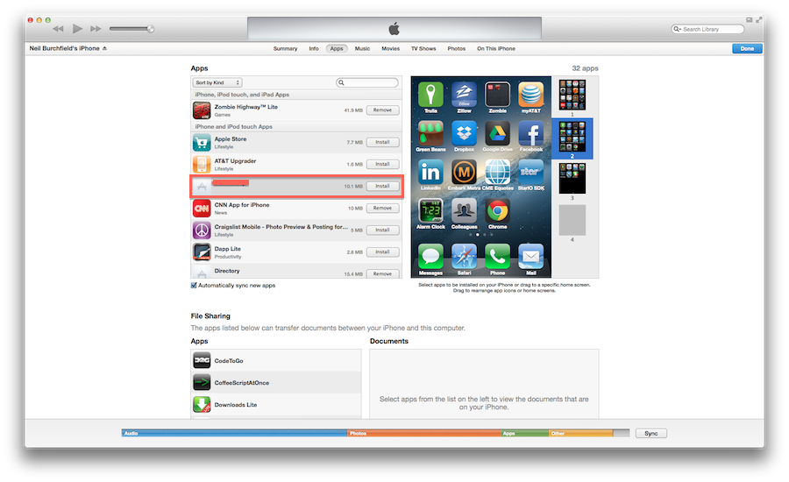

Questions? Feel free to contact me Neil.Burchfield@gmail.com