Quiz 6

Brooke Charbonneau

November 22, 2016

I examined the extent to which exam grades (E) were predicted by anxiety (A) and preparation (P). As indicated in Table 1, when the predictors were examined individually, there was a strong positive relation between anxiety and exam grades, *r* = .69, 95% CI[.64, .73], such that as anxiety increased exam grades increased. In addition, there was a strong positive relation between preparation and exam grades, *r* = .49, 95% CI[.42, .56], such that as preparation increased so did exam grades.

I used moderated multiple regression to test the extent to which the relation between anxiety and exam grades depended on the amount of exam preparation. I assessed this moderation by examining the interaction between anxiety and preparation using centered predictors (consistent with the recommendations of Cohen, Cohen, West, and Aiken (2003)), see Table 2. Together the predictors (anxiety, preparation, and their product) accounted for a substantial variance in exam grades, $R^{2}=.62$, 95% CI[.57, .66], *p* < .01. Results for the product term in this analysis were positive. Specifically, the *p*-value for the anxiety by preparation product term was less than .001, *t*(496) = 6.06, *p* < .001, which suggests the presence of an interaction. However, an inspection of squared semi-partial correlation for the product term indicated the proportion of variance accounted for was small, $sr^{2}=.03$, 95% CI[.01, .05]. As this information suggested the presence of an interaction, albeit one which only contributes slightly to the variance in exam grades, I explored the regression surface with simple-slope analyses.

The regression surface is presented in Figure 1 and the simple-slope cross-sections are presented in Figure 2. When preparation was high (i.e., +1 SD) there was a strong positive relation between anxiety and exam grades such that as anxiety increased exam grades increased, $b=19.49$, 95% CI[17.50, 21.48], t(496) = 19.25, *p* < .001, see Equation 1 below. When preparation was low (i.e., -1 SD), there was a weaker positive relation between anxiety and exam grades, such that as anxiety increased exam grades increased, $b=11.02$, 95% CI[9.08, 12.96], t(496) = 11.16, *p* < .001, see Equation 2 below.

$Ȇ=19.49A+55.90$ (1)

$Ȇ=11.02A+42.53$ (2)

Thus, the relation between anxiety and exam grades appears to be moderated by the extent to which students prepared for the exam. If students prepared extensively for the exam, high anxiety levels positively impacted exam performance. If students did not prepare extensively for the exam, high anxiety levels also predicted increased exam performance. However, the increase in exam performance was not as strong for students who prepared little for the exam as for those who prepared extensively.

Appendix

Tables and Figures

Table 1

*Means, standard deviations, and correlations with confidence intervals*

|  |  |  |  |  |
| --- | --- | --- | --- | --- |
| Variable | *M* | *SD* | 1 | 2 |
|  |  |  |  |  |
| 1. exam | 50.00 | 20.00 |  |  |
|  |  |  |  |  |
| 2. anxiety | 4.10 | 0.80 | .69** |  |
|  |  |  | [.64, .73] |  |
|  |  |  |  |  |
| 3. preparation | 3.90 | 0.70 | .49** | .23** |
|  |  |  | [.42, .56] | [.15, .31] |
|  |  |  |  |  |

*Note.* * indicates *p* < .05; ** indicates *p* < .01. *M* and *SD* are used to represent mean and standard deviation, respectively. Values in square brackets indicate the 95% confidence interval for each correlation. The confidence interval is a plausible range of population correlations that could have caused the sample correlation (Cumming, 2014).

Table 2

*Regression results using exam as the criterion*

|  |  |  |  |  |  |  |  |  |
| --- | --- | --- | --- | --- | --- | --- | --- | --- |
| Predictor | *b* | *b*  95% CI  [LL, UL] | *beta* | *beta*  95% CI  [LL, UL] | *sr2* | *sr2*  95% CI  [LL, UL] | *r* | Fit |
| (Intercept) | 49.21** | [48.09, 50.33] |  |  |  |  |  |  |
| x.centered | 15.25** | [13.85, 16.66] | 0.61 | [0.55, 0.67] | .35 | [.29, .41] | .69** |  |
| z.centered | 9.55** | [7.94, 11.16] | 0.33 | [0.28, 0.39] | .10 | [.07, .14] | .49** |  |
| I(x.centered * z.centered) | 6.05** | [4.09, 8.01] | 0.17 | [0.11, 0.22] | .03 | [.01, .05] |  |  |
|  |  |  |  |  |  |  |  | *R2*  = .617** |
|  |  |  |  |  |  |  |  | 95% CI[.57,.66] |
|  |  |  |  |  |  |  |  |  |

*Note.* * indicates *p* < .05; ** indicates *p* < .01. A significant *b*-weight indicates the beta-weight and semi-partial correlation are also significant. *b* represents unstandardized regression weights; *beta* indicates the standardized regression weights; *sr2* represents the semi-partial correlation squared; *r* represents the zero-order correlation. *LL* and *UL* indicate the lower and upper limits of a confidence interval, respectively.

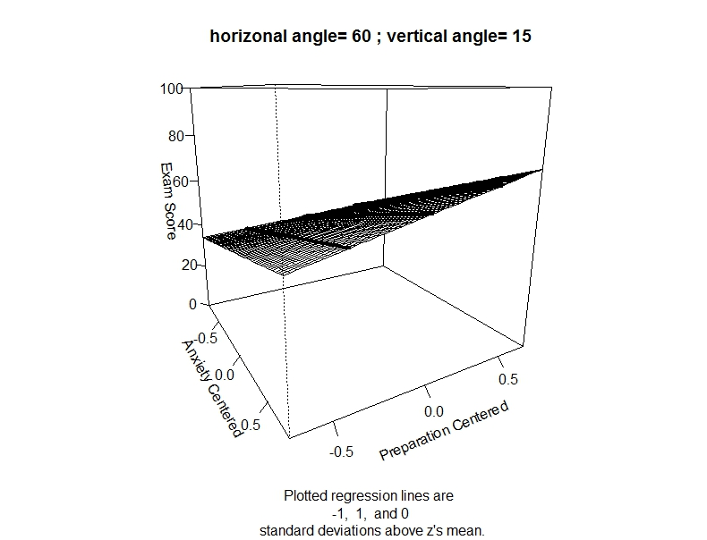

*Figure 1.* Regression surface.

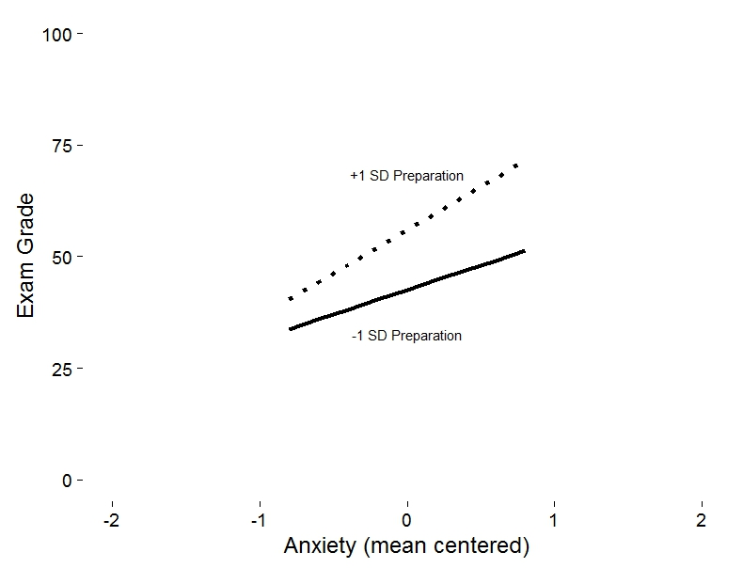

*Figure 2.* Simple-slope cross-sections of regression.