**Assignment 2.2 – Data Modeling**

Brooks

Bellevue University

WEB 335-339A Introduction to NoSQL

Professor Krasso

3/26/2023

# NodeShopper

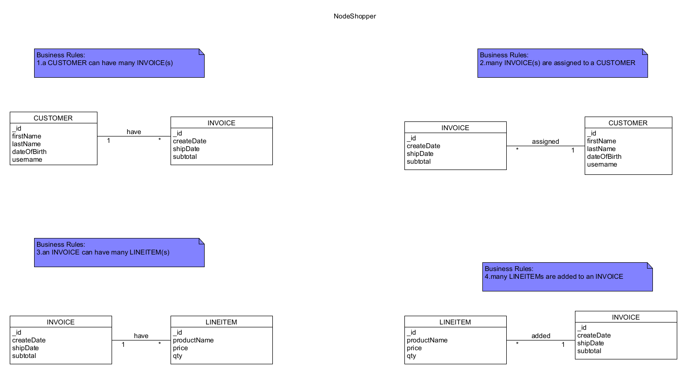

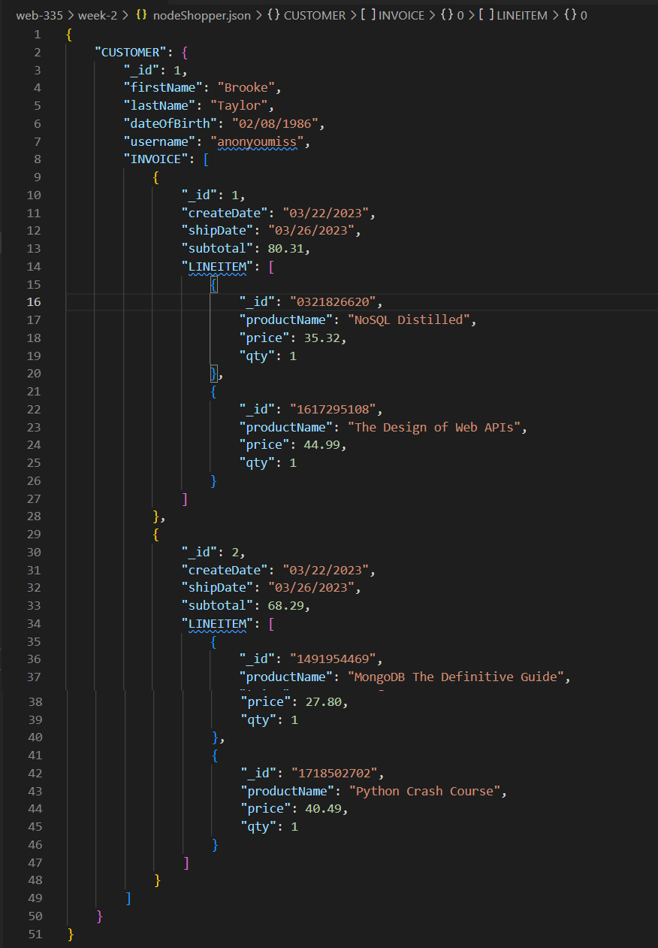

# NodeTech



