**Assignment 3.2 – 2NF**

Brooks

Bellevue University

WEB 335-339A Introduction to NoSQL

Professor Krasso

4/02/2023

# nodeSecurity

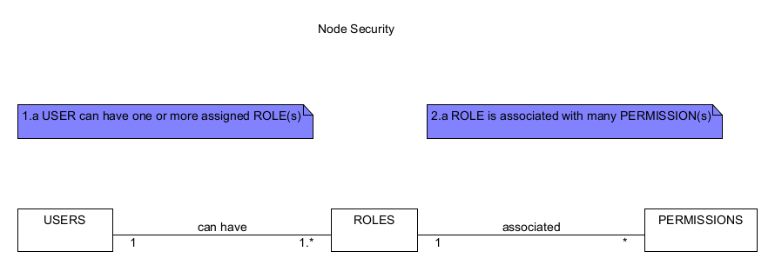

# nodeBookCO



