**Assignment 5.2 – Projections**

Brooks

Bellevue University

WEB 335-339A Introduction to NoSQL

Professor Krasso

4/14/2023

1. Write a query to add a new user to the user’s collection. Make sure the fields in the new document match the existing fields in the user’s collection. Take a screenshot of the output and save it as an image.

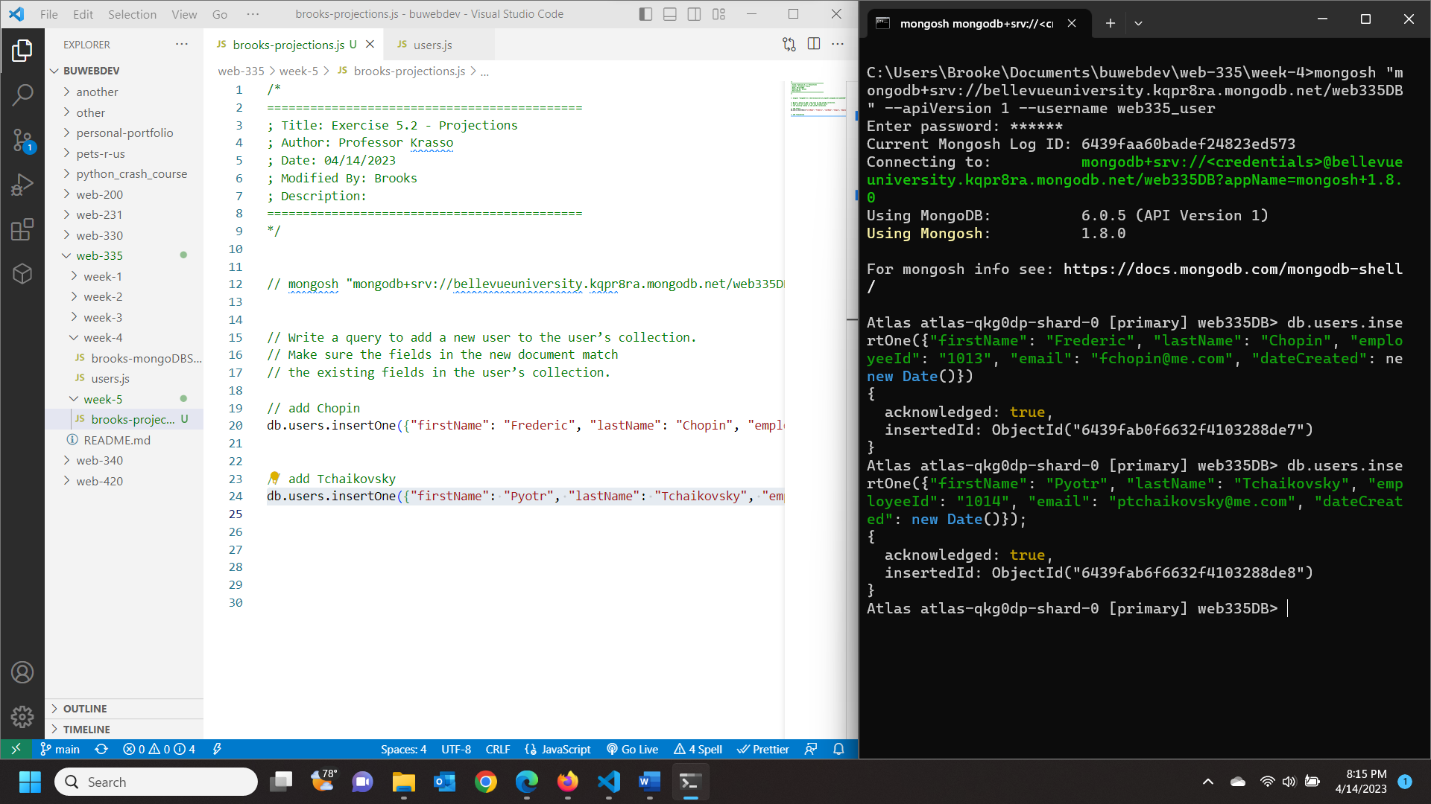

1. Write a query to update Mozart’s email address to [mozart@me.com](mailto:mozart@me.com). Take a screenshot of the output and save it as an image. 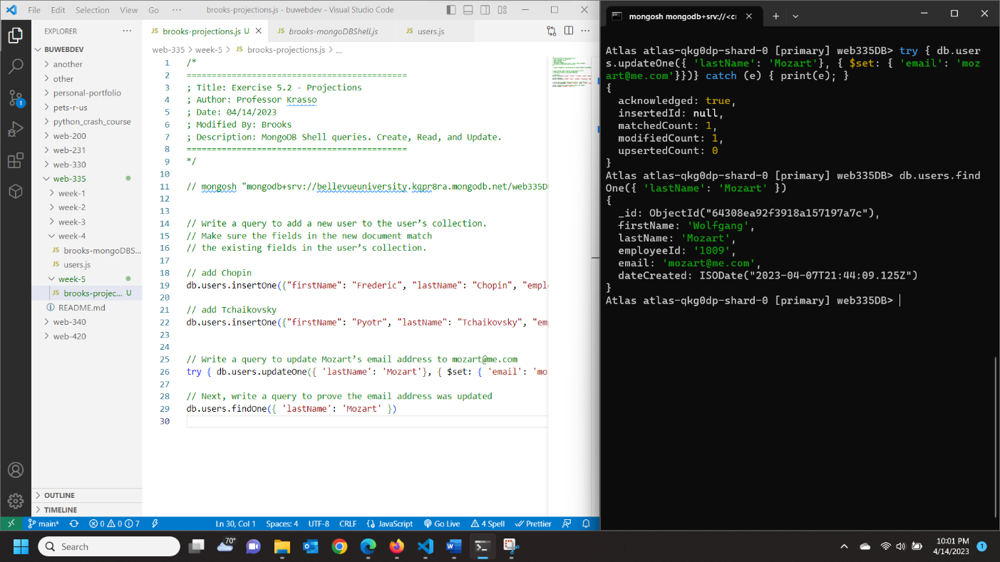

Next, write a query to prove the email address was updated. Take a screenshot of the output and save it as an image. 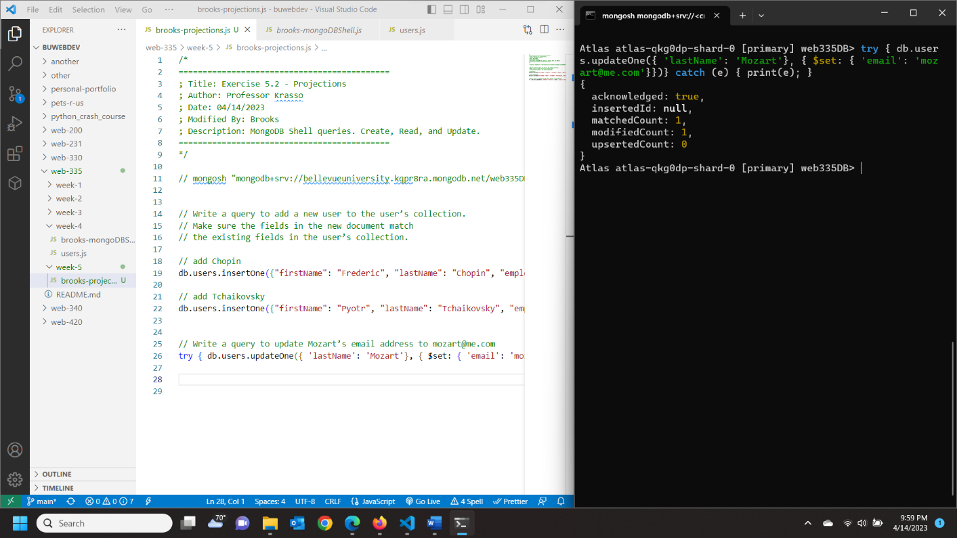

1. Write a query to list all documents in the user’s collection. Use projections to only display the firstName, lastName, and email fields. Take a screenshot of the output and save it as an image.

