**Assignment 6.2 – Aggregate Queries**

Brooks

Bellevue University

WEB 335-339A Introduction to NoSQL

Professor Krasso

4/21/2023

1. Write a query to show a list of documents in the houses collection. Take a screenshot of the output and save it as an image.

1. Write a query to show a list of documents in the student’s collection. Take a screenshot of the output and save it as an image.

1. Write a query to add a document to the student’s collection. Take a screenshot of the output and save it as an image.

Next, write a query to prove the document was added to the user’s collection. Take a screenshot of the output and save it as an image.

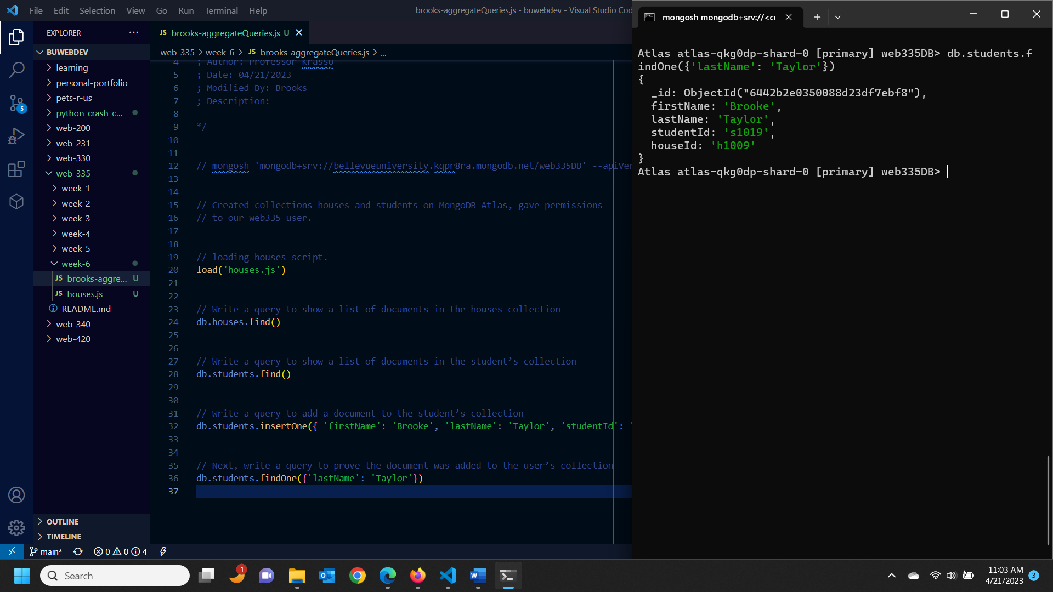

1. Write a query to delete the document you created in step 4. Take a screenshot of the output and save it as an image.

Next, write a query to prove the document was added to the user’s collection. Take a screenshot of the output and save it as an image.

1. Write a query to show a list of students by house (hint: use the lookup operation). Take a screenshot of the output and save it as an image.

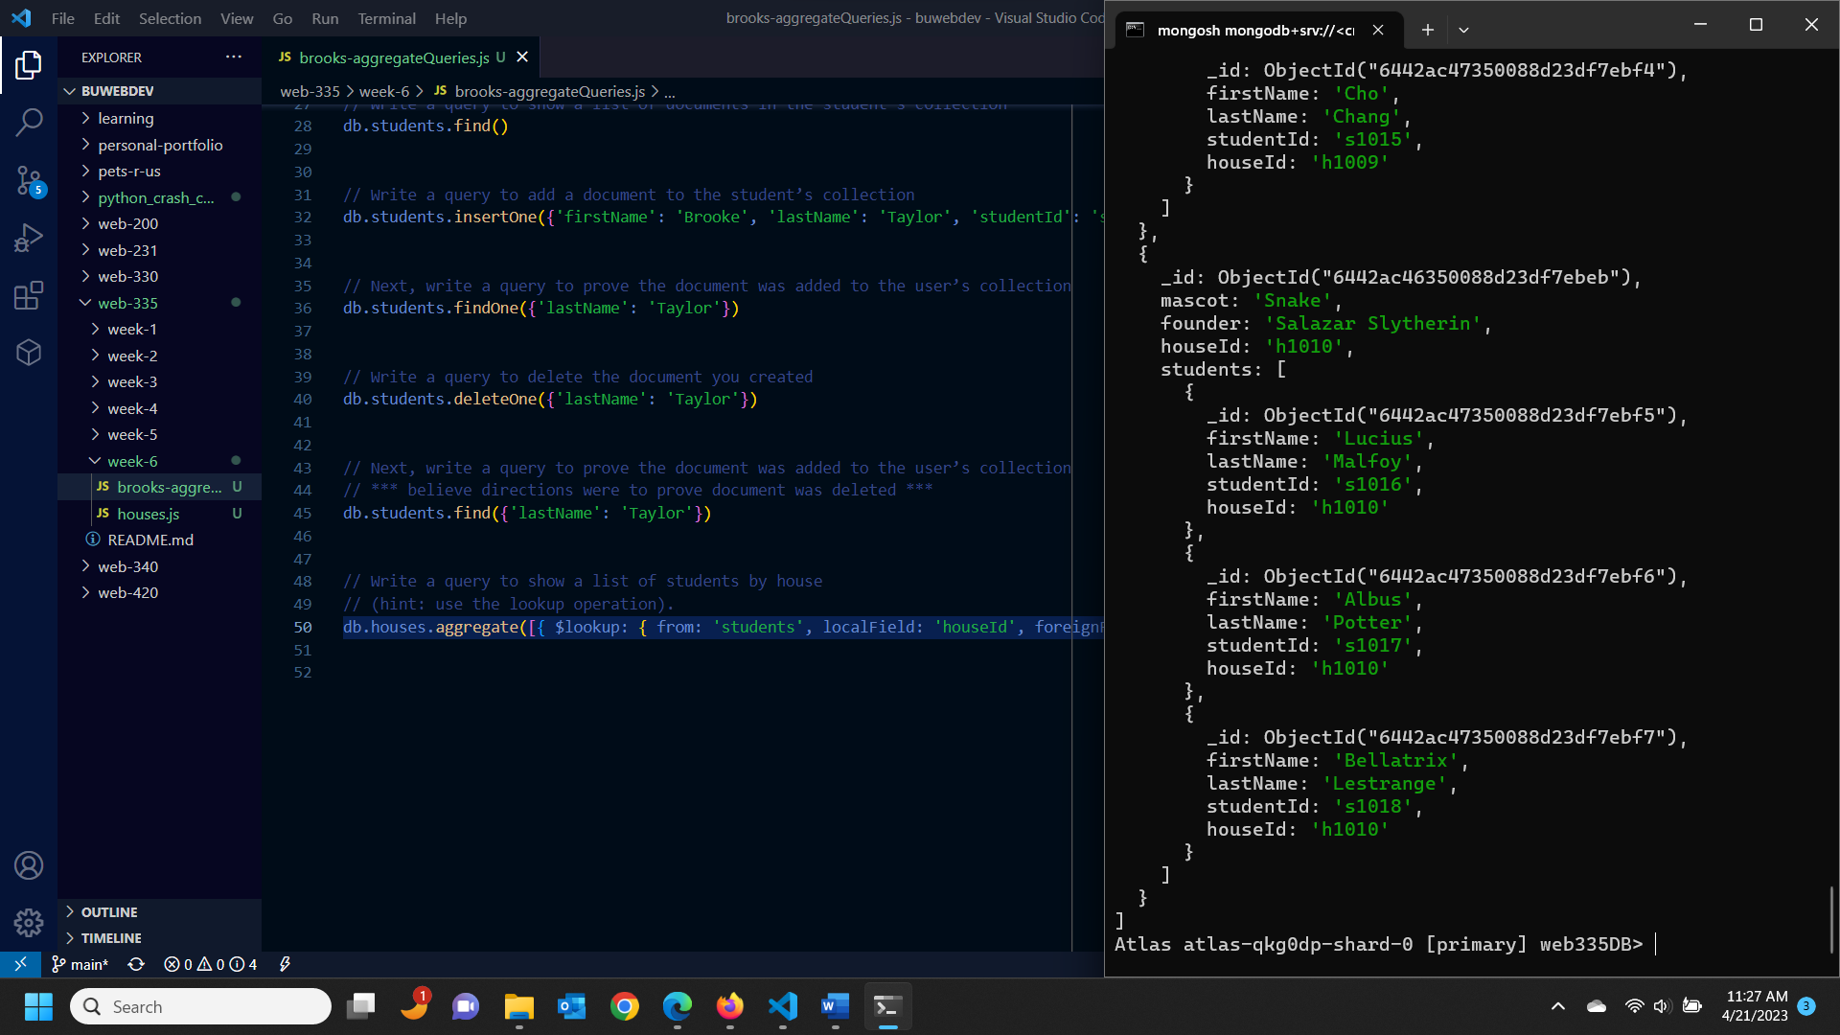

1. Write a query to show a list of students for house Gryffindor (hint: use the lookup and match operations). Take a screenshot of the output and save it as an image.

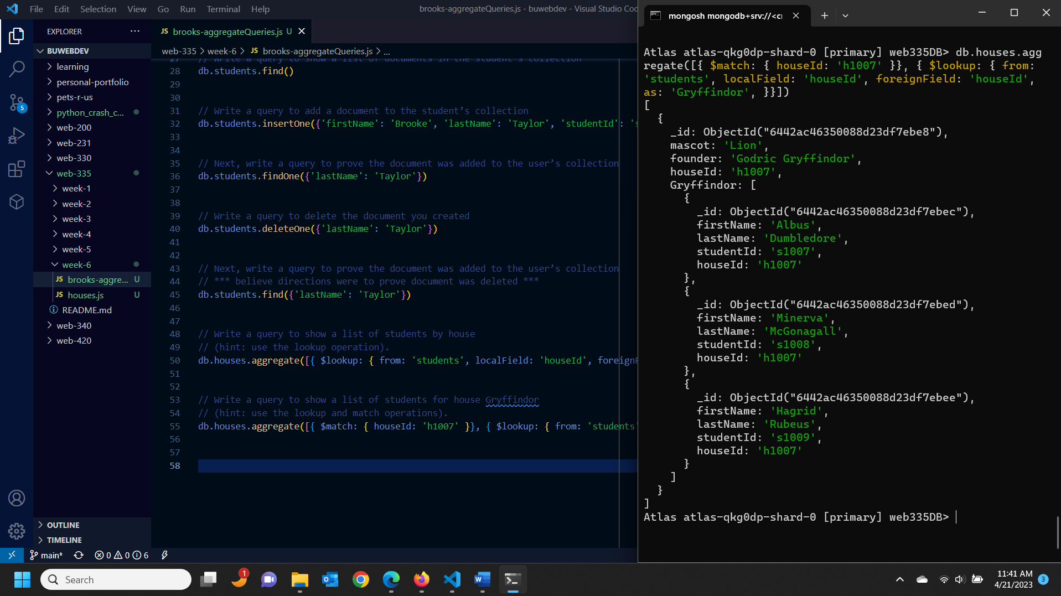

1. Write a query to show a list of students for the Eagle mascot (hint: use the lookup and match operations). Take a screenshot of the output and save it as an image.

