- Create an Eclipse project.
- Add a git repository for that project
  - Right click on the project.
  - Choose Team => Share Project…
  - Choose Git (if necessary).
  - Click Create…
  - The directory name should be something like “C:\Users\Jowi\git”. Change it to something like “C:\Users\Jowi\git\myRepository”.
  - Click Finish.
  - Click Finish.
- Add a class named Class1 to your project.
- Commit the change to the repository
  - Right click on the project.
  - Team => Commit
  - Select everything in the Unstaged Changes list.
  - Drag them to the Staged Changes list.
  - Enter a Commit message.
  - Click Commit.

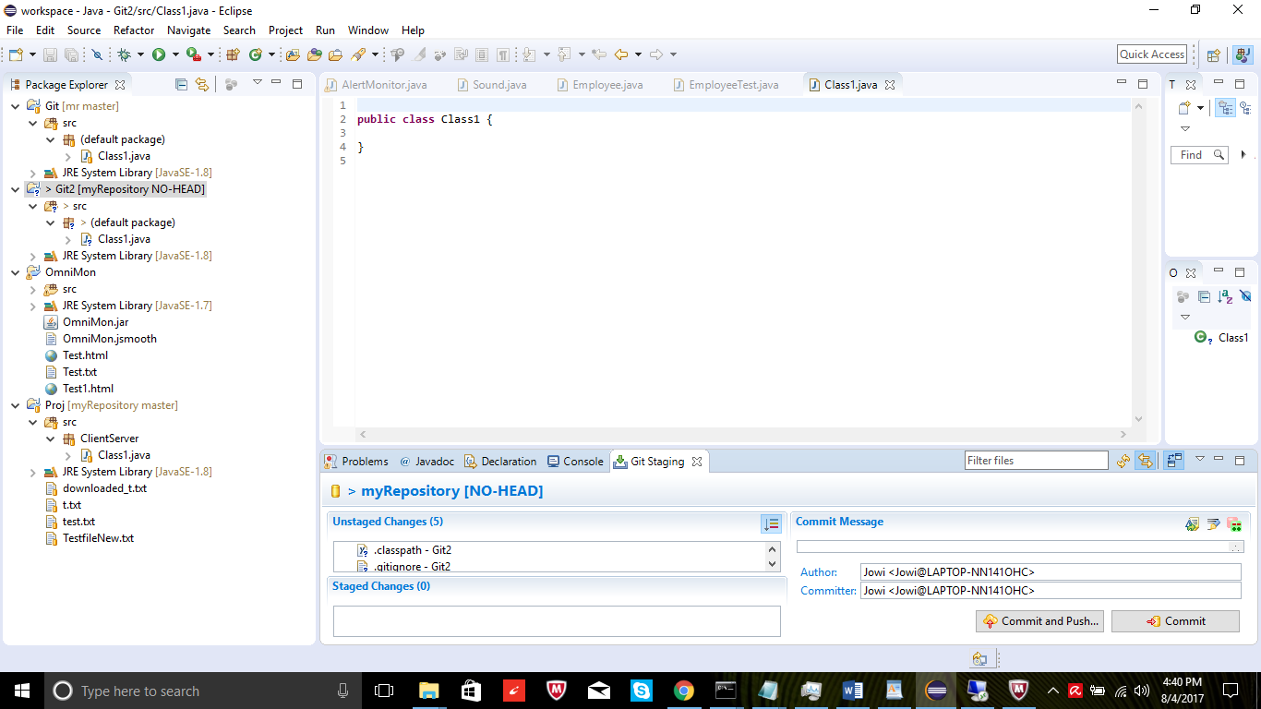
- Create a free GitHub account at https://github.com/
- Create a public repository.
- Go back to Eclipse.
- Push Branch ‘master’
  - Right click on the project.
  - Team => Push Branch ‘master’
  - Copy the repository URL (if it is not there click on the green Clone or Download button).

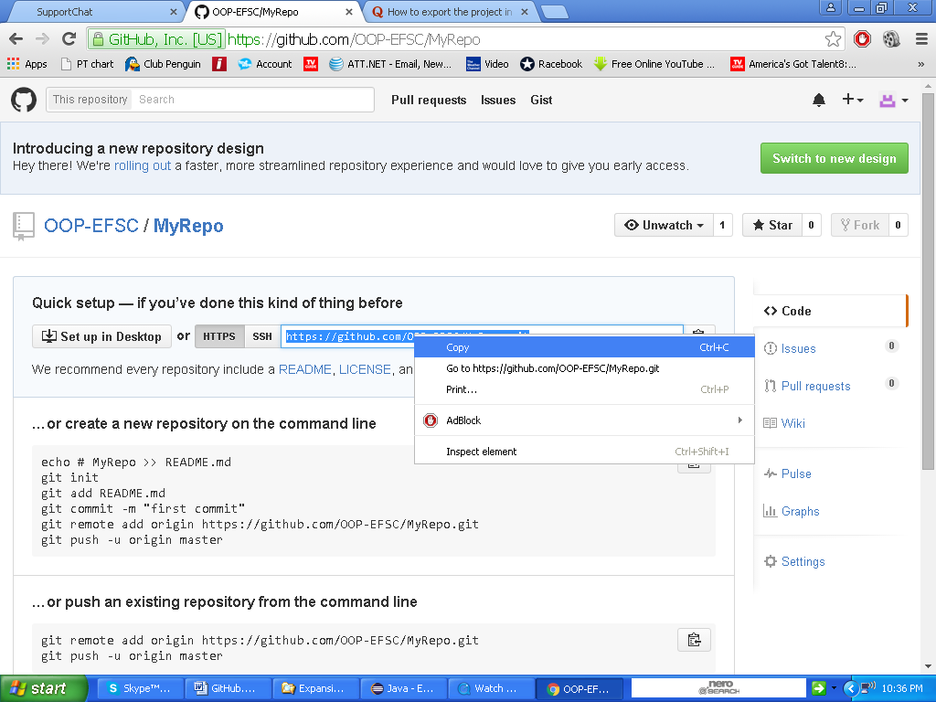

  - Paste the repository URL as highlighted

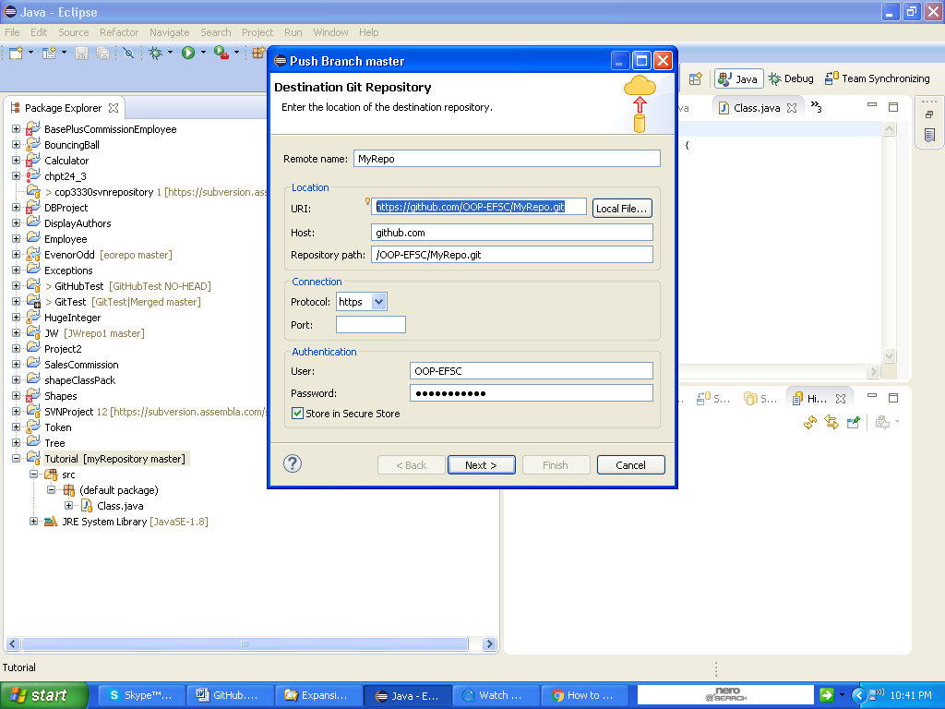

  - Enter the GitHub repository name as the Remote Name.
  - Click Next
  - Click Next
  - Login with remote Git Username and Password if necessary
  - Click Finish
  - Login with remote Git Username and Password again if necessary
  - Click Close or OK

Now you should see your project on GitHub.

Add a class named Class2 to your project and commit. Stage the changes as before and choose Commit and Push. Login again if necessary.

Click on Close.

Class2 is now in the GitHub repository.

Tags are basically snapshots of a project.

Create a tag after adding Class2.

Team => Advanced => Tag or Team => Advanced => Create Tag…

Name the tag Class2, create a tag message and choose Create Tag and Start Push.

Add Class3.

Create a tag after adding Class3.

Team => Advanced => Tag or Team => Advanced => Create Tag…

Name the tag Class3 and create a tag message. Stage the changes as before and choose Create Tag and Start Push.

You can use the Branch/Tags dropdown box to view your tags at github.com. You may need to refresh the page to see the new tags.

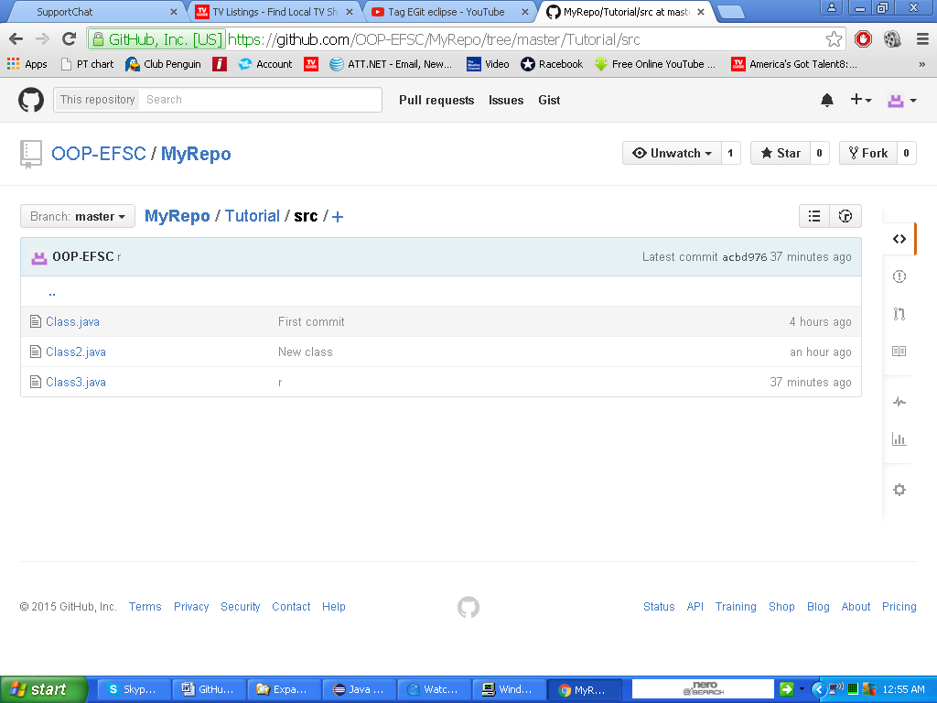

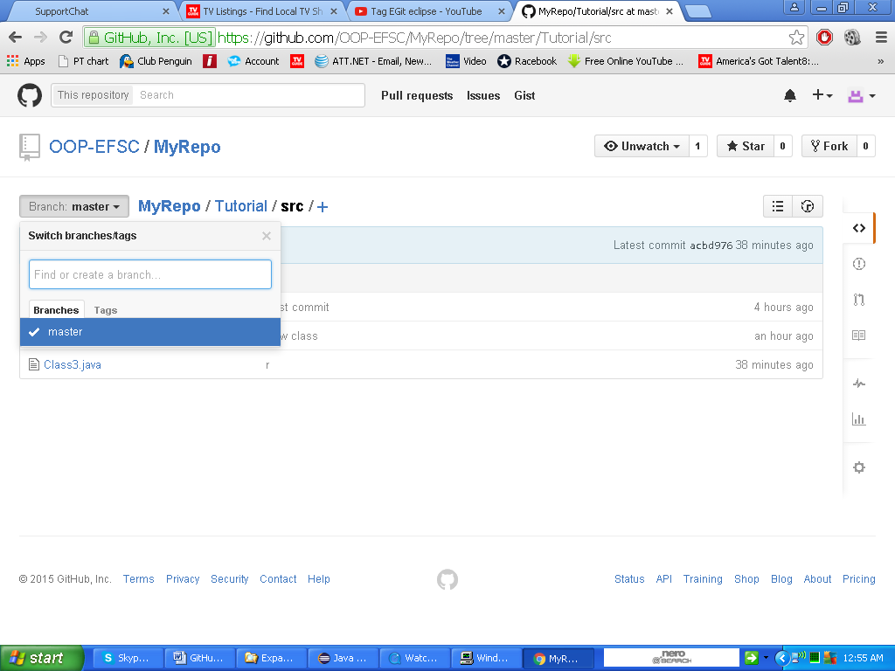

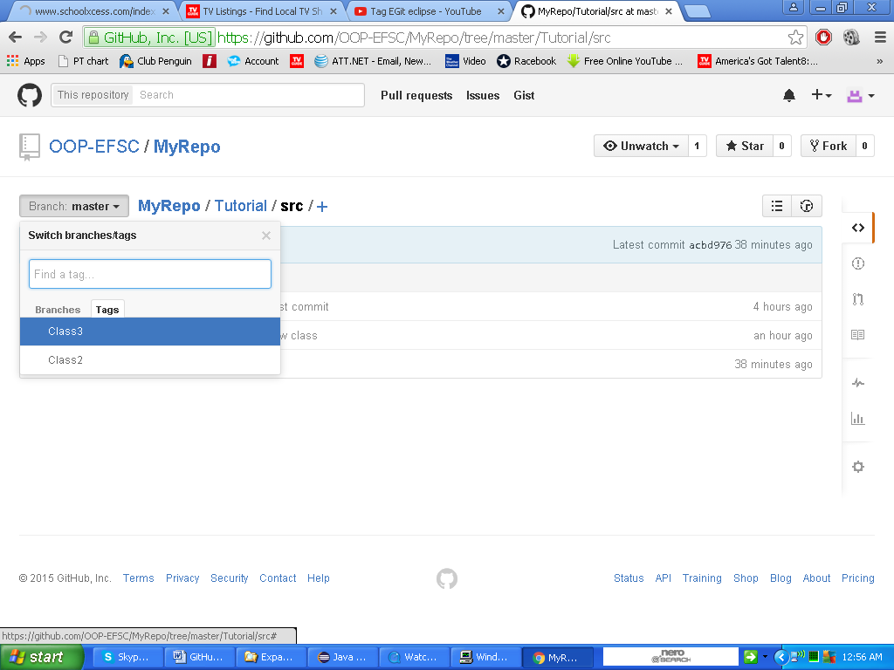

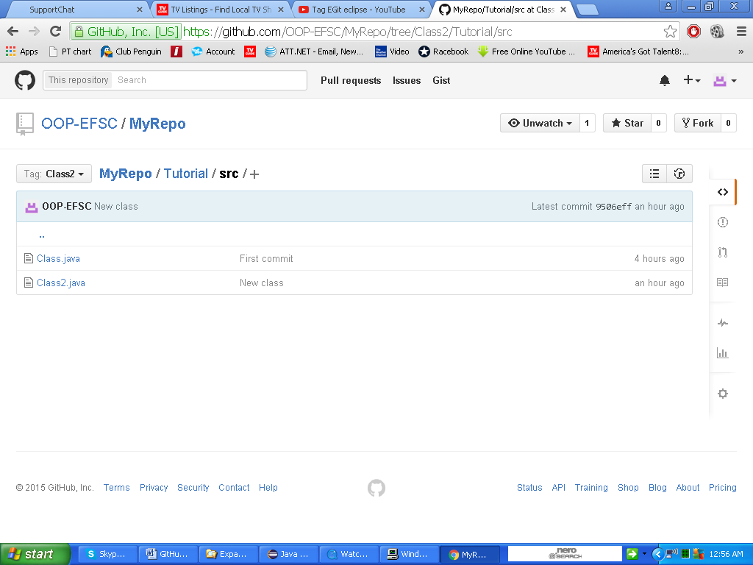

After completing all of this, you should submit to me your GitHub Username and the name of your repository on GitHub (in case you get excited and create more than one).

Supply it as a URL such as github.com/Myusername/Myrepo.

