Murder in the Ron Cooke Hub

User Manual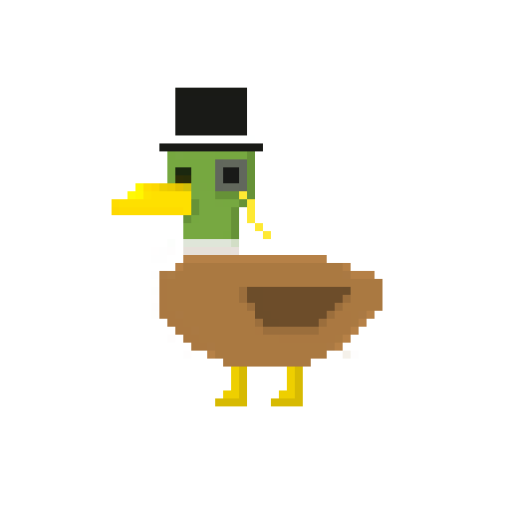

## 

## Developers

Brooke Hatton [@brookke](https://github.com/brookke)

Ben Jarvis [@beno11224](https://github.com/beno11224)

Benjamin Grahamslaw [@Penguin-Benjamin](https://github.com/Penguin-Benjamin)

Jason Mashinchi [@jasonmash](https://github.com/jasonmash)

Joseph Shufflebotham [@joeShuff](https://github.com/joeShuff)

Vishal Soomaney [@TheProgrammingDuck](https://github.com/TheProgrammingDuck)

**Note:** This user manual contains features not implemented in the game in its current state.

## Contents

**Developers****1**

**Contents****2**

**Introduction****2**

**Start/end game****2**

**Gameplay****2**

Clues 3

Detectives 3

How to win 3

Score 3

**Controls****3**

Movement 3

Interaction 4

## 

## Introduction

Welcome to the user manual for the Lorem Ipsum murder mystery game. This manual will tell you everything you need to know in order to play the game. Murder in the Ron Cooke Hub is a murder mystery game set in the University Of York. A lock in party for local detectives, great and small, was held in the Ron Cooke Hub. The night did not end as planned however, one of the guests was murdered. Now it is up to you to prove you are the greatest detective and solve the mystery.

## Start/end game

To start the game launch the “Murder in the Ron Cooke Hub” application. This will load up the main game screen, here you can simply click ‘new game’ to start the game. To exit the game return to this menu using the in-game menu and select quit to leave the game.

## **The main menu**Screen Shot 2017-01-23 at 15.25.16.png

## Gameplay

In order to win the game you must successfully figure out who the murderer is, and accuse them. To do this you must first find clues.

### **This is a section of the map you can walk around.**Screen Shot 2017-01-23 at 15.25.33.png

### Clues

To find the clues you need to explore the rooms of the Ron Cooke Hub. Each room you explore will hold a new clue. The clues you have collected can be seen from the menu at any time.

### Detectives

You will also meet other detectives from the party, one of them is the murderer. We suggest you download our detective’s handbook document so you can cross off detectives you believe are innocent to help you narrow it down. When you talk to a detective you can ask them about clues and also more generally about the murder and what they know. The detective may say something misleading but they will not lie. Your character has a personality meter, which will vary depending on whether you tend to question people kindly or aggressively, and it is shown at the bottom of the screen.

**The bar at the bottom has score, pause etc**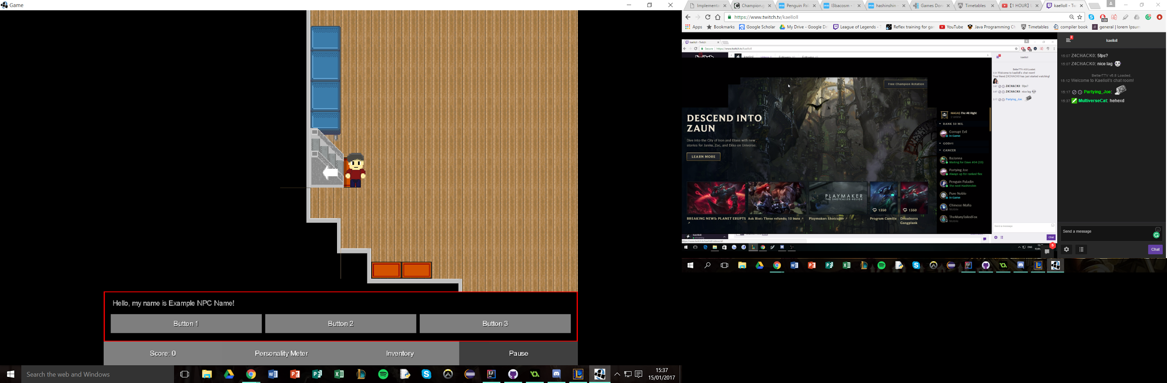

### How to win

To win, you need to find the weapon used to commit the murder, and correctly identify the killer. When you have found the weapon and made a decision about who you think is the murderer you can go and accuse them. If you are right you will win the game at that point. If you are wrong then your score will reduce and the game continues.

### Score

At the end of the game you will you will be given a score based on the actions you have made in the game. Your score increases by finding clues and by quickly solving the murder. Incorrectly accusing someone will reduce your score.

## Controls

### Movement

In order to find the clues and solve the murder you will need to explore the rooms of the Ron Cooke Hub. To move your detective around the map use the following:

**Move up:** Up arrow key or W key.

**Move left:** Left arrow key or A key.

**Move right:** Right arrow key or D key.

**Move down:** Down arrow key or S key.

### **Use mats to go from room to room in the RCH. When you arrive in a room you are also told the name of the room.**

### Interaction

You will need to interact with objects that you find while exploring, as they may contain useful clues. You will also need to talk to other detectives who were at the party. To interact in this way use the following:

**Interact with an object:** Enter key.

**Start conversation with detective:** Enter key.

Some parts of the game requires the use of the mouse, such as menus. To interact use the following:

**Interact with menu:** Left mouse button.

**Select options when talking to a detective:** Left mouse button.