Murder in the Ron Cooke Hub

User Manual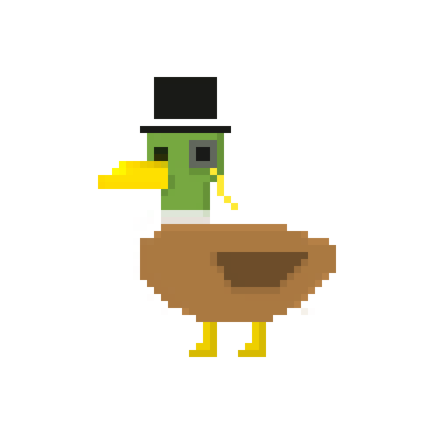

## 

## Developers

Brooke Hatton [@brookke](https://github.com/brookke)

Ben Jarvis [@beno11224](https://github.com/beno11224)

Benjamin Grahamslaw [@Penguin-Benjamin](https://github.com/Penguin-Benjamin)

Jason Mashinchi [@jasonmash](https://github.com/jasonmash)

Joseph Shufflebotham [@joeShuff](https://github.com/joeShuff)

Vishal Soomaney [@TheProgrammingDuck](https://github.com/TheProgrammingDuck)

## Contents

**Developers** **1**

**Contents** **2**

**Introduction** **2**

**Start/end game** **2**

**Gameplay** **2**

Clues 3

Detectives 3

How to win 3

Score 3

**Controls** **3**

Movement 3

Interaction 4

## 

## Introduction

Welcome to the user manual for the Lorem Ipsum murder mystery game. This manual will tell you everything you need to know in order to play the game. Murder in the Ron Cooke Hub is a murder mystery game set in the University Of York. A lock in party for local detectives, great and small, was held in the Ron Cooke Hub. The night did not end as planned however, one of the guests was murdered. Now it is up to you to prove you are the greatest detective and solve the mystery.

## Start/end game

To start the game launch the “Murder in the Ron Cooke Hub” application. This will load up the main game screen, here you can simply click ‘new game’ to start the game. Remember that the .jar file AND the database db.db file need to be in the same directory for the game to work.

## **The main menu**

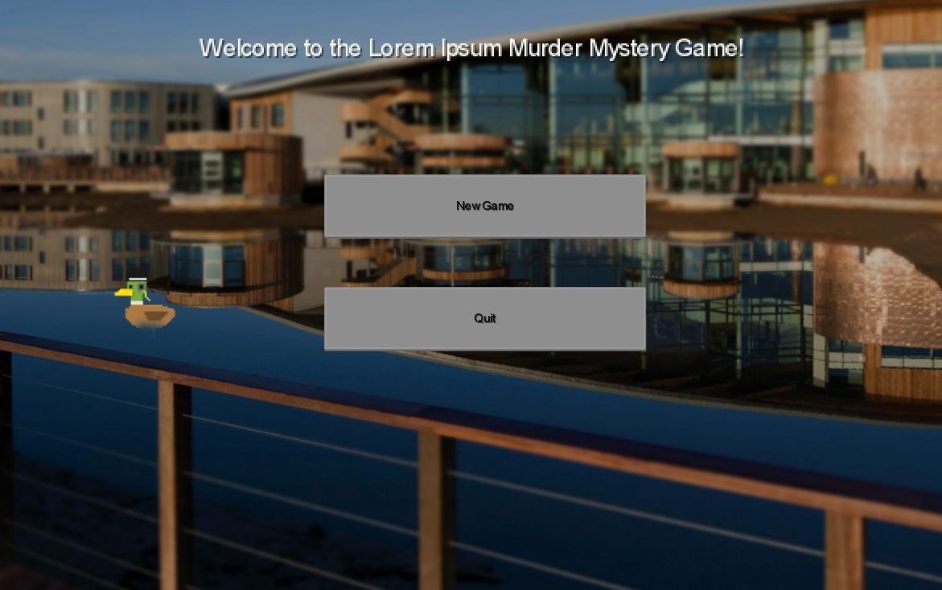

## Gameplay

In order to win the game you must successfully figure out who the murderer is, and accuse them. To do this you must first find clues.

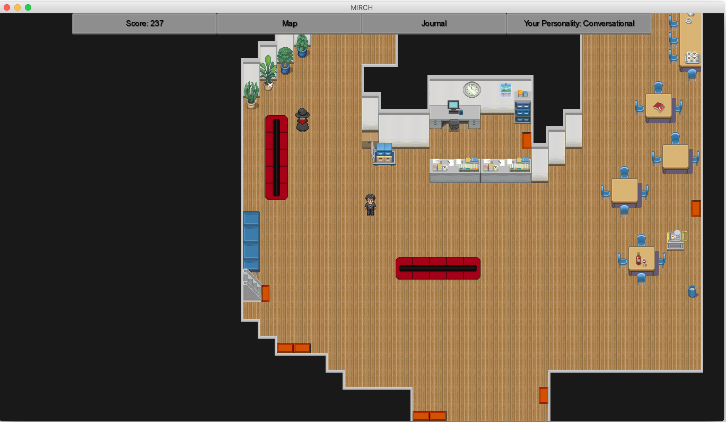

**This is a section of the map you can walk around.**

### Clues

To find the clues you need to explore the rooms of the Ron Cooke Hub. Each room you explore will hold a new clue. The clues you have collected can be seen from the journal at any time. A clue may or may not help solve the murder.

### Detectives

You will also meet other detectives from the party, one of them is the murderer. When you talk to a detective you can ask them about clues and also more generally about the murder and what they know. This dialogue is stored in the journal. The detective may say something misleading but they will not lie. Your character has a personality meter, which will vary depending on whether you tend to question people kindly or aggressively, and it is shown at the bottom of the screen.

### How to win

To win, you need to find the weapon used to commit the murder, and correctly identify the killer. When you have found the weapon and made a decision about who you think is the murderer you can go and accuse them. If you are right you will win the game at that point. If you are wrong then your score will reduce and the game continues.

### Score

At the end of the game you will you will be given a score based on the actions you have made in the game. Your score increases by finding clues and by quickly solving the murder. Incorrectly accusing someone will reduce your score. You also lose score over time.

## Controls

### Movement

In order to find the clues and solve the murder you will need to explore the rooms of the Ron Cooke Hub. To move your detective around the map use the following :

**Move up:** Up arrow key or W key.

**Move left:** Left arrow key or A key.

**Move right:** Right arrow key or D key.

**Move down:** Down arrow key or S key.

You can also click a position on the game map to move there.

### Screenshot1

### **Use mats to go from room to room in the RCH.**

### Interaction

You will need to interact with objects that you find while exploring, as they may contain useful clues. You will also need to talk to other detectives who were at the party. To interact in this way use the following:

**Interact with an object:** Left click on the object.

**Start conversation with detective:**  Left click on the detective.

Some parts of the game requires the use of the mouse, such as menus. To interact use the following:

**Interact with menu:** Left mouse button.

**Select options when talking to a detective:** Left mouse button.