Each team will meet for 20 minutes with one of the faculty and their GTA mentor will also attend. These meetings, which will be conducted by the team leader (now team lead #2 according to the schedule), are intended to discuss the **current status of the project**, **work planned for the next week**, and any **issues that the team is facing**. A hardware**/software block diagram** should be prepared to highlight key components of the project and **work done to date**. Each team member should comment on their design tasks.

1. Current Status
   1. Beginning to develop prototype
   2. Configuring the APIs and market database
   3. Initializing frontend
2. Work Planned for Next Week
   1. Frontend:
      1. Create Main Page
      2. Linking Screens -figure out by Thursday
      3. Football Field Screen
      4. Valuation Screen
   2. Backend:
      1. Figure out backend flows in response to each front end action.
      2. Plan each function of the backend so that we can begin coding. Things like what input we will receive from the front end and what output will out backend produce to display.
3. Issues the team is facing
   1. Lack of information about API / database details
   2. Team members lacking experience with the front end.
4. Software Block Diagram
   1. Frontend:
      1. Use wireframes to demonstrate user flow
   2. Backend

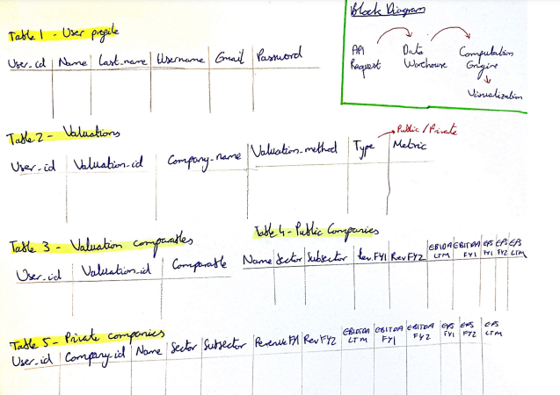

1. Individual Design Task Comments:
   1. Suyash
      1. Backend development
      2. Database design decisions
      3. How we will design the computation engine. Design requirements for it. Language choices etc. C++ preferable.
   2. Ignacio
      1. Backend development
      2. Database construction
   3. Zen
      1. Using XCode to simulate application running on iOS
      2. Working on an agile environment with GitHub
   4. Prithika
      1. Using Android Studios to simulate Android

**IEX Cloud - Apparate**

Tasks:

* Top of every page
  + Workshop Finance Logo
  + Side bar
* Login Page
  + Set up user authentication (google & firebase)
    - Name (First, Last), Email, Username, Password, Confirm Password
    - Sign Up
    - Sign In
      * Username, pss
* Main Page
  + Target (user input box target)
  + Draw
  + Coverage (File System)
    - Football Fields
    - Valuations
    - Companies
  + Screener
    - (**ask Brendan)
    - Another word for search
    - FIitered, multivariable search
    - On the confluence page, this refers to more of the UI to create a screener
    - There is already an automatic screener of just giving basic data/valuations when you search/open the initial football field
    - (Recommendation Engine) subset of the criteria
* Football Field
  + Editable
  + Add Valuation (to Football Field)
  + D3 JS Libraries to creating bars on football field
    - SVG type images
* Add Valuation
  + *Create and add valuation*
  + Type ()
  + Metric
* Online/Offline App

Next Week’s Tasks

Frontend

* Create Main Page
* Linking Screens
* Football Field Screen
* Valuation Screen

Backend

* API integration - obtaining market data
* Creation of database structure