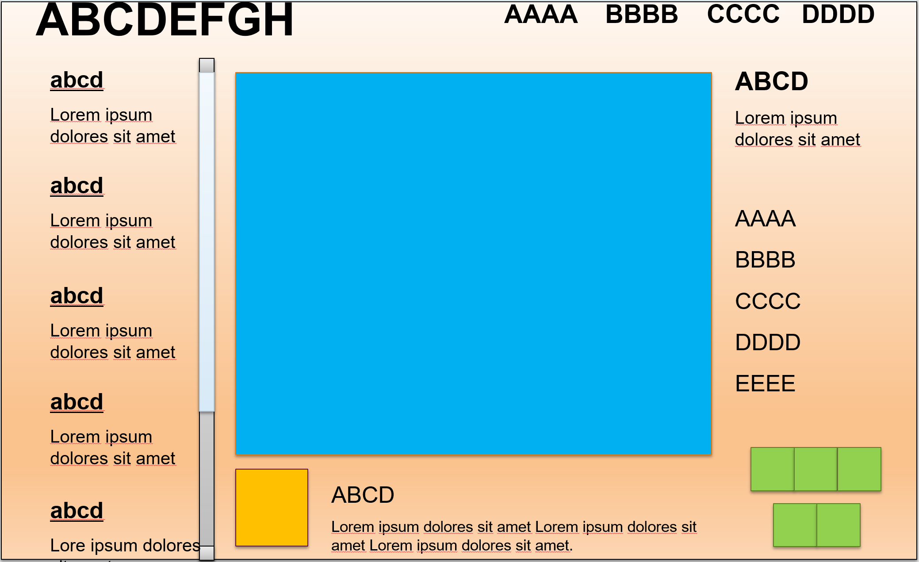

<Window x:Class="HelloWPF.Views.MainWindow"

xmlns="http://schemas.microsoft.com/winfx/2006/xaml/presentation"

xmlns:x="http://schemas.microsoft.com/winfx/2006/xaml"

xmlns:d="http://schemas.microsoft.com/expression/blend/2008"

xmlns:mc="http://schemas.openxmlformats.org/markup-compatibility/2006"

xmlns:local="clr-namespace:HelloWPF"

xmlns:viewModels="clr-namespace:HelloWPF.ViewModels"

xmlns:views="clr-namespace:HelloWPF.Views"

mc:Ignorable="d"

d:DataContext="{d:DesignInstance viewModels:MainWindowVm}"

Title="DemoWPF"

Height="450"

Width="625"

Foreground="Black">

<Window.Background>

<LinearGradientBrush EndPoint="0.5,1" MappingMode="RelativeToBoundingBox" StartPoint="0.5,0">

<GradientStop Color="#FFD94321" Offset="1" />

<GradientStop Color="#FFFBD95F" Offset="0.634" />

</LinearGradientBrush>

</Window.Background>

<Window.DataContext>

<viewModels:MainWindowVm />

</Window.DataContext>

<Grid>

<Grid.ColumnDefinitions>

<ColumnDefinition Width="150" />

<ColumnDefinition Width="*" />

</Grid.ColumnDefinitions>

<Grid.RowDefinitions>

<RowDefinition Height="30" />

<RowDefinition />

</Grid.RowDefinitions>

<TextBlock x:Name="Title" Text="ABCDEFG" Margin="5" FontWeight="Bold" />

<WrapPanel x:Name="TopMenu" Grid.Row="0" Grid.Column="1">

<TextBlock Text="AAAA" Margin="5" />

<TextBlock Text="BBBB" Margin="5" />

<TextBlock Text="CCCC" Margin="5" />

<TextBlock Text="DDDD" Margin="5" />

</WrapPanel>

<views:NavigationMenuUc Grid.Row="1" Grid.Column="0" DataContext="{Binding NavigationMenu}" />

<Grid x:Name="Content" Grid.Row="1" Grid.Column="1">

<views:ContentUc />

</Grid>

</Grid>

</Window>

<UserControl x:Class="HelloWPF.Views.NavigationMenuUc"

xmlns="http://schemas.microsoft.com/winfx/2006/xaml/presentation"

xmlns:x="http://schemas.microsoft.com/winfx/2006/xaml"

xmlns:mc="http://schemas.openxmlformats.org/markup-compatibility/2006"

xmlns:d="http://schemas.microsoft.com/expression/blend/2008"

xmlns:local="clr-namespace:HelloWPF.Views"

xmlns:viewModels="clr-namespace:HelloWPF.ViewModels"

mc:Ignorable="d"

d:DesignHeight="450" d:DesignWidth="800"

d:DataContext="{d:DesignInstance viewModels:MenuVm}">

<ListBox x:Name="NavigationMenu"

ItemsSource="{Binding MenuItems}"

SelectedItem="{Binding SelectedItem}">

<ListBox.ItemTemplate>

<DataTemplate>

<local:MenuItemUc />

</DataTemplate>

</ListBox.ItemTemplate>

</ListBox>

</UserControl>

<UserControl x:Class="HelloWPF.Views.MenuItemUc"

xmlns="http://schemas.microsoft.com/winfx/2006/xaml/presentation"

xmlns:x="http://schemas.microsoft.com/winfx/2006/xaml"

xmlns:mc="http://schemas.openxmlformats.org/markup-compatibility/2006"

xmlns:d="http://schemas.microsoft.com/expression/blend/2008"

xmlns:local="clr-namespace:HelloWPF.Views"

xmlns:viewModels="clr-namespace:HelloWPF.ViewModels"

mc:Ignorable="d"

d:DataContext="{d:DesignInstance viewModels:MenuItemVm}"

d:DesignHeight="300" d:DesignWidth="100">

<StackPanel Orientation="Vertical">

<TextBlock Text="{Binding Title}" FontWeight="Bold" />

<TextBlock Text="{Binding SubTitle}" TextWrapping="Wrap" Width="100" />

</StackPanel>

</UserControl>

<UserControl x:Class="HelloWPF.Views.ContentUc"

xmlns="http://schemas.microsoft.com/winfx/2006/xaml/presentation"

xmlns:x="http://schemas.microsoft.com/winfx/2006/xaml"

xmlns:mc="http://schemas.openxmlformats.org/markup-compatibility/2006"

xmlns:d="http://schemas.microsoft.com/expression/blend/2008"

xmlns:local="clr-namespace:HelloWPF.Views"

xmlns:viewModels="clr-namespace:HelloWPF.ViewModels"

mc:Ignorable="d"

d:DataContext="{d:DesignInstance viewModels:MainWindowVm}"

d:DesignHeight="300" d:DesignWidth="350">

<Grid>

<Grid.ColumnDefinitions>

<ColumnDefinition Width="260"/>

<ColumnDefinition Width="Auto"/>

</Grid.ColumnDefinitions>

<Rectangle x:Name="Rectangle" Grid.Column="0" Margin="30,50,90,110">

<Rectangle.Fill>

<SolidColorBrush Color="DarkBlue" />

</Rectangle.Fill>

</Rectangle>

<StackPanel Grid.Column="1">

<local:MenuItemUc DataContext="{Binding NavigationMenu.SelectedItem}" />

</StackPanel>

<Rectangle Fill="#FFFFF830" HorizontalAlignment="Left" Height="34" Margin="30,257,0,0"

VerticalAlignment="Top" Width="43" />

<TextBlock HorizontalAlignment="Left" Margin="78,257,0,0" TextWrapping="Wrap" VerticalAlignment="Top">

<Run Text="ABCD" /><LineBreak />

<InlineUIContainer>

<TextBlock TextWrapping="Wrap">

<Span FontSize="12.6666666666667" FontFamily="Consolas">

<Run Text="Lorem ipsum dolores sit amet" />

</Span>

</TextBlock>

</InlineUIContainer>

</TextBlock>

<Canvas>

<Rectangle Fill="DarkGreen" HorizontalAlignment="Left" Height="21" Margin="284,252,0,0"

VerticalAlignment="Top" Width="22" />

<Rectangle Fill="DarkGreen" HorizontalAlignment="Left" Height="21" Margin="257,226,0,0"

VerticalAlignment="Top" Width="22" />

<Rectangle Fill="DarkGreen" HorizontalAlignment="Left" Height="21" Margin="284,226,0,0"

VerticalAlignment="Top" Width="22" />

<Rectangle Fill="DarkGreen" HorizontalAlignment="Left" Height="21" Margin="311,226,0,0"

VerticalAlignment="Top" Width="22" />

</Canvas>

</Grid>

</UserControl>

public class MainWindowVm:INotifyPropertyChanged

{

public MainWindowVm()

{

NavigationMenu = new MenuVm();

}

public MenuVm NavigationMenu { get; set; }

public event PropertyChangedEventHandler PropertyChanged;

[NotifyPropertyChangedInvocator]

protected virtual void OnPropertyChanged([CallerMemberName] string propertyName = null)

{

PropertyChanged?.Invoke(this, new PropertyChangedEventArgs(propertyName));

}

}

public class MenuVm:INotifyPropertyChanged

{

private MenuItemVm _selectedItem;

public ObservableCollection<MenuItemVm> MenuItems { get; } = new ObservableCollection<MenuItemVm>();

public string SelectedTitle { get; set; }

public MenuItemVm SelectedItem

{

get { return _selectedItem; }

set

{

_selectedItem = value;

this.OnPropertyChanged();

}

}

public MenuVm()

{

InitializeFakeMenuItems();

}

private void InitializeFakeMenuItems()

{

this.MenuItems.Add(new MenuItemVm(new MenuItem() { Title = "abcd", SubTitle = "Lorem ipsum dolores sit amet" }));

this.MenuItems.Add(new MenuItemVm(new MenuItem() { Title = "abcd1", SubTitle = "Lorem ipsum dolores sit amet" }));

}

public event PropertyChangedEventHandler PropertyChanged;

[NotifyPropertyChangedInvocator]

protected virtual void OnPropertyChanged([CallerMemberName] string propertyName = null)

{

PropertyChanged?.Invoke(this, new PropertyChangedEventArgs(propertyName));

}

}

public class MenuItemVm

{

private readonly MenuItem _menuItem;

public MenuItemVm(MenuItem menuItem)

{

_menuItem = menuItem;

}

public string Title => _menuItem.Title;

public string SubTitle => _menuItem.SubTitle; }