Alex Breault

ENGL 516

An Overview of Computers

The computer has evolved on an exponential scale since its creation in 1946. The world’s first computer weighed over 50 tons and covered over 1800 square feet. Nowadays, a computer is everywhere from our smart phones to massive clusters of supercomputers. According to Merriam-Webster, a computer can be defined as an electronic device for storing and processing data, typically in binary form, according to instructions given to it in a variable program. Computers are everywhere and, at least soon, will continue to be a very prominent part of society.

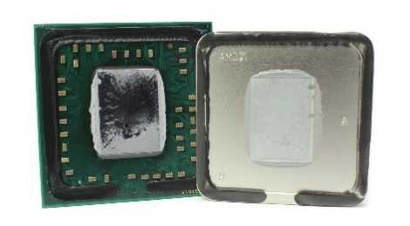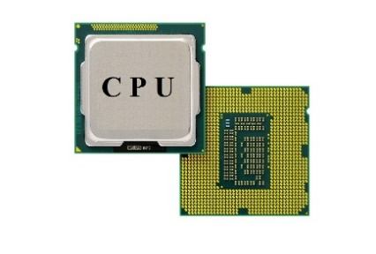 To start, there are many different components that go into a computer. The main component of a computer is the central processing unit, often referred to as the CPU. The processor acts as the brain of the computer by sending signals to all other components and controlling the hardware. In the picture, it shows the front and back of a processor. The metallic top is called a heatsink, a material to properly disperse heat evenly. The body of the processor is made of microprocessors and millions of transistors. The microprocessors are integrated circuits containing all functions of the processor, operating on a register-based system storing data by using binary. The microprocessor uses the transistors as logic gates to hold 0’s or 1’s. On each processor, they can contain multiple cores and threads. A core is an independent processing unit on the chip, able to read and execute programs either together or independently. A thread of execution is the smallest sequence of programmed instructions that can be managed independently by a scheduler, which is typically a part of the operating system. The clock speed of the processor is measured in Hertz but referenced to as gigahertz, meaning one billion Hertz. The clock speed refers to the clock cycles per second. As an example, the Intel i7-8700k, a high-end gaming processor, has a base clock speed of 3.7 GHz and a boost clock speed of up to 4.7 GHz. The base clock speed means that this is the normal speed of the chip under a light load. The processor can increase the speed up to 4.7 GHz if it is being given a lot of work or under a heavy load.

On the processor, it contains registers and cache to help store small amounts of data. A register is a quickly accessible memory location on the actual CPU. There are different levels of cache, ranging in sizes indirectly related to the speed; the smaller the size, the faster the processor can access the memory. The processor uses cache to store small amounts of data to avoid calls to main memory. On the bottom of the processor are over 200 tiny pins. They are laid out in a way to connect to a specific chipset of the motherboard.

There are two main manufacturers of processors, Intel and Advanced Micro Devices (AMD). The battle between the two processor giants has been going on for over 40 years and is constantly back and forth. Intel has always prided itself in single core performance while AMD focuses on the value per dollar. Both companies have been pushing the limits of computer processors with both moving towards a much smaller process. This means that they are wanting the surface area of each microprocessor to decrease as much as possible. Currently, the majority of microprocessors are on a 14nm process and moving towards a 10nm process or even a 7nm process. Decreasing the process size will increase speeds, the amount of hardware you can fit on the processor, and efficiency.

While the processor has the attached heatsink, the processor needs more to prevent overheating. Passively cooled (no direct coolant applied to the processor) systems exist, but they are very rare and expensive. Therefore, an additional cooling solution is required. There are multiple options to cool the processor, with the most effective cooling solutions costing the most. Between the processor heatsink and the cooler heatsink is thermal paste, a paste that evenly spreads the heat and helps keep everything cooler. In lower costing computers, a simple heatsink with an attached fan will do the trick. The additional heatsink absorbs the heat and disperses it throughout the heat pipes. In higher end computers, water cooling is a very effective option. There are multiple options with water cooling such as a closed loop or a custom loop. If you decide to go with water cooling, you need a radiator, fans, and a pump to move and cool the water. A closed loop solution includes everything needed in a very compact manner; a custom loop does about the same but with more customization options. A closed loop and a custom loop offer the same performance and thermals.

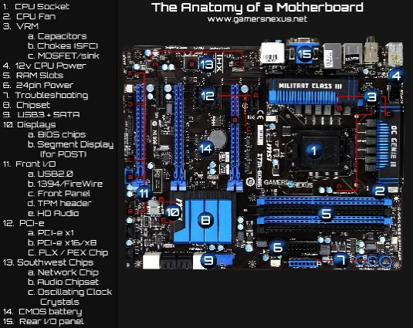 Inside of the computer, the processor sits on the motherboard. The motherboard is a large circuit board that holds the processor, the graphics card, and the connectors for all pieces of hardware inside the computer. As you can see by the picture, there is a lot going on. The main section of the motherboard is the processor socket. The processor socket has a chipset that must match the processor otherwise the hardware will be damaged, and it will not work. From the picture on the left, you can see the multiple difference aspects of the motherboard. The CPU fan (2) is a 3 or 4 pin header where the processor cooler plugs in. The motherboard will increase and decrease the processor cooler’s fan automatically and as needed. The Voltage Regulator Module (VRM) (3) is the part of the motherboard that regulates how the electricity gets distributed. The CPU Power header (4) is where the power supply connects to the motherboard for the processor power. The RAM slots (5) is where the random-access memory modules live. Normally, motherboards have either 2 or 4 slots for RAM sticks. The 24-pin power (6) is where the power supply connects to the motherboard to give power to all other components. The troubleshooting (7) light will help a user determine if anything is wrong with the board. Normally, there is a light for CPU, RAM, and memory and when booting up the computer, the motherboard will signify if anything is wrong by lighting the certain light. The chipset (8) is the spinal cord of the computer. It is the hub where all communication, transactions, and interactions between components happen. The USB and SATA (9) section is where you connect any external devices and storage devices. The display chips (10) is where the BIOS (Basic Input/Output System) is stored. The BIOS is a “settings hub” for the computer where you can tweak any hardware settings, change boot priority, or increased frequency and voltage for components. The front Input/Output (11) section is where you connect the cases front options. Normally this includes the power button, a reset button, USB slots, and headphone and microphone ports. PCI-e connectors (12) are for expansion cards such as graphics cards, networking, video capture, or sound. They vary on bandwidth, speed, and priority. The Southwest Chips (13) are to handle networking, audio, and any additional motherboard features. The CMOS (14), or complementary metal-oxide-semiconductor, is where the BIOS configuration, date, time, and other needed startup information is stored. The battery supplies power to the CMOS chip even while the computer is shut down to make sure this information is never lost. The rear I/O panel (15) is what the user can see from the back of the computer and is where all displays, USB devices, and other devices are connected.

On the motherboard, there are busses that allow the transfer of information between components. Cheaper motherboards tend to have a small number of busses and they can be rather slow. On the expensive motherboards, they have more busses because the processor can use multiple busses at once. There are multiple companies that manufacture motherboards, such as Asus, MSI, EVGA, Gigabyte, ASRock, Acer, Intel, Apple, and Dell. All motherboards perform the exact same tasks, but the speed, efficiency, and features can vary. As an example, Asus tends to make high performance gaming motherboards while Intel and Dell make low feature and cheap motherboards.

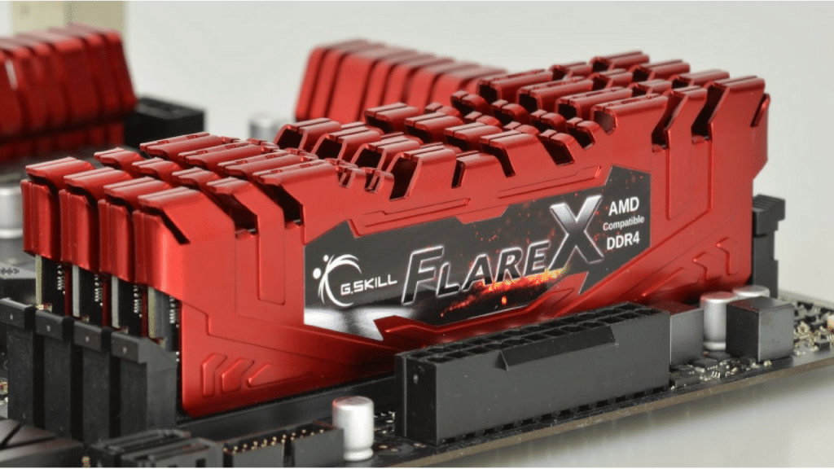 The next piece of hardware needed is the Random-Access Memory, otherwise known as RAM. RAM is computer data storage that stores information currently being used. When the current tasks of the computer cannot be handled using the processor cache, the RAM is used. Most computers have 8 gigabytes of RAM, but the high-performance machines can have from 16 to 128 gigabytes. Most tasks are handled easily by the RAM such as internet browsing or typing this paper. RAM contains volatile memory meaning that it holds the data only while it is needed and once powered off, it empties itself. RAM also needs to be refreshed multiple times per clock cycle because the capacitors are constantly discharging, and the input is being fed continuously. RAM speed is measured in Hertz as well and there are many different categories. Over the past 10 years, the average RAM speed has increased from around 200MHz to 3000MHz. The engineers designing RAM sticks have also decreased the power draw while increasing the speed and bandwidth. With RAM speeds comes RAM timing, the measure of the specific amount of time in milliseconds it takes to access a single bit of data in the memory array. There are many companies in the market for RAM, such as Samsung, SK Hynix, Micron Group, Nany, and Winbond.

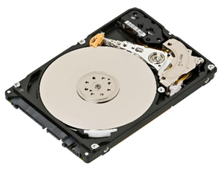 Storage is something everyone always seems to be running out of. There are multiple different options for storage inside of a computer, from hard drives to solid state drives to floppy disks. These all keep your files safe and store all the information regarding your operating system. Unlike RAM and the processor cache, storage devices keep your information even after your computer shuts down. The picture to the right is a mechanical hard drive. It uses magnetic storage using rotating disks and read and written by a moving actuator arm. The capacities can range from 250 gigabytes to 8 terabytes. This is a rather cheap storage method because a 1 terabyte hard drive can cost around $50. The one negative of the mechanical hard drive is the read and write speeds, normally ranging between 20 and 100 megabytes per second. While this is not noticeable to the average user, it can seem very slow to someone who uses solid state drives often.

A solid-state drive uses integrated circuit assemblies to store data, called flash storage. It is very fast and 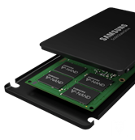efficient and expensive. For the same 1 terabyte of storage, a solid-state drive can cost around $200. A solid-state drive can have read and write speeds ranging from 200 to 5000 megabytes per second. As expected, the price for each will increase as read and write speed increases.

All storage devices need power and a connection to the motherboard. While the majority of storage devices are connected via SATA cable to the motherboard, solid-state drives have the option for M.2 connection using a connector on the motherboard. Most hard drives are 3.5” form factor while solid-state drives are 2.5” form factor. This just means that solid-state drives have the potential to be much more compact than hard drives because there are no moivng parts.

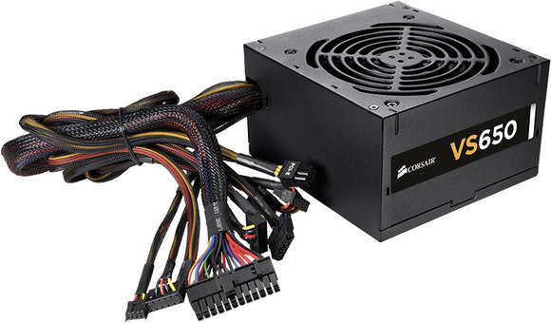Everything inside the computer needs to be powered somehow. A power supply is the most efficient way of doing so because it only needs one connection to a power source (a wall outlet) and it has the cords to connect to all components inside of the computer. All power supplies convert the alternating current from the wall to a regulated direct current and it also regulates the correct voltage and frequency for each component. Power supplies are measured in wattage output with most ranging from around 400 watts to 1200 watts. There are also modularity classifications of power supplies. For complete custom computers, there is a fully modular option to where there are no cables pre-attached to the power supply. This can be beneficial because there is no possibility of being forced to have extra cables laying around and not being used. A semi-modular power supply has some cables pre-attached, most often only the 24 pin motherboard power cord. A non-modular power supply has all cables pre-attached and these are only for computers where the exact hardware list is known (for example, the computers in an education lab). The market leaders for power supplies are Gigabyte, Delta, EVGA, Antec, and Corsair.

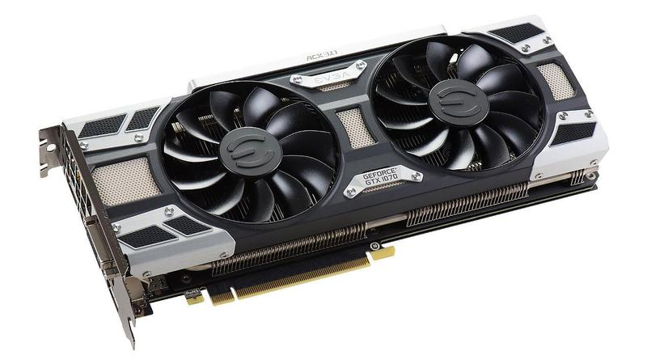All of the above components are required for a computer. A processor, processor cooler, motherboard, RAM, storage, and a power supply have to be inside of a computer for it to function. Now, we are getting to the additional components where they are not necessary but can provide massive performance advantages. A graphics card is an expansion card which generates a feed of output images to a display. Graphics cards are very popular in the gaming community because of their ability to render graphical output and do matrix computations (how most graphics are stored). Pictured at the right is an EVGA Geforce GTX 1080. Graphics cards contain multiple components, such as a graphics processing unit, a heat sink, BIOS, video memory, output, and the PCI-e connector at the bottom. In short, a graphics card is a computer inside of your computer; the components align with the whole system just aimed for a different purpose. These cards are mainly used for gaming because of how the graphical output is calculated. There are multiple cards that can output clean gameplay at 1080p resolution and, as the component capability and price increases, so does the performance. There are graphics cards that can output incredible detail and framerate numbers at 4K resolution, which has 4 times the number of pixels as 1080p. The graphics card is installed using the PCI-e connector and most cards require an additional 8 pin connector for more power.

The market leaders for graphics cards are NVIDIA and AMD. The battle for superiority has been going back and forth for years due to technological advantages. NVIDIA has been aiming for the future of graphical computations by advancing their technology rather than upping the hardware on the cards. AMD has a goal to provide the cards with the greatest value to the customer on a value to dollar ratio.

All these components need to stay cool to operate to the fullest ability. The processor needs to be directly cooled but what else does? Normally, large computers have multiple fans throughout the computer to bring cool air in and push the warm air out. This provides a passively cooled environment for the motherboard and all other components. The graphics card can also get rather hot because, when gaming or doing other computationally heavy activities, it takes most of the work. All graphics cards have fans on the card and it will automatically speed up as temperature rises.

In conclusion, the computer is one of the most complex parts of our society. They can do extreme tasks and they help make life easier. The advancements of computures has changed how humans do every day tasks. Once the user understands what is happening under the hood, they can fully utilitze the technology to its fullest ability.