Alex Breault

EDCEP 502

Final Paper

Exercise and Stress Management

Stress is everywhere, whether it be positive or negative. Today, stress is viewed as inevitable and people have been trying to find ways of dealing with stress. Only in recent years has stress been studied to the extent of today. Exercise has been proven to show signs of relief no matter the athletic ability of the individual. From yoga to aerobics to walking, any form of exercise or physical activity is linked to stress relief.

To begin, stress is an absence of inner peace in Eastern philosophies. In Western culture, stress can be described as a loss of emotional control. Psychologically speaking, stress as defined by noted researcher Richard Lazarus is a state of anxiety produced when events and responsibilities exceed one’s coping abilities. Noted healer Serge Kahili King has defined stress as any change experienced by the individual. This definition may be rather general, but it is quite correct. Physiologically speaking, stress is defined as the rate of wear and tear on the body. (Seaward)

There are three different types of stress: eustress, neustress, and distress. Eustress is good stress and can be produced in any situation that the person finds inspiring or motivating. Eustress is good for the body and should not be considered a threat. Neustress is a stress is neither good or bad stress and has no impact on the body. As an example, news of a potentially dangerous storm over a remote portion of the world could fall into this category. Distress is the negative form of stress, often abbreviated as just stress, and can have the most impact on the mind and body. There are two types of distress: acute and chronic stress. Acute stress is stress that is very intense on the surface and tends to disappear quickly. An example of acute stress is seeing flashing blue and red lights in your rear-view mirror as you are driving down the highway. Chronic stress is less intense and seems to linger for prolonged periods of time. An example of chronic stress would be dealing with a job you don’t enjoy or a “roommate from hell” for a school year.

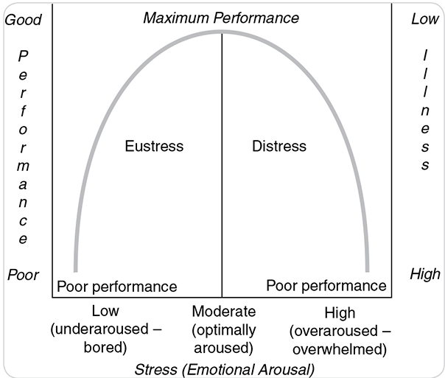 The following graph represents the Yerkes-Dodson principle, which applies to athletic performance, ties the relationship among eustress, distress, and health. It shows that, as stress increases and moves from eustress to distress, there is a peak performance one can reach and it is a swift downhill from there. The main problem with this concept is that the performance peak is different for every single person. Once on the side of distress, your body is at risk of disease and illness and performance will suffer greatly.

Physical exercise has been proven to help reduce stress levels. Benefits from physical exercise can come from all over. According to The Mayo Clinic, exercise increases your overall health and your sense of well-being. Apart from the possible muscle gain and weight loss aspects of physical exercise, it also has some direct stress relieving benefits. Being active promotes the production of endorphins, which are hormones that your body produces, and they trigger a positive feeling in your body. Exercise also helps your mind remain calm and clear throughout the day. While doing a strenuous workout routine or a cardio exercise, your body focuses on that one task and this can result in energy and optimism for the rest of the day. Also, after working out or being active, you feel good about yourself. You’re glad that you were active, and it really relaxes you and can increase your self-confidence. (Mayo Clinic)

According to Seaward in the textbook, there are five main benefits of physical exercise. It describes the benefits of exercise as if it were a pill, “If you could take all the benefits of physical exercise and manufacture them in a pill, it would be the most popular pharmaceutical in the world. But you cannot.” The human body was designed to be physical, be active, and to exercise. In our society, the average job is sitting in front of a computer screen all day. While this can be beneficial for the brain by giving it constant problems to solve, this is not good for the body. The benefits are, “Increased immune system function, Increased quality of sleep, Decreased resting heart rate and blood pressure, Increased mental alertness and concentration skills, A decrease of the aging process.”

In my personal experience, I have seen these benefits directly. Throughout high school and college, I have always had jobs where I’m on my feet doing physical work, whether it be grilling, washing cars, yardwork, or junk removal. I’ve loved having jobs that strain my body and force me to use my strength. Recently, I have taken up a job as a software developer and I’ve seen the impact on my body. I’ve gained weight, my leg strength has declined, and I have less energy throughout the day. Seeing this, I decided to change my behavior. I started this job in May and in August, I saw the impact it had on me and I decided to change. Forcing myself to workout at least four times a week and eating healthy has been a phenomenal change for my body. After working out, you always just feel so good about yourself. I have been stressed about school work and working out helps me clear my head and focus on one thing at a time. I can personally back up the studies that physical exercise has a massive impact on stress.

In conclusion, physical exercise leads to a much-improved outlook on stress. It strengthens your body while allowing your self confidence and mood to prosper. Being active improves your ability to handle stress and greatly helps your ability to sleep. There are many benefits of physical activity and our society needs to hop on this bandwagon and get active. It really does make a difference. 😊

Works Cited

“Exercise and Stress: Get Moving to Manage Stress.” Mayo Clinic, Mayo Foundation for Medical Education and Research, 8 Mar. 2018, www.mayoclinic.org/healthy-lifestyle/stress-management/in-depth/exercise-and-stress/art-20044469.

Seaward, Brian L. Essentials of Managing Stress, 4th Edition. Jones & Bartlett Learning, 2017. [Chegg].