**This Documentation illustrates all the steps and procedures that will be taken to setup the complete Jenkins Job to create the Infrasrtucture as code using terraform and Github for this project.**

**STEPS**

* ***Step1(Creating our nodes and Instances):***

Create two seperate EC2 Instances on the AWS cloud platform.

EC2 Instances:

Instance1(Will be for our Jenkins Controller Node Server)

Instance2(Will be for our Development Server Where the specified files from the GitHub repo are to be copied to)

Instance1 is created mnually and a public ip should be given to it.

First Jenkins Pipeline

Instance2 will be created during the Jenkins pipeline job run, it will use the IAC(Infrastructure as a code to run) scripts placed or pushed to the git repo to create the aws vpc and ec2 instance resources.

Second Jenkins Pipeline

This pipeline will be used to delete resources ---- Optional

Third Jenkins Pipeline

This pipeline is what performs the main task of this project:

It will pull the specified files from the github repo into the EC2 Instance2 that has been created in the First jenkins pipeline

These Jenkins Pipelines can all have tags you might use to identify them like:

:dev

:test

:production

**Installing our Jenkins Node on Instance1:**

Steps:

On Debian and Debian-based distributions like Ubuntu you can install Jenkins through apt.

sudo apt-get update

sudo apt-get install \

apt-transport-https \

ca-certificates \

curl \

gnupg \

lsb-release

---wget -q -O - https://pkg.jenkins.io/debian-stable/jenkins.io.key | sudo apt-key add -

---sudo sh -c 'echo deb https://pkg.jenkins.io/debian-stable binary/ > \

/etc/apt/sources.list.d/jenkins.list'

---sudo apt-get update

Install Java On the EC2 server1

To install the Open Java Development Kit (OpenJDK) run the following:

sudo apt install openjdk-11-jdk

java –version

Then before you can now install Jenkins

---sudo apt-get install jenkins

sudo apt install git

Then configure your jenkins node on that server.

Access the Jenkins node via the url

<public_ip>:8080

Port 8080 is the default port for Jenkins server

**Then instance terraform on Instance1 as well:**

sudo apt-get update && sudo apt-get install -y gnupg software-properties-common curl

curl -fsSL https://apt.releases.hashicorp.com/gpg | sudo apt-key add -

sudo apt-add-repository "deb [arch=amd64] https://apt.releases.hashicorp.com $(lsb_release -cs) main"

sudo apt-get update && sudo apt-get install terraform

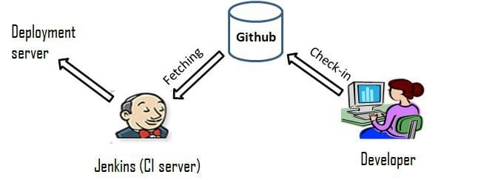Pictorial Illustration for Overral CI-CD Workflow: