Shard & Sovereign
Game Description & Current Prototype Definition
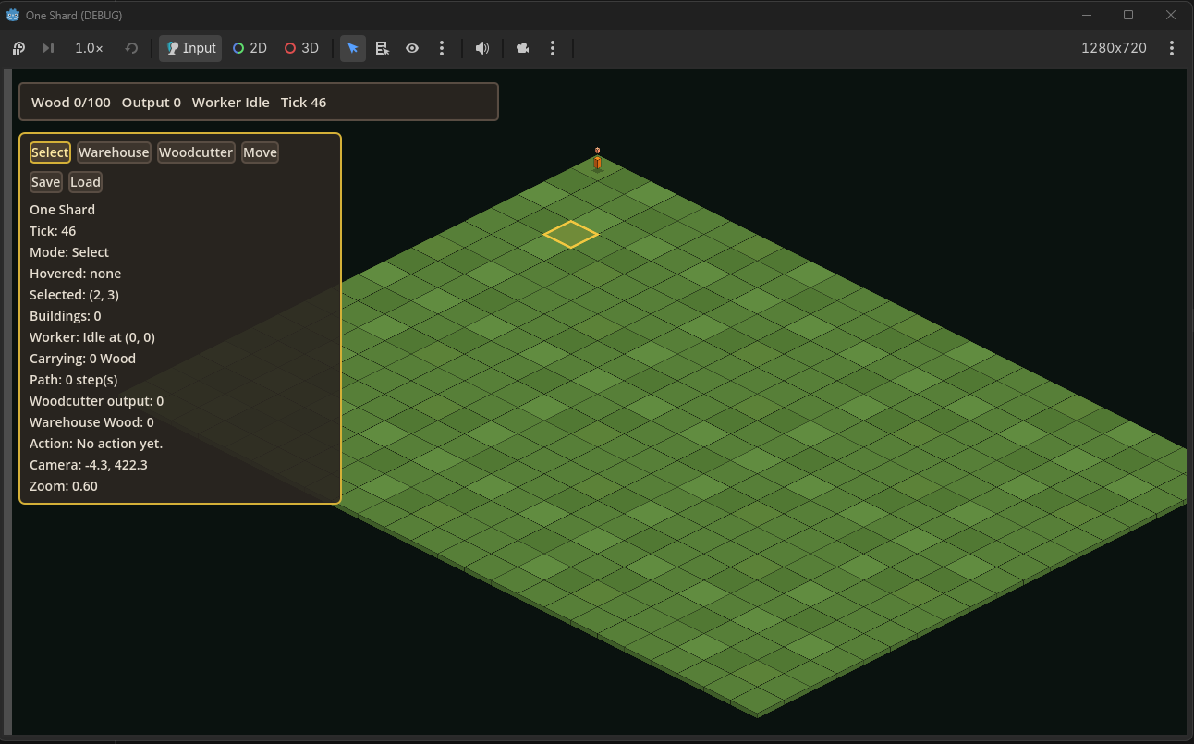
Current Codex debug build: isometric grid, basic selection/build UI, tick loop, worker status, and save/load controls.

Purpose. This document defines the game that the current Codex prototype should grow into. The attached Gemini HTML prototype is treated as the mechanics reference, while the current Codex/Godot debug build is treated as the implementation target.

1. High Concept
Shard & Sovereign is an isometric, Settlers-like fantasy kingdom-builder about turning a fragile foothold into a functioning sovereign realm. The player is not a direct hero unit. The player is the founder and operator of a small domain: placing roads, constructing buildings, enabling workers, moving resources, feeding population, defending the realm, and finally claiming the corrupting Shard that dominates the map.
Genre | Isometric logistics / colony / kingdom-building survival game.
Prototype Name | One Shard.
Core Fantasy | Build the kingdom. Connect the roads. Feed the workers. Hold the night. Claim sovereignty.
Session Goal | A short 15-25 minute run that can end in victory or collapse.
Win Condition | Build an Outpost adjacent to the Shard and survive the claim phase for two nights.

2. Design Pillars
1. Living Logistics. Roads, carriers, local inventories, and travel time are the real game. Resources should not teleport unless explicitly stored in the Town Hall/warehouse abstraction.
2. Settlement Before Empire. The player begins with one Town Hall and must earn every layer of expansion: road, extraction, processing, housing, food, defense, outpost, sovereignty.
3. Simulation First. The fun comes from visible systems interacting: a disconnected sawmill stalls, carriers bottleneck, food runs short, workers abandon posts, and night attacks punish weak logistics.
4. Player as Founder. The player directs the realm by placing infrastructure and priorities, not by micromanaging combat or directly piloting units.
5. Readable Isometric World. Every important state should be visible: connection, inventory, construction progress, carrier movement, danger, night pressure, starvation, victory progress.

3. Core Player Loop
1. Read the terrain and expand the road network from the Town Hall.
2. Place extraction buildings near useful resources: Lumber Camp, Quarry, Farm.
3. Let workers produce local outputs while carriers move goods through roads.
4. Build processing chains: wood to planks through the Sawmill, wheat to bread through the Bakery.
5. Add houses to expand population, then spend that population on workers and defenses.
6. Survive escalating night waves from the Shard using roads, towers, and redundancy.
7. Build an Outpost adjacent to the Shard and defend it through the claim phase.

4. Current Prototype State
The current Codex build shown in the screenshot is a bare but promising implementation skeleton: an isometric tile grid, basic camera/view, input modes, simple building buttons, save/load controls, a tick counter, a visible selected tile, and a single worker/resource debug loop. It is not yet the real game. It should be treated as the seed of the Godot implementation.
The attached Gemini HTML prototype is much richer mechanically. It already specifies the intended resource loop, building list, road-network dependency, construction deliveries, carriers, local inventories, food/starvation pressure, day/night cycle, enemy waves, towers, Outpost claim phase, scoring, objectives, event log, pause, save/load, and summary screens. Codex should port the mechanics and architecture into the proper project rather than copy the browser implementation directly.

5. Reference Systems from the Gemini Prototype
System | Reference Behavior
World | A 35x35 isometric tile map with grass, trees, rock deposits, and one Shard. Town Hall starts near the center. The Shard is placed far enough away to force expansion.
Visibility | Fog of war begins around the Town Hall. Roads and buildings reveal additional tiles.
Buildings | Town Hall, Road, House, Lumber Camp, Quarry, Sawmill, Farm, Bakery, Watchtower, Outpost, and Construction Site/scaffolding.
Resources | Wood, planks, stone, wheat, bread, population used, and population maximum.
Logistics | Road-connected network from the Town Hall. Carriers take materials to construction sites, supply processors, and bring finished goods back to central storage.
Workers | Woodcutter, miner, farmer, sawyer, baker, and carrier. Production buildings use population and can be disabled by starvation.
Production Chains | Trees to wood, rocks to stone, wood to planks, wheat to bread, and all materials into construction.
Population and Food | Houses and Outposts increase population cap. Workers consume food every 15 seconds. Night doubles food demand. Starvation abandons staffed buildings until restaffed.
Threat | Night waves spawn from the Shard. Enemies target the claim Outpost first during claiming, otherwise the nearest valuable building/HQ.
Defense | Watchtowers fire at visible enemies within range if connected and staffed.
End States | HQ destroyed means defeat. Outpost near Shard surviving two nights means victory.

6. Building and Resource Reference
Building | Cost / Staff | Purpose
Road | 1 wood | Connects the road network; expands visibility; required for logistics.
House | 4 wood | +5 population cap.
Lumber Camp | 2 wood, 1 population | Woodcutter gathers wood from trees into local inventory.
Quarry | 2 wood, 1 population | Miner extracts stone from a rock deposit.
Sawmill | 4 wood, 2 stone, 1 population | Converts delivered wood into planks.
Farm | 4 wood, 2 population | Produces wheat.
Bakery | 4 planks, 4 stone, 1 population | Converts delivered wheat into bread.
Watchtower | 4 stone, 2 planks, 2 population | Fires at visible enemies.
Outpost | 8 planks, 5 stone | +5 population cap; starts Shard claim if adjacent to the Shard.

7. Tone and Presentation
- Visual direction: readable low-poly isometric medieval fantasy, dark wilderness, warm settlement UI, glowing Shard corruption, distinct day/night state.
- UI direction: top resource bar, bottom build bar, left objective and realm log, right inspection panel, contextual notifications, construction progress, connection warnings, and combat/danger feedback.
- Narrative tone: low-magic, Wyrd-adjacent frontier sovereignty. The Shard should feel valuable, dangerous, and half-mythic, not like a generic crystal objective.

8. What the Next Build Must Prove
- The player can understand and use road-connected logistics without external explanation.
- Workers and carriers create visible, satisfying motion on the map.
- Production bottlenecks are legible and fixable.
- Food pressure creates meaningful tradeoffs without feeling random.
- Night attacks generate tension and teach the need for towers/outposts.
- The Shard claim is a clear dramatic climax.
- The game has a beginning, middle, and end inside one playable run.

9. Non-Goals for This Stage
- Do not build the full MMO, multiplayer, PvP, full-loot systems, or action combat yet.
- Do not add hero control, factions with gameplay bonuses, diplomacy, market simulation, or procedural content sprawl.
- Do not prioritize art complexity over simulation clarity.
- Do not fake the logistics loop by making resources appear in global counters without carriers or local inventories.

10. Target Experience Statement
A first playable version of Shard & Sovereign should feel like a small realm fighting to become real. The map begins quiet and empty. The player creates order through roads. Workers make the settlement feel alive. Carriers reveal whether the economy actually works. Night reveals whether the realm deserves to survive. The final Outpost near the Shard should feel like planting a flag at the edge of a hostile world.

Source basis: Current Codex debug screenshot, attached Gemini HTML prototype shard_sovereign_mobile(3).html, and prior One Shard design direction.

