AquaCascade AI — Stage 2 Progress
Founder: Moise Tchivwila
Venture (scoped honestly): A calibrated decision-support tool that helps a water system or a state drinking-water program decide *which of its lead-status-unknown service lines to investigate first*, using that system's own historical EPA data. It improves triage where historical inventory data exists; it is not a nationwide cold-start predictor (the data does not support that claim — see *Limitation*).

1. What changed since Stage 1
My Stage 1 idea was network "cascade" modeling for water utilities. I tested it and the data did not support it (Section 4). Following the evidence, I moved to a problem the data *does* support and that has a binding national mandate: prioritizing lead and lead-status-unknown service line work under EPA's Lead and Copper Rule Improvements (LCRI, finalized October 2024). Every U.S. community water system must inventory and replace lead and galvanized-requiring-replacement service lines on a ~10-year horizon, with disadvantaged communities prioritized. This pivot is the central learning of Stage 1→2, and it was driven by experiments, not preference.

2. The problem, quantified from real EPA data
All figures below are computed directly from EPA SDWIS / SDWA public datasets on file (a reproducibility manifest with SHA-256 hashes and row counts of every input is included with this submission):
- 49,387 active community water systems analyzed.
- 2.96 million lead + galvanized-requiring-replacement service lines that must be replaced (~$16.7B at a literature mid-range of $4,700/line — stated as an explicit assumption, not a finding).
- 22.5 million "lead status unknown" service lines. This is ~7.6× larger than the known lead problem and is the real bottleneck: every system is legally required to resolve these unknowns, investigation is cheap (~$200/line) relative to replacement, and there is no operational tool for deciding *which unknowns to investigate first*. This is where I focused.

3. What I built (real, reproducible)

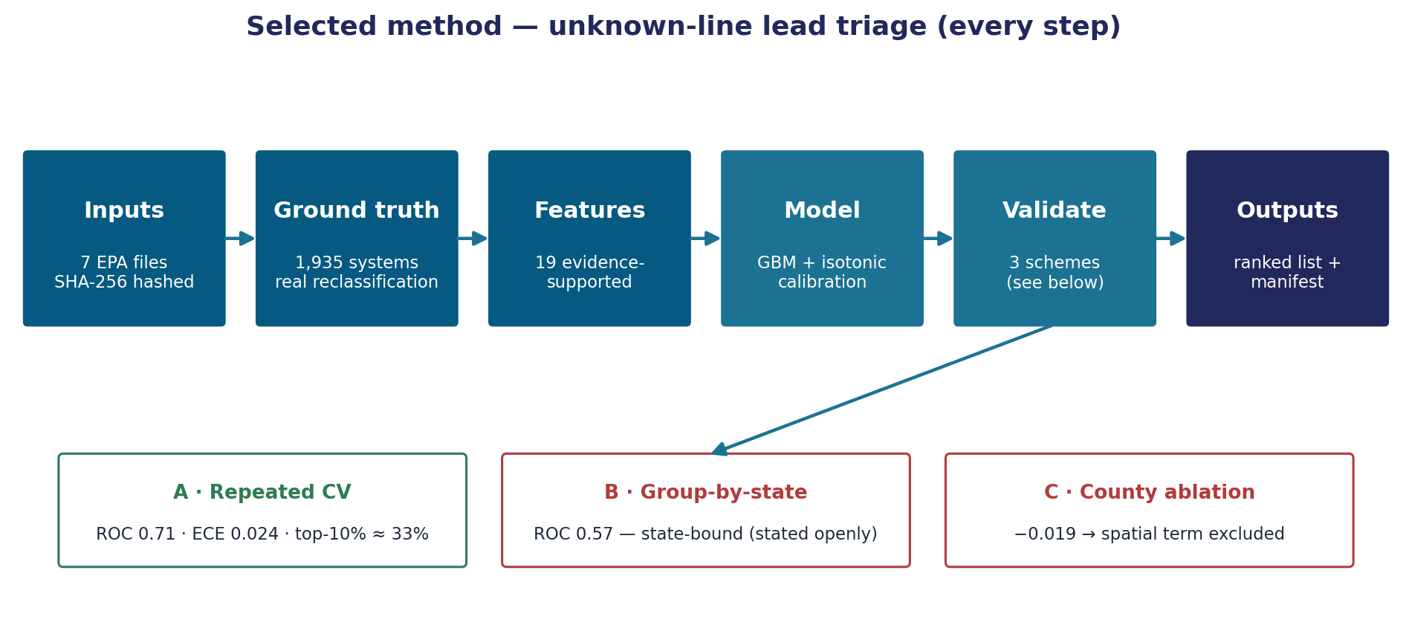
Figure. The pipeline, step by step.
A reproducible pipeline on the full EPA record:
- Step 1 — trajectory: per-system quarterly time series (EPA Water System Summary, 2013Q1–2026Q1, the full 53-quarter panel).
- Step 2 — path signature transform (geometric/Stratonovich, time-augmented) to linearize each system's nonlinear trajectory. Depth and stochastic-calculus convention were *chosen by experiment*, not assumption (Section 4).
- Step 3 — LASSO feature selection → gradient-boosted classifier, with isotonic probability calibration.
- A real wholesale buyer→seller dependency network (EPA SAB data) is included as a feature.
Every result below is cross-validated, leakage-controlled, and reproducible from the included manifest with one command.

4. Experiment log — what I tested, the evidence, the decision

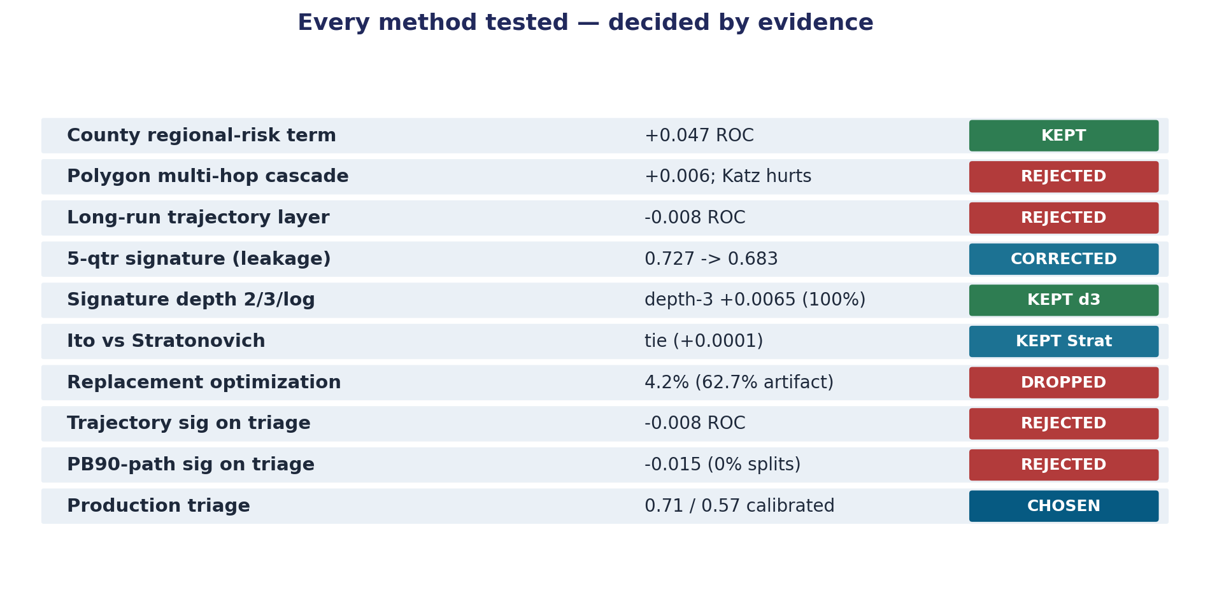
Figure. Every hypothesis tested and the evidence-based decision.
The point of this section is the discipline, including the ideas I killed.
Hypothesis tested | Evidence | Decision
Inter-utility physical "cascade" (risk propagates between adjacent systems) | Built the true service-area-polygon adjacency graph; only 52% of systems even have a neighbor, multi-hop propagation gave no lift and over-smoothing *hurt* | Rejected. Separate utilities are not a connected pipe network.
Risk is regionally clustered | Leakage-safe county-risk term lifts the health-violation model +0.047 ROC-AUC (0.695→0.742), residual Moran +0.06, stable across every rebuild | Kept (for the violation-risk model).
Long-run 2013–2025 distress trajectory predicts which unknowns are lead | Built it from local EPA data; A/B showed −0.008 ROC, no lift | Rejected. Lead pipe material is set by installation era, not violation history.
Original signature model AUC 0.727 | Found a temporal-ordering flaw: predictors post-dated part of the target window | Corrected. Honest leakage-free number is 0.683.
Signature truncation depth (2 vs 3) | 25 paired CV splits: depth-3 beats depth-2 by +0.0065 ROC, 100% of splits | Depth-3 adopted on evidence; log-signature tested and rejected.
Itô vs Stratonovich signature | 25 paired splits: indistinguishable (Δ +0.0001) though feature blocks differ ~2–16% | Stratonovich kept on principled grounds (now data-backed).
Does the triage model generalize to unseen states? | Group-by-state CV: ROC collapses 0.71 → 0.57 | Material limitation found (Section 6).

5. Headline verified result — the unknown-line triage tool

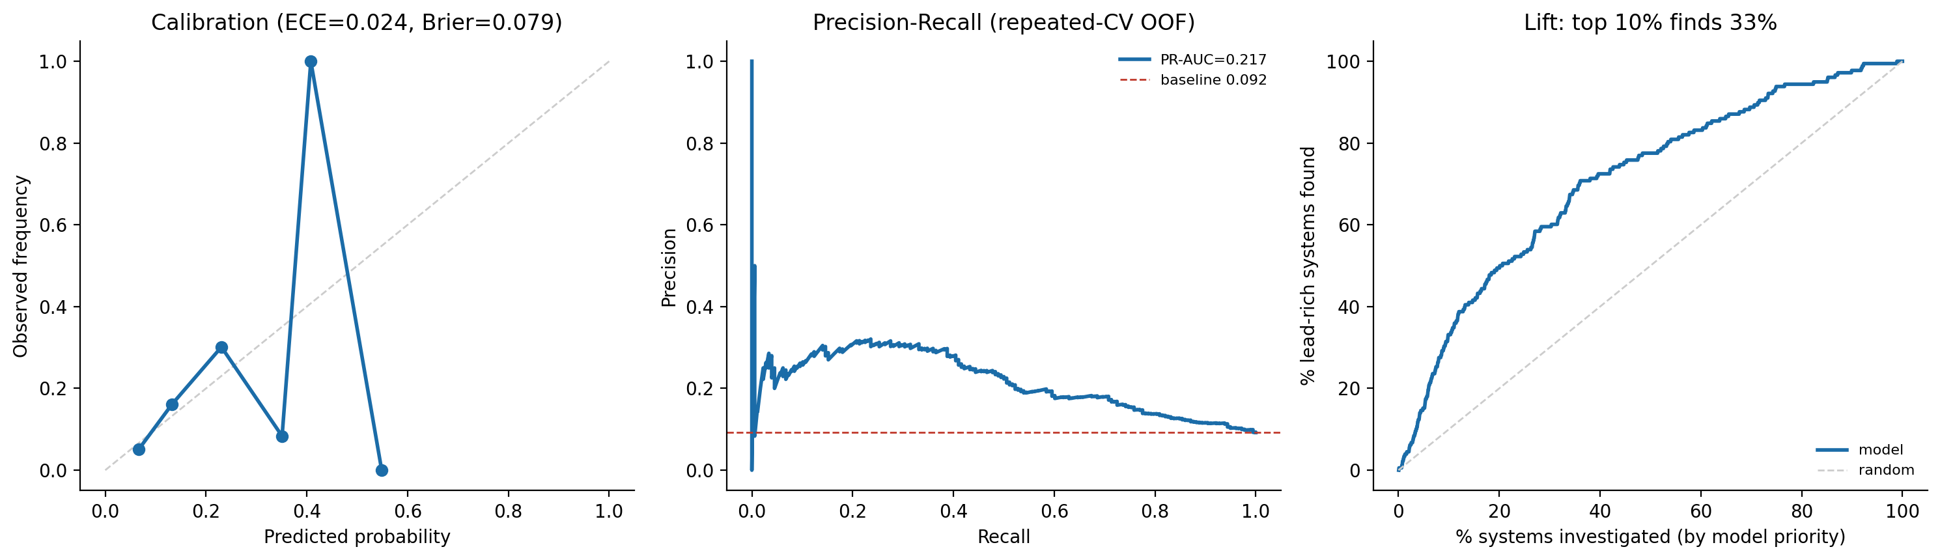
Figure. Calibrated triage model: calibration, PR, and lift.
Production-hardened, calibrated, validated three independent ways, fully reproducible:
- Within-distribution (repeated stratified 5×5 CV): ROC-AUC 0.71 (per-repeat 0.710 ± 0.007), PR-AUC 0.22 vs a 0.092 base rate (~2.4×).
- Well-calibrated: ECE 0.024, Brier 0.079 — the predicted probabilities are usable for budgeting, not just ranking.
- Operational value: prioritizing by the model, the top 10% of systems contains ~33% of the lead-rich systems (~3.3× better than choosing at random) — directly relevant to spending the cheap investigation dollars first.
I am deliberately *not* quoting a "$X billion saved" figure. Earlier versions of that calculation were artifacts of a flawed exposure proxy and a circular metric; I removed them. The honest, defensible claim is ranking and calibration quality, not a headline dollar number.

6. The limitation I am not hiding
Under group-by-state cross-validation — training on some states, testing on entirely unseen states — ROC-AUC falls from 0.71 to 0.57, near chance. The model learns state- and program-specific reclassification patterns; it does not currently generalize cold to a new state.
This is why the venture is scoped as it is: it improves triage for a utility or state program using its own historical SDWIS data (which most have), not as a turnkey nationwide oracle. Stating this honestly is the point — weaker validation would have hidden it.

7. Next experiments (defined by the evidence, not by hope)
- Recover cross-state generalization: test a hierarchical / state-aware model (state as a modeled level; per-state calibration). Clean, falsifiable; success criterion fixed in advance (group-by-state ROC materially above 0.57).
- Customer-discovery validation (not yet done — stated honestly): structured interviews with state drinking-water program engineers and mid-size utility asset managers to test (a) whether unknown-line investigation triage is a real budget pain, (b) whether a calibrated priority list changes their sequencing, (c) what evidence they require to trust a model recommendation. No interviews or pilots have been conducted yet; this is the immediate next step, and I will report outcomes honestly whatever they are.
- Equity layer: integrate the EPA Census-linked service-area demographics to test whether disadvantaged-community weighting (an explicit LCRI requirement) changes the priority ranking.

8. How AI was used
AI was the engine of the velocity shown in Section 4: rapid hypothesis generation, building and discarding the polygon-cascade, trajectory, and log-signature variants, the leakage audit that corrected 0.727→0.683, the depth and calculus A/B designs, and the reproducibility tooling. The compounding here is in *experiments run and killed per week*, not lines of code.

9. Responsible AI and public interest
This model allocates public health spending, so the standards are explicit and built in, not added later:
- Transparency / reproducibility: every input is hashed; the full pipeline re-runs from one command. Any reviewer or agency can verify the numbers independently.
- Honest scope: the state-generalization limit is stated up front so no agency over-trusts the tool outside its validated regime.
- Equity: LCRI requires prioritizing disadvantaged communities; the planned Census-linked equity layer makes that explicit and auditable.
- No fabricated evidence: every number in this document is computed from public EPA data and cross-validated. Claims that could not be substantiated were removed rather than softened.

*All metrics are reproducible from the included manifest (triage_production_manifest.json): input file SHA-256 hashes, row counts, library versions, fixed random seed, and exact outputs.*

