|  |
| --- |
| Colmq2 (1).jpgégio Jardim Getsêmani  Name:______________________________________ Year: 4º value: 10,0  Teacher: Luciana Fialho Date: __/__/2020 Bimestre: 4º  **Avaliação Bimestral – Inglês**   * Leia atentamente os comandos de cada questão antes de respondê-las; |
| |  | | --- | | **Questão 01** – **1,0 cada do item = valor total = 1,0** | |

1. **Look ! How do weather? It’s _____________.**



1. Raining .
2. Sunny .
3. Cloudy .
4. Snowing .

|  |
| --- |
| **Questão 02** – **1,0 cada item = valor total 1,0** |

1. **Look the picture ! I ______.**



1. Can ride a bike.
2. Can sing .
3. Can swim.
4. Can cook.

|  |
| --- |
| **Questão 03** – **1,0 cada item = valor total 1,0** |

1. **Where is the mother? She is in the ________**



1. kitchen.
2. Garden .
3. Bedroom .
4. Garage.

|  |
| --- |
| **Questão 04** – **1,0 cada item = valor total 1,0** |

1. **What’s this? It’s a _____ .**



1. Bed .
2. Stove .
3. sofa.
4. Table .

|  |
| --- |
| **Questão 05 - 1,0 cada item = valor total 1,0** |

1. **Look! The flower is _______.**



1. Big.
2. Small.
3. Tall.
4. Fat .

|  |
| --- |
| **Questão 06 - 1,0 cada item = valor total 1,0** |

1. **Look ! this is a _____.**



1. Tie .
2. Coat .
3. Blouse .
4. Hat .

|  |
| --- |
| **Questão 07 - 1,0 cada item = valor total 1,0** |

1. **What time is it? It is ___________ o’clock.**

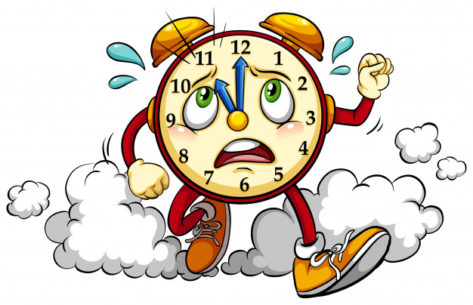

1. Eleven .
2. Twelve .
3. Ten .

|  |
| --- |
| **Questão 08 - 1,0 cada item = valor total 1,0** |

1. **Look ! this is ______.**



1. Mouth.
2. Nose.
3. Toe.
4. Legs.

|  |
| --- |
| **Questão 09- 1,0 cada item = valor total 1,0** |

1. **How much is the airplane? Airplane is ____________________.**



**U$ 20,00**

1. Ten dollars.
2. Thirty dollars .
3. Forty dollars .
4. Twenty dollars.

|  |
| --- |
| **Questão 10 - 1,0 cada item = valor total 1,0** |

1. **Look! I eat _______for breakfast.**
2. Juice .
3. Rice .
4. Bread .
5. Soda .

.

