|  |
| --- |
| Colmq2 (1).jpgégio Jardim Getsêmani  Name:______________________________________ Year: 3º value: 10,0  Teacher: Luciana Fialho Date: __/__/2020 Bimestre: 4º  **Prova de Inglês 4º Bimestre (3º Ano)**   * Leia atentamente os comandos de cada questão antes de respondê-las; |
| |  | | --- | | **Questão 01** – **1,0 cada do item = valor total = 1,0** | |

1. **Look the Picture . Circule the correction option**



1. Goodbye.
2. Good night.
3. Good evening.
4. Good morning.

|  |
| --- |
| **Questão 02** – **1,0 cada item = valor total 1,0** |

1. **Look the picture ! I can see ________toys.**

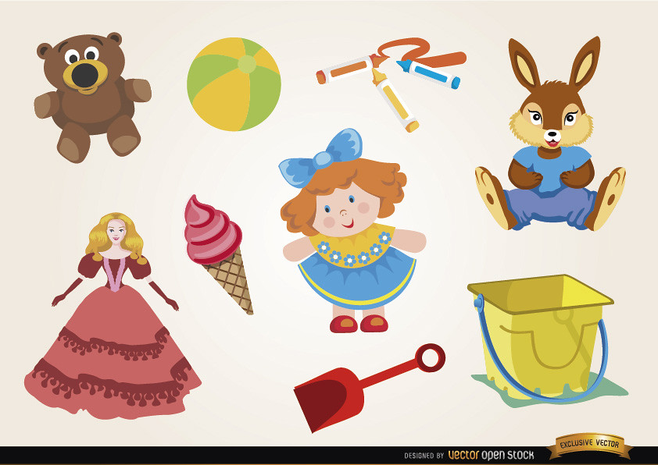

1. Twenty.
2. Nine.
3. Seven.
4. Thirty.

|  |
| --- |
| **Questão 03** – **1,0 cada item = valor total 1,0** |

1. **Circle the different Word.**
2. Pear / Orange/ grapes / banana.
3. Nose / mouth / ear / hair.
4. Kite / Ball/ puzzle/ doll.
5. Cat / dog / bird / umbrella.

|  |
| --- |
| **Questão 04** – **1,0 cada item = valor total 1,0** |

1. **What’s this? It’s _____ ruler.**



1. An.
2. A.
3. Is.
4. Are.

|  |
| --- |
| **Questão 05 - 1,0 cada item = valor total 1,0** |

1. **Look! He is my _______.**

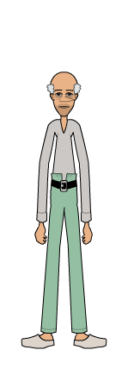

1. Father.
2. Mother.
3. Grandma .
4. Grandpa .

|  |
| --- |
| **Questão 06 - 1,0 cada item = valor total 1,0** |

1. **She is a __________ girl.**
2. Cut .
3. Open .
4. Beautiful .
5. Go.

|  |
| --- |
| **Questão 07 - 1,0 cada item = valor total 1,0** |

1. **Circle the opposite word:**

**BIG**

1. Go.
2. Study.
3. Small .

|  |
| --- |
| **Questão 08 - 1,0 cada item = valor total 1,0** |

1. **Look ! this is ______.**



1. Mouth.
2. Nose.
3. Toe.
4. Legs.

|  |
| --- |
| **Questão 09- 1,0 cada item = valor total 1,0** |

1. **Look! Whats is this? This is an _________________.**



1. Bike .
2. Bus .
3. Train .
4. Airplane.

|  |
| --- |
| **Questão 10 - 1,0 cada item = valor total 1,0** |

1. **What is the day before Thursday? ____________.**
2. Friday .
3. Monday .
4. Tuesday .
5. Sunday .

.

