

**QD. 01 CONJ. ”N” LOTE 17/19-ITAPOÃ**

**TEL.3488-1608 CEL.99174-4443  
Teacher : Luciana  
 Name:­­­­­­­­­­­­­­­__________________________________________________value:10,0**

**Avaliação Diagnóstica de Inglês 1º Ano**

MATCH.

( LIGUE)



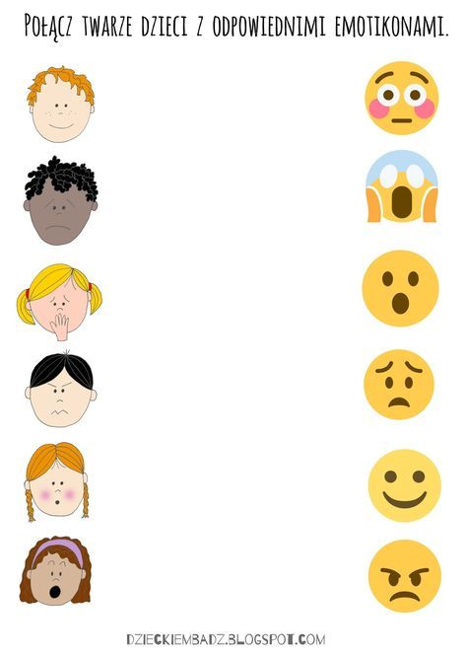



READ AND MATCH.

( LEIA E LIGUE)

(99

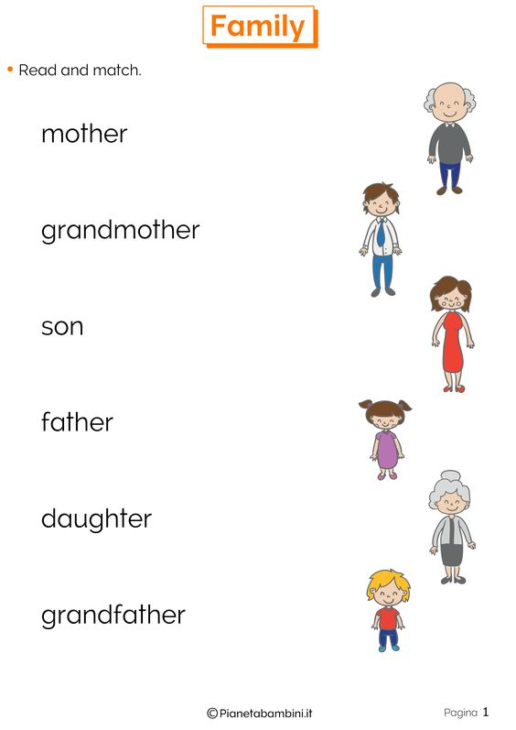

READ,TRACE ,MATCH AND COLOR.

( LEIA, TRACE, LIGUE E COLORIR)



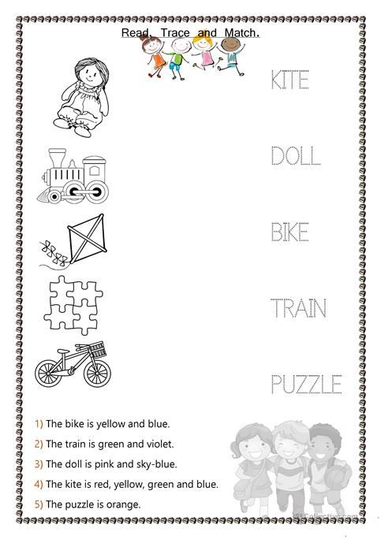

   
 **BOA PROVA !!!**