

**QD. 01 CONJ. ”N” LOTE 17/19-ITAPOÃ**

**TEL.3488-1608 CEL.99174-4443**   
 **Teacher : Luciana  
 Name:­­­­­­­­­­­­­­­________________________________________________value:10,0**

**Avaliação Diagnóstica de Inglês 4º Ano**

COLOR THE **BIG** IN EACH GROUP.



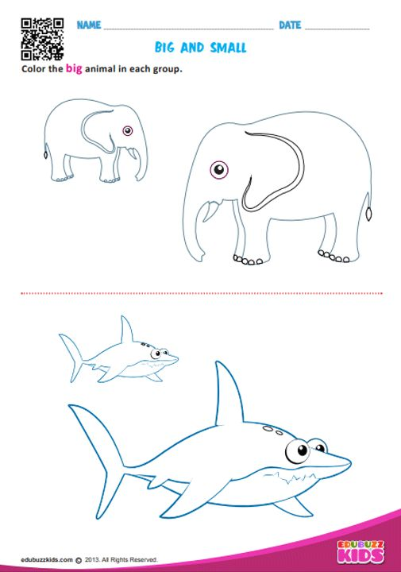



MATCH**.**

( LIGUE)

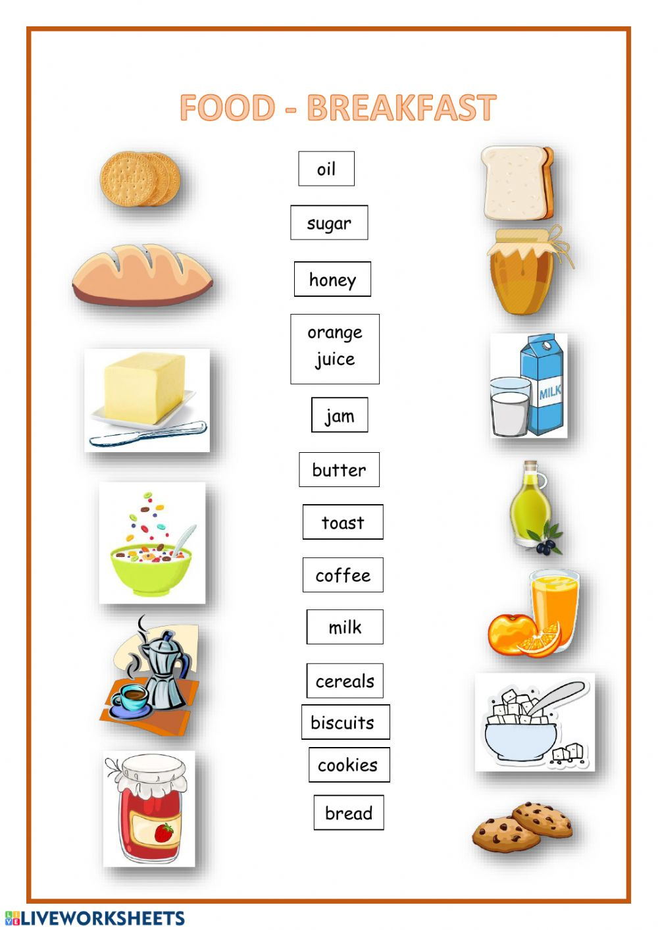

READ AND TRACE .

( LEIA E TRACE.)



