Technical Notes
This document contains technical notes for the article “Drug-drug interaction signals for major bleeding in nursing home residents: high-throughput screening of clopidogrel and oral anticoagulants.” These notes include additional details not already included in the published manuscript and supplements.
Contents
Technical Notes 1
Additional Technical Methods 1
Identifying object drug use 1
Case definitions 1
Identifying candidate precipitant drugs and time exposed 1
Statistical analyses 2
Expert Panel 2
Additional Technical Tables 3
Additional Technical Table 1. Medications most likely to interact with clopidogrel. 3
Additional Technical Figures 4
Additional Technical Figure 1: Constructing observation windows. 4
Additional Technical Figure 2: Identifying precipitant-exposed time. 5
Additional Technical Figure 3: Unused plan for identifying precipitant-exposed time in stability analyses. 5

Additional Technical Methods

Identifying object drug use
For the negative control object (pravastatin), we did not consider any therapeutic alternatives in the constructing of drug use episodes or in determining which episodes were considered new use.

Constructing Observation Windows
Observation windows either began at object initiation [for eligible individuals who were already in the nursing home (NH)] or at the start of a period of non-SNF NH time [for eligible individuals who were already taking the object before NH entry]. The object drug episode had to meet criteria for a new use episode (i.e., have a 6-month washout period without the object or a therapeutic alternative prior to initiation) Observation windows ended at the first of: discontinuation of object; switching from object to a therapeutic alternative; disenrollment from Medicare Parts A, B, or D or enrollment in Medicare Advantage; discharge from the NH; death; or end of the study period. For visual representation, see Additional Technical Figure 1.

Case definitions
Since hospitalizations occur outside of the NH, observation windows were extended by one day in the case of an outcome event.

Identifying candidate precipitant drugs and time exposed
Prior to constructing precipitant use episodes, we restricted the list of potential precipitant medications for efficiency.
We identified oral prescription drugs that were frequently co-prescribed with clopidogrel by first ascertaining the top 100 medication names in Part D claims based on the frequency of dispensings during the study period for beneficiaries included in either the major bleeding or FRI cohorts. We also considered drugs belonging to classes suspected of interacting with clopidogrel, which are listed in Additional Technical Table 1 below. Medications that had multiple names in Part D were categorized as a single drug (e.g., atorvastatin and atorvastatin calcium).
Among the medications identified from either source, we constructed precipitant use episodes using the dates of medication dispensing and days of medication supplied without the addition of any grace periods. We only screened precipitants if 30 or more residents in the cohort initiated the drug (with at least 6 months washout without use) during their observation windows. While some drugs identified in this way belonged to classes suspected of interaction with clopidogrel, all were in the top 100. Further, many of the top 100 drugs didn’t have sufficient data to be advanced to screening. Thus, our assumptions about drugs likely to interact with clopidogrel had no impact on which drugs were advanced to screening. For the oral anticoagulant object drugs and the negative control object, we did not prespecify any precipitants that we thought would interact, and based screening entirely on frequency of use in the object-specific cohorts.
Time within an observation window was only considered precipitant-exposed if the medication was initiated (with at least 6 months washout without use) during that observation window. All other time in the observation window was considered precipitant-unexposed (Additional Technical Figure 2). This exposure classification scheme may have led to some misclassification (of prevalent use time as unexposed). However, under the assumption that most time at risk occurs shortly after precipitant initiation, this decision should have led to less misclassification than if such prevalent use time was categorized as new use. Had we enough data, we planned to perform stability analyses in which we accounted for this with additional precipitant exposure categories for prevalent use time or time since initiating precipitant (Additional Technical Figure 3).
Precipitant exposed days could occur before and/or after unexposed days. Variation in the use of the precipitant drug was not required; thus, an individual could contribute only exposed days or only unexposed days and still be included. However, since no covariates were included in the models, the results are equivalent to analyses in which only those with variation in exposure were included.

Statistical analyses
We had to scale back the complexity of the statistical analyses we implemented after confronting the sample size constraints of our data. We originally planned to look at time since initiating object as an effect modifier. We also abandoned plans to include time-varying covariates in our models, including age, average daily dose, and history of outcome. In terms of precipitant exposure categorization, we had hoped to do stability analyses in which we created a separate exposure category for prevalent use of the precipitant, rather than maintaining the binary exposure categorizing and categorizing this time as unexposed.

Expert Panel
Panel members were selected after reviewing evidence of expertise and accounting for potential conflicts of interest. Panel members were financially compensated for their time.

Additional Technical Tables

Additional Technical Table 1. Medications most likely to interact with clopidogrel.
Medication Class | Mechanism of Interaction with Clopidogrel | Expected Outcome of Drug-Drug Interaction | Medications in Class
Proton Pump Inhibitors | Inhibition of CYP2C19 | Reduced antiplatelet effect of clopidogrel | Prescription Drugs  pantoprazole, pantoprazole (as pantoprazole sodium sesquihydrate), rabeprazole, rabeprazole sodium, dexlansoprazole  Nonprescription (OTC) Drugs, esomeprazole, esomeprazole (as magnesium trihydrate), esomeprazole (as sodium), esomeprazole strontium, lansoprazole, omeprazole
Selective Serotonin Reuptake Inhibitors | Inhibition of CYP2C19 or CYP3A4  Both clopidogrel and selective serotonin reuptake inhibitors inhibit platelet aggregation | Reduced antiplatelet effect of clopidogrel, , Increased risk of bleeding | citalopram, citalopram (as citalopram hydrobromide), escitalopram oxalate, escitalopram, fluoxetine (as hydrochloride), fluoxetine, fluvoxamine maleate, fluvoxamine, paroxetine hydrochloride, paroxetine mesylate, paroxetine, sertraline, sertraline hydrochloride, vilazodone hydrochloride, vilazodone, vortioxetine (as hydrobromide), vortioxetine
Statins | Competition with CYP3A4 enzymes | Reduced antiplatelet effect of clopidogrel | atorvastatin, fluvastatin sodium, fluvastatin, lovastatin, pitavastatin, pitavastatin (as calcium), pravastatin, pravastatin sodium, rosuvastatin, rosuvastatin calcium, simvastatin, cerivastatin
Anticoagulants | Both clopidogrel and anticoagulants affect hemostasis | Increased risk of bleeding | apixaban, betrixaban, dabigatran, dabigatran etexilate, dalteparin, dalteparin sodium, edoxaban, edoxaban (as tosylate), enoxaparin, enoxaparin sodium, fondaparinux, fondaparinux sodium, heparin, rivaroxaban, tinzaparin, warfarin, warfarin sodium
Nonsteroidal Anti-Inflammatory Drugs | Both clopidogrel and nonsteroidal anti-inflammatory drugs inhibit platelet aggregation | Increased risk of bleeding | Prescription Drugs  celecoxib, rofecoxib, valdecoxib, bromfenac (as sodium sesquihydrate), bromfenac, diclofenac epolamine, diclofenac potassium, diclofenac sodium, diclofenac, diflunisal, etodolac, fenoprofen calcium, fenoprofen, flurbiprofen, flurbiprofen sodium, indomethacin, ketoprofen, ketorolac tromethamine, ketorolac, meclofenamate sodium, meclofenamate, mefenamic acid, meloxicam, nabumetone, nepafenac, oxaprozin, oxyphenbutazone, phenylbutazone, piroxicam, sulindac, suprofen, tolmetin sodium, tolmetin, salsalate  Nonprescription (OTC) NSAIDs, ibuprofen, naproxen, naproxen (as sodium), naproxen sodium, aspirin
Calcium Channel Blockers | Inhibition of CYP3A4 | Reduced antiplatelet effect of clopidogrel | diltiazem hydrochloride, diltiazem, verapamil hydrochloride, verapamil
Macrolide Antibiotics | Inhibition of CYP3A4 | Reduced antiplatelet effect of clopidogrel | erythromycin, erythromycin ethylsuccinate, erythromycin lactobionate, erythromycin stearate, azithromycin, clarithromycin, telithromycin

Additional Technical Figures

Additional Technical Figure 1: Constructing observation windows.
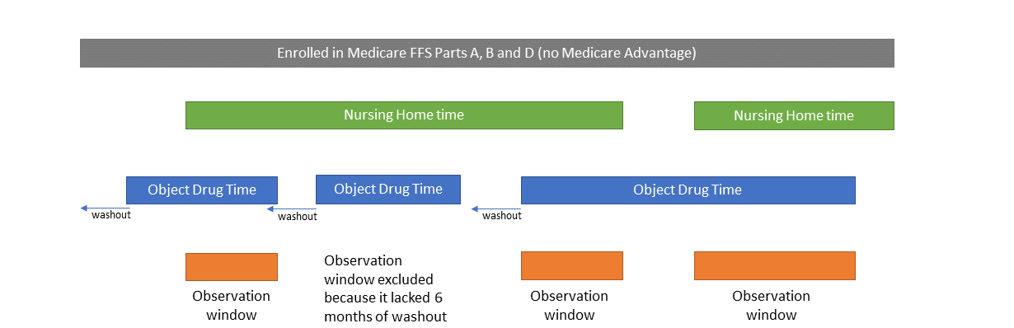

Additional Technical Figure 2: Identifying precipitant-exposed time.
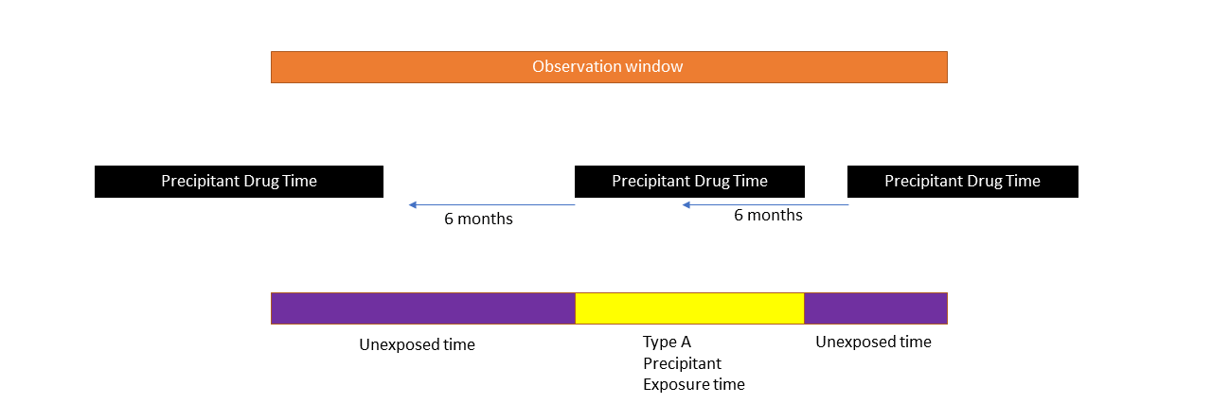
Precipitant-exposed time is limited to new use of precipitant (with a 6-month washout without use), initiated during that observation window. All other time is considered precipitant=unexposed.

Additional Technical Figure 3: Unused plan for identifying precipitant-exposed time in stability analyses.
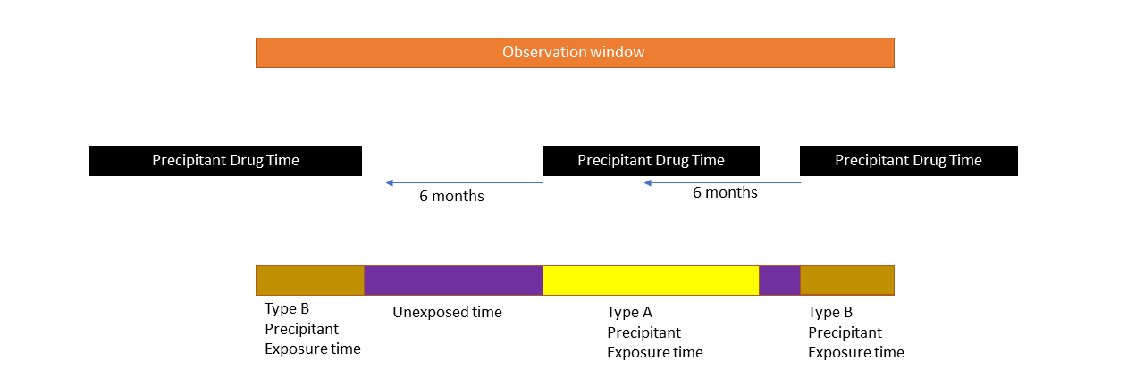
We originally planned to run stability analyses in which prevalent use of the precipitant drug was given its own exposure category (“Type B precipitant exposed time”). Because of sample size constraints, we ultimately did not run these analyses.

