# Technical Notes

This document contains technical notes for the article “Feasibility of applying pharmacoepidemiologic drug-drug interaction screening methods to nursing home residents: An application to clopidogrel.” These notes include additional details not already included in the published manuscript and supplements.

Contents

Technical Notes 1

Additional Technical Methods 1

Case definitions and follow-up time 1

Identifying candidate precipitant drugs and time exposed 1

Statistical analyses 2

Expert Panel 2

Additional Technical Tables 2

Additional Technical Table 1. Medications most likely to interact with clopidogrel. 2

Additional Technical Figures 3

Additional Technical Figure 1: Constructing observation windows. 3

Additional Technical Figure 2: Identifying precipitant-exposed time. 4

Additional Technical Figure 3: Unused plan for identifying precipitant-exposed time in stability analyses. 4

## Additional Technical Methods

### Case definitions and follow-up time

Since hospitalizations occur outside of the NH, observation windows were extended by one day in the case of an outcome event.

### Identifying candidate precipitant drugs and time exposed

Prior to constructing precipitant use episodes, we restricted the list of potential precipitant medications for efficiency.

We identified oral prescription drugs that were frequently co-prescribed with clopidogrel by first ascertaining the top 100 medication names in Part D claims based on the frequency of dispensings during the study period for beneficiaries included in either the major bleeding or FRI cohorts. We also considered drugs belonging to classes suspected of interacting with clopidogrel, which are listed in **Additional Technical Table 1** below. Medications that had multiple names in Part D were categorized as a single drug (e.g., atorvastatin and atorvastatin calcium).

Among the medications identified from either source, we constructed precipitant use episodes using the dates of medication dispensing and days of medication supplied without the addition of any grace periods. We only screened precipitants if 30 or more residents in the cohort initiated the drug (with at least 6 months washout without use) during their observation windows. While some drugs identified in this way belonged to classes suspected of interaction with clopidogrel, all were in the top 100. Further, many of the top 100 drugs didn’t have sufficient data to be advanced to screening. Thus, the process of reducing the list of potential precipitant medications did an impact in the selection of drugs that were actually advanced to screening.

Time within an observation window was only considered precipitant-exposed if the medication was initiated (with at least 6 months washout without use) during that observation window. All other time in the observation window was considered precipitant-unexposed (**Additional Technical Figure 2**). This exposure classification scheme may have led to some misclassification (of prevalent use time as unexposed). However, under the assumption that most time at risk occurs shortly after precipitant initiation, this decision should have led to less misclassification than if such prevalent use time was categorized as new use. Had we enough data, we planned to perform stability analyses in which we accounted for this with additional precipitant exposure categories for prevalent use time or time since initiating precipitant (**Additional Technical Figure 3**).

Precipitant exposed days could occur before and/or after unexposed days. Variation in the use of the precipitant drug was not required; thus, an individual could contribute only exposed days or only unexposed days and still be included. (However, since no covariates were included in the models, the results were equivalent to analyses in which only those with variation in exposure were included.)

### Statistical analyses

We had to scale back the complexity of the statistical analyses we implemented after confronting the sample size constraints of our data. We originally planned to look at time since initiating clopidogrel as an effect modifier. We also abandoned plans to include time-varying covariates in our models, including age, average daily dose, and history of outcome. In terms of precipitant exposure categorization, we hoped to do stability analyses in which we created a separate exposure category for prevalent use of the precipitant, rather maintaining the binary exposure categorizing and categorizing this time as unexposed.

### Expert Panel

Panel members were selected after reviewing evidence of expertise and accounting for potential conflicts of interest. Panel members were financially compensated for their time.

## Additional Technical Tables

### Additional Technical Table 1. Medications most likely to interact with clopidogrel.

|  |  |  |
| --- | --- | --- |
| **Medication Class** | **Mechanism of Interaction with Clopidogrel** | **Expected Outcome of Drug-Drug Interaction** |
| Proton Pump Inhibitors | Inhibition of CYP2C19 | Reduced antiplatelet effect of clopidogrel |
| Selective Serotonin Reuptake Inhibitors | Inhibition of CYP2C19 or CYP3A4  Both clopidogrel and selective serotonin reuptake inhibitors inhibit platelet aggregation | Reduced antiplatelet effect of clopidogrel  Increased risk of bleeding |
| Statins | Competition with CYP3A4 enzymes | Reduced antiplatelet effect of clopidogrel |
| Anticoagulants | Both clopidogrel and anticoagulants affect hemostasis | Increased risk of bleeding |
| Nonsteroidal Anti-Inflammatory Drugs | Both clopidogrel and nonsteroidal anti-inflammatory drugs inhibit platelet aggregation | Increased risk of bleeding |
| Calcium Channel Blockers | Inhibition of CYP3A4 | Reduced antiplatelet effect of clopidogrel |
| Macrolide Antibiotics | Inhibition of CYP3A4 | Reduced antiplatelet effect of clopidogrel |
| Note: Individual medications included in each class are listed in excel file in GitHub under the sheet “Drug Classes of Interest.” | | |

## Additional Technical Figures

### Additional Technical Figure 1: Constructing observation windows.

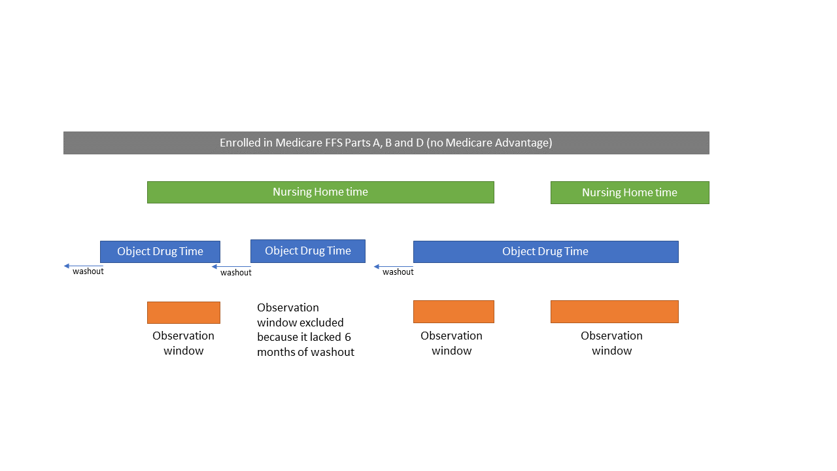

Observation windows either began at clopidogrel initiation (for eligible individuals who were already in the NH) or the start of a period of non-SNF NH time (for eligible individuals who were already taking clopidogrel before NH entry). Clopidogrel had to meet eligibility criteria for a new use episode (i.e., have a 6-month washout period without clopidogrel or other prescription antiplatelet prior to the start of clopidogrel use episodes.) Observation windows ended at the first of: discontinuation of clopidogrel; switching from clopidogrel to an alternative prescription antiplatelet; disenrollment from Medicare Parts A, B, or D or enrollment in Medicare Advantage; discharge from the NH; death; or end of the study period.

### Additional Technical Figure 2: Identifying precipitant-exposed time.

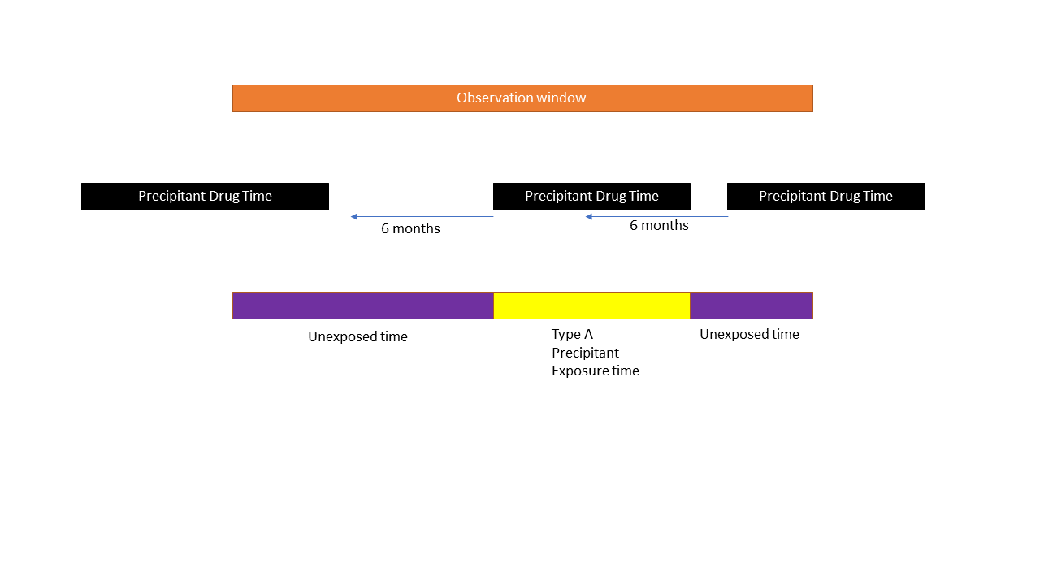

Precipitant exposed time is limited to new use of precipitant (with a 6-month washout without use), initiated during that observation window. All other time is considered precipitant unexposed.

### Additional Technical Figure 3: Unused plan for identifying precipitant-exposed time in stability analyses.

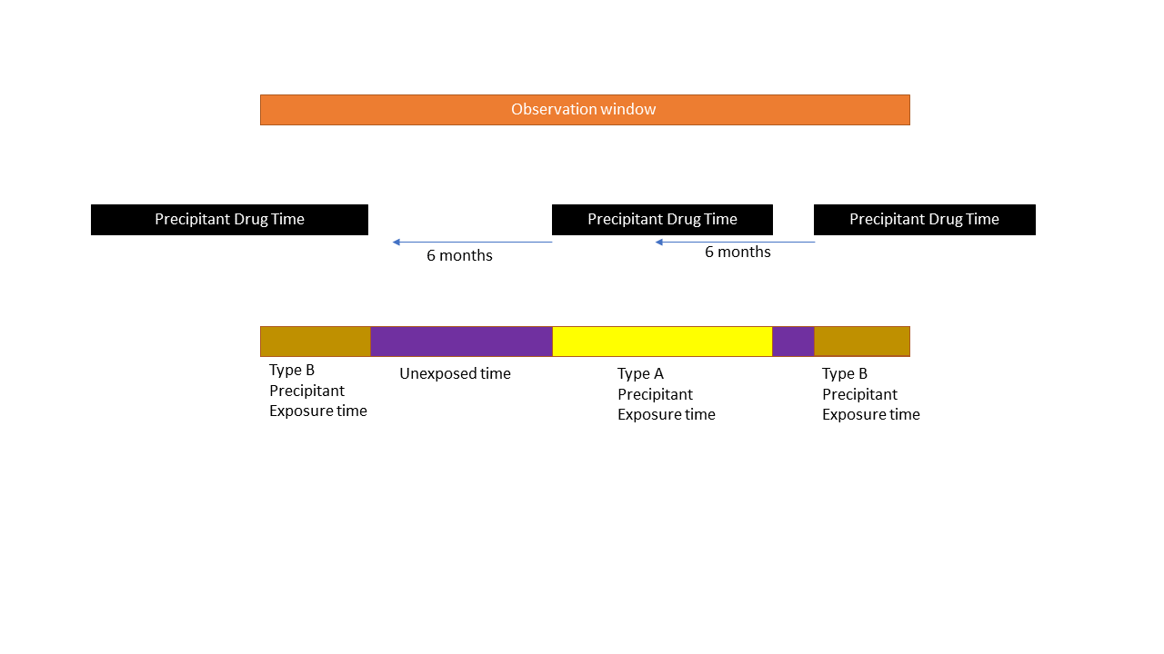

We originally planned to run stability analyses in which prevalent use of the precipitant drug was given its own exposure category (“Type B precipitant exposed time”). Because of sample size constraints, we ultimately did not run these analyses.